1. Create an arraylist of user-defined data type Book. it should have:-

i)Name of the Book

ii)Author of the book

iii)year of publication of the book

iV)number of copies sold.

sort the array list based on the year of publication.

Solution

*package sba2;*

*import java.util.*;*

*class Book implements Comparable {*

*int sold;*

*Integer year;*

*String name, author;*

*public Book(String name, String author, int year, int sold) {*

*this.name = name;*

*this.author = author;*

*this.year = year;*

*this.sold = sold;*

*}*

*public int getYear() {*

*return this.year;*

*}*

*@Override*

*public int compareTo(Object o) {*

*Book b1 = (Book) o;*

*return (this.year.compareTo(b1.getYear()));*

*}*

*}*

*public class Q1 {*

*public static void main(String[] args) {*

*// Creating list of Books*

*List<Book> list = new ArrayList<Book>();*

*// Creating Books*

*Book b1 = new Book("Mein Kampf", "Adolf Hitler", 1925, 100000);*

*Book b2 = new Book("Geetanjali", "Rabindra Nath Tagore", 1910, 6000000);*

*Book b3 = new Book("Das Kapital", "Karl Marx", 1867, 500000000);*

*// Adding Books to list*

*list.add(b1);*

*list.add(b2);*

*list.add(b3);*

*// Traversing list*

*Collections.sort(list, Collections.reverseOrder());*

*for (Book b : list) {*

*System.out.println(b.name + ", " + b.author + ", " + b.year + ", " + b.sold);*

*}*

*}*

*}*

Output

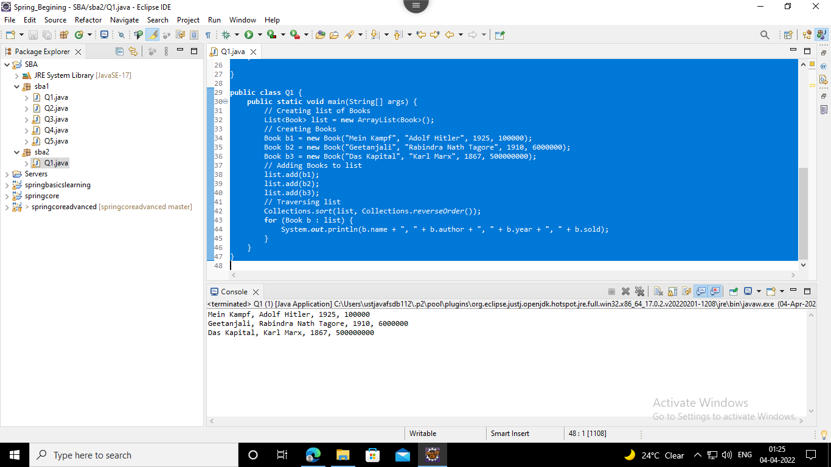

2. Write a program to create, write and read from a file.

Solution

*package sba2;*

*import java.io.File;*

*import java.io.FileNotFoundException;*

*import java.io.FileWriter;*

*import java.io.IOException;*

*import java.util.Scanner;*

*public class Q2 {*

*public static void main(String[] args) {*

*try {*

*FileWriter f1 = new FileWriter("D:NewFile.txt");*

*Scanner sc = new Scanner(System.in);*

*System.out.println("Write data to the file");*

*String s = sc.nextLine();*

*f1.write(s);*

*System.out.println("Data written successfully");*

*f1.close();*

*sc.close();*

*} catch (IOException e) {*

*System.out.println("an unexpected error has occured");*

*System.out.println(e);*

*}*

*try {*

*File f2 = new File("D:NewFile.txt");*

*Scanner sc1 = new Scanner(f2);*

*while (sc1.hasNextLine()) {*

*String fileData = sc1.nextLine();*

*System.out.print("Reading data from the file..: ");*

*System.out.println(fileData);*

*}*

*sc1.close();*

*} catch (FileNotFoundException e) {*

*System.out.println("There is some unexpected Problem");*

*System.out.println(e);*

*}*

*}*

*}*

Output

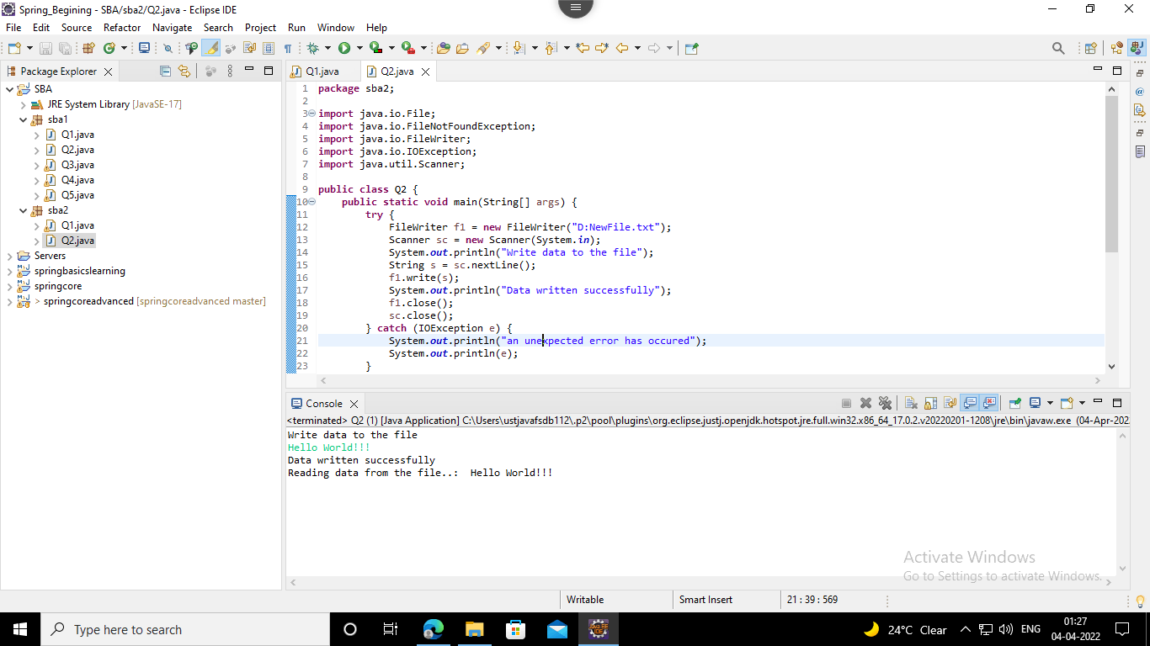

3. Write a program to get the information about the file.

Solution

*package sba2;*

*import java.io.File;*

*import java.io.FileWriter;*

*import java.io.IOException;*

*public class Q3 {*

*public static void main(String[] args) throws IOException {*

*File f1 = new File("D:FileCreateExample.txt");*

*FileWriter obj1 = new FileWriter("D:FileCreateExample.txt");*

*obj1.write("Hello World..This is a Java File Program");*

*obj1.close();*

*if (f1.exists()) {*

*System.out.println("The file name is: " + f1.getName());*

*System.out.println("Is the file Writeable: " + f1.canWrite());*

*System.out.println("The absolute Path of the file is: " + f1.getAbsolutePath());*

*System.out.println("Is the file Readable: " + f1.canRead());*

*System.out.println("The size of the file in bytes: " + f1.length());*

*System.out.println("Hidden: " + f1.isHidden());// Returns true if the specified Path locates a file that is*

*// considered hidden by the file system.*

*System.out.println("lastModifiedTime: " + f1.lastModified());// Returns the specified file's last modified*

*System.out.println("isDirectory: " + f1.isDirectory());// Returns true if the specified Path locates a file*

*// that is a directory.*

*} else {*

*System.out.println("the file does not exist");*

*}*

*}*

*}*

Output

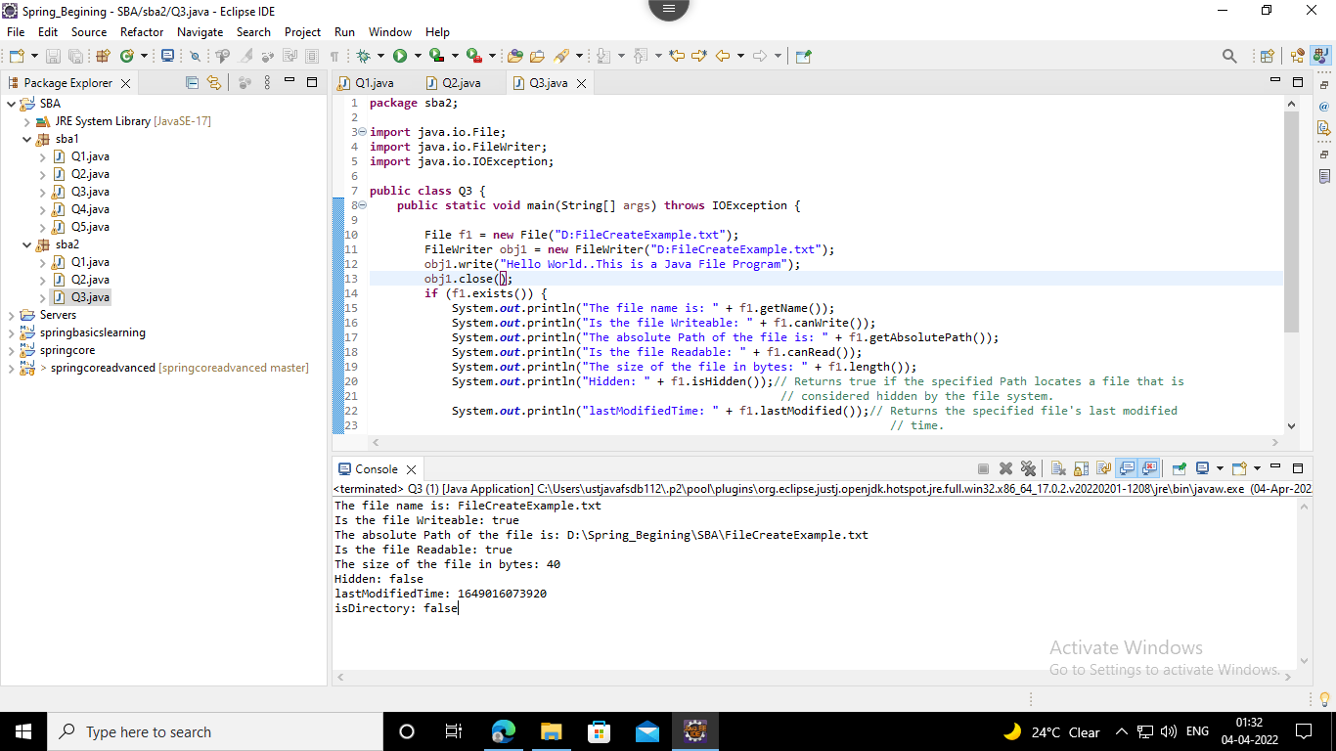

4. Write a program Implement the filereader until the file ending character is “-1” and print all the data of the file.

Solution

*package sba2;*

*import java.io.FileReader;*

*import java.io.FileWriter;*

*import java.io.IOException;*

*public class Q4 {*

*public static void main(String[] args) {*

*try {*

*FileWriter obj1 = new FileWriter("D:Q3_NewFile.txt");*

*obj1.write(*

*"Program to Implement the filereader until the file ending character is “-1” and print all the data of the file.");*

*obj1.close();*

*} catch (IOException e) {*

*System.out.println("Some unexpected error has occured");*

*System.out.println(e);*

*}*

*try {*

*FileReader textFileReader = new FileReader("D:Q3_NewFile.txt");*

*int i;*

*while ((i = textFileReader.read()) != -1)*

*System.out.print((char) i);*

*textFileReader.close();*

*} catch (IOException e) {*

*System.out.println("Some unexpected error has occured");*

*System.out.println(e);*

*}*

*}*

*}*

Output

