1. Write a program to take an integer array from the user and give the user a choice to sort using bubble sort (or) selection sort. Sort the array elements according to the selected algorithm of the user and display the sorted array.

Solution

*package sba4;*

*import java.util.Scanner;*

*public class Q1 {*

*// *****BUBBLE SORT\*\*\*\*\*\*\*\*\*\*\*\**

*void bubbleSort(int arr[]) {*

*int n = arr.length;*

*for (int i = 0; i < n - 1; i++)*

*for (int j = 0; j < n - i - 1; j++) {*

*if (arr[j] > arr[j + 1]) {*

*// swap arr[j+1] and arr[j]*

*int temp = arr[j];*

*arr[j] = arr[j + 1];*

*arr[j + 1] = temp;*

*}*

*// for debugging every move made by the algorithm*

*/\**

*\* for (int k=0; k<n; ++k) { System.out.print(arr[k]+","); }*

*\* System.out.println("");*

*\*/*

*} // inner for closes*

*}*

*/* Prints the array */*

*void printArray(int arr[]) {*

*int n = arr.length;*

*for (int i = 0; i < n; ++i)*

*System.out.print(arr[i] + " ");*

*System.out.println();*

*}*

*// ********SELECTION SORT\*\*\*\*\*\*\*\*\*\*\*\*\*\**

*void Selectionsort(int arr[]) {*

*int n = arr.length; // 6*

*for (int i = 0; i < n - 1; i++) {*

*int min_idx = i;//*

*for (int j = i + 1; j < n; j++) {*

*if (arr[min_idx] > arr[j])*

*min_idx = j;// 5*

*}*

*int temp = arr[min_idx];*

*arr[min_idx] = arr[i];*

*arr[i] = temp;*

*/\**

*\* for (int k=0; k<n; ++k) { System.out.print(arr[k]+" "); }*

*\* System.out.println();*

*\*/*

*}*

*}*

*// Prints the array*

*void printArray2(int arr[]) {*

*int n = arr.length;*

*for (int i = 0; i < n; ++i)*

*System.out.print(arr[i] + " ");*

*System.out.println();*

*}*

*//****MAIN CLASS\*\*\*\*\*\*\*\*\**

*public static void main(String[] args) {*

*// int arr[] = {64, 34, 25, 12, 22, 11, 90};*

*int[] arr = new int[5];*

*System.out.println("Enter 5 integer values");*

*Scanner sc = new Scanner(System.in);*

*for (int i = 0; i < 5; i++) {*

*arr[i] = sc.nextInt();*

*}*

*System.out.print("Unsorted Array is : [");*

*for (int i = 0; i < 5; i++) {*

*System.out.print(arr[i] + ",");*

*}*

*System.out.println("]");*

*Q1 ob = new Q1();*

*System.out.println("Enter 1:Bubble Sort 2:Selection Sort");*

*int n = sc.nextInt();*

*switch (n) {*

*case 1: {*

*ob.bubbleSort(arr);*

*System.out.println("Sorted array");*

*ob.printArray(arr);*

*break;*

*}*

*case 2: {*

*ob.Selectionsort(arr);*

*System.out.println("Sorted array");*

*ob.printArray2(arr);*

*break;*

*}*

*}*

*}*

*}*

Output

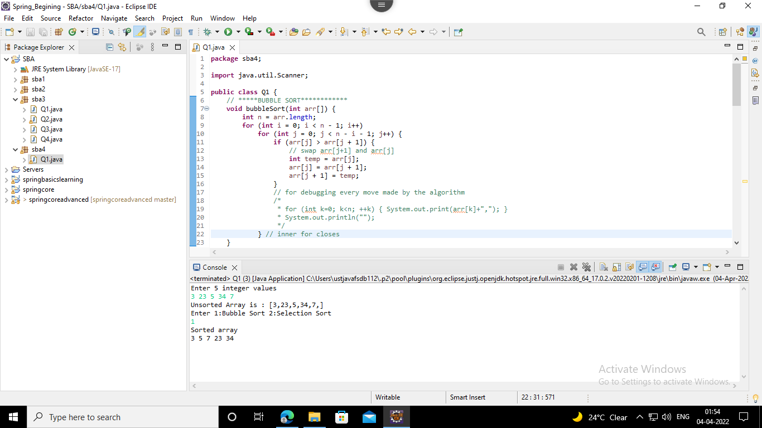

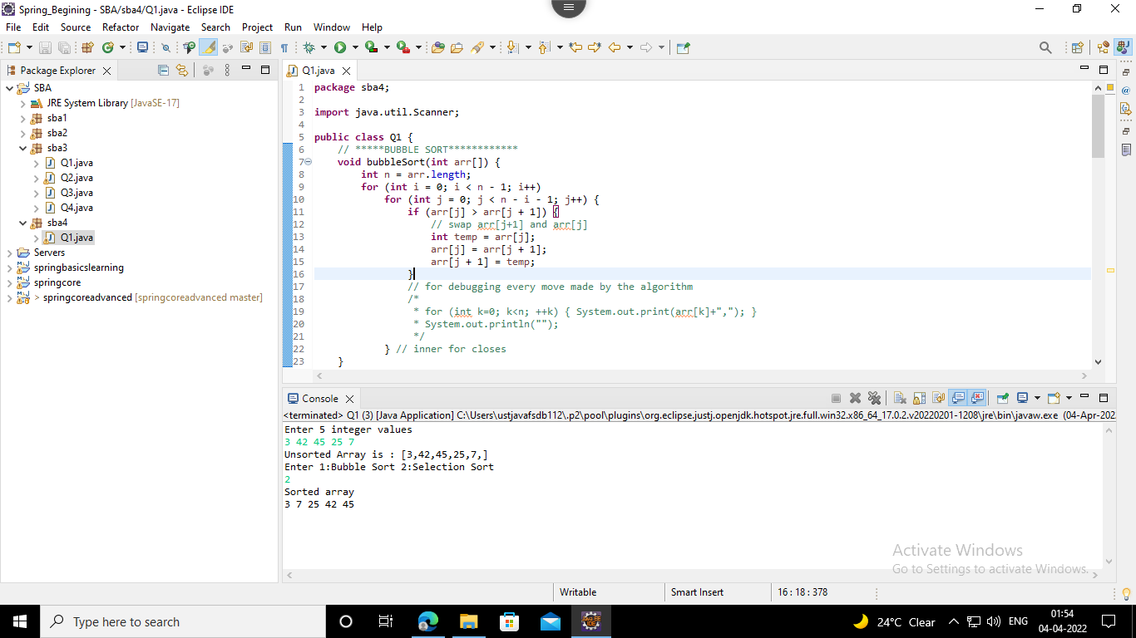

2. Write a program to implement insertion sort.

Solution

*package sba4;*

*public class Q2 {*

*void sort(int arr[]) {*

*int n = arr.length;*

*for (int i = 1; i < n; ++i) {*

*int key = arr[i];*

*int j = i - 1;*

*/\**

*\* Move elements of arr[0..i-1], that are greater than key, to one position*

*\* ahead of their current position*

*\*/*

*while (j >= 0 && arr[j] > key) {*

*arr[j + 1] = arr[j];*

*j = j - 1;*

*}*

*arr[j + 1] = key;*

*}*

*}*

*/* A utility function to print array of size n */*

*static void printArray(int arr[]) {*

*int n = arr.length;*

*for (int i = 0; i < n; ++i)*

*System.out.print(arr[i] + " ");*

*System.out.println();*

*}*

*// Driver method*

*public static void main(String args[]) {*

*int arr[] = { 12, 11, 13, 5, 6 };*

*Q2 ob = new Q2();*

*ob.sort(arr);*

*printArray(arr);*

*}*

*}*

Output

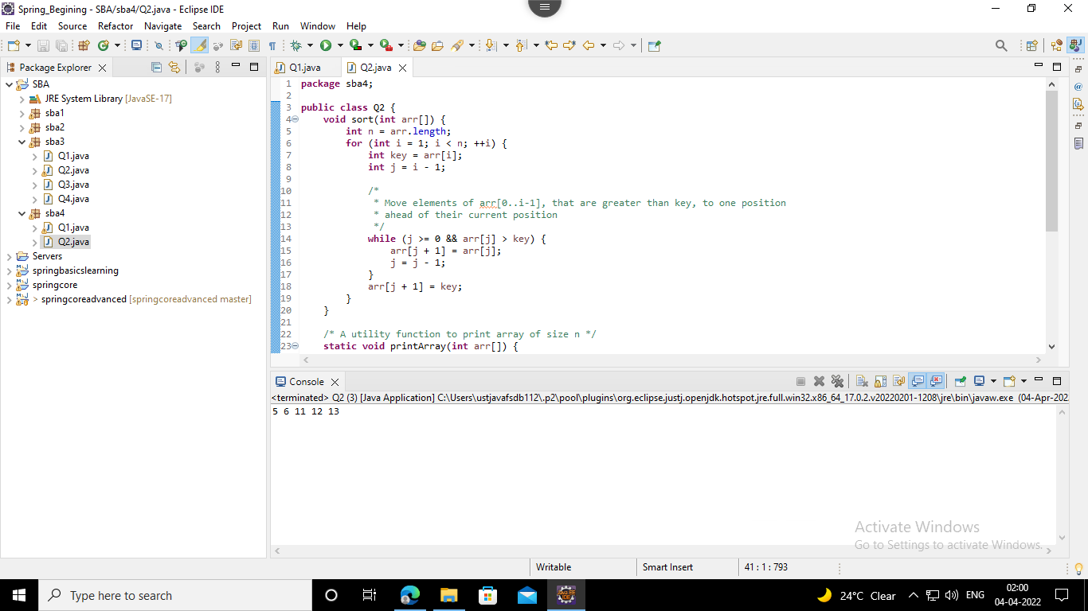

3. Write a program to implement Hashtable and add at least 4 values into it, implement the putIfAbsent() method.

Solution

*package sba4;*

*import java.util.*;*

*class Q3{*

*public static void main(String args[]){*

*Hashtable<Integer,String> map=new Hashtable<Integer,String>();*

*map.put(100,"Amit");*

*map.put(102,"Ravi");*

*map.put(101,"Vijay");*

*map.put(103,"Rahul");*

*System.out.println("Initial Map: "+map);*

*map.putIfAbsent(104,"Gaurav");*

*System.out.println("Updated Map: "+map);*

*map.putIfAbsent(101,"Vijay");*

*System.out.println("Updated Map: "+map);*

*}*

*}*

Output

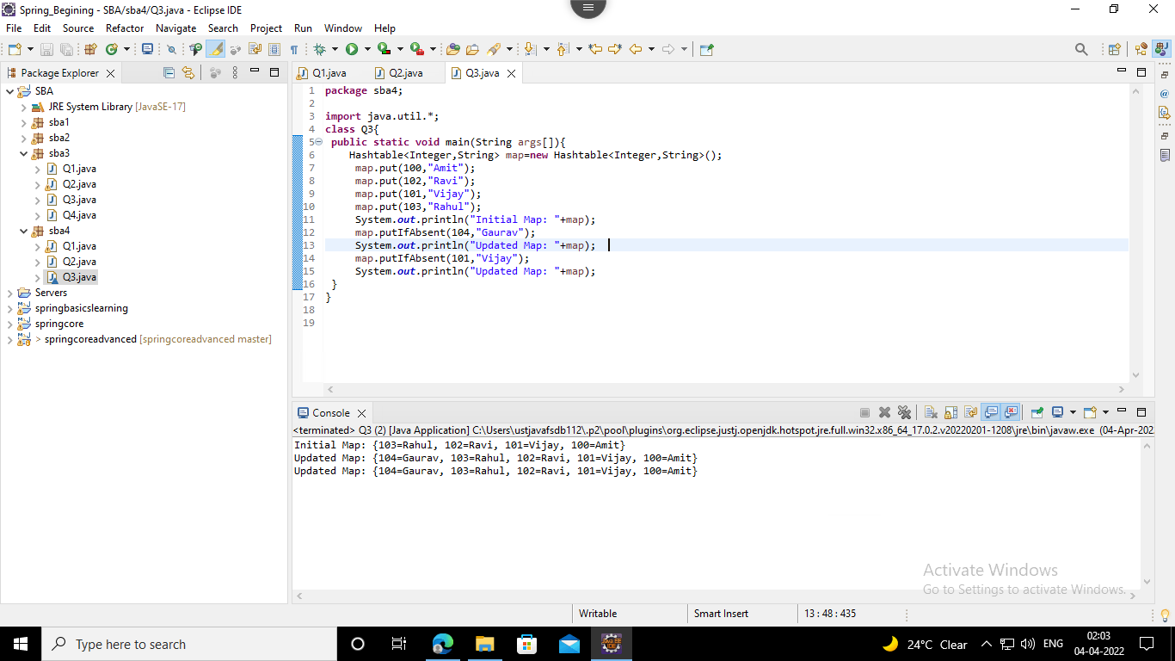

4. Create a class of Books with attributes:

a)id

b)name

c)author

d)publisher

e)quantity sold.

Implement a Hashtable to implement the objects of Books type. Print all the details of books by traversing through the Hashtable.

Solution

*package sba4;*

*import java.util.Hashtable;*

*import java.util.Map;*

*class Book {*

*int id;*

*String name, author, publisher;*

*int quantity;*

*public Book(int id, String name, String author, String publisher, int quantity) {*

*this.id = id;*

*this.name = name;*

*this.author = author;*

*this.publisher = publisher;*

*this.quantity = quantity;*

*}*

*}*

*public class Q4 {*

*public static void main(String[] args) {*

*// Creating map of Books*

*Map<Integer, Book> map = new Hashtable<Integer, Book>();*

*// Creating Books*

*Book b1 = new Book(101, "Let us C", "Yashwant Kanetkar", "BPB", 8);*

*Book b2 = new Book(102, "Data Communications & Networking", "Forouzan", "Mc Graw Hill", 4);*

*Book b3 = new Book(103, "Operating System", "Galvin", "Wiley", 6);*

*// Adding Books to map*

*map.put(1, b1);*

*map.put(2, b2);*

*map.put(3, b3);*

*// Traversing map*

*for (Map.Entry<Integer, Book> entry : map.entrySet()) {*

*int key = entry.getKey();*

*Book b = entry.getValue();*

*System.out.println(key + " Details:");*

*System.out.println(b.id + " " + b.name + " " + b.author + " " + b.publisher + " " + b.quantity);*

*}*

*}*

*}*

Output

