1. Create Database project_movie_data and deploy table data according to ER diagram.

Solution

*create database project_movie_data;*

*use project_movie_data;*

2. Create 9 tables which are presented in ER model and load the data with their foreign key and primary key values.

Solution

*create table actor(*

*act_id int primary key auto_increment,act_fname varchar(45),*

*act_lname varchar(45),act_gender enum('M','F'))auto_increment=101;*

*create table director(*

*dir_id int primary key auto_increment,*

*dir_fname varchar(45),dir_lname varchar(45))auto_increment=201;*

*create table movie(*

*mov_id int primary key auto_increment,*

*mov_title varchar(50),mov_year int not null,mov_time int not null,*

*mov_lang varchar(50) not null,mov_dt_rel date,mov_rel_country varchar(10))auto_increment=901;*

*create table movie_direction(*

*dir_id int not null,mov_id int not null,*

*foreign key(dir_id) references director(dir_id),*

*foreign key(mov_id) references movie(mov_id));*

*create table movie_cast(*

*act_id int not null,*

*mov_id int not null,role varchar(30),*

*foreign key(act_id) references actor(act_id),*

*foreign key(mov_id) references movie(mov_id));*

*create table reviewer(*

*rev_id int primary key auto_increment,*

*rev_name varchar(30))auto_increment=9001;*

*create table genres(*

*gen_id int primary key auto_increment,*

*gen_title varchar(20))auto_increment=1001;*

*create table movie_genres(*

*mov_id int not null,gen_id int not null,*

*foreign key(mov_id) references movie(mov_id),*

*foreign key(gen_id) references genres(gen_id));*

*create table rating(*

*mov_id int not null,*

*rev_id int not null,*

*rev_stars int,num_o_ratings int,*

*foreign key(mov_id) references movie(mov_id),*

*foreign key(rev_id) references reviewer(rev_id) );*

*show tables;*

*insert into actor(act_fname,act_lname,act_gender) values*

*('James','Stewart','M'),('Deborah','Kerr','F'),('Peter','OToole','M'),*

*('Robert','De Niro','M'),('F. Murray','Abraham','M'),('Harrison','Ford','M'),*

*('Nicole','Kidman','F'),('Stephen','Baldwin','M'),('Jack','Nicholson','M'),*

*('Mark','Wahlberg','M'),('Woody','Allen','M'),('Claire','Danes','F'),*

*('Tim','Robbins','M'),('Kevin','Spacey','M'),('Kate','Winslet','F'),*

*('Robin','Williams','M'),('Jon','Voight','M'),('Ewan','McGregor','M'),*

*('Christian','Bale','M'),('Maggie','Gyllenhaal','F'),('Dev','Patel','M'),*

*('Sigourney','Weaver','F'),('David','Aston','M'),('Ali','Astin','F');*

*insert into director(dir_fname,dir_lname) values*

*('Alfred','Hitchcock'),('Jack','Clayton'),('David','Lean'),('Michael','Cimino'),*

*('Milos','Forman'),('Ridley','Scott'),('Stanley','Kubrick'),('Bryan','Singer'),*

*('Roman','Polanski'),('Paul','Thomas Anderson'),('Woody','Allen'),('Hayao','Miyazaki'),*

*('Frank','Darabont'),('Sam','Mendes'),('James','Cameron'),('Gus','Van Sant'),*

*('John','Boorman'),('Danny','Boyle'),('Christopher','Nolan'),('Richard','Kelly'),*

*('Kevin','Spacey'),('Andrei','Tarkovsky'),('Peter','Jackson');*

*insert into genres(gen_title) values*

*('Action'),('Adventure'),('Animation'),('Biography'),('Comedy'),('Crime'),*

*('Drama'),('Horror'),('Music'),('Mystery'),('Romance'),('Thriller'),('War');*

*insert into movie(mov_title,mov_year,mov_time,mov_lang,mov_dt_rel,mov_rel_country) values*

*('Vertigo',1958,128,'English','1958-08-24','UK'),*

*('The Innocents',1961,100,'English','1962-02-19','SW'),*

*('Lawrence of Arabia',1962,216,'English','1962-12-11','UK'),*

*('The Deer Hunter',1978,183,'English','1979-03-08','UK'),*

*('Amadeus',1984,160,'English','1985-01-07','UK'),*

*('Blade Runner',1982,117,'English','1982-09-09','UK'),*

*('Eyes Wide Shut',1999,159,'English',null,'UK'),*

*('The Usual Suspects',1995,106,'English','1995-08-25','UK'),*

*('Chinatown',1974,130,'English','1974-08-09','UK'),*

*('Boogle Nights',1997,155,'English','1998-02-16','UK'),*

*('Annie Hall',1977,93,'English','1977-04-20','USA'),*

*('Princess Mononoke',1997,134,'Japanese','2001-10-19','UK'),*

*('The Shawshank Redemption',1994,142,'English','1995-02-17','UK'),*

*('American Beauty',1999,122,'English',null,'UK'),*

*('Titanic',1997,194,'English','1998-01-23','UK'),*

*('Good Will Hunting',1997,126,'English','1998-06-03','UK'),*

*('Deliverance',1972,109,'English','1982-10-05','UK'),*

*('Trainspotting',1996,94,'English','1996-02-23','UK'),*

*('The Prestige',2006,130,'English','2006-11-10','UK'),*

*('Donnie Darko',2001,113,'English',null,'UK'),*

*('Slumdog Millionaire',2008,120,'English','2009-01-09','UK'),*

*('Allens',1986,137,'English','1986-08-29','UK'),*

*('Beyond the Sea',2004,118,'English','2004-11-26','UK'),*

*('Avatar',2009,162,'English','2009-12-17','UK'),*

*('Seven Samurai',1954,207,'Japanese','1954-04-26','JP'),*

*('Spirited Away',2001,125,'Japanese','2003-09-12','UK'),*

*('Back to the Future',1985,116,'English','1985-12-04','UK'),*

*('Braveheart',1995,178,'English','1995-09-08','UK');*

*insert into movie_cast(act_id,mov_id,role) values*

*(101,901,'John Scottie Ferguson'),(102,902,'Miss Giddens'),(103,903,'T.E. Lawrence'),*

*(104,904,'Michael'),(105,905,'Antonio Salieri'),(106,906,'Rick Deckard'),*

*(107,907,'Alice Harford'),(108,908,'McManus'),(110,910,'Eddie Adams'),*

*(111,911,'Alvy Singer'),(112,912,'San'),(113,913,'Andy Dufresne'),*

*(114,914,'Lester Burnham'),(115,915,'Rose DeWitt Bukater'),(116,916,'Sean Maguire'),*

*(117,917,'Ed'),(118,918,'Renton'),(120,920,'Elizabeth Darko'),*

*(121,921,'Older Jamal'),(122,922,'Ripley'),(114,923,'Bobby Darin'),*

*(109,909,'J.J. Gittes'),(119,919,'Alfred Borden');*

*insert into movie_direction(dir_id,mov_id) values*

*(201,901),(202,902),(203,903),(204,904),(205,905),*

*(206,906),(207,907),(208,908),(209,909),(210,910),*

*(211,911),(212,912),(213,913),(214,914),(215,915),*

*(216,916),(217,917),(218,918),(219,919),(220,920),*

*(218,921),(215,922),(221,923);*

*insert into movie_genres(mov_id,gen_id) values*

*(922,1001),(917,1002),(903,1002),(912,1003),*

*(911,1005),(908,1006),(913,1006),(926,1007),(928,1007),*

*(918,1007),(921,1007),(902,1008),(923,1009),(907,1010),*

*(927,1010),(901,1010),(914,1011),(906,1012),(904,1013);*

*insert into reviewer(rev_name) values*

*('Righty Sock'),('Jack Malvern'),('Flagrant Baronessa'),*

*('Alec Shaw'),(null),('Victor Woeltjen'),('Simon Wright'),*

*('Neal Wruck'),('Paul Monks'),('Mike Salvati'),(null),*

*('Wesley S. Walker'),('Sasha Goldshtein'),('Josh Cates'),('Krug Stillo'),*

*('Scott LeBrun'),('Hannah Steele'),('Vincent Cadena'),*

*('Brandt Sponseller'),('Richard Adams');*

*insert into rating(mov_id,rev_id,rev_stars,num_o_ratings) values*

*(901,9001,8.4,263575),*

*(902,9002,7.9,20207),(903,9003,8.3,202778),(906,9005,8.2,484746),*

*(924,9006,7.3,null),(908,9007,8.6,779489),(909,9008,null,227235),*

*(910,9009,3,195961),(911,9010,8.1,203875),(912,9011,8.4,null),*

*(914,9013,7,862618),(915,9001,7.7,830095),(916,9014,4,642132),*

*(925,9015,7.7,81328),(918,9016,null,580301),(920,9017,8.1,609451),*

*(921,9018,8,667758),(922,9019,8.4,511613),(923,9020,6.7,13091);*

3. Write a query in SQL to list the Horror movies?

Solution

*select mov_title,gen_title from movie*

*inner join movie_genres on movie.mov_id=movie_genres.mov_id*

*inner join genres on genres.gen_id=movie_genres.gen_id*

*where genres.gen_title='Horror';*

Output

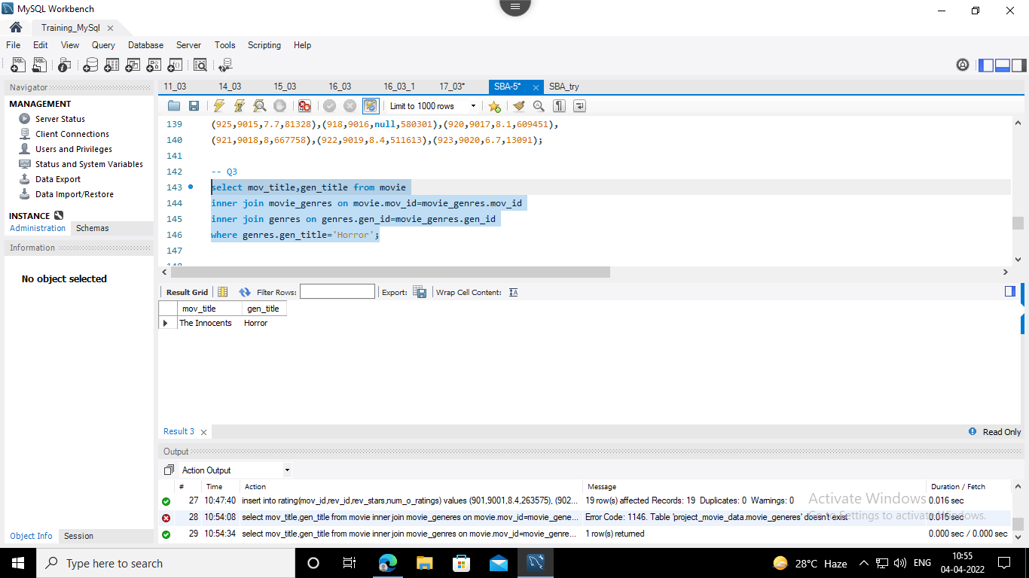

4. Write a query in SQL to find the name of all reviewers who have rated 8 or more stars?

Solution

*select rev_name,rev_stars from reviewer*

*inner join rating on reviewer.rev_id=rating.rev_id*

*where rev_stars>=8;*

Output

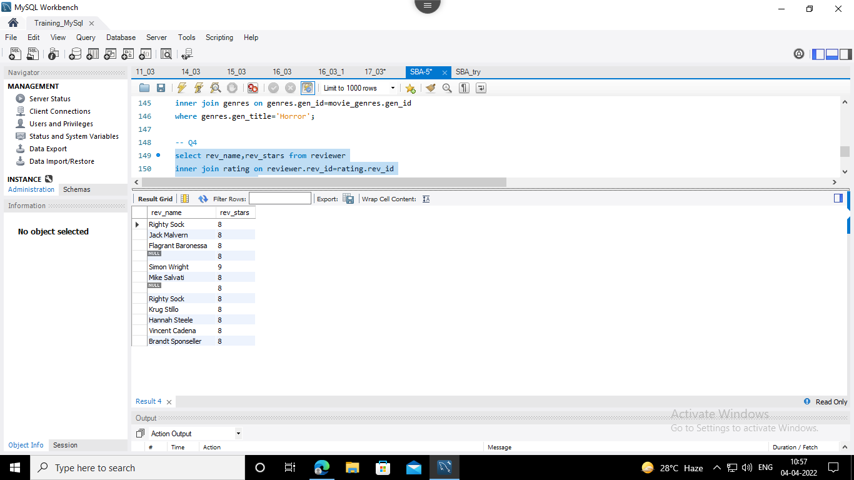

5. Write a query in SQL to list all the information of the actors who played a role in the movie ‘Deliverance’.

Solution

*select act_fname,act_lname,act_gender,mov_title from actor*

*inner join movie_cast on actor.act_id=movie_cast.act_id*

*inner join movie on movie_cast.mov_id=movie.mov_id*

*where movie.mov_title='Deliverance';*

Output

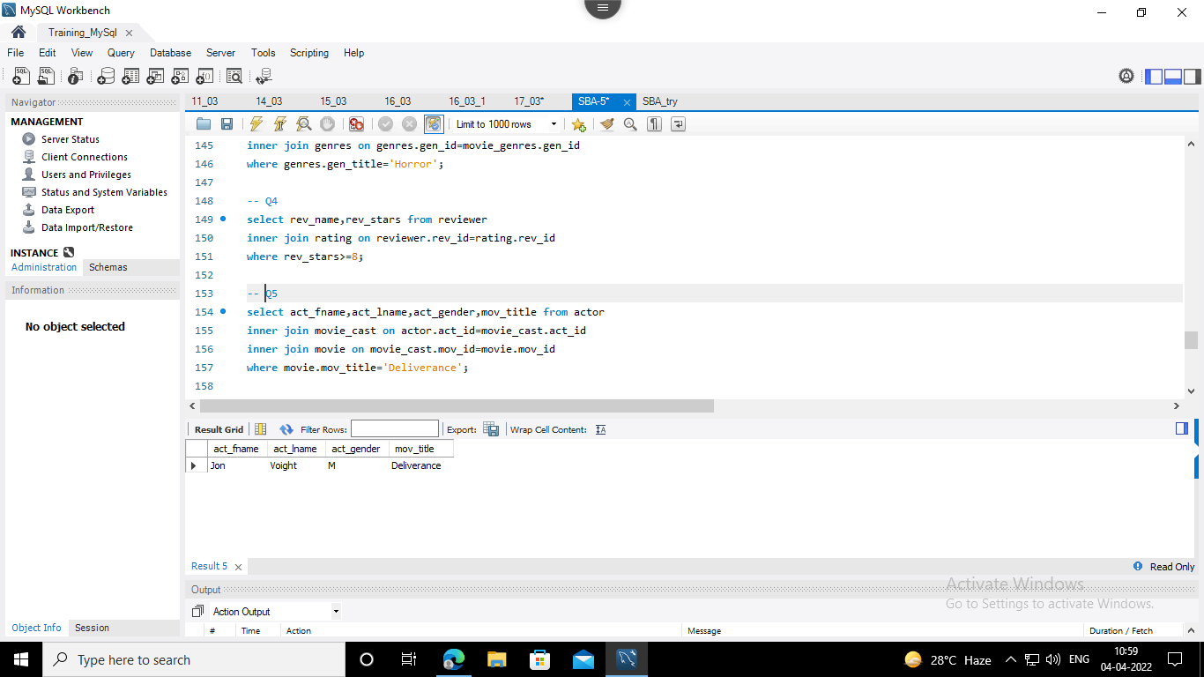

8. Write a query in SQL to find all the years which produced at least one movie and that received a rating of more than 4 stars.

Solution

*select mov_title,rev_stars,mov_year from movie*

*inner join rating on movie.mov_id=rating.mov_id*

*where rev_stars>=4;*

Output

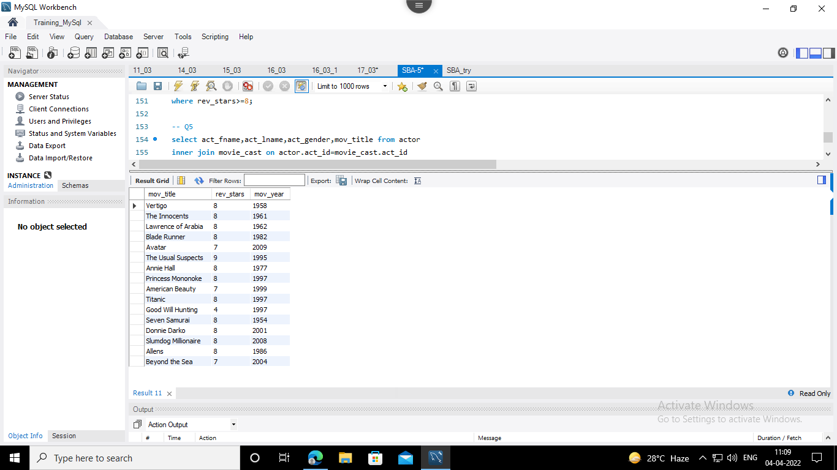

10. Write a query in SQL to find the name of movies who were directed by ‘David’

Solution

*select mov_title,dir_fname,dir_lname from movie*

*inner join movie_direction on movie.mov_id=movie_direction.mov_id*

*inner join director on movie_direction.dir_id=director.dir_id*

*where director.dir_fname='David' or director.dir_lname='David';*

Output

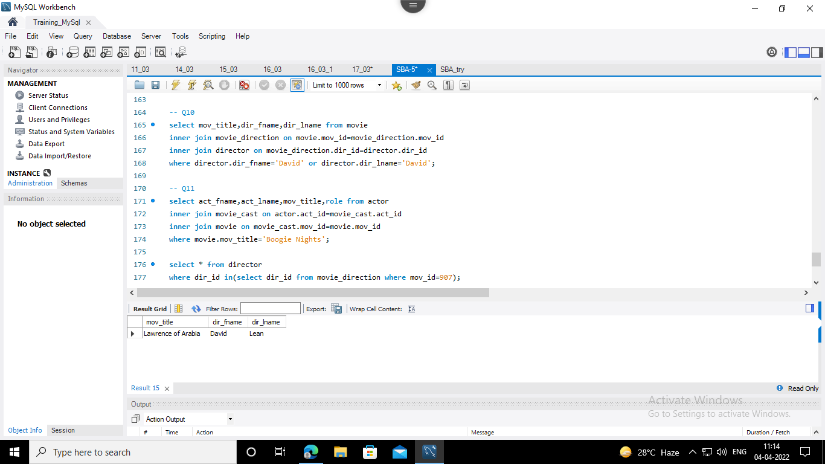

12. Find the name of the actor who have worked in more than one movie.

Solution

*select mov_title,act_fname,act_lname,role*

*from movie*

*join movie_cast*

*on movie_cast.mov_id=movie.mov_id*

*join actor*

*on movie_cast.act_id=actor.act_id*

*where actor.act_id in (*

*select act_id from movie_cast*

*group by act_id*

*having count(*)>1);*

Output

