Program Name: AgriEdge AI – μT-Kernel 3.0 Edge AI Precision Agriculture & Crop Protection System
Overview: AgriEdge AI is a fully autonomous, solar-powered edge device that monitors plant and soil health in real time and controls irrigation and disease prevention without any cloud dependency. Using multiple sensors and a camera module, the system performs on-device leaf disease detection and 24–48-hour predictive analysis for irrigation needs and disease risk. μT-Kernel 3.0 ensures deterministic multitasking, precise timing, and power efficiency on the Renesas EK-RA8P1 board. The device automatically activates solenoid valves or pumps when needed, significantly reducing water waste and crop loss.This project directly supports the contest theme “TRON × AI” by combining μT-Kernel’s deterministic real-time capabilities with edge AI inference on the Ethos-U55 NPU. The system ensures millisecond-level sensor-to-actuator response while performing intelligent decision-making locally, delivering a scalable and practical solution for smallholder farmers in India and beyond.
Development Plan: This is a group entry consisting of five students from NIST University, School of Electronics and Communication Engineering.
- Member 1: Hardware integration, sensor/actuator drivers, power management, and camera interface.
- Member 2: AI model training, and quantization.
- Member 3: NPU deployment.
- Member 4: μT-Kernel task design, synchronization primitives, real-time scheduling, and deadline management.
- Member 5: System integration, UI, field testing, documentation, and open-source packaging.
We will use Git for version control and hold weekly progress reviews. The division of labor can be adjusted after receiving the board. Total development period after board arrival: approximately 5 months.
Development Environment and Program:
- Target board: Renesas EK-RA8P1 (1st choice) – Cortex-M85 + Ethos-U55 NPU, MIPI CSI camera support.
- IDE: Renesas e² studio + Flexible Software Package (FSP) + official μT-Kernel 3.0 BSP.
- Programming language: C/C++ (with optimized assembly for critical sections if required).
- Additional tools: Additional tools: Edge Impulse or TensorFlow Lite Micro for model quantization and deployment; the AI model will be a lightweight CNN (e.g., MobileNetV2/EfficientNet-Lite, input size 224×224) trained on plant disease datasets such as PlantVillage and optimized for Ethos-U55 NPU inference; Git for collaboration.
- Peripherals: capacitive soil moisture, DHT22/AM2302 (temp/humidity), BH1750 (light), OV2640 camera module, relay module for pumps/valves, 0.96" OLED display, buzzer, solar panel + Li-ion battery.
Development Scope: Estimated total source code: F2,800–3,800 lines (including comments and drivers).
- μT-Kernel core tasks, drivers, and synchronization: ~1,300 lines
- AI inference wrapper and model integration: ~700 lines
- Sensor fusion, prediction logic, and control algorithms: ~800 lines
- UI, logging, and testing framework: ~500 lines Memory target: < 512 KB RAM / < 2 MB Flash (well within RA8P1 limits, leaving headroom for expansion).
Functions: The system is built around four prioritized μT-Kernel tasks with clear synchronization.
RTOS Task Design (using μT-Kernel 3.0)
Task Name | Priority | Main Function | μT-Kernel Primitives Used
Sensor Acquisition Task | 10 (Highest) | Periodic reading of all sensors + camera trigger | Event Flag (data ready notification)
AI Inference Task | 8 | NPU-accelerated CNN for disease detection + predictive model | Semaphore (triggered by sensor task)
Actuator Control Task | 9 | Real-time pump/valve control with precise timing | Mutex (shared GPIO access) + Deadline monitoring
UI & Logging Task | 5 (Lowest) | OLED display, buzzer alerts, SD card logging | Event Flag (alerts from control task)
μT-Kernel 3.0 ensures hard real-time performance by assigning strict priorities and using efficient synchronization primitives. High-priority tasks (Sensor and Actuator) are never blocked by the AI inference task, guaranteeing sensor-to-actuator response within milliseconds even during heavy NPU computation. The architecture guarantees deterministic task execution and bounded latency, ensuring reliable operation even under concurrent AI and control workloads. Additional features are, Watchdog timer, low-power sleep modes via μT-Kernel APIs, and future-proof stub for model updates.
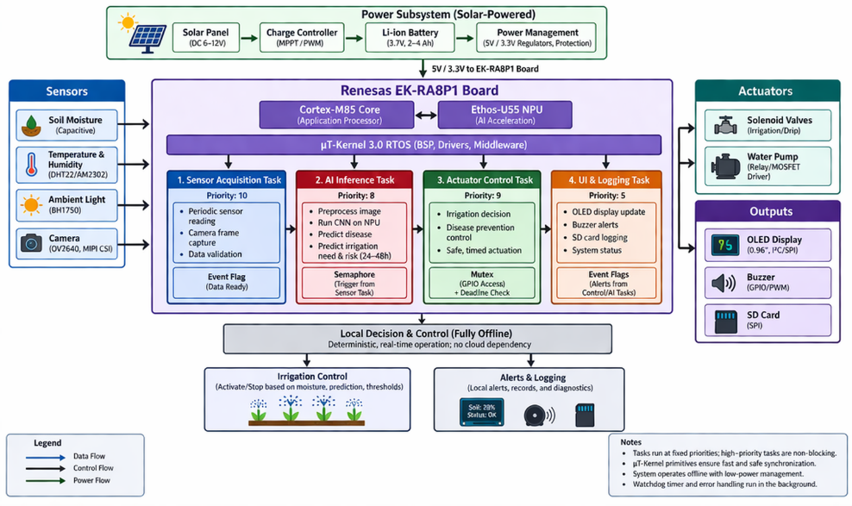
Figure 1. System Architecture of AgriEdge AI – μT-Kernel 3.0 Edge AI Precision Agriculture System
Appealing Features of the Program:
- Complete originality: This is a novel precision-agriculture approach within the TRON ecosystem, integrating edge AI with deterministic RTOS-based control, no previous entries have addressed crop disease detection, predictive irrigation, or plant health using edge AI + RTOS.
- Perfect TRON × AI synergy: Leverages the RA8P1’s NPU for efficient on-device CNN inference while μT-Kernel guarantees hard real-time sensor-to-actuator response even under heavy AI load.
- Strong social impact: Reduces water usage by an estimated 30–50% through adaptive irrigation and helps prevent crop loss in rural/off-grid farms (highly relevant to India). Fully offline, low-cost, and solar-powered.
- Superior to existing solutions: Commercial systems are cloud-dependent and lack deterministic real-time control. This project is open-source ready and demonstrates the full power of μT-Kernel 3.0 + modern edge AI.
- Scalability: Easy extension to multi-device LoRa mesh or swarm coordination.
Appealing Features of the Applicant:
We are a group of 5 undergraduate students from NIST University, Berhampur, Odisha, India (School of Electronics and Communication Engineering). While this is our first formal entry into the TRON ecosystem, we have a strong foundation in Embedded C and Linux-based systems, and we are treating this contest as an opportunity to explore real-time embedded systems aligned with human-centric automation principles inspired by IEEE 2050-2018. The EK-RA8P1 was our first-choice board because of its outstanding edge-AI performance. We discovered the contest via social media and see it as the perfect opportunity to apply embedded systems knowledge to a real societal challenge sustainable agriculture in developing regions. We are committed to open sourcing the complete project (code, models, and documentation) on GitHub after the contest and presenting our work at university events and potentially the TRON Symposium. This project reflects our enthusiasm, teamwork, and desire to push the boundaries of TRON technology with AI.

