## [**Step 1 — Setting Up the Project**](https://www.digitalocean.com/community/tutorials/angular-internationalization#step-1-setting-up-the-project)

You can use [@angular/cli](https://cli.angular.io/) to create a new Angular Project.

In your terminal window, use the following command:

npx @angular/cli new angular-internationalization-example --style=css --routing=false --skip-tests

Copy

This will configure a new Angular project with styles set to “CSS” (as opposed to “Sass”, Less", or “Stylus”), no routing, and skipping tests.

Navigate to the newly created project directory:

cd angular-internationalization-example

Copy

To create the basis for the translation project, open app.component.html in your code editor and replace the code with the following lines:

src/app/app.component.html

<section>

<article>

<h1>Under Construction!</h1>

<p>This page is under construction.</p>

</article>

</section>

Copy

This code will display "Under Construction!" and "This page is under construction" messages.

Next, open app.component.css and replace the code with the following lines:

sec/app/app.component.css

section {

background: #8e2de2; /* fallback for old browsers */

background: -webkit-linear-gradient(to right, #4a00e0, #8e2de2); /* Chrome 10-25, Safari 5.1-6 */

background: linear-gradient(to right, #4a00e0, #8e2de2);

display: flex;

justify-content: center;

align-items: center;

height: 100vh;

}

article {

border: 1px solid white;

box-shadow: 1px 1px 100px 10px rgba(0, 0, 0, 0.8);

color: white;

padding: 40px;

text-align: center;

}

Copy

This code uses flexbox, viewport height values, linear-gradient backgrounds, and box-shadows to center the "Under Construction!" message on the screen.

Then, open styles.css and replace the code with the following lines:

src/styles.css

html,

body {

padding: 0;

margin: 0;

}

Copy

This will remove any padding and margin that the browser user styles tend to place by default. By using these styles you can create a consistent baseline between all the browsers with different defaults.

In a terminal window, start your application:

npm start

Copy

Visit localhost:4200 in your web browser:

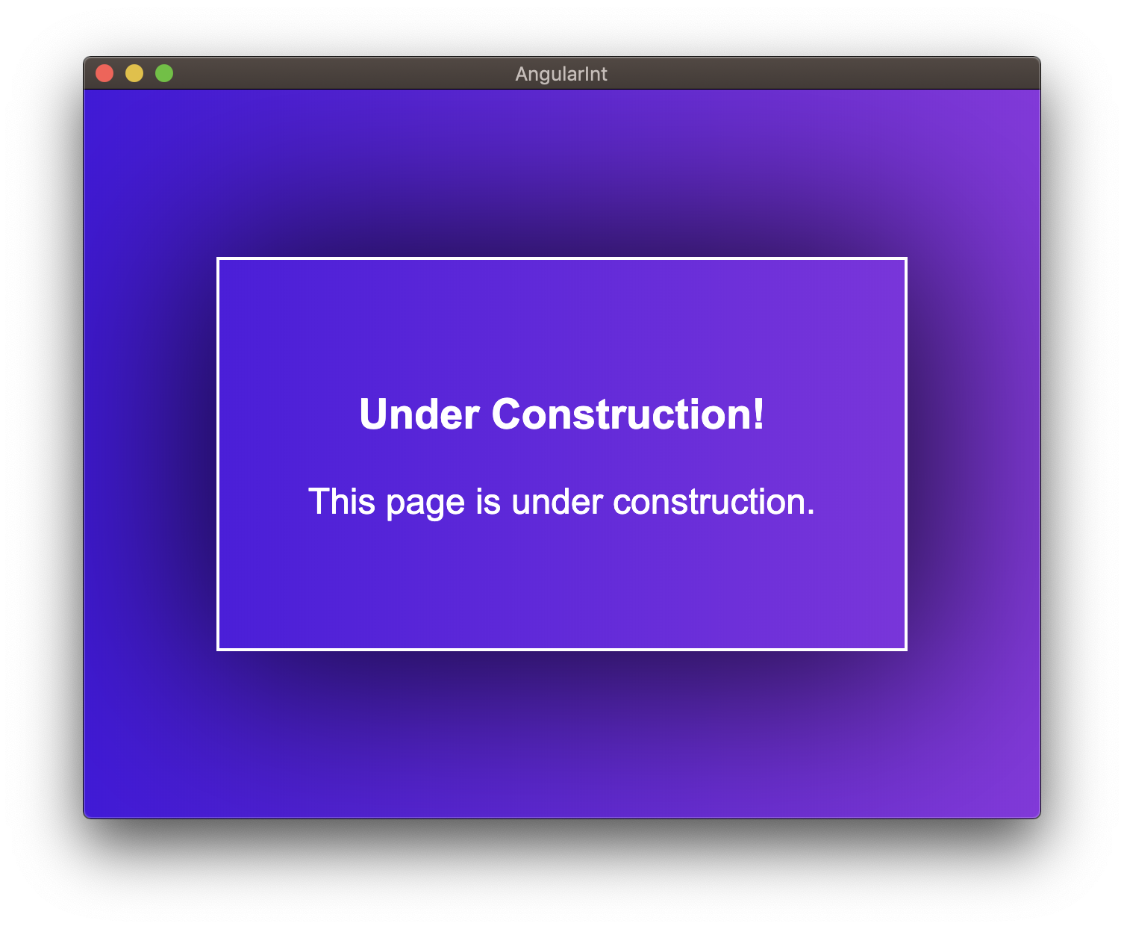

Once you are able to verify that the application is behaving as expected, you can begin to extract the messages you want to translate.

## [**Step 2 — Using xi18n to Extract messages.xlf**](https://www.digitalocean.com/community/tutorials/angular-internationalization#step-2-using-xi18n-to-extract-messages-xlf)

Let’s start by marking text that you would like to translate within the application. In this tutorial, you will be translating the application into French (fr) and German (de) with Google Translate providing the translations.

Add the i18n directive to all of the text that you would like to translate:

src/app/app.component.html

<section>

<article>

<h1 i18n>Under Construction!</h1>

<p i18n>This page is under construction.</p>

</article>

</section>

Copy

Then, you will have to make an npm script inside package.json that uses the Angular CLI to extract the marked items from app.component.html into a messages.xlf file:

package.json

{

// ...

"scripts": {

"ng": "ng",

"start": "ng serve",

"build": "ng build",

"test": "ng test",

"lint": "ng lint",

"e2e": "ng e2e",

"i18n:extract": "ng extract-i18n"

},

// ...

}

Copy

Install @angular/localize in the application folder

npm install @angular/localize

After adding this, run your new script in a terminal window:

npm run i18n:extract

Copy

Then, open up messages.xlf and you will observe something similar to this:

messages.xlf

<?xml version="1.0" encoding="UTF-8" ?>

<xliff version="1.2" xmlns="urn:oasis:names:tc:xliff:document:1.2">

<file source-language="en-US" datatype="plaintext" original="ng2.template">

<body>

<trans-unit id="48a16ab522feaff81571155668deb1a4304291f4" datatype="html">

<source>Under Construction!</source>

<context-group purpose="location">

<context context-type="sourcefile">src/app/app.component.html</context>

<context context-type="linenumber">3</context>

</context-group>

</trans-unit>

<trans-unit id="84c778d7a95cb5dc26c9cc9feb5b7abb4d295792" datatype="html">

<source>This page is under construction.</source>

<context-group purpose="location">

<context context-type="sourcefile">src/app/app.component.html</context>

<context context-type="linenumber">4</context>

</context-group>

</trans-unit>

</body>

</file>

</xliff>

Copy

For each item that needs translating (i.e., has the i18n directive), a trans-unit will be created.

You can also use this structure to provide more information about the translation. This is useful if you are getting each message translated by a third party and want to provide more information.

Inside of app.component.html, update the i18n items with a *description*:

src/app/app.component.html

<article>

<h1 i18n="Title for the under construction card">Under Construction!</h1>

<p i18n="A description for the under construction card.">This page is under construction.</p>

</article>

Copy

You can further add context to this by using the pipe character (|). This gives an item *meaning* and each item with the same *meaning* will have the same translation:

src/app/app.component.html

<article>

<h1 i18n="Card Header|Title for the under construction card">Under Construction!</h1>

<p i18n="Card Descritpion|A description for the under construction card.">This page is under construction.</p>

</article>

Copy

You can also give each i18n item an *id* by using two at symbol characters (@@) to enforce persistence when you generate the translations:

src/app/app.component.html

<article>

<h1 i18n="Card Header|Title for the under construction card@@constructionHeader">Under Construction!</h1>

<p i18n="Card Descritpion|A description for the under construction card.@@constructionDescription">This page is under construction.</p>

</article>

Copy

Let’s build the translations once again:

npm run int:extract

Copy

The items will now be updated with the *id*, *meaning* and *description*:

messages.xlf

<?xml version="1.0" encoding="UTF-8" ?>

<xliff version="1.2" xmlns="urn:oasis:names:tc:xliff:document:1.2">

<file source-language="en-US" datatype="plaintext" original="ng2.template">

<body>

<trans-unit id="constructionHeader" datatype="html">

<source>Under Construction!</source>

<context-group purpose="location">

<context context-type="sourcefile">src/app/app.component.html</context>

<context context-type="linenumber">3</context>

</context-group>

<note priority="1" from="description">Title for the under construction card</note>

<note priority="1" from="meaning">Card Header</note>

</trans-unit>

<trans-unit id="constructionDescription" datatype="html">

<source>This page is under construction.</source>

<context-group purpose="location">

<context context-type="sourcefile">src/app/app.component.html</context>

<context context-type="linenumber">4</context>

</context-group>

<note priority="1" from="description">A description for the under construction card.</note>

<note priority="1" from="meaning">Card Descritpion</note>

</trans-unit>

</body>

</file>

</xliff>

Copy

Once you have a messages.xlf file with multiple trans-units, description, meaning, and id, you can begin to create French and German translations.

## [**Step 3 — Creating French and German Translations**](https://www.digitalocean.com/community/tutorials/angular-internationalization#step-3-creating-french-and-german-translations)

By default, Angular considers everything to be in the “American English” (en-US) locale. You will have to add other locales and update the configuration to support them.

These locales are referred to by locale identifiers (ID). For example, “American English” uses the ID en-US. The first two characters - en - assign a locale identifier for “English”. The last two characters - US - assign a locale extension for “United States”. These identifiers are [derived from rules established by BCP47](https://angular.io/guide/i18n#refer-to-locales-by-id).

To avoid cluttering the project directory, it may be beneficial to store the translation files in a new directory. You can provide an output-path option to your i18n:extract script to place them in a locales directory:

package.json

{

// ...

"scripts": {

"ng": "ng",

"start": "ng serve",

"build": "ng build",

"test": "ng test",

"lint": "ng lint",

"e2e": "ng e2e",

"i18n:extract": "ng xi18n --output-path src/locale"

},

// ...

}

Copy

Remove the existing messages.xlf file:

rm messages.xlf

Copy

And re-run the i18n:extract command;

npm run i18n:extract

Copy

Once you have verified the script change works as expected and that there is a messages.xlf file in the locales directory, you can begin to add targets for translations.

### [**French**](https://www.digitalocean.com/community/tutorials/angular-internationalization#french)

First, copy messages.xlf to messages.fr.xlf:

cp src/locale/messages.xlf src/locale/messages.fr.xlf

Copy

Then, add a target for each item:

src/locale/messages.fr.xlf

<?xml version="1.0" encoding="UTF-8" ?>

<xliff version="1.2" xmlns="urn:oasis:names:tc:xliff:document:1.2">

<file source-language="en-US" datatype="plaintext" original="ng2.template">

<body>

<trans-unit id="constructionHeader" datatype="html">

<source>Under Construction!</source>

<target>En construction</target>

<context-group purpose="location">

<context context-type="sourcefile">src/app/app.component.html</context>

<context context-type="linenumber">3</context>

</context-group>

<note priority="1" from="description">Title for the under construction card</note>

<note priority="1" from="meaning">Card Header</note>

</trans-unit>

<trans-unit id="constructionDescription" datatype="html">

<source>This page is under construction.</source>

<target>Cette page est en construction</target>

<context-group purpose="location">

<context context-type="sourcefile">src/app/app.component.html</context>

<context context-type="linenumber">4</context>

</context-group>

<note priority="1" from="description">A description for the under construction card.</note>

<note priority="1" from="meaning">Card Descritpion</note>

</trans-unit>

</body>

</file>

</xliff>

Copy

Each trans-unit now has a source message that is in English and a target message that is in French.

### [**German**](https://www.digitalocean.com/community/tutorials/angular-internationalization#german)

Next, copy messages.xlf to messages.de.xlf:

cp src/locale/messages.xlf src/locale/messages.de.xlf

Copy

Then, add a target for each item:

src/locale/messages.de.xlf

<?xml version="1.0" encoding="UTF-8" ?>

<xliff version="1.2" xmlns="urn:oasis:names:tc:xliff:document:1.2">

<file source-language="en-US" datatype="plaintext" original="ng2.template">

<body>

<trans-unit id="constructionHeader" datatype="html">

<source>Under Construction!</source>

<target>Im Bau</target>

<context-group purpose="location">

<context context-type="sourcefile">src/app/app.component.html</context>

<context context-type="linenumber">3</context>

</context-group>

<note priority="1" from="description">Title for the under construction card</note>

<note priority="1" from="meaning">Card Header</note>

</trans-unit>

<trans-unit id="constructionDescription" datatype="html">

<source>This page is under construction.</source>

<target>Diese Seite befindet sich im Aufbau</target>

<context-group purpose="location">

<context context-type="sourcefile">src/app/app.component.html</context>

<context context-type="linenumber">4</context>

</context-group>

<note priority="1" from="description">A description for the under construction card.</note>

<note priority="1" from="meaning">Card Descritpion</note>

</trans-unit>

</body>

</file>

</xliff>

Copy

Each trans-unit now has a source message that is in English and a target message that is in German.

## [**Step 4 — Creating French and German Builds**](https://www.digitalocean.com/community/tutorials/angular-internationalization#step-4-creating-french-and-german-builds)

You have versions of the application that are translated based on locale.

You can use the Angular CLI to generate specific builds for each locale that you want to support.

First, you will need to install @angular/localize:

./node_modules/@angular/cli/bin/ng add @angular/localize

Copy

Open angular.json in your code editor and add fr and de locales:

angular.json

{

"projects": {

"angular-internationalization-example": {

// ...

"i18n": {

"sourceLocale": "en-US",

"locales": {

"fr": {

"translation": "src/locale/messages.fr.xlf",

"baseHref": ""

},

"de": {

"translation": "src/locale/messages.de.xlf",

"baseHref": ""

}

}

},

"architect": {

// ...

}

}},

// ...

}

Copy

And create configuration settings for fr and de under build:

angular.json

{

"projects": {

"angular-internationalization-example": {

// ...

"architect": {

"build": {

// ...

"configurations": {

"production": {

// ...

},

"fr": {

"localize": ["fr"],

"outputPath": "dist/under-construction-fr/",

"i18nMissingTranslation": "error"

},

"de": {

"localize": ["de"],

"outputPath": "dist/under-construction-de/",

"i18nMissingTranslation": "error"

}

}

},

// ...

}

}},

// ...

}

Copy

Note: Previously, this tutorial used seperate values for "i18nFile", "i18nFormat", and ``“i18nLocale”. These have since been deprecated and localize` is the preferred approach.

You can also update the configuration settings under serve:

angular.json

{

"projects": {

"angular-internationalization-example": {

// ...

"architect": {

"serve": {

// ...

"configurations": {

"production": {

"browserTarget": "angular-internationalization-example:build:production"

},

"fr": {

"browserTarget": "angular-internationalization-example:build:fr"

},

"de": {

"browserTarget": "angular-internationalization-example:build:de"

}

}

},

// ...

}

}},

// ...

}

Copy

You can now make some more scripts inside of package.json which include the ability to build and serve the new locales:

package.json

{

"scripts": {

"ng": "ng",

"start": "ng serve",

"start:fr": "ng serve --configuration=fr",

"start:de": "ng serve --configuration=de",

"build": "ng build",

"build:fr": "ng build --configuration=fr",

"build:de": "ng build --configuration=de",

"test": "ng test",

"lint": "ng lint",

"e2e": "ng e2e",

"i18n:extract": "ng xi18n --output-path src/locale"

}

}

Copy

You can start all of our projects by running the following in the terminal:

npm start

Copy

And in another terminal window, start the French build:

npm run start:fr -- --port=4201

Copy

And in another terminal window, start the German build:

npm run start:de -- --port=4202

Copy

This will run the application for English on the default port, French on port 4201, and German on port 4202:

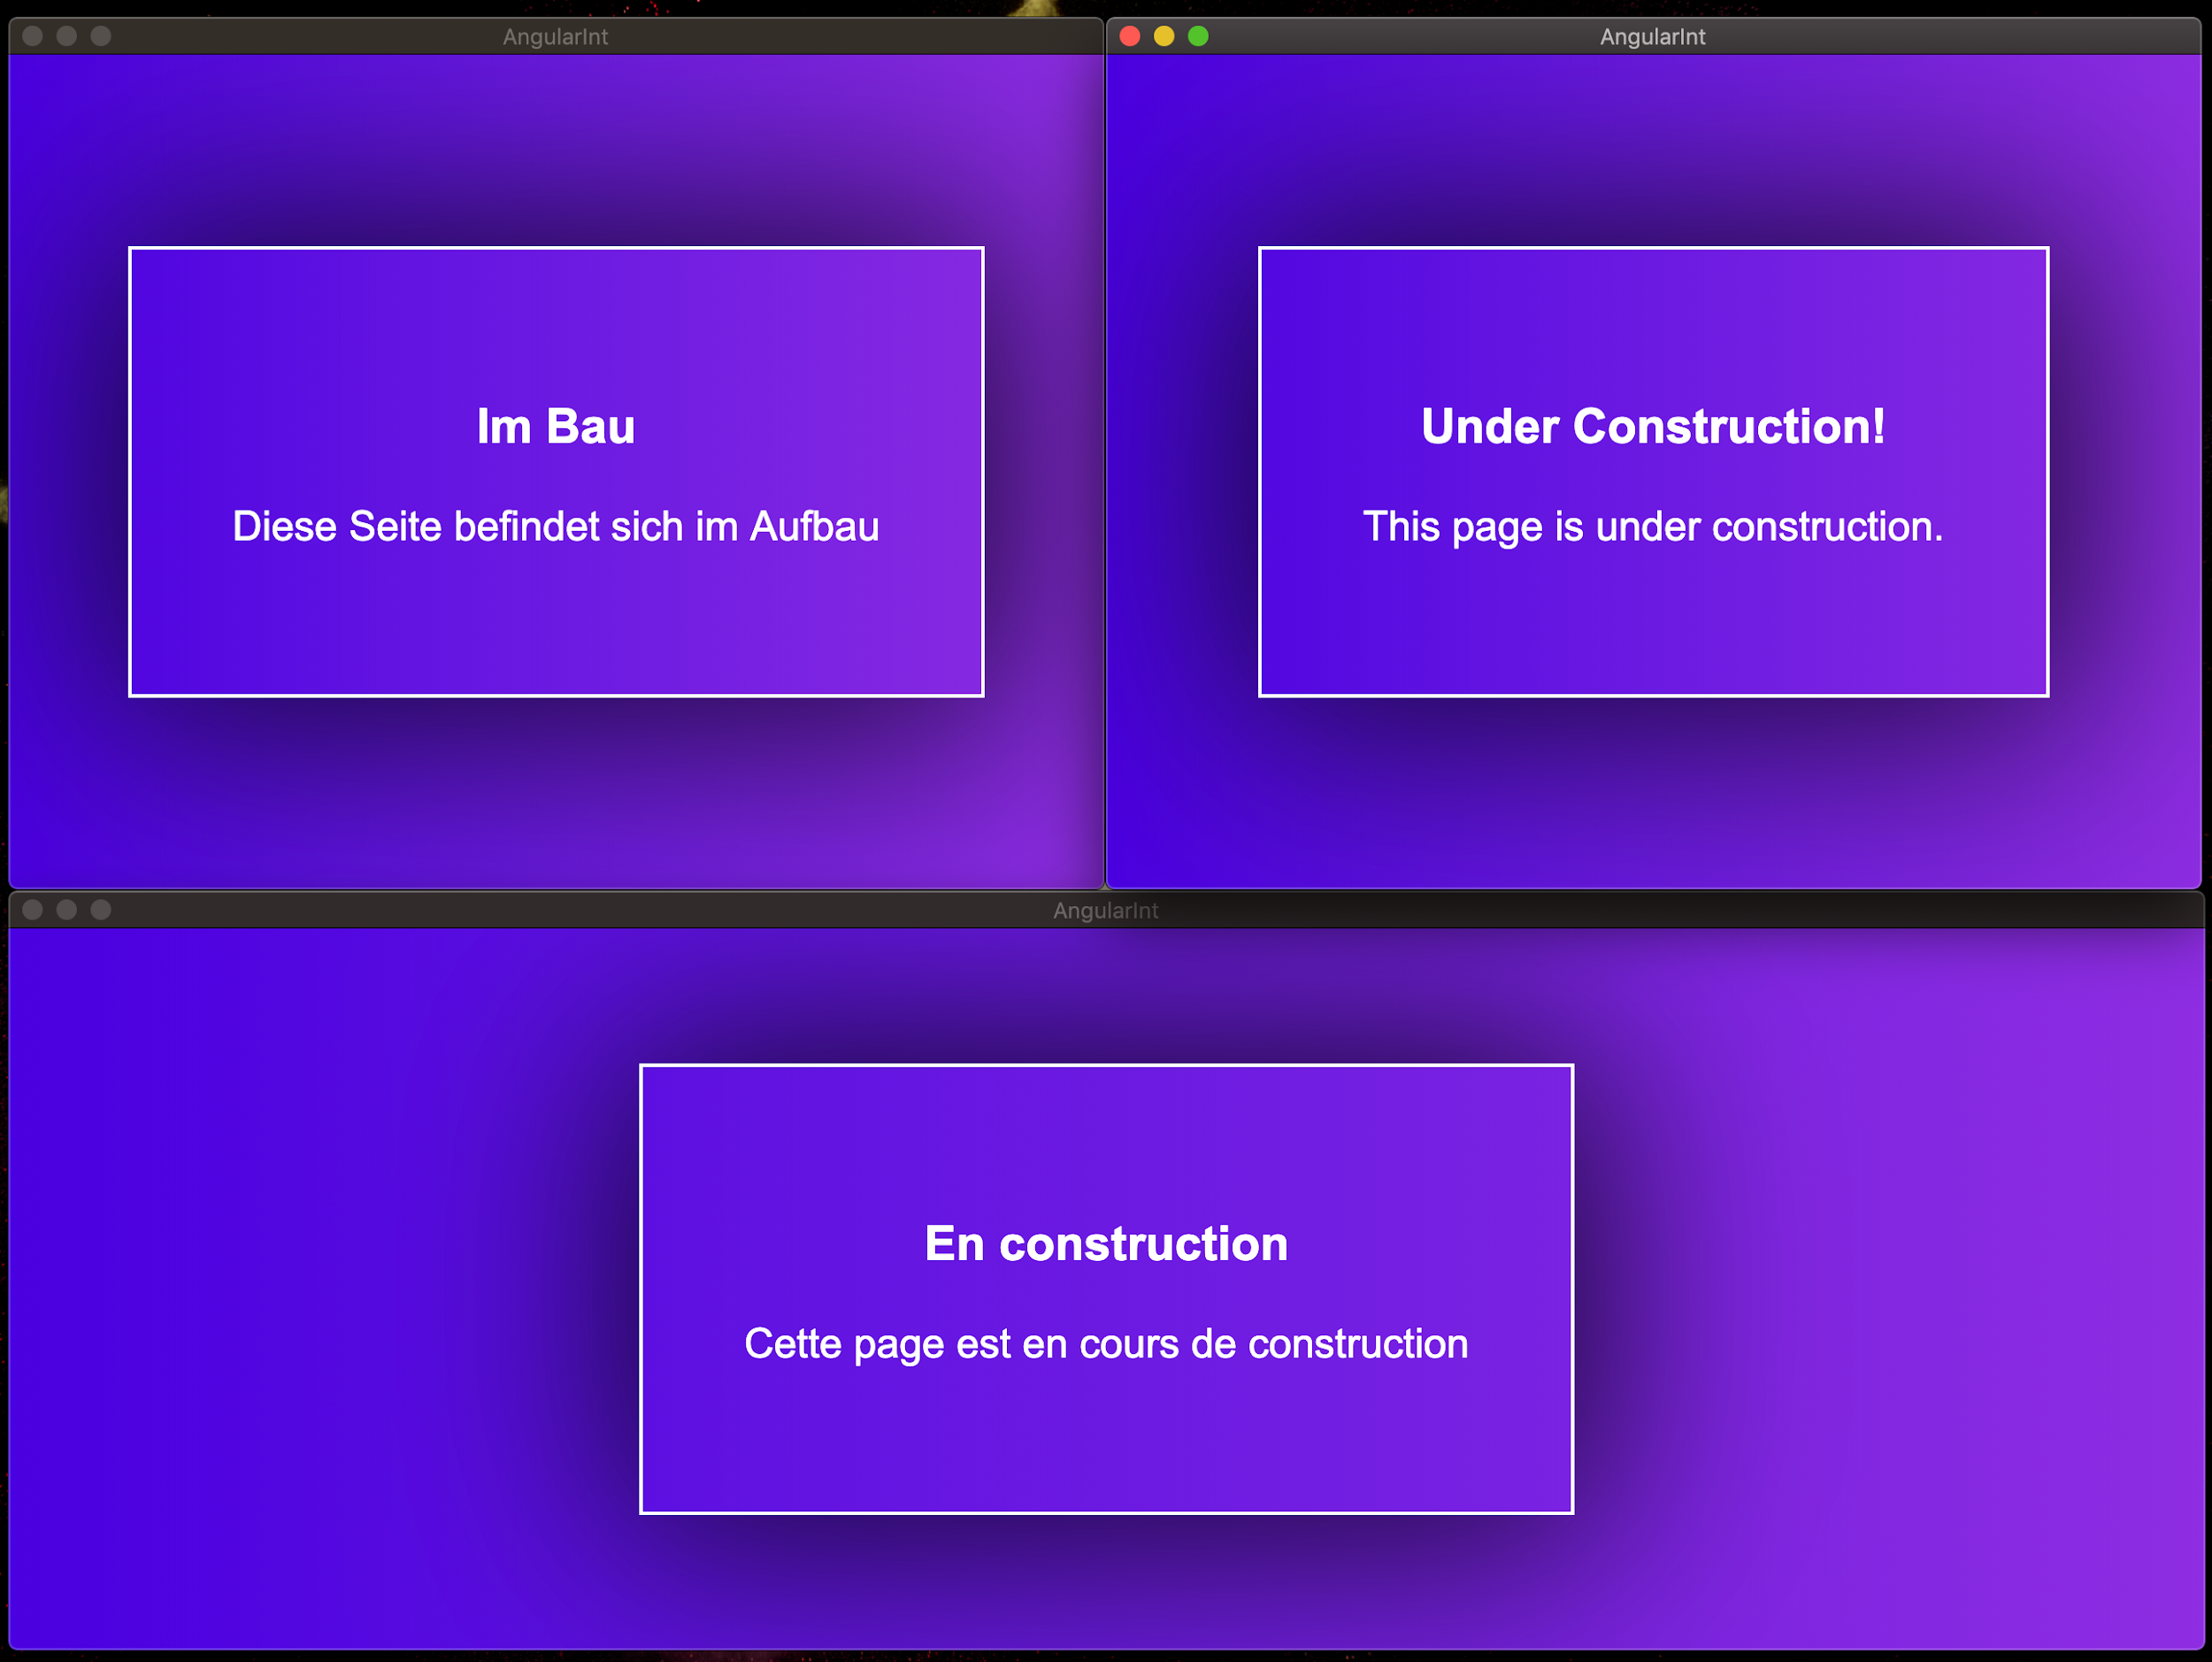

You have built translated versions of your application.