
RUFFLE VISION PVT. LTD.

Email: eruffle.group@gmail.com
13/02/2020
M/s. Charles & Chandrasekar
Chartered Accountants
No: 6, Dhanammal Street,
Spurtank Road, Chetpet,
Chennai – 600 031,
Tamil Nadu, INDIA.

Dear Sirs,

Sub: Appointment as First Statutory Auditors of our Company

We are pleased to inform you that the Board of Directors of our Company at their Board Meeting held on 13th February 2020 have appointed your Firm as the Statutory Auditors of our company and to hold office up to the conclusion of the first Annual General Meeting of the Company, on such remuneration as may be decided by the Board.

Thanking You

Yours Sincerely,
RUFFLE VISION PRIVATE LIMITED.
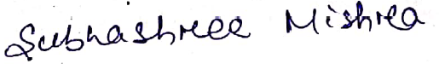
[MRS. SUBHASHREE MISHRA]
DIRECTOR

Address: 4642/466, SHAKTI
VIHAR GADAKANA NEAR KV-3
MANCHESWAR, KHORDHA
State ODISHA, Zip 751017,
eruffle.group@gmail.com

