Thoroughbred Fulfillment
Binpick ALL ORDERS Enhancement
L. Knechtel 03-07-26
Overview
Some time ago, the ALL ORDERS functionality in the tbcorp/Binpick application was been limited to New order batches for management reasons, we blocked it from being available for backorder batches. This enhancement expands on the existing ALL ORDERS functionality in the tbcorp Binpick application. It deals with variations in order quantity and the potential for running short with the physical product and having to do a partial backorder. It no longer matters whether the batch is New or Backorder orders, it will behave the same way in either case.
Approach
The ALL ORDERS scenario is governed by the assumption that it's not necessary for an operator to tell the system which orders got picked for the item in question, since all of the orders require the item. What this enhancement does is handle the possible exceptions to this assumption... which requires additional assumptions:
- All order lines involved which have an order quantity other than 1 must be explicitly picked and bugged by the operator. This activity must occur before picking any other order lines. This makes it clear to the operator that they are picking a quantity greater than one for these lines, and it allows us to dispose of the non-1 order lines up front, after which we have a homogenous set of order lines which can be managed as a group.
- Once the non-1 order lines have been picked, all remaining orders need to be physically picked by the operators in ascending folder ID sequence. This is so that, if a shortage is encountered, we can know that all orders with folder ID's higher than the last one physically picked need to be backordered.
- The operator should not tell the system to auto-pick the remaining items until the physical picking/stuffing has been completed for the item/bin. This is so that if a shortage is inadvertently encountered, then the operator can tell the system at what point they ran out of product... and the system can use that information to ship or backorder the order lines based on the input given.
So the expected sequence of events is :
- Manually pick and bug the non-1 quantity line items
- Let the system auto-pick all the quantity 1 line items, but only after the physical picking is completed for the item
- If a shortage is encountered, then the operator presses a Shortage button to enter a mode where they can tell the system at what point they ran out of product.
Implementation
As before, the batch creation process will sort out which items appear on all of the orders in the batch and flag those bins accordingly. This is visible in the bin selection screen:
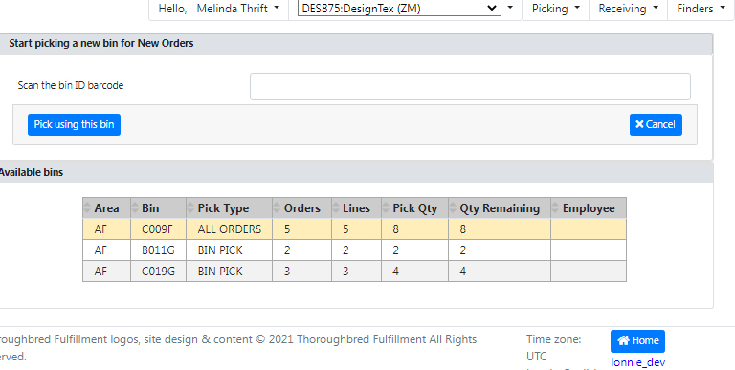
Here, we have an ALL ORDERS item... but since the total quantity is higher than the line count, there's some lines which have a quantity greater than 1.
Once the bin has been scanned, any non-1 lines are listed as per the normal process. In this batch there's a line for 2 units and a line for 3 units.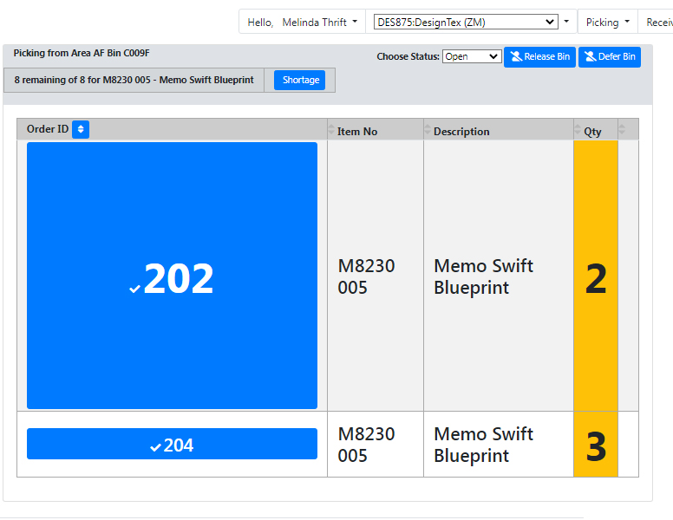
For argument's sake, the operator picks the first line shown for the quantity of 2... which leaves us with folder 204.
If at this point the operator runs out of product, pressing the Shortage button will display a pop-up window with a message: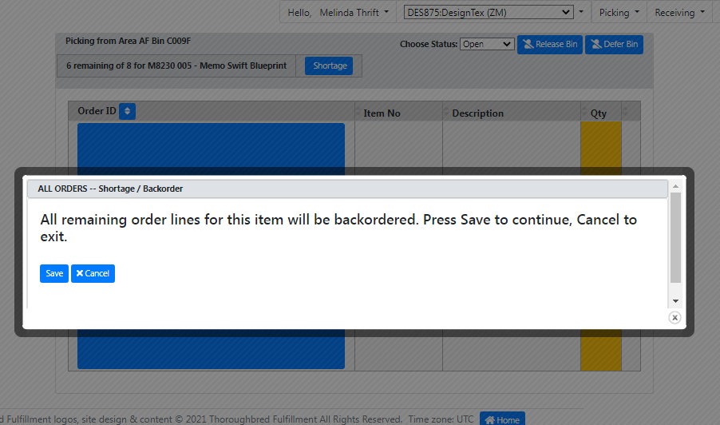
Pressing Save at this point will backorder the line for folder 204 as well as all other order lines in the batch except the one(s) already explicitly picked.
Assuming the operator does have sufficient product, they pick folder 204... at which point the application shifts into the normal ALL ORDERS appearance, with the Autopick All Orders button now visible :
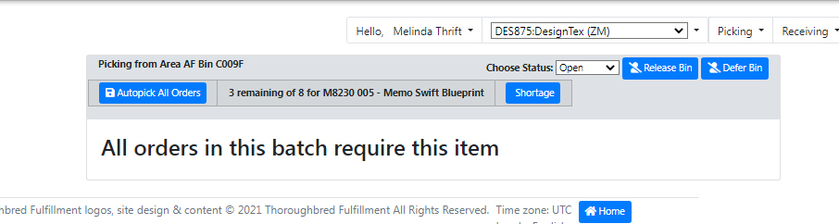

From here, the operator(s) should be picking the folders starting at the beginning of the range (200 in this case), while avoiding double-picking the folders which they explicitly picked already. A visual aid of some sort may need to be applied to the explicitly picked ones to facilitate this.
If at any point during this physical picking phase the operators do run out of product, pressing the Shortage button will present a different-looking popup, requiring the operator to indicate the lowest-numbered folder number that didn't get picked:
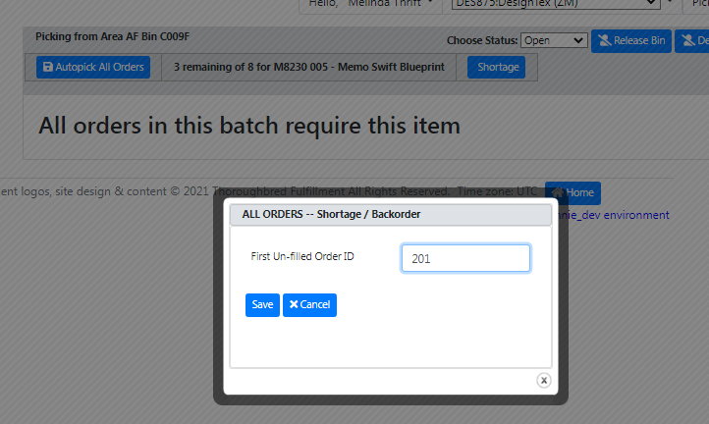
The folder number entered must exist in the current batch and it cannot be one of the folders they explicitly picked. When the operator presses Save, all un-picked order lines for the item with folder numbers less than the value entered are auto-picked, all lines with folder number greater than or equal to the value entered are backordered.
If no shortage is encountered and all folders got picked/stuffed correctly, then pressing the Autopick All Orders button will perform the auto-pick in the normal manner.
Final Thoughts
The enhancement gives a little more flexibility in handling the ALL ORDERS scenario... The additional inputs required are pretty simple.
At present, operator actions taken after the quantity exceptions are picked/bugged are non-reversible. Adherence to procedure should not require a reversal... but if the need does arise, we could consider adding the ability for a supervisor to 'Reset' an ALL ORDERS bin so that the actions could be re-done.

