Auto-Moved Items in TBCORP
L. Knechtel 09-25-24
Overview
The Auto-Moved Items feature is an alternative to the Replenishment Moves in the tbcorp application. It automatically performs replenishment stock moves for the binpick lines in response to existing order allocations for new orders which are not on hold. ( it will NOT respond to requirements for backorders regardless of hold status).
The generated stock moves are recorded in a table which drives the Auto-Moved Items screen. In this screen, users can check lines off of the list in the screen as they perform the physical moves, thus keeping track of what has been physically done vs. what hasn't. The data in the screen can also be downloaded to a spreadsheet.
Operation
All aspects of the new facility are contained in the Auto-Moved Items screen. This is an option appearing under the Picking dropdown menu.
When no moves have been generated for the day yet, the screen will be empty:
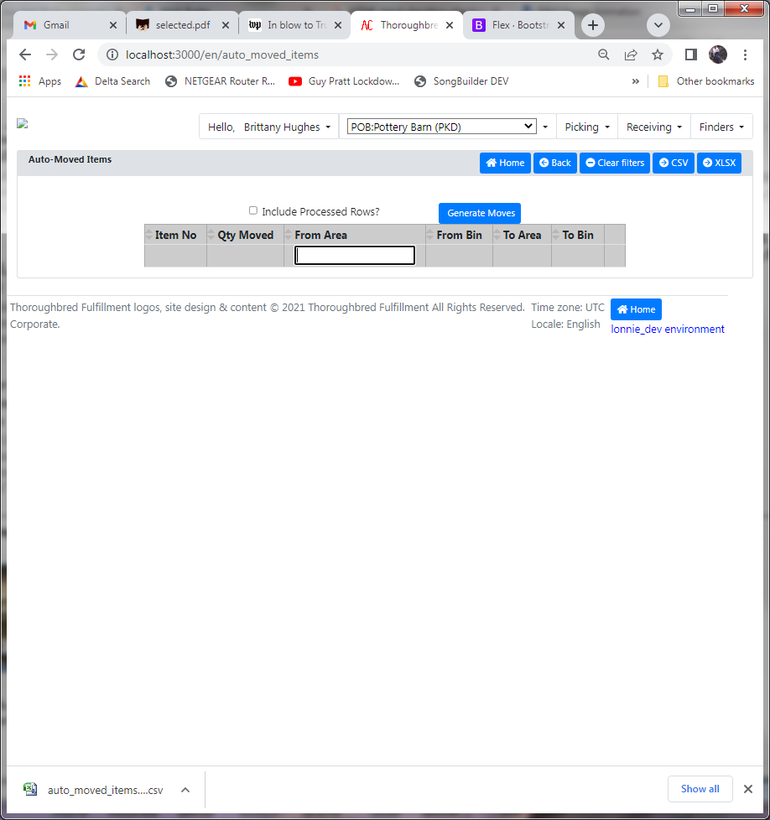

Pressing the Generate Moves button will run the process for creating and performing the replenishment moves in NDS. The user is prompted to confirm that they really want to generate the moves. The resulting list of moves will then be displayed in the screen :
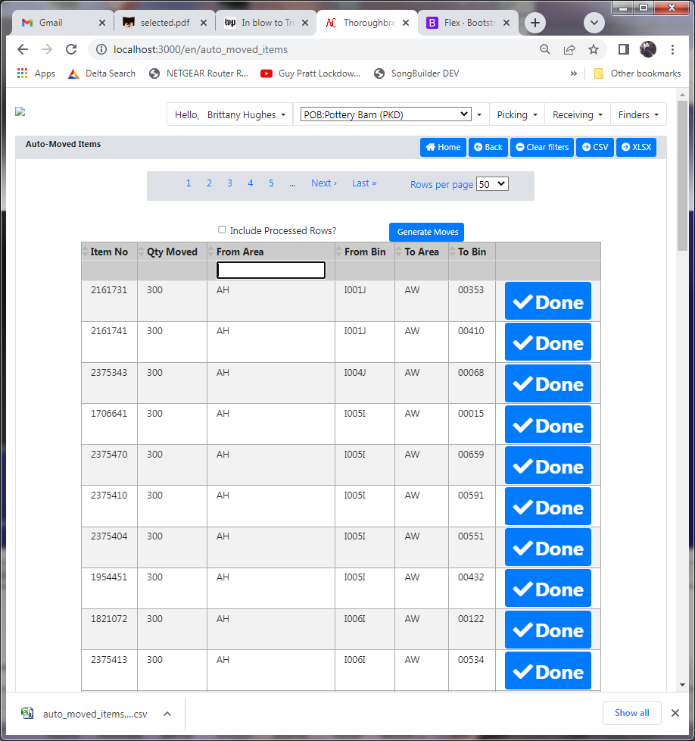
The person responsible for moving the product should physically perform each move shown on the screen. Once they have done the move, they can press the Done button and the row will be removed from the list.

If it becomes necessary to refer back to rows which have been processed by the users, one can press the Include Processed Rows? filter checkbox and then the display will show the processed rows, along with the employee number and date/time processed. The Done button is not shown when displaying in this mode.
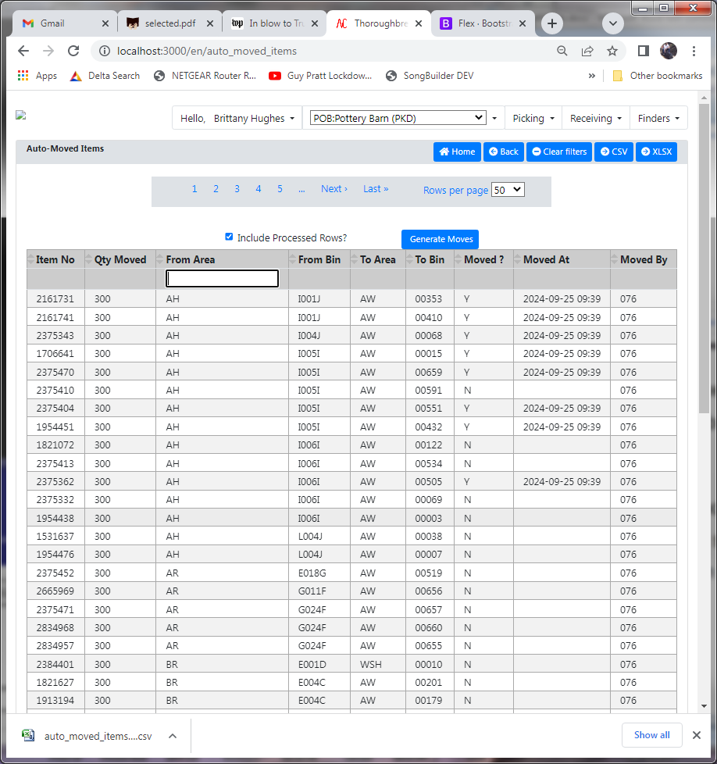

There is a filter on the From Stock Area column which allows focusing on specific areas where the items are being pulled from... this allows dividing up the work amongst multiple users if need be. Just enter the desired stock area in the filter field in the header. This works just like the filters in the dashboard application. Pressing the Clear Filters button will reset all filters to the default state.
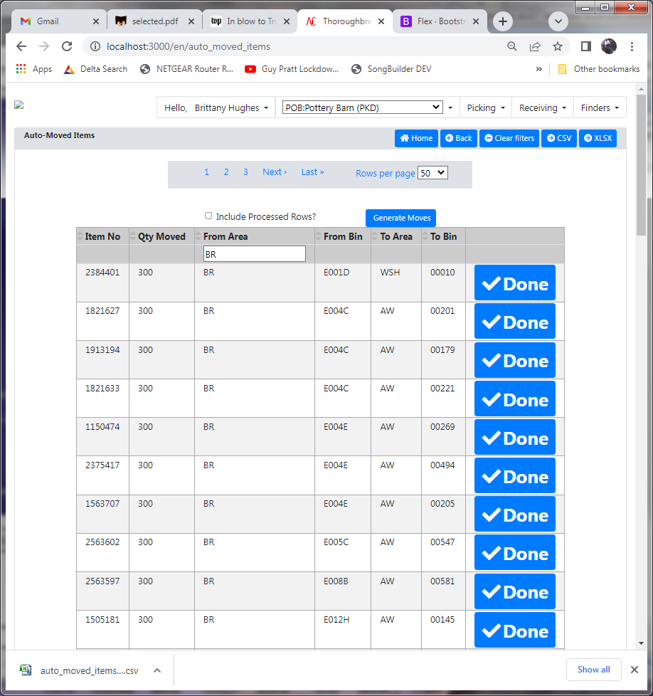

To obtain an Excel spreadsheet download of the info currently fetched into the screen ( including the pages not currently shown ), simply press the 'XLSX' button. The spreadsheet file will be delivered to the browser.
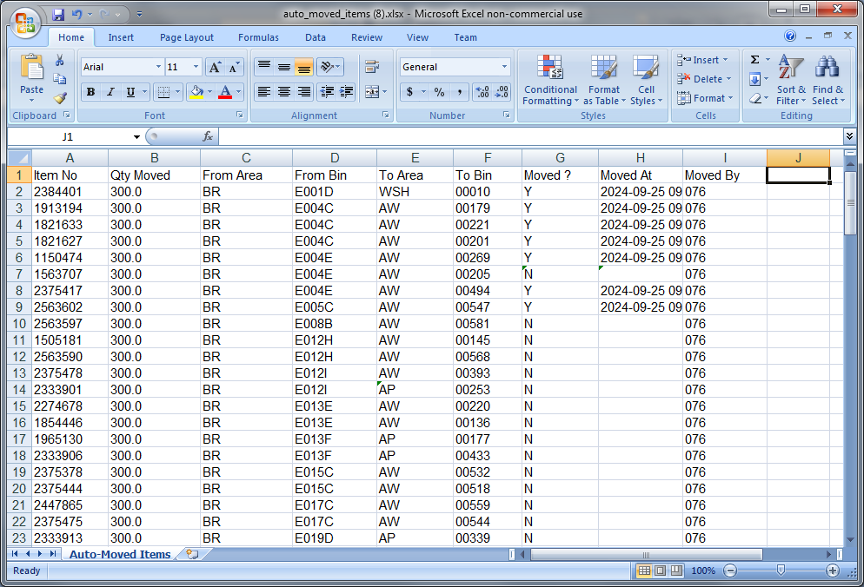
Life Cycle
- The screen and download only show move records which were generated on the current day.
- Any move records which users have not acted upon by the end of the day have their processed_flag value changed to 'A', indicating that it's possible nobody physically did the move. If necessary, we can add a filter option to display records for past days.
- Move records are purged after 7 days' retention

