Thoroughbred Fulfillment
Binpick Order Pick Application -- Operational Concepts
L. Knechtel 05-05-22

Overview
The 'Binpick' application is an aid to fulfillment order shipping which was designed to meet specific challenges in managing and picking large numbers of customer orders for certain types of products. The approach differs from 'wave pick' and traditional order picking typically done in warehouse settings, and is only practical ( as implemented ) when the orders and products conform to specific aspects of handling. The actual 'system' is a physical one, the application only assists in keeping track of what has been done and what hasn't.
Background
The 2020 Covid pandemic was the cause of much disruption in business generally... and at Thoroughbred the office furniture business declined dramatically while the home decorating clients enjoyed a major boom. It was a very different business mix with a high volume of 'small' orders for swatches and other flat samples. The operations management found it difficult to process the orders using the wave pick process normally used, it was too slow and labor intensive. We were approached to devise a system that could handle the order volume given the specifics of physical order and product handling involved.
The specifics were :
- Orders generally have fewer than 10 line items, a majority of them tend to have only 1 line item. Line item quantities are generally 5 or less, most of them 1.
- Products are generally flat swatches or chip samples which easily fit into a flat 9x12 shipping envelope.
- Products are generally stocked in small bins which are easily handled. Some bins will contain multiple products where turnover/volume is low.
- Customer orders are selected and pre-shipped in the NDS ERP system using the OESB batch shipping process and carrier shipping labels and envelopes are prepared based on what was shipped in the system. The OESB process relies on accurate inventory levels to decide what line items can be shipped and which ones must be backordered.
- The act of 'picking' is more akin to 'stuffing an envelope'.
The Problem
In normal order picking or wave picking, a single order or a small group of orders is what drives the process, and the warehouse simply acts as a random-access structure for physically accessing the required product. This works well for orders with large quantities or a large number of line items, as a lot of product can be picked in a single pass through the warehouse with such orders. What we faced was the inverse -- a very large number of small orders. Traditional wave picking using baskets and burden carriers can handle maybe a couple dozen orders in a pass without becoming unweildly. A day's worth of orders for a single client could easily involve more than 100 passes through the warehouse, all to collect a relatively low volume of very low-value product.
The Solution
The key to solving the problem lay in the nature of the orders themselves -- small orders shipped in an envelope. Which is something that could fit into, say, a hanging file folder. What we needed to do was invert the process such that the orders themselves were in a random-access structure and the warehouse would not directly participate in the picking. File cabinets are random-access devices. We suggested a 'giant file trough' or 'drawer' that could organize all the orders to be picked in a day for a given client. Then we would drive the picking from the inventory bins -- have them brought out of the warehouse in groups to the shipping line, pick all order lines which require product from the bins, then return the bins to the warehouse. Two days later a 10' long file trough had been built and a large supply of hanging folders was at hand. We were able to pilot the process manually on a sample basis using some pre-printed lists produced from the NDS database.
The shipped customer orders in the ERP system have detail information showing what line items were shipped, from which inventory locations, and what line items were backordered by the process due to insufficient stock. Inventory has already been decremented for the shipments. No 'updates' to the order in the ERP system are needed apart from final confirmation of the shipment. Thus, we could have implemented this as a completely 'manual' process utilizing a simple paper pick sheets organized by inventory bin. However, the operations management deemed it desirable to have a 'lightweight' application using small devices to help guide the picking and keep track of what's been picked. So we built one.
Mechanics
The customer (sales) orders in NDS are complex structures with many levels and attributes. We didn't want to incur the processing overhead in the database trying to read/update these when supporting a fast-paced picking process, we needed a lightweight representation. The orders are being shipped in the ERP system in a batch process, and the picking process itself felt like a 'batch' exercise, so we organized the order data into batches to facilitate management of the orders.
We created a processor which selects candidate batch-shipped NDS orders and creates lightweight representations of them and the inventory bins they were shipped from. The resulting representation structure looks like this :
- Batch Header
  - Order Header
    - Shipped Order Line ( referencing Inventory Item with Qty Shipped )
  - Inventory Bin
    - Inventory Item
The resulting batch contains all the selected orders, with their shipped line items tied to the inventory bins/items they were shipped from. There's no summarization involved in this, it's just a snapshot of the data, tied to a batch header. So it's a simplified representation of the order and shipment data in NDS.
This provides the basis for driving the picking process. The binpick application is simply an organizational tool and scorecard. The physical process is centered around an operator pulling product from a given bin which has been brought from the warehouse to the shipping line, and placing the proper quantities in the order envelopes which require the product. Multiple operators can work in parallel, each operator working from a different inventory bin.
The application assists the operator by showing them the list of order line items which require product from the bin they're working with. As they stuff each envelope, they press a button to 'bug off' the order, it drops off the screen and they proceed to the next order line. When the list is empty, no more product is needed from the inventory bin and it can be returned to the warehouse.
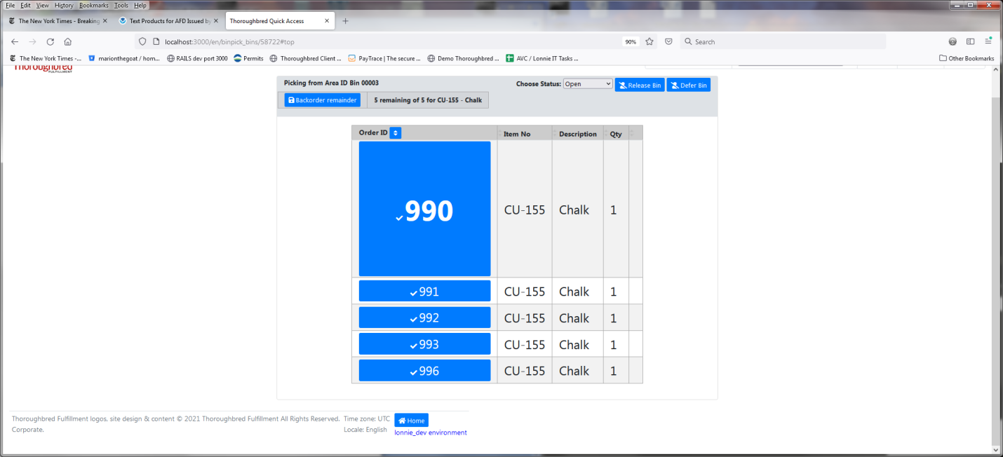
In order to keep things organized, it was deemed desirable to have each operator scan the bin/item they wish to work with, thus giving them exclusive access to the bin and the line items tied to it.
Once all bins are picked and all orders satisfied, a 'completion' process confirms all the customer orders in the NDS system and then flags the batch as closed so operators can no longer work with the batch.
It is worthy of note that, prior to completion, a binpick batch can be deleted from the application with absolutely no impact to the NDS system. It represents loss of work for the operators, but there's no synchronization problems or other issues that would result.
The NDS OESB batch shipping process assumes all inventory to be shipped must reside in the 'default' shipping bin location, if that location has insufficient product quantity then some order lines will be backorders once the existing quantity has been consumed/shipped in the system. There is often other stock present in the warehouse that could satisfy the batch, so prior to actually running the OESB process, it is desirable to perform stock moves to the default shipping location to cover the requirements of the order batch. We implemented a stock move screen to complement the binpick application, this performs a netting calculation of the candidate orders against the shipping bin locations and suggests stock moves based on shortages which can be satisfied from other 'offline' bin locations.
Refinements
After initial implementation, the real world prompted suggestions for improvement and provided some other issues to solve.
- Initially, the envelopes/folders were organized by order number as it was the only ID we had in the system for them. But this would require labeling the folders with the order numbers when preparing each batch and hunting down 6-digit order numbers wasn't fun for the operators. Management suggested generating new ID's and utilizing pre-numbered folders which worked well. Adding major dividers every 10 folders or so improved visual access. We modified the batch preparation to accept a starting ID to work with so whatever set of folders happened to be available could be utilized in the batch.
- Sometimes Operator A was busy with an order envelope which Operator B needed and didn't find in the file trough. Or sometimes another issue might lead the operator to defer a given line item. So we implemented a 'Defer' option which sends the line item to the end of the list, so they can re-address it after picking the other order lines.
- Some inventory items were present on every single order in a batch in the same quantity, often an info slip or other promotional material. In this case there's no selectivity on the order end of things -- every envelope must be stuffed. So rather than bug off individual orders, we implemented the capability to simply bug off the bin itself, signifying all orders had received product from it.
- Sometimes the inventory in the ERP system is not accurate and the inventory bin physically has less than the OESB process assumed. The operator cannot pick product they do not have. So we implemented a 'Backorder Remaining Lines' capability at the bin level, any order lines which have no completions logged against them are flagged to be backordered and the bin is considered to be returned to the warehouse empty. The batch completion process is responsible for un-shipping the affected line items in the NDS system and setting them to backordered.
- Some product may reside in bins too large for convenient handling. Also, some bins are only needed for very few order lines in the batch, making it questionable whether it's worth hauling the bin to the shipping line. For these cases, the line items can separated as 'Wave Pick' lines and deferred during the normal pick process, then the remaining handful orders requiring product can be picked in a single wave pass through the warehouse at the end.
- The web application is responsible for creating and managing the batches. This means all processing had to fit in the space of the HTTP request-response cycle. This worked fine for smaller batches but caused problems with batches containing several thousand orders. So we had to restructure things such that the batch preparation and completion processing processing was performed by a background job processor and not tied to the user's session.
- There proved to be a practical physical limit to the number of orders the shipping line wanted to deal with in a given batch. Thus it became desirable to limit the batch sizes somehow. Rather than arbitrary cutoffs, management wanted to separate out new orders from old backorders being re-circulated, and to separate client orders by the assigned sales location / business in NDS. So we added this selectivity to the batch preparation process.
- Until the above came to be, we only had to worry about one open binpick batch per client. But management wanted to have multiple separate batches being picked concurrently for a given client, somehow they were able to manage competition for inventory bins between the different shipping lines. So we added capability to have more than one open batch for a client and devised a means for the operators to easily select which batch they need to work with.
- People can do things to orders in NDS which causes problems -- they can unship an order, then add or remove line items, etc. This creates invalid conditions from the binpick standpoint. So we added detection of order status changes to render orders 'invalid', which prevents them from being confirmed or handled further within the batch, the assumption being whatever was done in NDS trumps the picking process. The envelopes for Invalid orders need to be physically removed from the batch file trough and receive whatever attention they require back in the NDS system.
Conclusion
Companies employ all sorts of physical access strategies to marry product with customer orders during shipment -- robotic 'jukebox' bins, conveyor systems, travel analysis, etc. The binpick process is a novel invention, something I've not seen anywhere else. It was possible only because of the particular nature of the orders and products involved. But things which are well-adapted to the environment tend to thrive.

