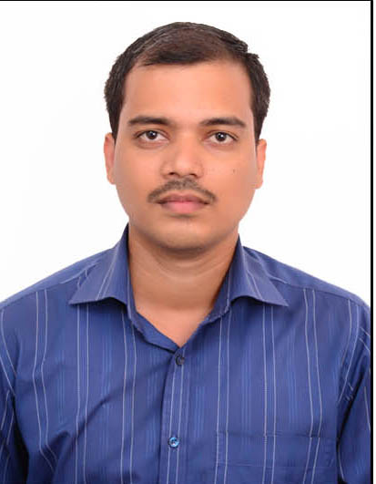

JAGANNATH DINDOOR

SOFTWARE ENGINEER

**CONTACT**

## Address

#12 1st cross, GKW Layout,

Vijayanagr, Bengaluru-560040

## Phone

(+91) – 8867814784

## E-mail

[jrdindoor@gmail.com](mailto:jrdindoor@gmail.com)

**SOFTWARE SKILLS**

Language: Java

RDBMS: MySQL

Web Framework: Spring-MVC, Spring- Boot

ORM Framework: JDBC, Hibernate, Spring-Core

Web Technologies: HTML, CSS, Bootstrap, JavaScript, Angular

IDE: Eclipse

Web Server: Apache Tomcat 9.0

Other Tools: GitHub, Maven, Log4J,Logback JUnit, ,Lombok

To secure a challenging position where, I can effectively contribute my skills.

To work in a reputed organization with dedication and integrity so as to gain knowledge and enhance my skills with continuous value addition to organization.

**PREVIOUS COMPANY DETAILS**

* COMPANY: Bangalore
* PERIOD: 3 September 2018 to till date
* DESIGNATION: Software Engineer

**EXPERIENCE SUMMARY**

In Total 2.05 years of experience

* Involved in production, supply and documentation of

ready-made software

* Consulted best solution for custom software
* Written code for web-page
* Developed functionality of web-application
* Practical Knowledge of IOC
* Integration of spring with hibernate, spring with java mail
* Integration of Spring with JDBC
* Experience in writing controller, Dao’s and services
* Handling exceptions in the Application
* Experience in designing webpages using HTML, CSS,

Java Script and Angular

* Experience in designing Enterprise Applications

Using Spring-MVC

* Experience in doing CRUD operation with Database

using servlet, spring core and Spring-MVC

* Understanding of JDBC Template
* Understanding of Transaction Management in

spring Framework

* Understanding application of Lombok
* Basic knowledge of Microservice and Webservice
* Understanding of Hibernate Validators
* Knowledge on connection pooling in spring
* Understanding of solid principles

.

**Language:**

* Kannada
* English
* Hindi

**Personal Information:**

Father: Ramanna Dindoor

Date of Birth: 08-08-1991

Sex: Male

**Hobbies:**

Reading novels

* Understanding of datasource and types
* Understanding of Web Client, Rest Template and

Eureka Server

* Understanding usage of Bootstrap in designing webpages
* knowledge of Creating and Configuring router in Angular
* Understanding integration of Angular with Spring-Boot
* Knowledge of Data Structures in Java
* Basic knowledge of JDK 8 features
* Knowledge on sql injection
* Basic Knowledge on design patterns
* Understanding of entire SDLC

**Education**

Master of Technology (M.Tech), 2015

Dayananda Sagar College, Bengaluru

**Projects**

1. POC: APP MANAGEMENT

* A web application for an enterprise that shows

different applications used in that enterprise

* It allows everyone to view the name, status, url, team etc
* It allows only the designated ones to add new applications

or make any changes.

TECHNOLOGY USED

* Sping mvc to spring Boot migration project
* AWS cloud, Micro services, REST, Agile Method

1. INVENTORY MANAGEMENT SYSTEM

* A web application for a company that allows inventory manager to view, add, edit and delete material details.
* Also facilitates receipt and bill generation.
* Spring mvc project, jdbc to hibernate enhancement

1. LEAVE MANAGEMENT SYSTEM

* Register employee into the system, Employee login, create leave request, approval or denial of request, view request status.