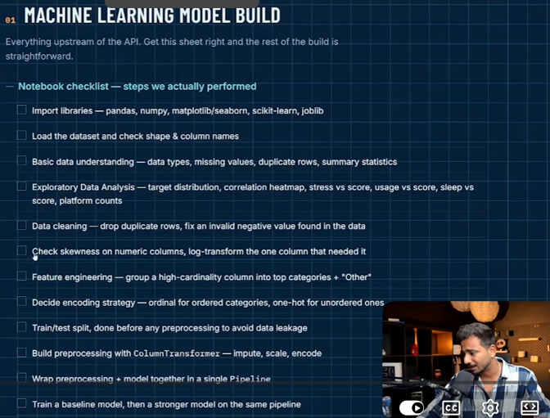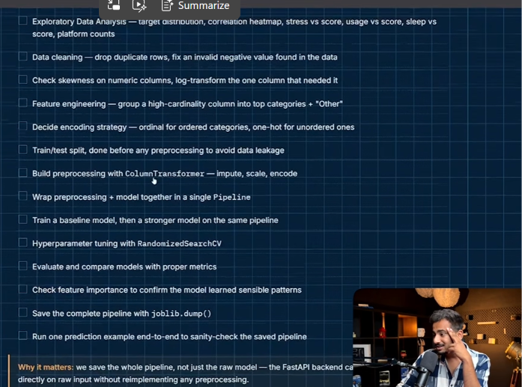
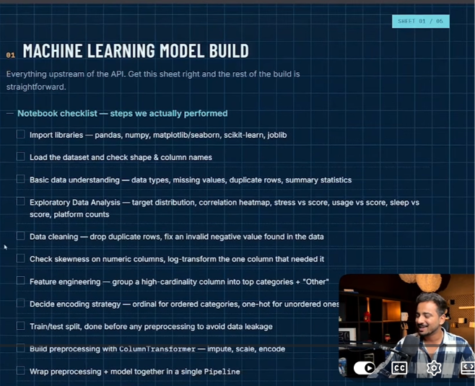

Other project link-- Invoice Intelligence System | End-to-End ML Project
Youtube link - Invoice Intelligence Machine Learning Project | Python + SQL + Scikit-Learn + Deployment

‘Age’, ‘Avg_Daily_Usage_Hours’, ‘Daily_Unlocks’ ‘Study_Hours’, ‘Physical_Activity_Hours’, ‘Sleep_Hours_Per_Night’ , ‘Mental_Health_Score’

‘Gender’ , ‘Academic_Level’ , ‘Most_Used_Platform’, ‘ Purpose_Of_Use’, ‘Country_Grouped’


