**Alpha-Beta Pruning**

**Algorithm:**

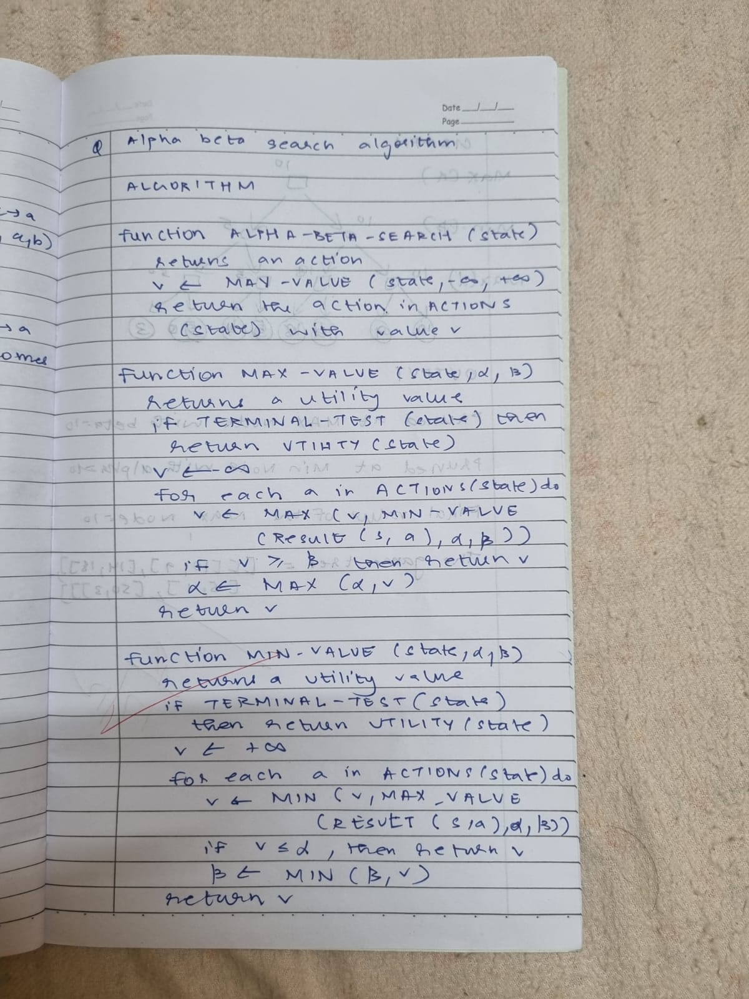

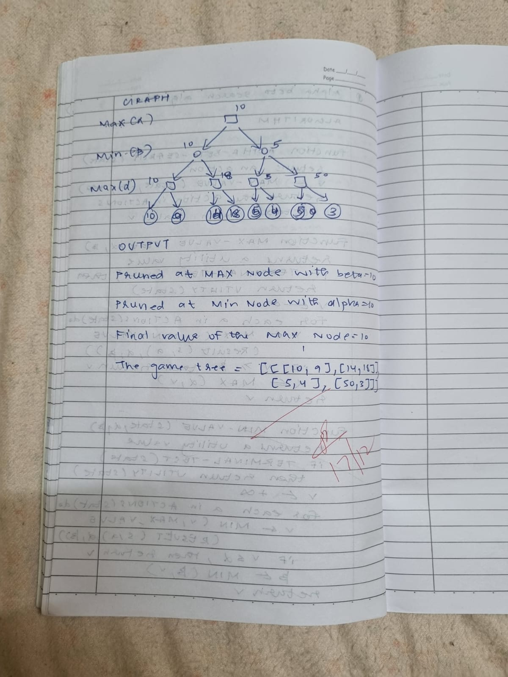

**Code:**

import math

def alpha_beta_search(tree, depth, alpha, beta, maximizing_player):

    if depth == 0 or isinstance(tree, int):

        return tree

    if maximizing_player:

        max_eval = -math.inf

        for child in tree:

            eval = alpha_beta_search(child, depth - 1, alpha, beta, False)

            max_eval = max(max_eval, eval)

            alpha = max(alpha, eval)

            if beta <= alpha:

                print("Pruned at MAX node with beta =", beta)

                break

        return max_eval

    else:

        min_eval = math.inf

        for child in tree:

            eval = alpha_beta_search(child, depth - 1, alpha, beta, True)

            min_eval = min(min_eval, eval)

            beta = min(beta, eval)

            if beta <= alpha:

                print("Pruned at MIN node with alpha =", alpha)

                break

        return min_eval

game_tree = [

    [[10, 9], [14, 18]],

    [[5, 4], [50, 3]]

]

final_value = alpha_beta_search(game_tree, 3, -math.inf, math.inf, True)

print("Final Value of the MAX Node:", final_value)

**Output:**

