**8 Puzzle Problem**

**Algorithm:**

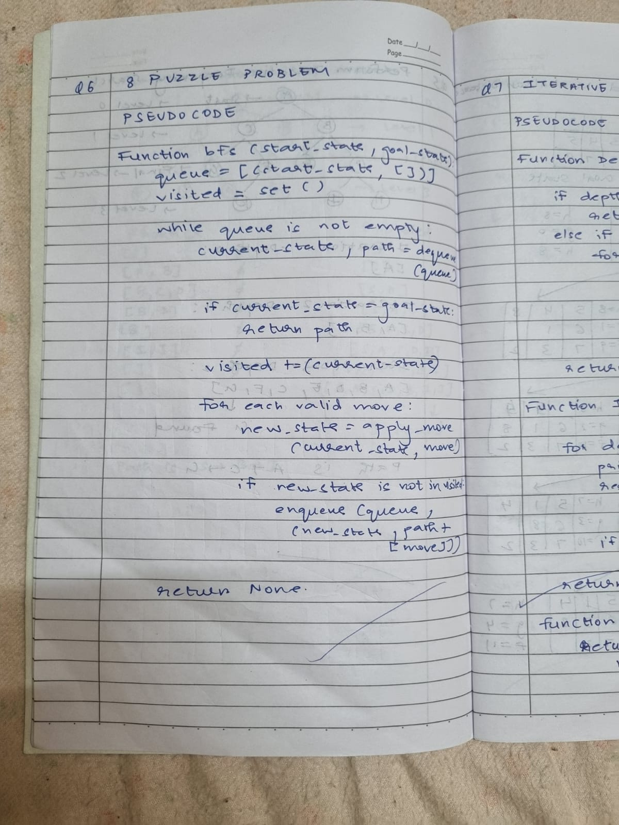

**State Space Tree:**

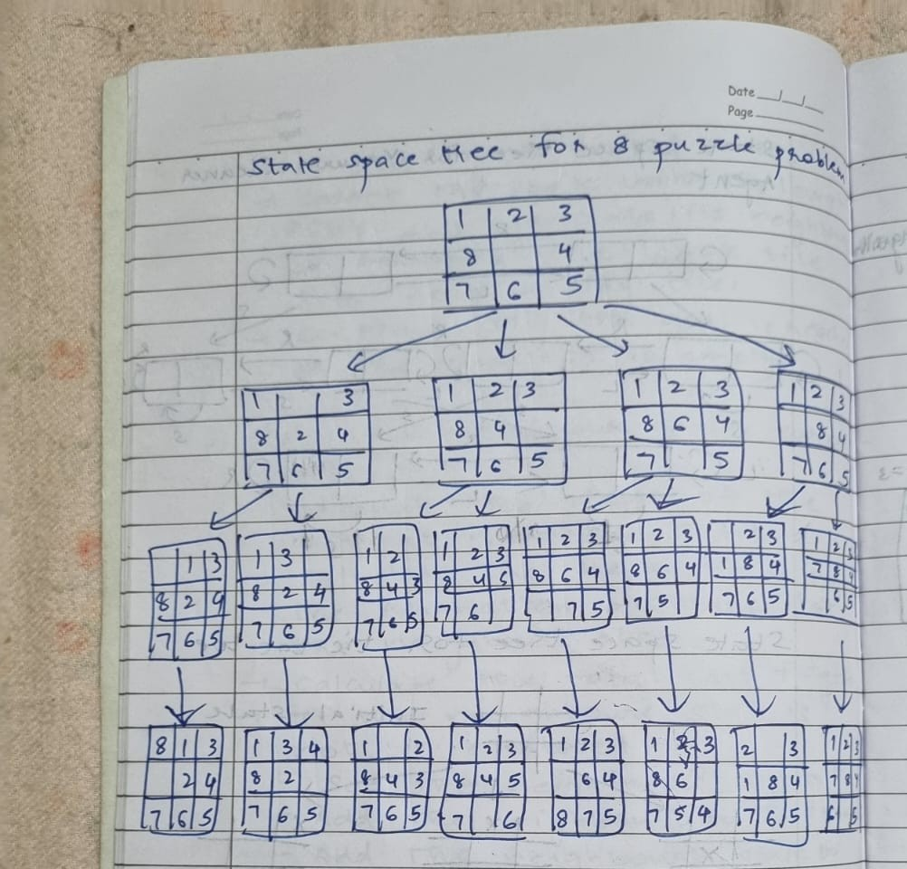

**Code:**

from collections import deque

# Moves: Up, Down, Left, Right

moves = {

'U': (-1, 0),

'D': (1, 0),

'L': (0, -1),

'R': (0, 1)

}

# Convert puzzle to string format for hashing

def puzzle_to_string(puzzle):

return ''.join(str(num) for row in puzzle for num in row)

# Print puzzle for better visualization

def print_puzzle(puzzle):

for row in puzzle:

print(row)

print()

# BFS algorithm

def bfs_8_puzzle(start, goal):

queue = deque([(start, [])]) # Each element is (current_state, path_taken)

visited = set()

visited.add(puzzle_to_string(start))

state_space_tree = []

while queue:

current, path = queue.popleft()

if current == goal:

state_space_tree.append((current, path)) # Record final state and path

return state_space_tree # Puzzle solved, return best path

zero_pos = [(i, j) for i in range(3) for j in range(3) if current[i][j] == 0][0]

for move, (dx, dy) in moves.items():

x, y = zero_pos[0] + dx, zero_pos[1] + dy

if 0 <= x < 3 and 0 <= y < 3:

new_state = [row[:] for row in current]

new_state[zero_pos[0]][zero_pos[1]], new_state[x][y] = new_state[x][y], new_state[zero_pos[0]][zero_pos[1]]

if puzzle_to_string(new_state) not in visited:

visited.add(puzzle_to_string(new_state))

queue.append((new_state, path + [move])) # Add move to the path

state_space_tree.append((new_state, path + [move])) # Record the state and path

return state_space_tree # Return the entire state space tree if no solution

# Function to get input from user

def get_input():

start_state = []

goal_state = []

print("Enter the start state (3x3 matrix, row by row, with 0 representing the blank space):")

for i in range(3):

row = list(map(int, input().split()))

start_state.append(row)

print("Enter the goal state (3x3 matrix, row by row, with 0 representing the blank space):")

for i in range(3):

row = list(map(int, input().split()))

goal_state.append(row)

return start_state, goal_state

# Example Usage

start_state, goal_state = get_input()

# Get the best path using BFS

solution_tree = bfs_8_puzzle(start_state, goal_state)

# Print all states in the best move sequence

if solution_tree:

print("goal state achieved")

print_puzzle(goal_state)

else:

print("No solution found.")

**Output:**

