**A* using Misplaced Tiles**

**Algorithm:**

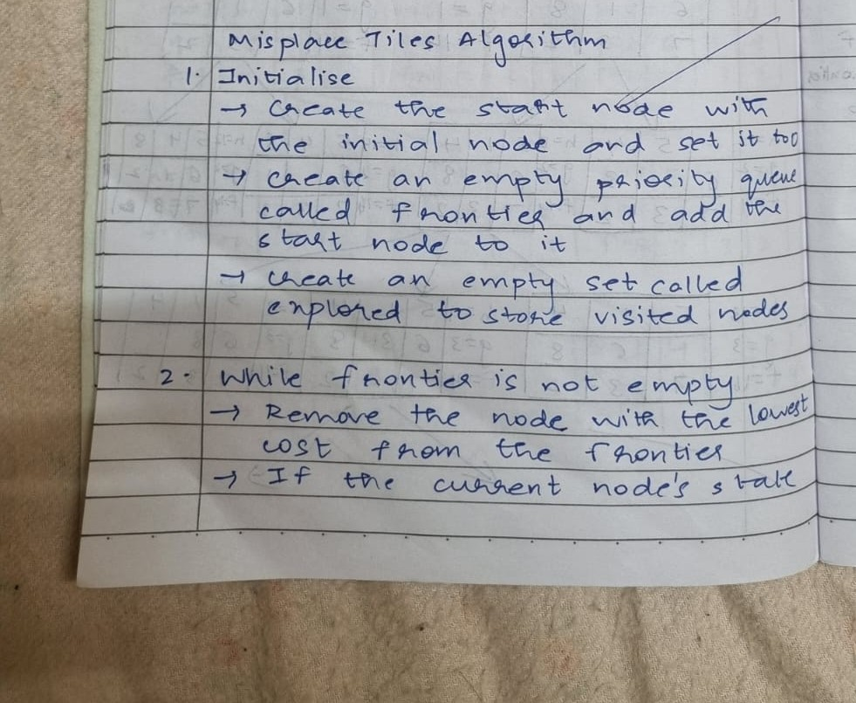

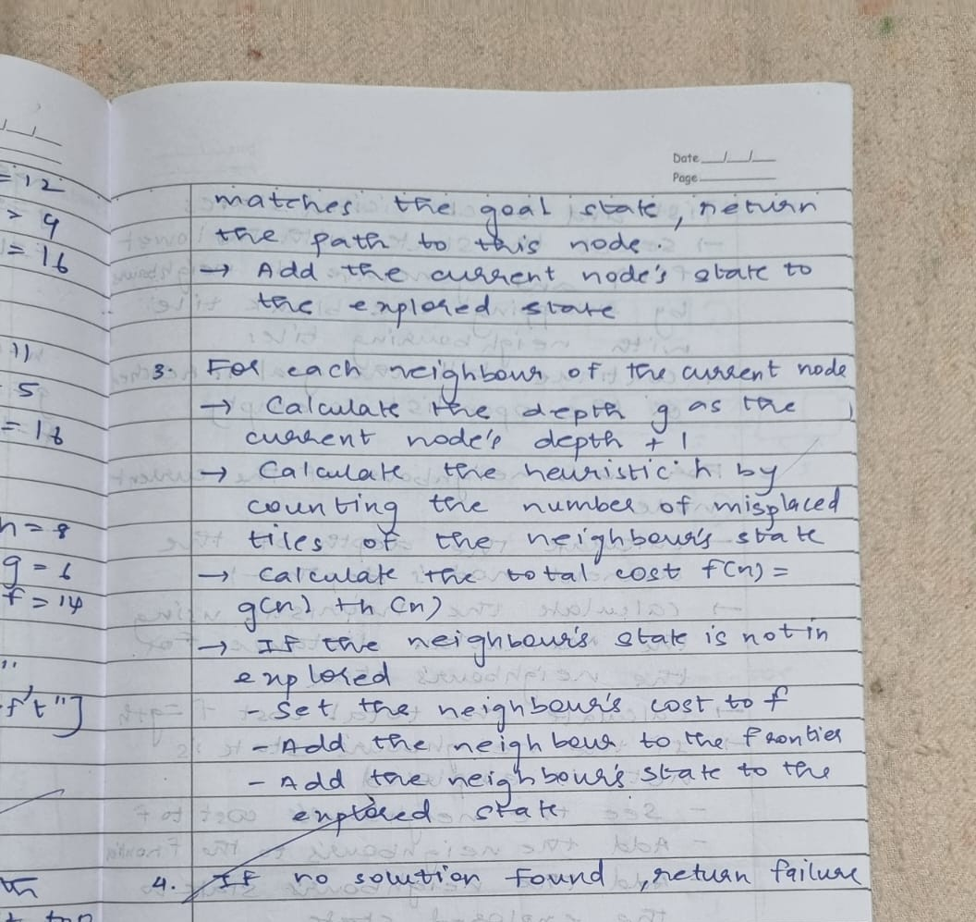

**State Space Tree:**

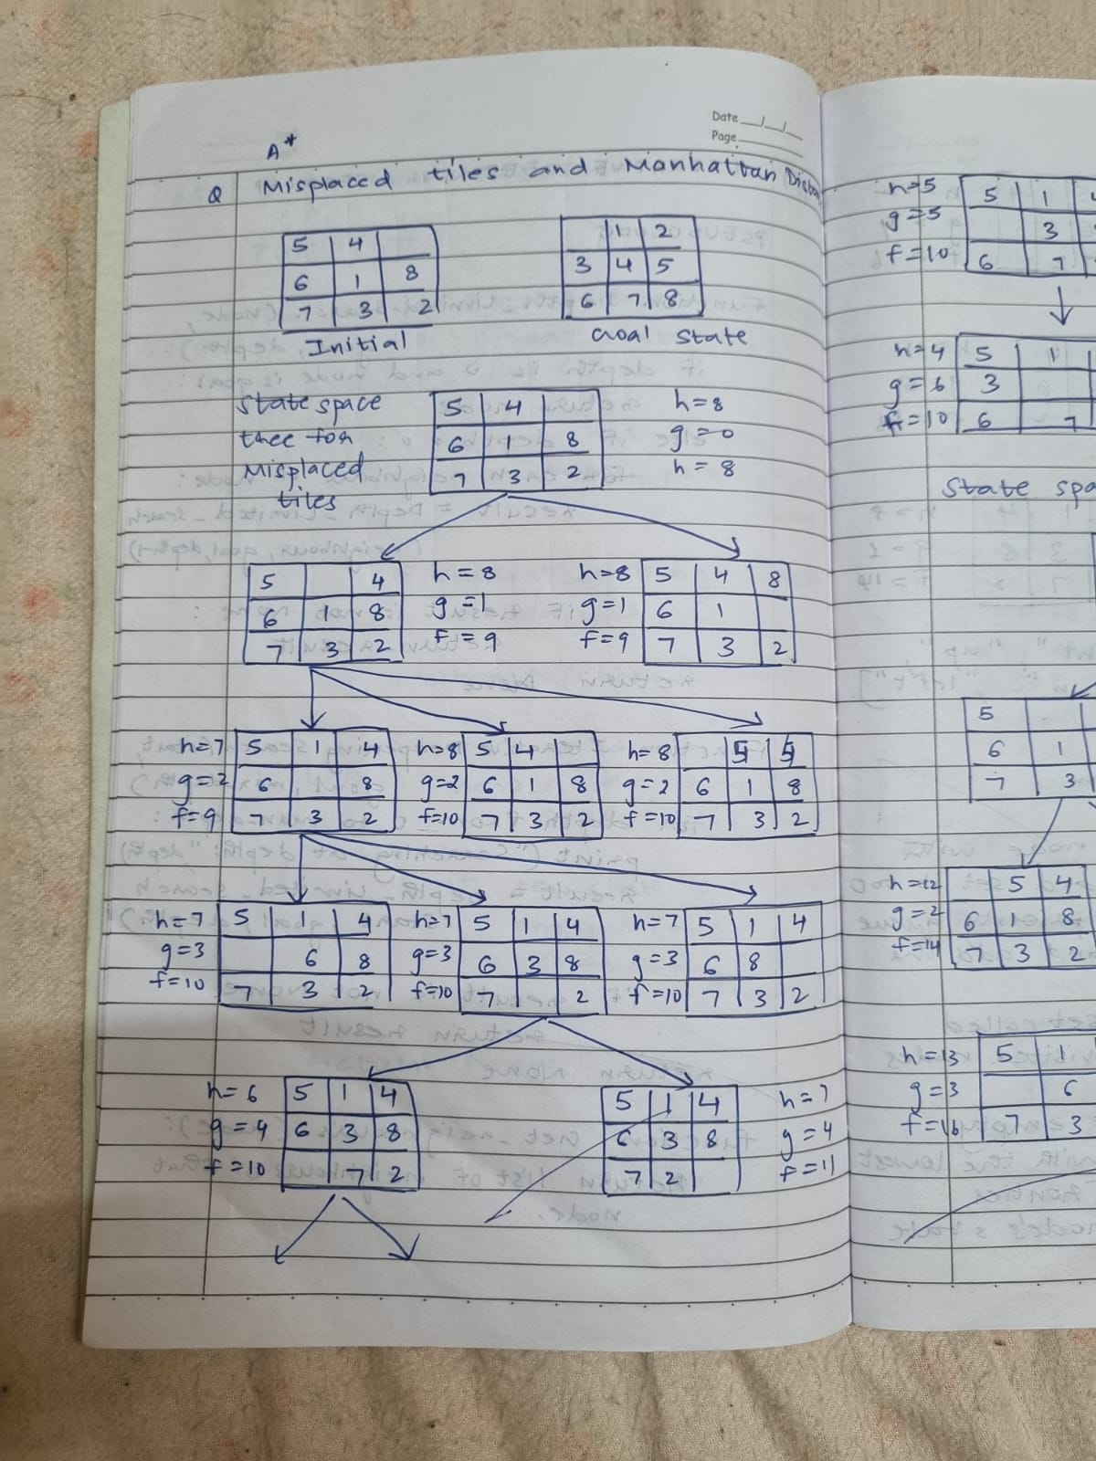

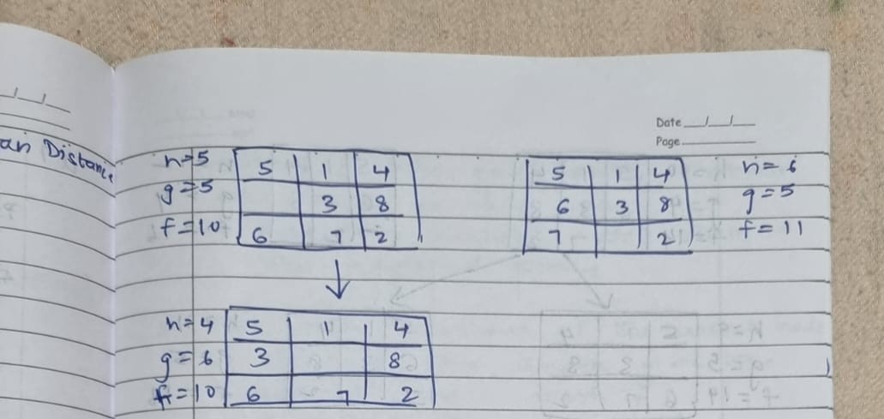

**Code:**

import heapq

# Define the goal state for the puzzle

goal_state = [[1, 2, 3], [8, 0, 4], [7, 6, 5]]

# Helper function to calculate the misplaced tiles heuristic

def misplaced_tiles(state, goal_state):

"""Calculate the number of misplaced tiles."""

count = 0

for i in range(3):

for j in range(3):

if state[i][j] != 0 and state[i][j] != goal_state[i][j]:

count += 1

return count

def is_goal(state):

"""Check if the current state is the goal state."""

return state == goal_state

def get_neighbors(state):

"""Generate neighbors for a given state."""

neighbors = []

# Find the position of the empty space (0)

x, y = [(ix, iy) for ix, row in enumerate(state) for iy, i in enumerate(row) if i == 0][0]

# Possible moves: up, down, left, right

moves = [(x-1, y), (x+1, y), (x, y-1), (x, y+1)]

for move_x, move_y in moves:

if 0 <= move_x < 3 and 0 <= move_y < 3:

# Create a copy of the current state and swap the empty space

new_state = [row[:] for row in state]

new_state[x][y], new_state[move_x][move_y] = new_state[move_x][move_y], new_state[x][y]

neighbors.append(new_state)

return neighbors

# A* algorithm using misplaced tiles heuristic

def a_star_misplaced(initial_state):

"""A* algorithm implementation for 8-puzzle problem with misplaced tiles heuristic."""

open_list = []

closed_set = set()

# Initial cost

g = 0

f = g + misplaced_tiles(initial_state, goal_state)

# Add the initial state to the open list

heapq.heappush(open_list, (f, g, initial_state, []))

while open_list:

f, g, current_state, path = heapq.heappop(open_list)

if is_goal(current_state):

return path + [current_state]

closed_set.add(tuple(map(tuple, current_state)))

for neighbor in get_neighbors(current_state):

if tuple(map(tuple, neighbor)) in closed_set:

continue

new_g = g + 1

new_f = new_g + misplaced_tiles(neighbor, goal_state)

heapq.heappush(open_list, (new_f, new_g, neighbor, path + [current_state]))

return None

# Helper function to print a state

def print_state(state):

for row in state:

print(row)

print()

# Initial state

initial_state = [[2, 8, 3], [1, 6, 4], [7, 0, 5]]

# Run the A* algorithm with misplaced tiles heuristic

print("Solution using misplaced tiles heuristic:")

solution_misplaced = a_star_misplaced(initial_state)

if solution_misplaced:

for step in solution_misplaced:

print_state(step)

else:

print("No solution found using misplaced tiles heuristic.")

**Output:**

Solution using misplaced tiles heuristic:  
[2, 8, 3]  
[1, 6, 4]  
[7, 0, 5]  
  
[2, 8, 3]  
[1, 0, 4]  
[7, 6, 5]  
  
[2, 0, 3]  
[1, 8, 4]  
[7, 6, 5]  
  
[0, 2, 3]  
[1, 8, 4]  
[7, 6, 5]  
  
[1, 2, 3]  
[0, 8, 4]  
[7, 6, 5]  
  
[1, 2, 3]  
[8, 0, 4] **[7, 6, 5]**