**JAGANNATHAN K R – 1BM22CS115**

**LAB-1**

Q. Write a C program to simulate the following non-pre-emptive CPU scheduling

algorithm to find turnaround time and waiting time.

**→FCFS**

#include<stdio.h>

void main()

{

int n;

printf("Enter number of processes:\n");

scanf("%d",&n);

int pr[n], at[n], bt[n], ct[n], tat[n], wt[n];

printf("Enter Process number:\n");

for (int i=0; i<n; i++)

{

scanf("%d", &pr[i]);

}

printf("Enter Arrival Time:\n");

for (int i=0; i<n; i++)

{

scanf("%d", &at[i]);

}

printf("Enter Burst Time:\n");

for (int i=0; i<n; i++)

{

scanf("%d", &bt[i]);

}

int temp1, temp2, temp3;

for (int i=0; i<n; i++)

{

for (int j=i+1; j<n; j++)

{

if (at[j]<at[i])

{

temp1 = at[j];

at[j] = at[i];

at[i] = temp1;

temp2 = bt[j];

bt[j] = bt[i];

bt[i] = temp2;

temp3 = pr[j];

pr[j] = pr[i];

pr[i] = temp3;

}

}

}

int x=at[0];

for (int i=0; i<n; i++)

{

if (x<at[i])

{

x = at[i];

}

ct[i] = bt[i] + x;

x = ct[i];

}

for (int i=0; i<n; i++)

{

tat[i] = ct[i] - at[i];

}

for (int i=0; i<n; i++)

{

wt[i] = tat[i] - bt[i];

}

for (int i=0; i<n; i++)

{

printf("%d\t%d\t%d\t%d\t%d\t%d\n", pr[i], at[i], bt[i], ct[i], tat[i], wt[i]);

}

float avg_tat = 0, avg_wt = 0;

for (int i=0; i<n; i++)

{

avg_tat = avg_tat + tat[i];

avg_wt = avg_wt + wt[i];

}

avg_tat = avg_tat/n;

avg_wt = avg_wt/n;

printf("The average Turnaround time is: %f", avg_tat);

printf("\nThe average Waiting time is: %f`", avg_wt);

}

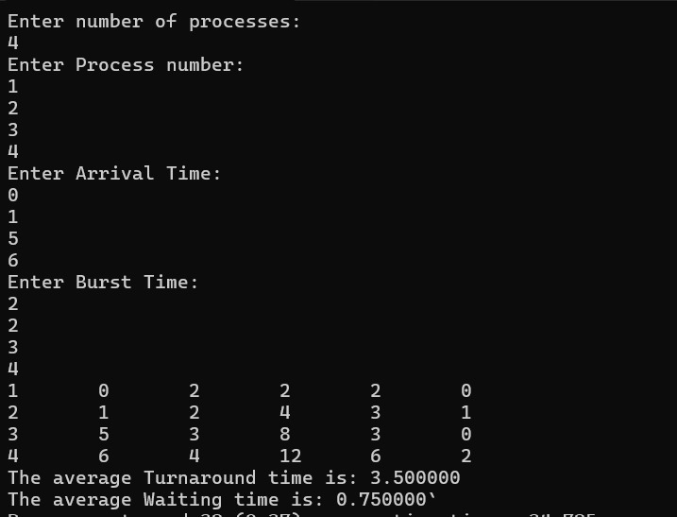

**→ SJF (pre-emptive)**

#include<stdio.h>

// Function to find the waiting time, turnaround time, and completion time for all processes using SJF (Preemptive)

void findCompletionTime(int processes[], int n, int bt[], int at[], int wt[], int tat[], int ct[])

{

int remaining[n]; // Array to store remaining burst time of processes

int currentTime = 0; // Current time

int completed = 0; // Counter for completed processes

// Initialize remaining array with burst times

for (int i = 0; i < n; i++)

remaining[i] = bt[i];

while (completed < n)

{

int shortest = -1; // Index of shortest remaining time process

// Find process with shortest remaining burst time

for (int i = 0; i < n; i++)

{

if (at[i] <= currentTime && remaining[i] > 0)

{

if (shortest == -1 || remaining[i] <= remaining[shortest])

shortest = i;

}

}

// If no process found, move to next time

if (shortest == -1)

{

currentTime++;

continue;

}

// Reduce remaining time of the process

remaining[shortest]--;

// If the process is completed

if (remaining[shortest] == 0)

{

completed++;

// Set completion time for the process

ct[shortest] = currentTime + 1;

// Calculate waiting time and turnaround time for the process

wt[shortest] = ct[shortest] - bt[shortest] - at[shortest];

tat[shortest] = ct[shortest] - at[shortest];

}

// Move to the next time

currentTime++;

}

// Print the table

for (int i = 0; i < n; i++)

{

printf("%d\t\t%d\t\t%d\t\t%d\t\t%d\t\t%d\n", processes[i], at[i], bt[i], ct[i], tat[i], wt[i]);

}

float avg_tat = 0, avg_wt = 0;

for (int i = 0; i < n; i++)

{

avg_tat += tat[i];

avg_wt += wt[i];

}

avg_tat /= n;

avg_wt /= n;

printf("The average Turnaround time is %f\n", avg_tat);

printf("The average Waiting time is %f\n", avg_wt);

}

void main()

{

// Number of processes

int n;

printf("Enter the number of processes: ");

scanf("%d", &n);

// Process id's

int processes[n];

// Burst time of all processes

int burst_time[n];

// Arrival time of all processes

int arrival_time[n];

printf("Enter Process Number:\n");

for (int i = 0; i < n; i++)

{

scanf("%d", &processes[i]);

}

printf("Enter Arrival Time:\n");

for (int i = 0; i < n; i++)

{

scanf("%d", &arrival_time[i]);

}

printf("Enter Burst Time:\n");

for (int i = 0; i < n; i++)

{

scanf("%d", &burst_time[i]);

}

// Arrays to store waiting time, turnaround time, and completion time

int wt[n], tat[n], ct[n];

printf("\nSJF (Preemptive) Scheduling:\n");

findCompletionTime(processes, n, burst_time, arrival_time, wt, tat, ct);

}

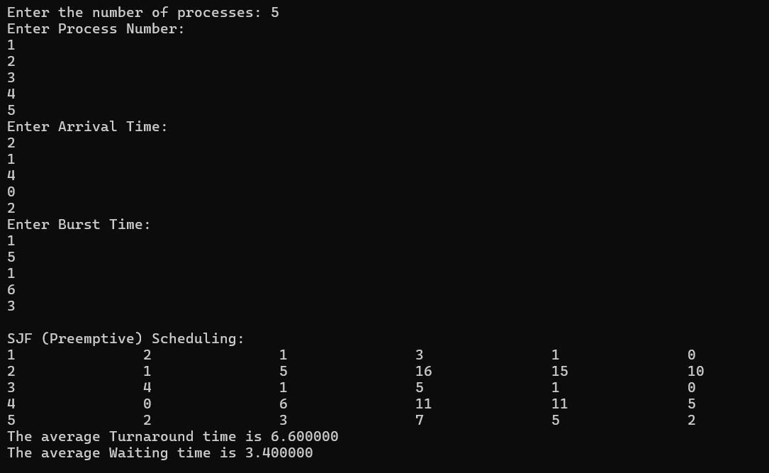

**→ SJF (non-pre-emptive)**

#include<stdio.h>

// Function to find the waiting time, turnaround time, response time, and completion time for all processes using SJF (Non-preemptive)

void findCompletionTime(int processes[], int n, int bt[], int at[], int wt[], int tat[], int rt[], int ct[])

{

int completion[n]; // Array to store completion times of processes

int remaining[n]; // Array to store remaining burst time of processes

// Initialize remaining array with burst times

for (int i = 0; i < n; i++)

remaining[i] = bt[i];

int currentTime = 0; // Current time

// Find process with shortest burst time

for (int i = 0; i < n; i++)

{

int shortest = -1;

for (int j = 0; j < n; j++)

{

if (at[j] <= currentTime && remaining[j] > 0)

{

if (shortest == -1 || remaining[j] < remaining[shortest])

shortest = j;

}

}

if (shortest == -1)

{

currentTime++;

continue;

}

// Set completion time for the process

completion[shortest] = currentTime + remaining[shortest];

// Update current time

currentTime = completion[shortest];

// Calculate waiting time, turnaround time, and response time for the process

wt[shortest] = currentTime - bt[shortest] - at[shortest];

tat[shortest] = currentTime - at[shortest];

rt[shortest] = wt[shortest]; // Response time for non-preemptive SJF is the same as waiting time

// Mark the process as completed

remaining[shortest] = 0;

}

// Copy completion times to ct[] and print the table

for (int i = 0; i < n; i++)

{

ct[i] = completion[i];

printf("%d\t\t%d\t\t%d\t\t%d\t\t%d\t\t%d\t\t%d\n", processes[i], at[i], bt[i], ct[i], wt[i], tat[i], rt[i]);

}

float avg_tat = 0, avg_wt = 0;

for (int i = 0; i < n; i++)

{

avg_tat += tat[i];

avg_wt += wt[i];

}

avg_tat /= n;

avg_wt /= n;

printf("The average Turnaround time is %f\n", avg_tat);

printf("The average Waiting time is %f\n", avg_wt);

}

void main()

{

// Number of processes

int n;

printf("Enter the number of processes: ");

scanf("%d", &n);

// Process id's

int processes[n];

// Burst time of all processes

int burst_time[n];

// Arrival time of all processes

int arrival_time[n];

printf("Enter Process Number:\n");

for (int i = 0; i < n; i++)

{

scanf("%d", &processes[i]);

}

printf("Enter Arrival Time:\n");

for (int i = 0; i < n; i++)

{

scanf("%d", &arrival_time[i]);

}

printf("Enter Burst Time:\n");

for (int i = 0; i < n; i++)

{

scanf("%d", &burst_time[i]);

}

// Arrays to store waiting time, turnaround time, response time, and completion time

int wt[n], tat[n], rt[n], ct[n];

// Initialize response times to -1

for (int i = 0; i < n; i++)

rt[i] = -1;

printf("\nSJF (Non-preemptive) Scheduling:\n");

findCompletionTime(processes, n, burst_time, arrival_time, wt, tat, rt, ct);

}

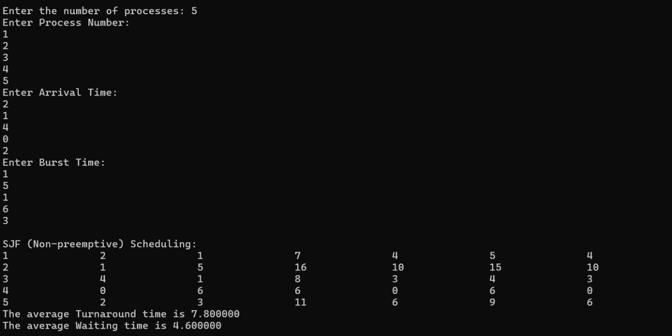

**LAB-2**

Q. Write a C program to simulate the following CPU scheduling algorithm to find

turnaround time and waiting time.

**→ Priority**

#include <stdio.h>

#include <stdbool.h>

// Function to find the waiting time, turnaround time, and completion time for all processes using Priority Scheduling (Preemptive)

void findCompletionTime(int processes[], int n, int bt[], int at[], int wt[], int tat[], int ct[], int rt[], int priority[], bool isLowerPriorityHigher)

{

int remaining[n]; // Array to store remaining burst time of processes

int currentTime = 0; // Current time

int completed = 0; // Counter for completed processes

bool isFinished[n]; // Array to indicate if the process is finished

// Initialize remaining array with burst times and set response times

for (int i = 0; i < n; i++) {

remaining[i] = bt[i];

isFinished[i] = false;

rt[i] = -1; // Response time is initially unset

}

while (completed < n) {

int highestPriorityIndex = -1;

int highestPriority = isLowerPriorityHigher ? 1000000 : -1; // Adjust initial value based on priority type

// Find the process with the highest priority that has arrived and is not finished

for (int i = 0; i < n; i++) {

if (at[i] <= currentTime && !isFinished[i] &&

((isLowerPriorityHigher && priority[i] < highestPriority) ||

(!isLowerPriorityHigher && priority[i] > highestPriority))) {

highestPriority = priority[i];

highestPriorityIndex = i;

} }

// If no process is found, move to the next time

if (highestPriorityIndex == -1) {

currentTime++;

continue;

}

int currentProcess = highestPriorityIndex;

// Set response time if it's the first time the process is executed

if (rt[currentProcess] == -1) {

rt[currentProcess] = currentTime - at[currentProcess];

}

// Execute the process for 1 unit of time

remaining[currentProcess]--;

currentTime++;

// If the process is completed

if (remaining[currentProcess] == 0) {

isFinished[currentProcess] = true;

completed++;

ct[currentProcess] = currentTime; // Set completion time for the process

tat[currentProcess] = ct[currentProcess] - at[currentProcess]; // Calculate turnaround time

wt[currentProcess] = tat[currentProcess] - bt[currentProcess]; // Calculate waiting time

} }

// Print the table

printf("Process\tArrival Time\tBurst Time\tPriority\tCompletion Time\tTurnaround Time\tWaiting Time\tResponse Time\n");

for (int i = 0; i < n; i++) {

printf("%d\t\t%d\t\t%d\t\t%d\t\t%d\t\t%d\t\t%d\t\t%d\n",

processes[i], at[i], bt[i], priority[i], ct[i], tat[i], wt[i], rt[i]);

}}

void main()

{

// Number of processes

int n;

printf("Enter the number of processes: ");

scanf("%d", &n);

// Process id's

int processes[n];

// Burst time of all processes

int burst_time[n];

// Arrival time of all processes

int arrival_time[n];

// Priority of all processes

int priority[n];

// Priority type (true for lower number = higher priority, false for higher number = higher priority)

int priorityType;

bool isLowerPriorityHigher;

printf("Enter 1 if lower number indicates higher priority, 0 if higher number indicates higher priority: ");

scanf("%d", &priorityType);

isLowerPriorityHigher = (priorityType == 1);

printf("Enter Process Number:\n");

for (int i = 0; i < n; i++) {

scanf("%d", &processes[i]);

}

printf("Enter Priority:\n");

for (int i = 0; i < n; i++) {

scanf("%d", &priority[i]);

}

printf("Enter Arrival Time:\n");

for (int i = 0; i < n; i++) {

scanf("%d", &arrival_time[i]);

}

printf("Enter Burst Time:\n");

for (int i = 0; i < n; i++) {

scanf("%d", &burst_time[i]);

}

// Arrays to store waiting time, turnaround time, completion time, and response time

int wt[n], tat[n], ct[n], rt[n];

printf("\nPriority Scheduling (Preemptive):\n");

findCompletionTime(processes, n, burst_time, arrival_time, wt, tat, ct, rt, priority, isLowerPriorityHigher);

}

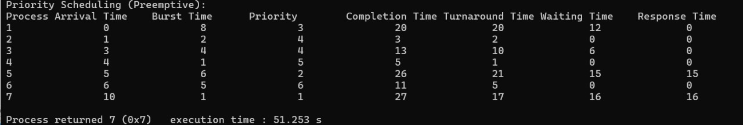

**→Round Robin (Experiment with different quantum sizes for RR algorithm)**

#include <stdio.h>

#include <stdbool.h>

void findCompletionTime(int processes[], int n, int bt[], int at[], int wt[], int tat[], int ct[], int rt[], int quantum)

{

int remaining[n]; // Array to store remaining burst time of processes

bool firstResponse[n]; // Array to track if response time has been set

int currentTime = 0; // Current time

int completed = 0; // Counter for completed processes

// Initialize remaining array with burst times and first response array

for (int i = 0; i < n; i++) {

remaining[i] = bt[i];

firstResponse[i] = true;

}

// Queue to hold the indices of the processes

int queue[n];

int front = -1, rear = -1;

// Function to add process to the queue

void enqueue(int process) {

if (rear == n - 1)

rear = -1;

queue[++rear] = process;

if (front == -1)

front = 0;}

// Function to remove process from the queue

int dequeue() {

int process = queue[front];

if (front == rear)

front = rear = -1;

else {

front++;

if (front == n)

front = 0;

} return process;

}

// To track which processes have been added to the queue

bool inQueue[n];

for (int i = 0; i < n; i++)

inQueue[i] = false;

while (completed < n) {

// Add all processes to the queue that have arrived by the current time

for (int i = 0; i < n; i++) {

if (at[i] <= currentTime && !inQueue[i]) {

enqueue(i);

inQueue[i] = true;

} }

// If no process is ready, increment the current time

if (front == -1) {

currentTime++;

continue; }

int currentProcess = dequeue();

// Set response time if it's the first time the process is executed

if (firstResponse[currentProcess]) {

rt[currentProcess] = currentTime - at[currentProcess];

firstResponse[currentProcess] = false;

}

// Execute the process for the time quantum or until completion

if (remaining[currentProcess] > quantum) {

remaining[currentProcess] -= quantum;

currentTime += quantum;

} else {

currentTime += remaining[currentProcess];

remaining[currentProcess] = 0;

completed++;

// Set completion time for the process

ct[currentProcess] = currentTime;

// Calculate waiting time and turnaround time for the process

tat[currentProcess] = ct[currentProcess] - at[currentProcess];

wt[currentProcess] = tat[currentProcess] - bt[currentProcess];

}

// Add all processes to the queue that have arrived by the current time

for (int i = 0; i < n; i++) {

if (at[i] <= currentTime && !inQueue[i]) {

enqueue(i);

inQueue[i] = true;

} }

// Re-enqueue the current process if it is not finished

if (remaining[currentProcess] > 0) {

enqueue(currentProcess);

} }

// Print the table

printf("Process\tArrival Time\tBurst Time\tCompletion Time\tTurnaround Time\tWaiting Time\tResponse Time\n");

for (int i = 0; i < n; i++) {

printf("%d\t\t%d\t\t%d\t\t%d\t\t%d\t\t%d\t\t%d\n",

processes[i], at[i], bt[i], ct[i], tat[i], wt[i], rt[i]);

}}

void main()

{

// Number of processes

int n;

printf("Enter the number of processes: ");

scanf("%d", &n);

// Process id's

int processes[n];

// Burst time of all processes

int burst_time[n];

// Arrival time of all processes

int arrival_time[n];

printf("Enter Process Number:\n");

for (int i = 0; i < n; i++) {

scanf("%d", &processes[i]);

}

printf("Enter Arrival Time:\n");

for (int i = 0; i < n; i++) {

scanf("%d", &arrival_time[i]);

}

printf("Enter Burst Time:\n");

for (int i = 0; i < n; i++) {

scanf("%d", &burst_time[i]);

}

// Time quantum for Round Robin

int quantum;

printf("Enter the time quantum: ");

scanf("%d", &quantum);

// Arrays to store waiting time, turnaround time, completion time, and response time

int wt[n], tat[n], ct[n], rt[n];

printf("\nRound Robin Scheduling:\n");

findCompletionTime(processes, n, burst_time, arrival_time, wt, tat, ct, rt, quantum);

}

