**Defect id: 1**

**Priority: High**

**Severity: Critical**

**Issue Description:**

Names/Labels given in navigation tab in admin panel settings are not displayed in front end.

**Steps to Reproduce:**

1. Open the [Admin](http://localhost:2368/ghost/) Url in any browser and login.
2. Click on Navigation tab under settings
3. Enter Label name as **Picture** and url as <https://www.finecomb.com>
4. Click on save and open the front end <http://localhost:2368/>
5. Click Menu and look for labels displayed

**Actual Result:**

User is not displayed Picture label under menu

**Expected Result:**

User should be displayed Picture label under menu and link should redirect to expected URL.

Screenshot:

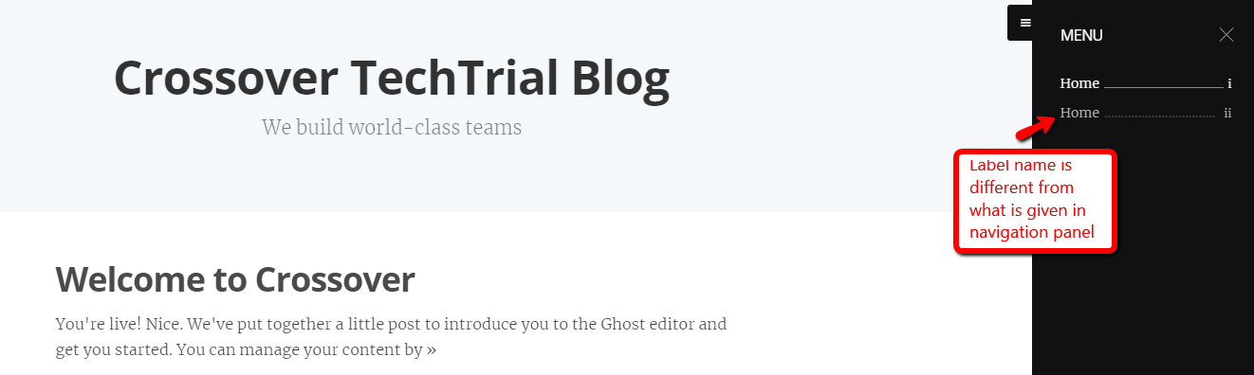

**Defect id: 2**

**Priority: High**

**Severity: Blocker**

**Issue Description:**

Subscribe button in front end under Menu option takes to Xml code page.

**Steps to reproduce:**

1. Open the URL <http://localhost:2368/> in chrome browser.
2. Click on Menu -> Subscribe

**Actual Result:**

User is taken to a page where XML page code is displayed.

**Expected Result:**

User should be able to subscribe to page

**Screenshot:**

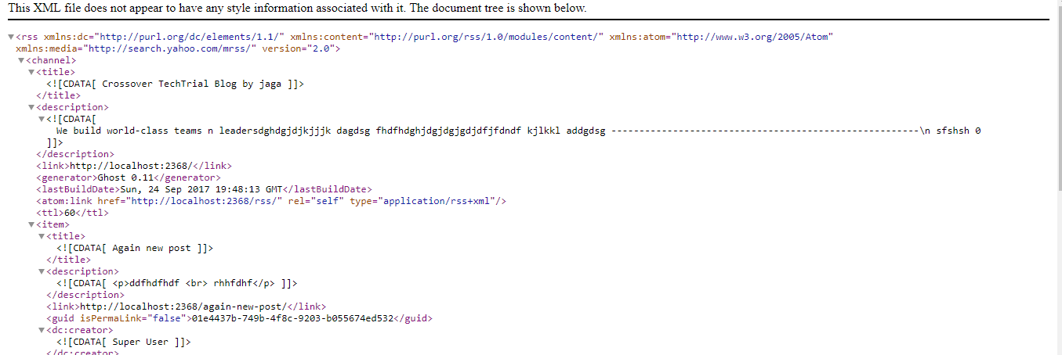

**Defect Id: 3**

**Priority: High**

**Severity: Critical**

**Issue Description:**

Blog footer is not displayed in pages

**Steps to reproduce:**

1. Open the [Admin](http://localhost:2368/ghost/) Url in any browser and login.
2. Click on Settings -> Code Injection.
3. Write any content in Blog footer eg : I am a geek and automation tester.
4. Click on Save.
5. Open the front end <http://localhost:2368/> in chrome browser.
6. Look out for footer message.

**Actual Result:** Footer content is not displayed.

**Expected Result:** Footer content should be displayed.

Screenshot:

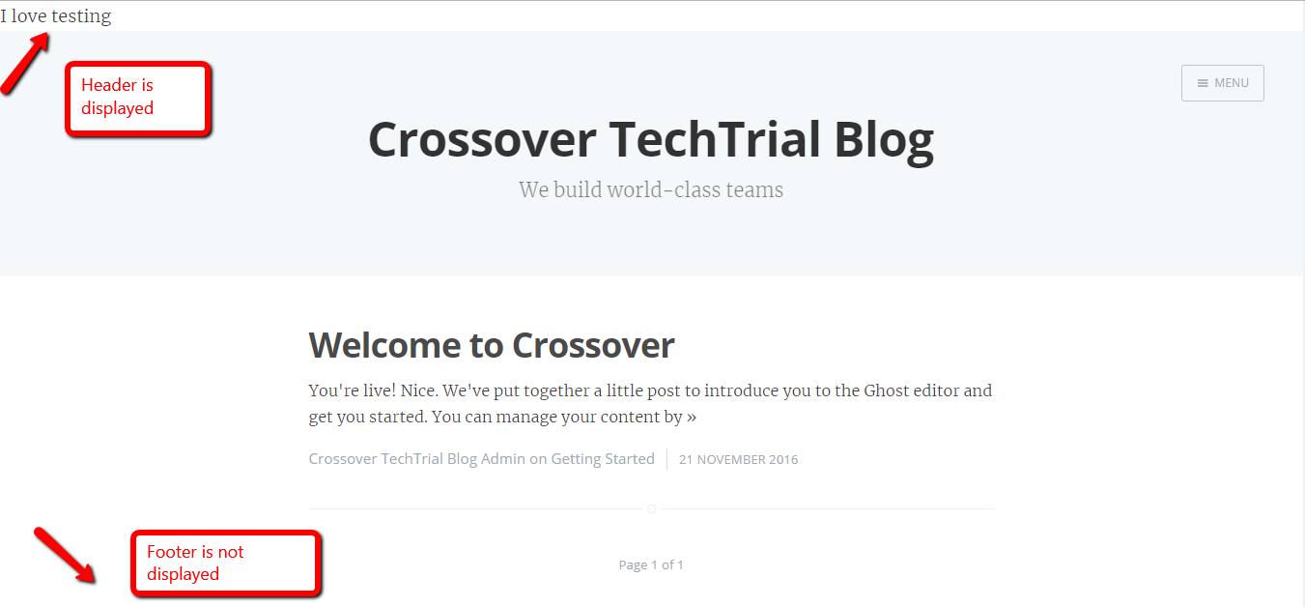

**Defect Id: 4**

**Priority**: Low

**Severity**: Critical

**Issue Description:**

FB and twitter URL under share post are redirected incorrectly.

**Steps to reproduce:**

1. Open the [Admin](http://localhost:2368/ghost/) Url in any browser and login.
2. Click on General under settings
3. Under Facebook Page give a URL : <https://www.facebook.com/ghost>
4. Under Twitter Profile Page give a URL : <https://twitter.com/ghost> and save
5. Go to front end and under Share the post click on FB and Twitter icons.

**Actual Result:**

1. User is redirected to Twitter handle when clicked on FB icon
2. User is redirected to FB page when clicked on Twitter icon

**Expected Result:**

User should be redirected to FB and twitter page when their respective icons are clicked.

Screenshot:

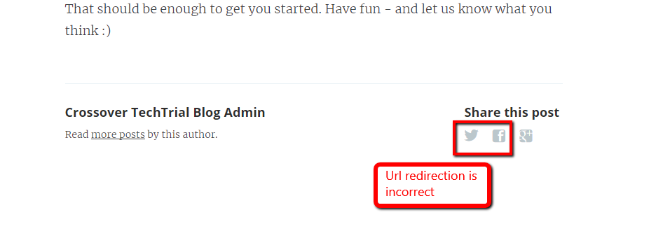

**Defect Id**: 5

**Priority:** High

**Severity:** Blocker

**Issue Description**:

Forgot password of Admin Panel is not working

Steps to Reproduce:

1. Open the [Admin](http://localhost:2368/ghost/) Url in any browser and enter user name as admin@test.com
2. Click on Forgot? In password text box

Actual Result:

User is shown error message “Error: Message could not be sent More info: Can't send mail - all recipients were rejected”

Expected Result: User should be sent forgot password link to mail address and relevant message should be displayed to user.

Screenshot:

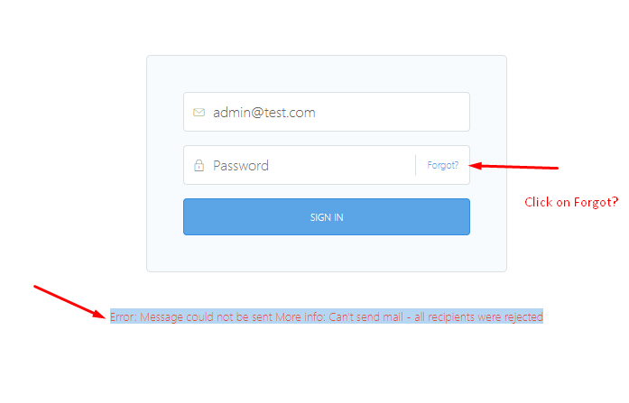

**Defect id**: 6

**Priority:** Low

**Severity:** Critical

**Issue Description**:

User is redirected to 404 page not found error on clicking on “Find Out How you can Get Involved” Button in About page.

**Steps to reproduce:**

1. Log in to Admin Panel
2. Click on Profile user above search box
3. Click on About Ghost option
4. Click on “Find Out How you can Get Involved” button

**Actual Result:**

User is redirected to 404 Page not found

**Expected Result:**

User should be redirected to proper page related to “Find Out How you can Get Involved”.

**Screenshot:**

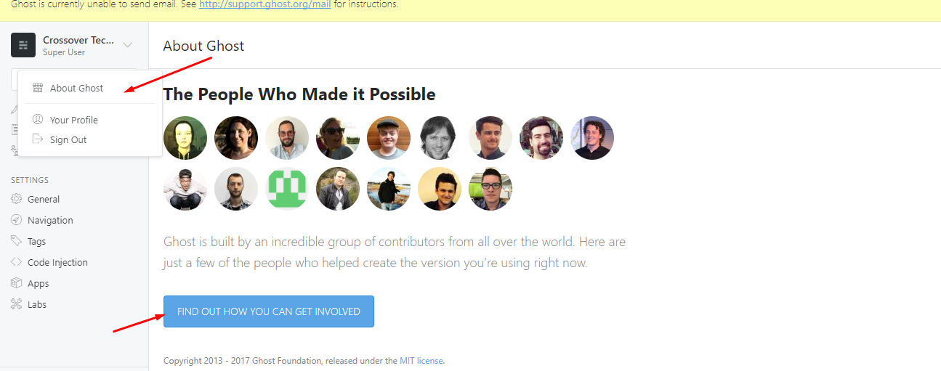

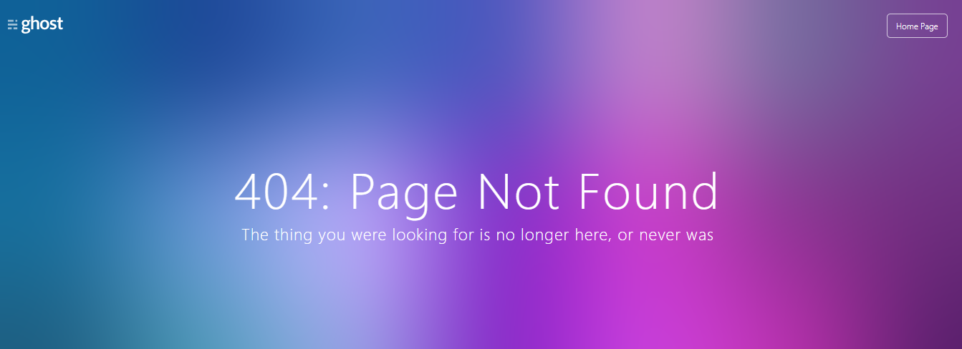

**Defect 7:**

**Priority: High**

**Severity: Critical**

**Issue Description:**

Invitation are not sent to Email id’s in Team Page

**Steps to Reproduce:**

1. Open the [Admin](http://localhost:2368/ghost/) Url in any browser and login.
2. Click on Team option
3. Click on Invite People and type in Email address and Role as Author in the pop up dialog Invite a New User.
4. Click on Send Invitation.

**Actual Result:**

Invitation is not sent to user email address. User is shown “Invitation not sent-Please try again” message.

**Expected Result:**

Invitation should be sent to specified email address and proper message should be displayed to user as “Invitation is sent”

**Screenshot:**

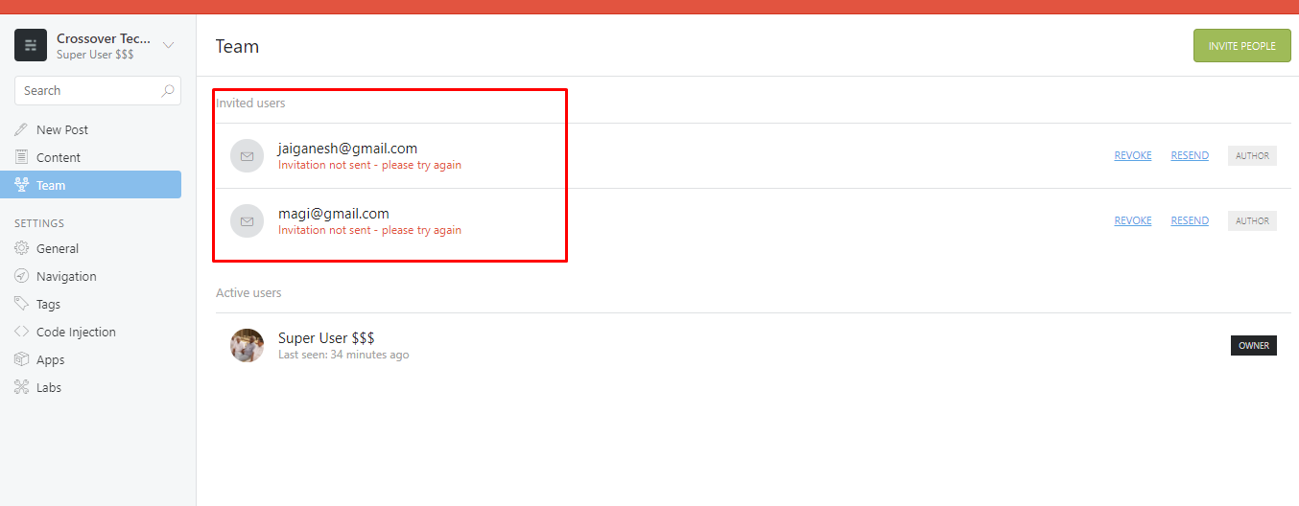

**Defect 8:**

**Priority:** High

**Severity**: Critical

**Issue Description:**

No action on clicking on Updated View Post pop up once post is updated.

**Steps to reproduce:**

1. Open the admin panel and login
2. Click on Content label and double click on any published post available.
3. Type in additional content to existing content.
4. Press on Update Post.
5. Click on “Updated View Post” message which appears at bottom of page.

**Actual Result:**

No action is performed on clicking on the Updated View Post.

**Expected Result:**

On Clicking on View Post user should be shown the updated view post in new tab.

**Screenshot:**

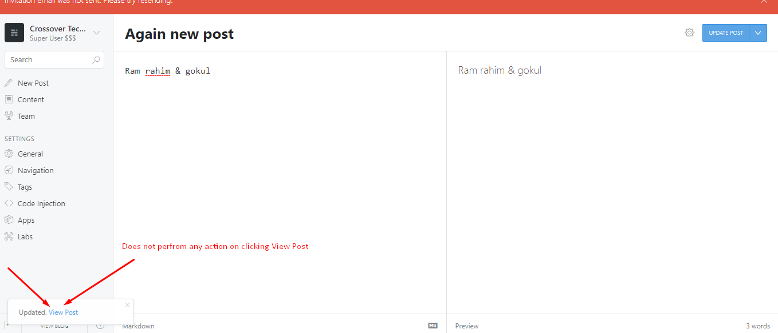

**Defect 9:**

**Priority:** High

**Severity**: Blocker

**Issue Description:**

No action on clicking on Published View Post pop up once post is published.

**Steps to reproduce:**

1. Open the admin panel and login.
2. Click on New Post and Type in Title name and content and Save Draft
3. Click on Publish Now and publish the post.
4. In the Pop up to bottom left, click on Published View Post.

**Actual Result:**

No action is performed on clicking on the published View Post.

**Expected Result:**

On Clicking on View Post user should be shown the Published view post in new tab.

**Screenshot:**

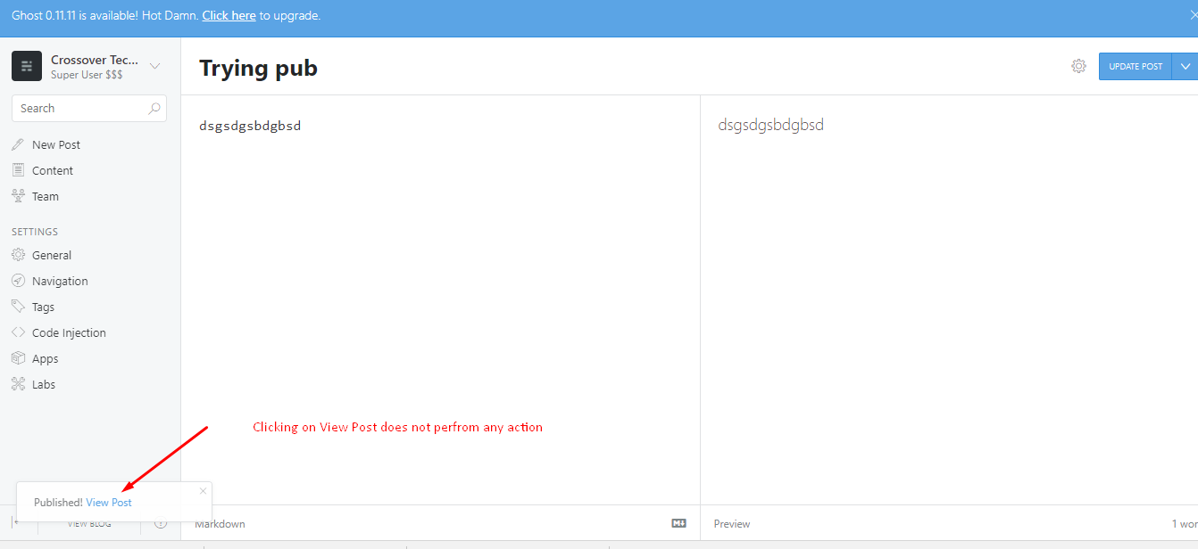

**Defect 10:**

**Priority:** High

**Severity**: Critical

**Issue Description:**

Send Email functionality in not working under Labs options of Admin Panel.

**Steps to reproduce:**

1. Login in to Admin Panel
2. Navigate to Labs -> Click on Send a test Mail Send Button

Actual Result:

User is thrown error message “Message could not be sent”.

Expected Result:

User should be sent a test mail to mail address specified.

**Screenshot:**

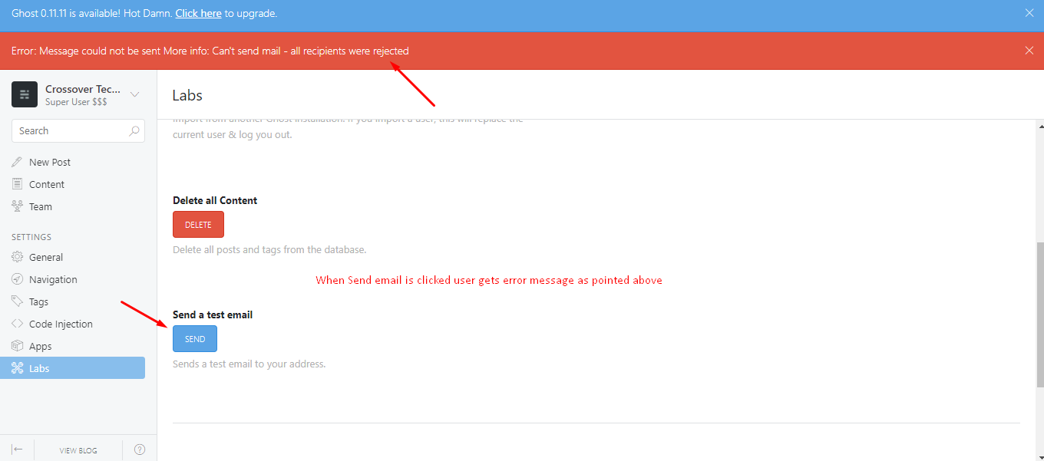

**Defect 11:**

**Priority:** Medium

**Severity**: Major

**Issue Description:**

Calendar pop up is not functional on clicking on Calendar icon in publish date settings options.

**Steps to reproduce:**

1. Login to Admin Panel.
2. Click on New Post, enter Title and enter some content.
3. Click on Post settings -> Click on Calendar Icon in Publish date.

**Actual Result:**

Calendar pop up is not displayed.

**Expected Result:**

Calendar pop up should be displayed and user should be able to select date from calendar pop up.

**Screenshot:**

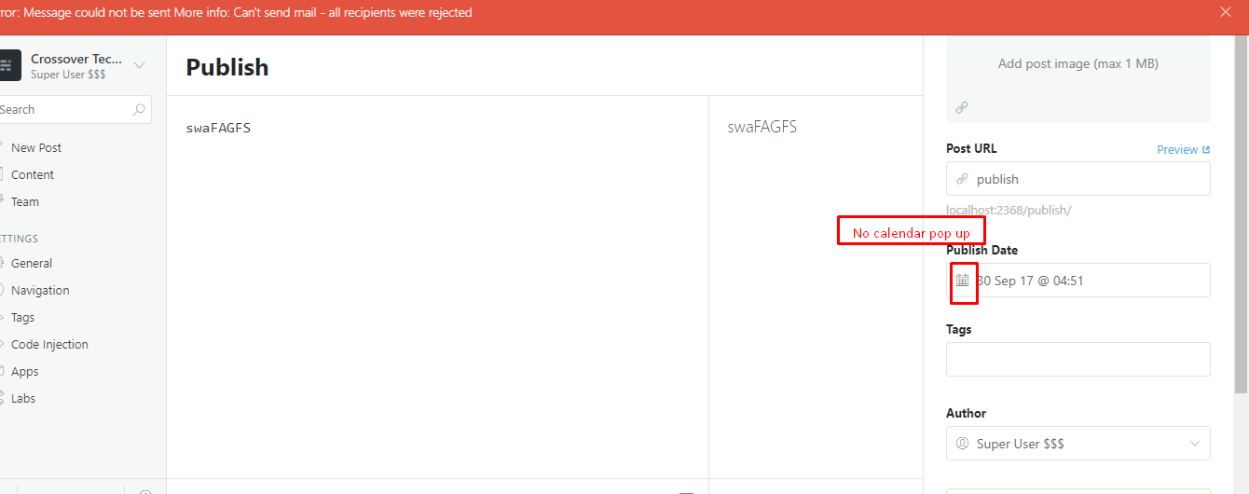

**Defect 12:**

**Priority: High**

**Severity: Critical**

**Issue Description:**

User is not sent slack notification.

**Steps to reproduce:**

1. Login to Admin Panel.
2. Click on Apps -> Enter webhook url “https://hooks.slack.com/services/dinesh”
3. Click on send test notification

**Actual Result:**

User is thrown message “Ghost is currently unable to send email.

**Expected Result:**

Notification should be received in slack.

