Webcam-Based Physical Activity Game Website: Evaluating Webcam Pose Estimation for Real-Time Game Control
Phanuphong Raksanit and Prawi Wongsawatsuriya
Department of Computer Science, Faculty of Liberal Arts and Science, Kasetsart University, Kamphaeng Saen Campus, Nakhon Pathom, Thailand; phanupong.ruk@ku.th, poravee.w@ku.th

Abstract—Exercise games that react to the whole body usually need a depth camera or motion controllers. "Webcam-Based Physical Activity Game Website" is a web application that recognises four body movements with an ordinary webcam and shows them as a character's actions in a three-lane scene: a side step moves the character to the left, centre or right lane, an overhead clap makes it jump, hands on hips raise a shield, and alternating knee lifts make it run. Pose estimation with MediaPipe Pose Landmarker runs entirely in the browser, so no video leaves the device. This paper describes the four movement detectors, which use only scale-invariant body measurements and a per-player lane calibration, and evaluates how accurately and how quickly they recognise the movements. In a single-participant study, the participant followed the application's Guide Mode, and the application scored each of the 50 prompted attempts as correct, incorrect or missed. The error rate was 44% overall (95% CI 31–58%) and 40–50% across the four movements. The response latency from detection to the displayed character action was 27 ms on average (31 ms at the 95th percentile) at 31 FPS. Most errors were a different movement being recognised, most often a knee lift (14 of 22 errors).
Keywords—exergame, web application development, pose estimation, MediaPipe, body movement recognition, latency

Introduction
Many people in Thailand are physically inactive, and average daily step counts are below the recommended level [1]. Active video games (exergames), which use body movement as game input, can raise heart rate and energy expenditure to levels comparable with moderate exercise [2], [3]. They usually depend on dedicated hardware: a depth camera, a console, or motion controllers. This limits who can play and where. Lightweight pose estimation models such as BlazePose can now track 33 body landmarks in real time on ordinary devices [4], which makes it possible to build an exergame that needs nothing more than a web browser and a webcam.
Detecting a pose is not the same as recognising a movement. A movement recogniser must respond to almost every performed movement, must not respond to anything else, and must do so within a fraction of a second, or the player feels the system ignoring them. The accuracy of MediaPipe Pose depends strongly on camera viewpoint and the exercise performed [5], and recent exergame research names the trade-off between accuracy and real-time responsiveness as an open challenge [6]. An earlier endless-runner exergame built on MediaPipe found its controls less responsive than intended but did not measure the delay [7].
To address this, our project created "Webcam-Based Physical Activity Game Website", a browser application that recognises four body movements and shows each one as an action of a 3D character, and measured how well its recognition works. Its salient features are:
- Four movements recognised from the webcam: side step (three lanes), overhead clap, hands on hips, and knee lifts
- Per-player lane calibration, so the lane boundaries follow how far this player actually steps
- Client-side pose processing, with no video sent to or stored on a server
- Guided practice with live text cues and rep counting, which also scores every prompted attempt automatically
- Live measurements of frame rate, inference time and response latency
The evaluation answers three research questions:
- RQ1: How accurately does the system recognise each of the four movements?
- RQ2: How fast does the character respond, and is the frame rate stable?
- RQ3: What kinds of errors occur: missed movements, wrong lane or wrong knee, or a different movement recognised?

Related Work
This section gives an overview of existing products and research on body-controlled exercise games. It begins with a comparison of systems that offer similar experiences, followed by a literature review of pose estimation accuracy and movement recognition.
Commercial exergames such as Ring Fit Adventure (Nintendo Switch) track the body with a hand-held controller and a leg strap. Kinect-based games used a dedicated depth camera that is no longer sold. Research prototypes have moved to RGB cameras. Törnquist [7] built an endless runner controlled by MediaPipe skeletal tracking in the Godot engine, and Wang et al. [8] built a knee-rehabilitation exergame on BlazePose. Table 1 compares them with this work.

Table 1. Feature comparison (verify every row except Wang et al. before submission)
Feature | Ring Fit Adventure | Kinect games | Törnquist [7] | Wang et al. [8] | Webcam-Based Physical Activity Game Website
Needs only a webcam | No | No | Yes | Yes | Yes
Runs in a web browser | No | No | No | No | Yes
Movements recognised | Several | Several | Runner controls | 7 exercises | 4 (3 lanes, clap, hips, knees)
Error rate reported per movement | n/a | n/a | No | Yes | Yes
Latency measured | n/a | n/a | Qualitative only | No | Yes

On the literature side, Biddiss and Irwin [2] and Peng et al. [3] showed that active video games increase physical activity relative to sedentary play. Walking-in-place techniques convert stepping on the spot into locomotion in virtual environments [9], and jogging in place is a physiologically meaningful exercise in its own right [10]. Dill et al. [5] compared MediaPipe Pose with a reference system for physical exercises and found high accuracy under favourable viewpoints that falls quickly when the camera angle or the exercise is less favourable. A follow-up study fused two cameras to reduce depth noise [11]. Wang et al. [8] reported 95.2% overall motion-recognition accuracy across seven rehabilitation exercises, measured by comparing recorded video with the system's output. Wang and Kong [12] proposed a pose-based algorithm for counting fitness-action repetitions, which is closely related to our rep counting. Phosanarack et al. [6] discuss smartphone exergames with markerless motion capture and identify the balance between accuracy and responsiveness as a central open problem, but report no measurements.
None of these works reports, per movement and under controlled conditions, how often a browser-based recogniser misses or confuses movements, or how long it takes to show the result. This is the gap Webcam-Based Physical Activity Game Website addresses.

Application Development and Pose Modeling

Architecture
Webcam-Based Physical Activity Game Website is a web application written in TypeScript (Next.js and React) with a Three.js character scene. All processing runs in the browser (Fig. 1). A pose loop runs once per decoded camera frame: the frame is passed to the pose model, the four detectors update, and their events and body readout are published. An application loop runs on every display refresh and uses these events to count guided repetitions, score trial attempts, animate the character and record measurements. Keeping the loops separate lets the character animate smoothly on 60 Hz displays even though the camera delivers about 24–30 frames per second. Video frames are never stored or transmitted.
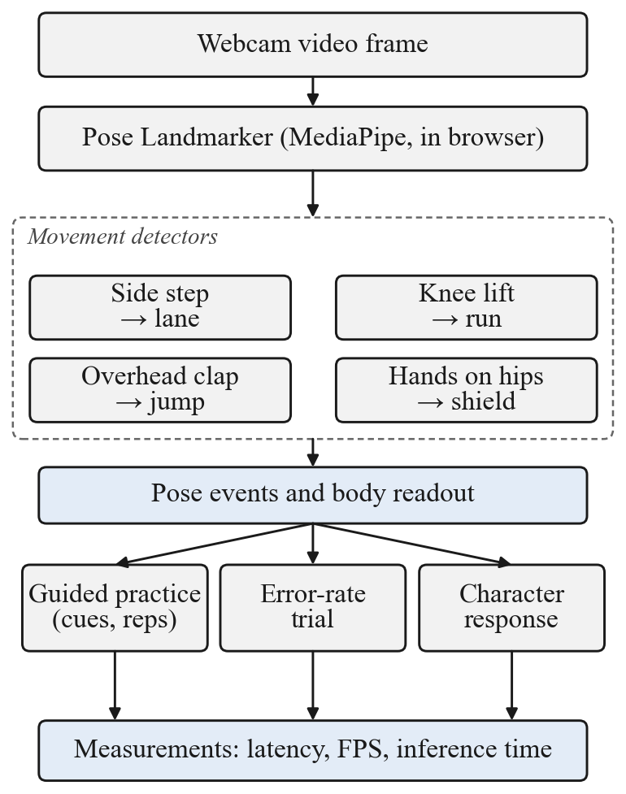
- System architecture: the webcam frame passes through the pose model and four movement detectors; their events drive guided practice, the error-rate trial, the character and the measurements.

Pose estimation model
The application uses MediaPipe Pose Landmarker [4] (Tasks Vision 1.0.1) in video mode with the lite model, detecting one person, with detection, presence and tracking confidence of 0.5. It prefers the GPU (WebGL) delegate and falls back to the CPU if the GPU delegate fails. Landmarks with a visibility below 0.5 are treated as missing. Every detector works on two body measurements derived from the shoulders and hips: the shoulder width and the torso length. Dividing by them makes the thresholds independent of how far the player stands from the camera.

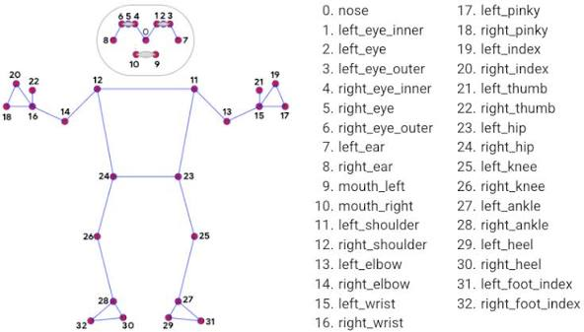

Movement detectors
Each detector is a pure function of the previous state, the landmarks and the time, so it can be tested without a browser. Table 2 gives the signals and the parameters used.

Table 2. Movements, character responses and detector parameters
Movement | Character response | Measured signal | Main thresholds | Timing
Side step (three lanes) | Moves to the LEFT, CENTRE or RIGHT lane | Offset of the shoulder-weighted body midline from the calibrated centre, in shoulder widths | Enter 0.5, exit 0.3; per player, enter = 0.55 × the first measured reach (0.3 to 0.75) | 1 s calibration; smoothing 0.35
Knee lift | Runs | Height difference of the two knees, in torso lengths | Cross 0.025; each phase must peak at 0.05 | Smoothing 0.65; 2 steps within 2.5 s; released after 1.5 s
Overhead clap | Jumps | Distance between the wrists, in shoulder widths, with both wrists above the shoulders | Raised by 0.4 torso; closed at 0.45; open at 0.8 | Open for 120 ms to arm; closed for 40 ms to fire
Hands on hips | Raises a shield while held | Wrist distance to its own hip, in torso lengths; elbow offset from the midline, in shoulder widths | Wrist within 0.5; elbow out by 0.25 | Held 300 ms to raise; broken 250 ms to drop

Side step. The lateral centre of the body is a weighted midline, x = w·x_shoulders + (1 − w)·x_hips, with w = 0.7. The pelvis sways sideways on every step while the shoulders stay close to the body axis, so weighting the shoulders keeps knee lifts from being read as lateral movement. During a 1 s stand-still the detector learns the centre. A signed hysteresis then sets the label: the offset must exceed the enter threshold to commit to LEFT or RIGHT and must fall back inside the exit threshold on the same side to return to CENTRE. The first excursion to each side records how far this player actually steps, and that side's enter threshold becomes 0.55 of it (clamped to 0.3–0.75 shoulder widths). The camera view draws the resulting lane lines. A lean and a full step both move the midline, so either can be used.
Knee lift. The detector uses the difference between the two knees, not the height of either knee alone, as in jogging-in-place detection [10]. Symmetric motions such as squatting or camera shake cancel out in the difference, while alternating knee lifts do not. A switch of the higher knee counts as a step only if the preceding phase peaked above the noise gate. The player counts as running while at least two steps fall within 2.5 s at a cadence between 40 and 300 steps/min. During guided practice, steps are counted per knee, and a rep is the prompted knee.
Overhead clap. A clap is an edge from open to closed above the head, never an arm raise. The hands must first be at least 0.8 shoulder widths apart for 120 ms, which arms the detector; both wrists must then be at least 0.4 torso lengths above the shoulder line and come within 0.45 shoulder widths of each other for 40 ms. The detector disarms after each clap.
Hands on hips. The pose is detected when each wrist is close to its own hip and the elbow sits further from the body midline than the wrist, which separates it from arms hanging down. Resting hands cover the hips, so this detector reads its landmarks at a lower visibility floor (0.3) and reuses the last good hip positions for up to 1.5 s. The pose is a held state: it is raised after 300 ms and dropped 250 ms after it breaks.

Guided practice and character response
Guided Mode runs a 20-minute session through the four movements in a randomised order with five or ten repetitions each, 3 s transitions, 20 s rests and automatic rounds. The screen shows the camera with the skeleton and the lane lines, the 3D character and a movement guide (Fig. 2). Rep rules follow each movement: a side-step rep is centre, prompted side, back to centre, alternating sides; a knee rep needs the prompted knee after the other; a clap rep needs the hands to separate again; a hip rep needs the hands to be down first. Cues are updated live, for example "Move Left", "Return to Centre", "Separate Your Hands" or "Lift Left Knee".

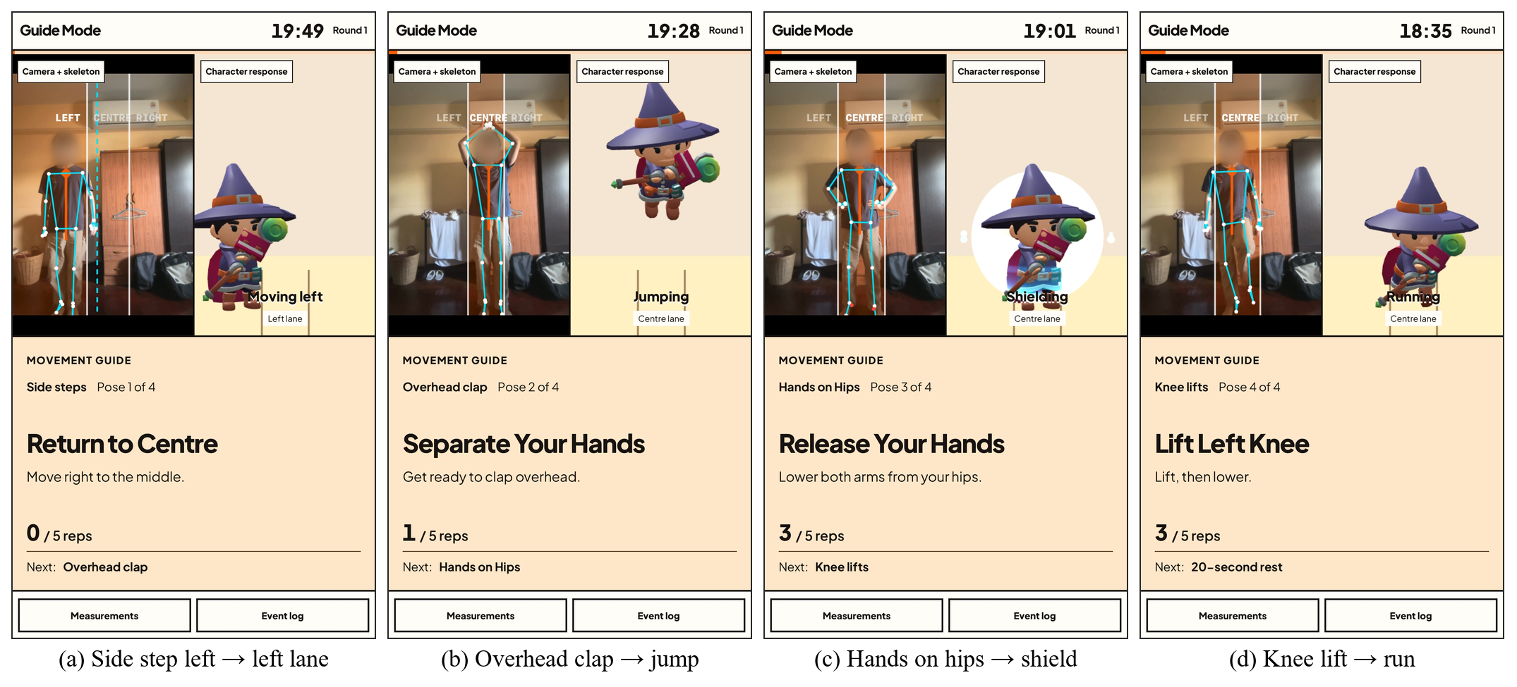
- Guide Mode screenshots (face blurred): (a) side step left moves the character to the left lane, (b) overhead clap makes it jump, (c) hands on hips raise the shield, (d) knee lifts make it run.

Built-in evaluation instruments
The application contains two instruments used in the evaluation. Guide Mode scores every cue it shows as one prompted attempt, which gives the detectors an external ground truth so that the detector is not its own reference. The Measurements panel shows the pose and render frame rates, the processing and inference times, and the response latency, which is the time from the start of processing the camera frame in which a movement was detected to the first game frame that renders the response, summarised as mean and 95th percentile (P95) per movement. Camera capture and display delays are not included.

Application and Model Testing

Participant and apparatus
The participant was one adult, 168 cm tall, who was also one of the authors. The apparatus was an iPhone 14 (Apple A15 Bionic), running Google Chrome (latest version) with the iPhone 14 built-in camera at 480 × 640 px (portrait), mounted 0.5 m above the floor, on application version 2.39.0-alpha.0. All thresholds were left at their default values and were not tuned during data collection.

Design
The study was a single Guide Mode session under normal room lighting. The participant followed the live cues for two rounds of five repetitions of each movement. A side-step repetition has two cues, out to the prompted lane and back to the centre, so the session gave 50 scored attempts: 20 side steps and 10 each of knee lifts, overhead claps and hands on hips. The application randomised the order of the movements and the first side. Before the session the lane centre was calibrated while standing still.

Scored attempts
In Guide Mode every cue is one attempt and is scored once (Table 3). An attempt is correct if the prompted movement is detected inside a 5 s window, incorrect if a different movement or the wrong lane or knee is detected first, and missed if nothing is detected before the window closes. A matching detection in the same frame wins over a wrong one. An attempt cut off by lost tracking, a pause, a skip or a cue change is voided and not scored.

Table 3. Prompts and scoring in Guide Mode
Movement | Prompt | Correct when
Side step | Alternating LEFT and RIGHT lane, with a return to CENTRE between prompts | The lane label reaches the prompted lane
Knee lift | Alternating left and right knee | The prompted knee becomes the higher knee
Overhead clap | Clap | A clap is detected
Hands on hips | Hands on hips, starting with the hands down | The held pose is raised

Metrics
- Error rate (RQ1): (missed + incorrect) / attempts, per movement, with a 95% Wilson confidence interval. The application's own pass criterion is an error rate of at most 10%.
- Error type (RQ3): the split between missed movements, wrong lane or wrong knee, and a different movement recognised.
- Response latency (RQ2): mean and P95 per movement.
- System performance (RQ2): pose and render FPS, inference and processing time, and body-loss incidents.
Results are descriptive: with one participant, one session and 10 to 20 attempts per movement, no inferential test is applied.

Results
The session produced 50 scored attempts, of which 28 were correct (Table 4). The overall error rate was 44% (95% CI 31–58%), above the 10% pass criterion, and no movement passed. The error rate was 45% for side steps, 50% for knee lifts and 40% for overhead claps and for hands on hips. With 10 to 20 attempts per movement the confidence intervals overlap widely, so the movements cannot be ranked reliably.
Table 4. Scored attempts per movement in the Guide Mode session
Movement | Correct | Error rate, % (95% CI) | Missed / wrong / other
Side step | 11 of 20 | 45 (26–66) | 0 / 0 / 9
Knee lift | 5 of 10 | 50 (24–76) | 0 / 1 / 4
Overhead clap | 6 of 10 | 40 (17–69) | 0 / 0 / 4
Hands on hips | 6 of 10 | 40 (17–69) | 0 / 0 / 4
All | 28 of 50 | 44 (31–58) | 0 / 1 / 21
Table 5. Detection-to-render latency per movement
Movement | Detections | Mean (ms) | P95 (ms)
Side step | 43 | 26.8 | 30
Knee lift | 46 | 27.0 | 31
Overhead clap | 10 | 26.6 | 30
Hands on hips | 10 | 28.7 | 44
All | 109 | 27.1 | 31
1. Recognition accuracy (RQ1): knee lifts had the highest error rate (5 of 10 correct) and overhead claps and hands on hips the lowest (6 of 10 correct each), but the difference is within what 10 attempts can show (Table 4, Fig. 4).
2. Latency and frame rate (RQ2): detection-to-render latency was 27 ms on average (P95 31 ms, maximum 59 ms, 109 detections), well below the 100 ms often cited for perceived immediacy (Table 5, Fig. 5). Pose estimation ran at 31 FPS and rendering at 75 FPS, with an inference time of 25 ms per frame. Tracking was lost twice during the session.
3. Error types (RQ3): no attempt was missed. Of 22 errors, 21 were a different movement recognised first and one was the wrong knee (Fig. 6). A knee lift was the movement detected in 14 of the 21: all 9 side-step errors, 2 of the 4 hands-on-hips errors and 3 of the 4 clap errors. The other errors were a side step detected instead of a knee lift (4), of hands on hips (2) or of a clap (1).
In an earlier pilot, the Measurements panel of a smartphone session (model lite, GPU delegate, 480×640 camera, version 2.37.2-alpha.0) showed 24 pose FPS and 24 render FPS, 35 ms inference, 36 ms processing, and a response latency of 32 ms mean and 38 ms P95 (Fig. 3). This is a single snapshot taken before the scored session.
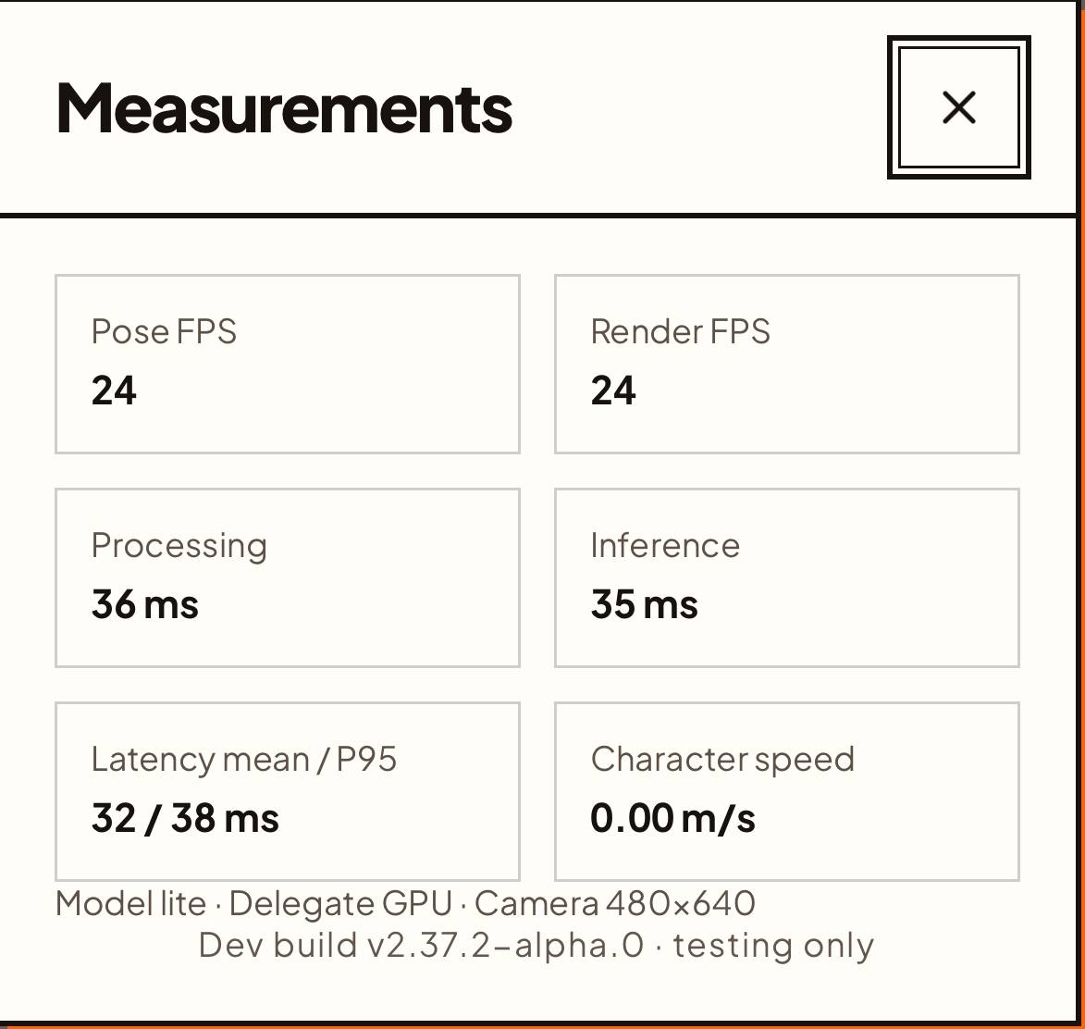
- Measurements panel during a pilot smartphone session.
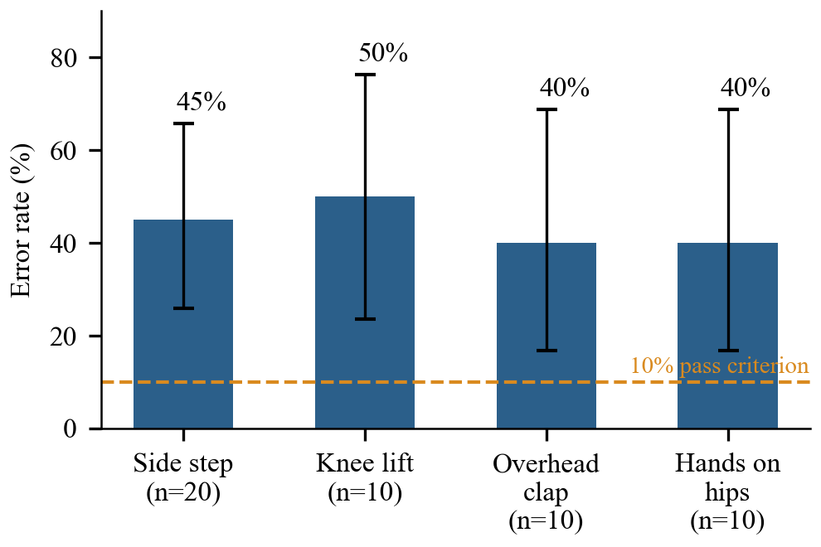
- Error rate per movement with 95% Wilson confidence intervals; the dashed line is the 10% pass criterion.
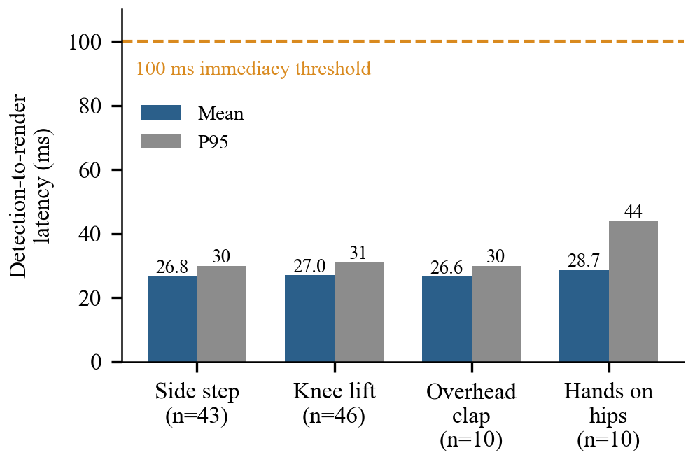
- Detection-to-render latency per movement (mean and P95); n is the number of detections.
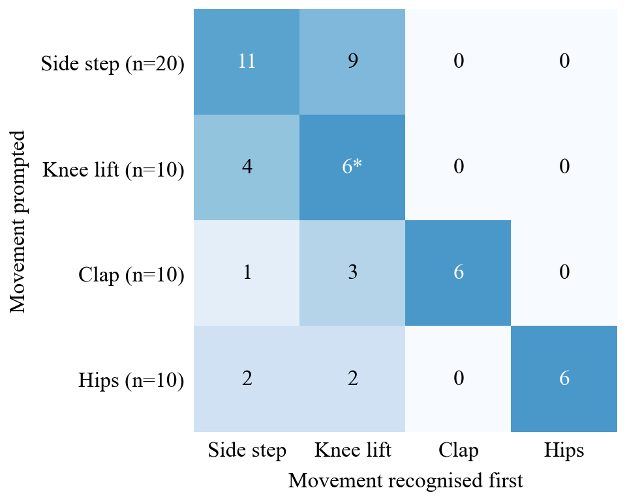
- Prompted versus first-recognised movement for the 50 scored attempts (counts). *5 correct and 1 wrong-knee error.

Discussion
The system does not yet meet the 10% pass criterion. The overall error rate was 44% (95% CI 31–58%), and no movement passed, whereas Wang et al. [8] report 95.2% per-motion accuracy, although their task and measurement differ. The errors were not missed movements: none of the 50 attempts was missed. Instead, 21 of the 22 errors were a different movement recognised first, and 14 of these were knee lifts, which fired during side steps (all 9 side-step errors), hands on hips and claps. The detectors therefore respond reliably but too eagerly, and the knee-lift detector is the main source of false recognitions. Because distance and viewpoint were not varied, this study cannot show whether normalising by body size protects against the viewpoint sensitivity reported in [5].
Hands on hips, which hides the hips from the camera, was recognised in 6 of 10 attempts. Its four errors were a side step (2) or a knee lift (2), never a clap, but with ten attempts we cannot tell whether the lower visibility floor and the hold of the last hip positions helped. Responsiveness was not the limiting factor. The mean detection-to-render latency was 27 ms (P95 31 ms), well under the 100 ms often cited for perceived immediacy, whereas Törnquist [7] reported poor responsiveness without measuring it. Camera capture and display delay are not included, so the delay the player feels is somewhat longer.
The results point to a clear next step: make the knee-lift detector less eager while a side step or clap is in progress, then repeat the session to check that the error rate falls. Detector thresholds were left at their defaults in this study, so the 44% error rate is a baseline, not a tuned result.
Limitations. There was only one participant, who was also an author and knew the prompts, so the results describe the system under favourable, motivated use and do not generalise to a population. Guide Mode scores recognition of the prompted movement but does not check that the participant performed it correctly, and it counts false detections only inside the attempt windows, not during rests and transitions. The response latency starts when a camera frame is processed, so it excludes camera capture and display delay and underestimates the delay the player feels. Only one device, one camera, one camera height and one session were tested. Detector thresholds were not optimised.

Conclusion
Webcam-Based Physical Activity Game Website shows that four body movements, namely side steps across three lanes, an overhead clap, hands on hips and knee lifts, can be recognised from an ordinary webcam inside a web browser, without sending video to a server. In a single guided session, the error rate was 44% overall (40–50% per movement), the character responded within 27 ms on average (31 ms at P95) at 31 FPS, and most errors were a different movement being recognised, most often a knee lift. Future work will test more participants and devices, add the motivation study from the project proposal, and tune the detection thresholds to each player.

References
- Topothai et al., study of daily step counts in the Thai population, 2020. (Cited as Topothai et al. (2020) in the project proposal; add the full citation.)
- E. Biddiss and J. Irwin, "Active video games to promote physical activity in children and youth: A systematic review," Arch. Pediatr. Adolesc. Med., vol. 164, no. 7, pp. 664–672, 2010.
- W. Peng, J.-H. Lin, and J. Crouse, "Is playing exergames really exercising? A meta-analysis of energy expenditure in active video games," Cyberpsychol. Behav. Soc. Netw., vol. 14, no. 11, pp. 681–688, 2011.
- V. Bazarevsky, I. Grishchenko, K. Raveendran, T. Zhu, F. Zhang, and M. Grundmann, "BlazePose: On-device real-time body pose tracking," arXiv:2006.10204, 2020.
- S. Dill et al., "Accuracy evaluation of 3D pose estimation with MediaPipe Pose for physical exercises," Current Directions in Biomedical Engineering, 2023.
- M. Phosanarack, L. Wallard, S. Lepreux, C. Kolski, and E. Avril, "Smartphone exergames with real-time markerless motion capture: Challenges and trade-offs," in CHI '25 Workshop on Envisioning the Future of Interactive Health, arXiv:2507.06669, 2025.
- E. Törnquist, "Design and implementation of an endless runner as an exergame," B.Sc. thesis, Dept. Comput. Inf. Sci., Linköping Univ., Linköping, Sweden, LIU-IDA/LITH-EX-G--22/048--SE, 2022.
- G. Wang et al., "Design and evaluation of an exergame system to assist knee disorders patients' rehabilitation based on gesture interaction," Health Inf. Sci. Syst., vol. 10, no. 1, art. 20, 2022, doi: 10.1007/s13755-022-00189-5.
- J. Lee, S. C. Ahn, and J.-I. Hwang, "A walking-in-place method for virtual reality using position and orientation tracking," Sensors, vol. 18, no. 9, p. 2832, 2018.
- N. M. Papazoglou, E. S. Kolokouri-Dervou, P. A. Viaros, S. V. Vassiliou, and G. A. Korkodilos, "Jogging in place: A valid alternative to multistage exercise testing," Am. J. Cardiol., vol. 61, no. 13, pp. 1146–1147, 1988.
- S. Dill et al., "Accuracy evaluation of 3D pose reconstruction algorithms through stereo camera information fusion for physical exercises with MediaPipe Pose," Sensors, vol. 24, no. 23, p. 7772, 2024.
- M. Wang and W. Kong, "Fitness action counting algorithm based on pose estimation," in Proc. 2024 7th Int. Conf. Artificial Intelligence and Pattern Recognition (AIPR), ACM, 2025, doi: 10.1145/3703935.3704003.

