DESIGN AND ANALYSIS OF ALGORITHMS
ASSIGNMENT 1
Design, Analyse and Validate an Efficient Search Strategy for a Large-Scale Student Record System

Field | Details
Student Name | JAGARAJUPALLI BHANUPRAKASH REDDY
Registration Number | 192524171
Group | A
Programming Language | Python
Personal Dataset Seed | 4171
Mandatory Algorithms | Linear Search; Recursive Binary Search
Group-A Algorithm | Hash Table
Submission Format | Microsoft Word (.docx)
Evidence Timestamp | 2026-10-06 21:37:03 IST
GitHub Repository Link:
[https://github.com/JagarajupalliBhanuprakashReddy/DAA-C0-1-AT-1]
Prepared for CO1: Algorithm fundamentals, efficiency analysis, asymptotic analysis, mathematical analysis and recurrence analysis.
Total Marks: 50

1. Problem Statement and Design Context
The university maintains a large academic database in which each student record is identified by a unique Registration Number. The system must determine whether a requested registration number exists and retrieve the corresponding record. The database may grow from 1,000 to 10,000, 100,000 and 1,000,000+ records.
The design must remain practical as the database grows, and any preprocessing such as sorting or restructuring must be included in the efficiency analysis.
The later design challenge changes the operating condition to 50,000 search requests per hour on 1,000,000 records, while new records are added only once per day. This update makes the relationship between preprocessing cost and repeated search cost central to the final design decision.

Student-Specific Experimental Configuration
Item | Value
Registration number | 192524171
Random seed | 4171
Required found key | 192524171
Required not-found key | 192524172
Group | A
Third strategy | Hash Table
Dataset sizes | 1,000; 10,000; 100,000; 1,000,000

Task 1 – Design the Algorithm
Three meaningfully different strategies are selected. Linear Search is iterative, Recursive Binary Search is recursive and relies on ordered data, and Hash Table Search uses a restructuring/indexing strategy that supports expected constant-time lookup.

Algorithm 1: Linear Search
Basic idea: inspect registration numbers sequentially from the first record until the requested key is found or the entire collection has been exhausted.
- Design strategy: sequential/iterative search.
- Preprocessing: none.
- Why selected: it provides the baseline against which the more scalable strategies can be evaluated.
LINEAR_SEARCH(A, key)
1. for i ← 0 to n − 1
2. if A[i] = key
3. return FOUND
4. return NOT_FOUND

Algorithm 2: Recursive Binary Search
Basic idea: first sort the registration numbers. At each recursive call, compare the key with the middle element and discard half of the remaining search interval.
- Design strategy: divide-and-conquer.
- Preprocessing: sorting the records, costing Θ(n log n) with Python's comparison sort.
- Why selected: it demonstrates a recursive divide-and-conquer strategy and provides logarithmic search after ordering.
BINARY_SEARCH(A, key, low, high)
1. if low > high
2. return NOT_FOUND
3. mid ← floor((low + high) / 2)
4. if A[mid] = key
5. return FOUND
6. if A[mid] < key
7. return BINARY_SEARCH(A, key, mid + 1, high)
8. else
9. return BINARY_SEARCH(A, key, low, mid − 1)

Algorithm 3: Hash Table Search – Group A
Basic idea: build a hash-table-backed index containing the registration numbers. A lookup hashes the requested key and checks the corresponding location. In Python, the set data structure provides the required hash-table-based membership operation.
- Design strategy: hashing/indexing.
- Preprocessing: construct a set from the records, Θ(n) expected time.
- Why selected: Group A is assigned Hash Table by the submission rules, and the low update frequency makes a reusable index particularly attractive for a large number of searches.
BUILD_HASH_INDEX(A)
1. H ← empty hash table
2. for each x in A
3. insert x into H
4. return H
HASH_SEARCH(H, key)
1. if key ∈ H
2. return FOUND
3. return NOT_FOUND
Design rationale: the three approaches differ in their underlying strategy rather than merely using iterative versus recursive versions of the same algorithm.

Task 2 – Identify the Basic Operation
Algorithm | Basic operation | Where it occurs | Why it dominates
Linear Search | Equality comparison A[i] == key | Inside the sequential loop | Each examined record causes one key comparison; the count can grow directly with n.
Recursive Binary Search | Middle-element comparison A[mid] == key (and ordering comparison) | At each recursive level | Each call removes roughly half the remaining records, so the number of levels grows logarithmically.
Hash Table | Hash-table membership/probe for key ∈ H | During each lookup | The index is consulted directly; expected work per lookup remains approximately constant as n grows.
For experimental comparison, the linear and binary implementations explicitly count key comparisons. Hash-table lookup is treated as one high-level membership operation because the collision-resolution details are handled internally by Python's set implementation.

Task 3 – Derive the Time-Complexity Function Mathematically

3.1 Linear Search
Let n be the number of records. For an unsuccessful search, every record is examined, so the number of equality comparisons is C_L(n) = n. Therefore:
C_L(n) = n
T_L(n) = c0 + c1 n
Therefore T_L(n) = Θ(n)
If the key is uniformly successful, the expected position is:
E[C_L(n)] = (1 + 2 + ... + n) / n
= [n(n + 1)/2] / n
= (n + 1)/2
So the average successful search is also Θ(n).

3.2 Recursive Binary Search
After sorting, a recursive call continues with approximately half the current interval. If the current input size is n, the recursive subproblem has size floor(n/2), and only constant work c is performed outside the recursive call:
T_B(n) = T_B(floor(n/2)) + c
T_B(1) = c
The preprocessing cost is:
P_B(n) = Θ(n log n)
Therefore, for one search including preprocessing:
T_total,B(n) = Θ(n log n) + Θ(log n)
= Θ(n log n)
For Q searches after one preprocessing step:
T_total,B(n,Q) = Θ(n log n) + Θ(Q log n).

3.3 Hash Table
Building the hash index inserts n records. Assuming expected constant-time insertion, the expected preprocessing cost is:
P_H(n) = c1 + c1 + ... + c1 (n insertions)
= c1 n
= Θ(n)
Expected search:
S_H(n) = c2 = Θ(1)
For Q searches using the same index:
T_total,H(n,Q) = Θ(n) + Θ(Q)
= Θ(n + Q) expected.
Worst-case hashing with severe collisions can degrade toward Θ(n), but this is not the expected behaviour of a well-designed hash table.
The experimental benchmark therefore reports both preprocessing time and lookup time so that the indexing cost is not hidden.

Task 4 – Best, Average and Worst-Case Behaviour
Algorithm | Best case | Average case | Worst case | Reason
Linear Search | 1 comparison: key is first. | ≈(n+1)/2 successful comparisons. | n comparisons: key absent or last. | The algorithm examines records sequentially and cannot skip records.
Recursive Binary Search | 1 comparison: key is at middle. | Θ(log n). | ⌊log2 n⌋+1 comparisons. | Each comparison discards about half the remaining interval.
Hash Table | Expected Θ(1) lookup. | Expected Θ(1) lookup. | Potential Θ(n) under extreme collisions. | Hashing normally maps the key directly to a small number of candidate locations; pathological collisions can cause degradation.
For this experiment, the not-found key REG+1 is deliberately used for the large-scale benchmark. This creates a strong and reproducible worst-case test for Linear Search and a logarithmic unsuccessful-search test for Binary Search.

Task 5 – Perform Asymptotic Analysis
n | Linear worst comparisons | Binary worst comparisons | Hash expected lookup operations
1,000 | 1,000 | 10 | ≈1
10,000 | 10,000 | 14 | ≈1
100,000 | 100,000 | 17 | ≈1
1,000,000 | 1,000,000 | 20 | ≈1
Asymptotically:
- Linear Search: O(n), Ω(1), Θ(n) for worst/typical growth; the worst-case upper bound grows directly with the number of records.
- Recursive Binary Search: O(log n), Ω(1), Θ(log n) for search after sorting.
- Hash Table: expected O(1), expected Ω(1), expected Θ(1) per lookup; preprocessing is expected Θ(n).
From 1,000 to 1,000,000 records, linear search increases its worst-case comparison count from 1,000 to 1,000,000. Binary search rises only from about 10 to 20 worst-case comparisons. Expected hash lookup remains approximately constant, although its index-building cost increases linearly.

Task 6 – Formulate the Recurrence Relation
The recursive approach is Recursive Binary Search. The original input has size n. After comparing the middle element, exactly one recursive subproblem remains, with size approximately n/2. The work outside the recursive call consists of a constant number of arithmetic, indexing and comparison operations.
Recurrence component | Binary-search interpretation
Original problem | n ordered records in the current interval
Recursive subproblem | floor(n/2) records
Number of recursive calls | 1
Work outside recursive call | constant c
Base case | n ≤ 0 / empty interval, or a one-element interval
Recurrence | T(n) = T(floor(n/2)) + c
T(n) = T(floor(n/2)) + c
T(1) = c

Task 7 – Solve the Recurrence Relation
The iteration method is appropriate because every recursive level reduces the problem size by approximately a factor of two and performs constant additional work.
T(n) = T(n/2) + c
= [T(n/4) + c] + c
= T(n/4) + 2c
= T(n/8) + 3c
...
= T(n/2^k) + kc
Stop when n/2^k = 1.
Thus 2^k = n and k = log2(n).
Therefore:
T(n) = T(1) + c log2(n)
= c + c log2(n)
= Θ(log n).
This result explains why the number of recursive binary-search comparisons remains very small even when the database grows to one million records.

Task 8 – Implement and Test the Algorithms
The implementation was written in Python. The benchmark uses the same deterministic, seed-controlled data generation process for all three strategies. The student's registration number is included as the required found key, and REG+1 is used as the required not-found key.
The benchmark measures search time with Python's high-resolution performance counter and separately measures preprocessing for Binary Search (sorting) and Hash Table (set construction).

Correctness test output
Test | Result | Operations / comparisons
Linear found | FOUND | 1
Linear not found | NOT FOUND | 10000
Binary found | FOUND | 11
Binary not found | NOT FOUND | 13
Hash found | FOUND | 1
Hash not found | NOT FOUND | 1
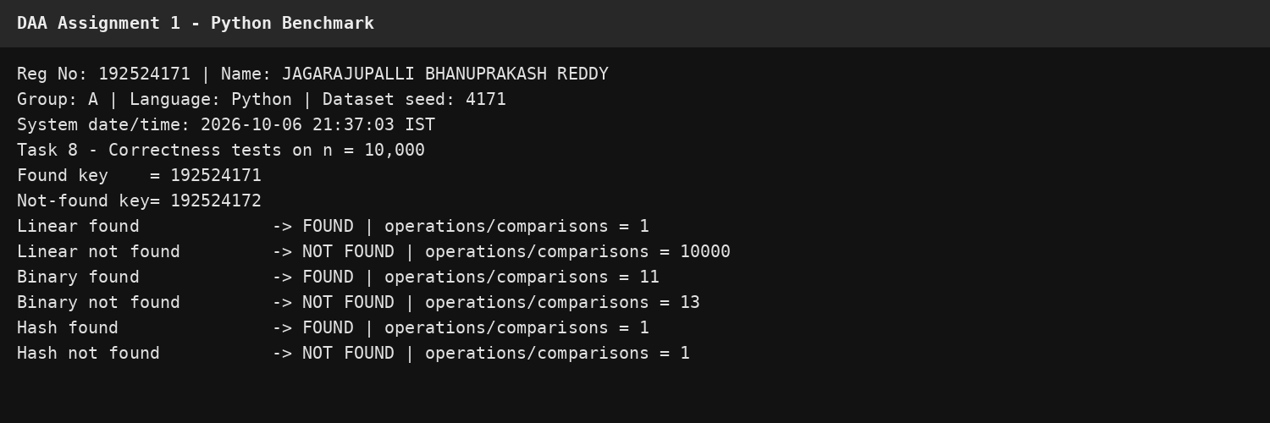
Figure 8.1: Correctness-test terminal output with student identity and timestamp.

Task 9 – Record Experimental Performance
The required dataset sizes are 1,000, 10,000, 100,000 and 1,000,000 records. The following table is generated from the student's deterministic dataset with seed 4171. Search time is the median of seven measurements for each lookup. Preprocessing is reported separately.
n | Linear search ms | Linear cmp | Binary sort ms | Binary search µs | Binary cmp | Hash build ms | Hash lookup µs
1,000 | 0.028192 | 1,000 | 0.057988 | 1.773000 | 10 | 0.024176 | 0.180000
10,000 | 0.287494 | 10,000 | 0.685355 | 1.873000 | 13 | 0.119400 | 0.170000
100,000 | 3.057436 | 100,000 | 5.972067 | 2.323000 | 16 | 4.767258 | 0.190000
1,000,000 | 30.930983 | 1,000,000 | 127.551111 | 2.815000 | 20 | 43.690414 | 0.200000
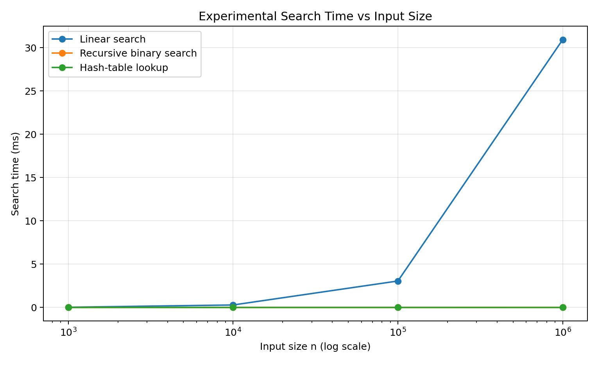
Figure 9.1: Experimental search-time comparison generated from the benchmark results.
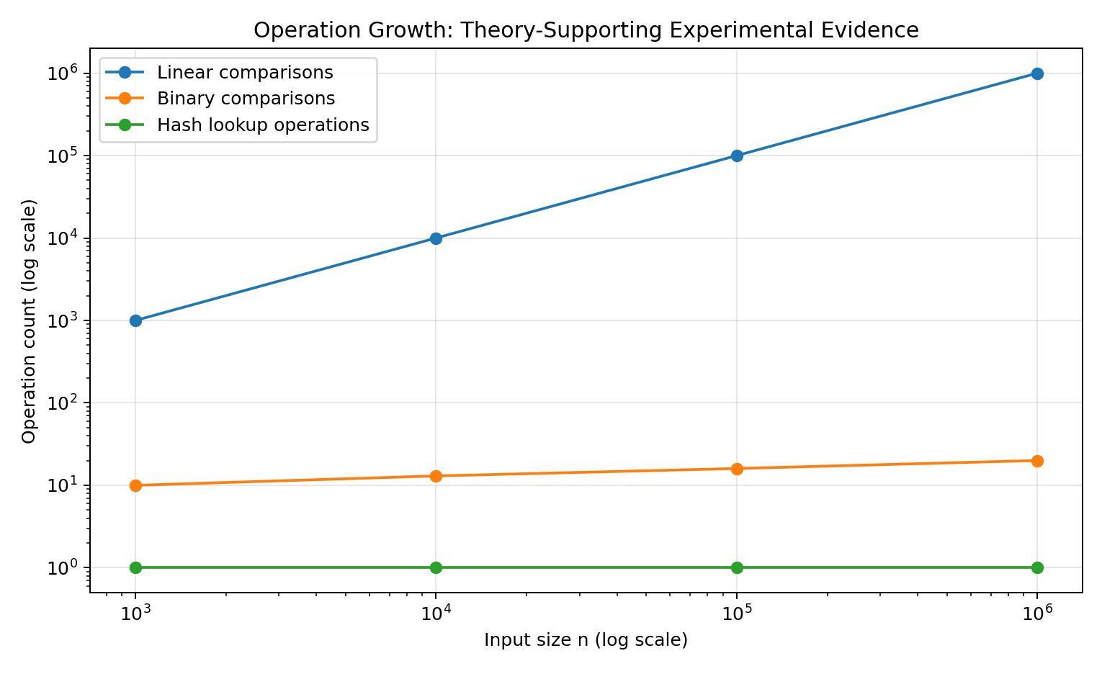
Figure 9.2: Operation-count growth generated from the same experimental data.
All graphs were generated from the benchmark's own results.csv file. The 1,000,000-record result is included rather than extrapolated.
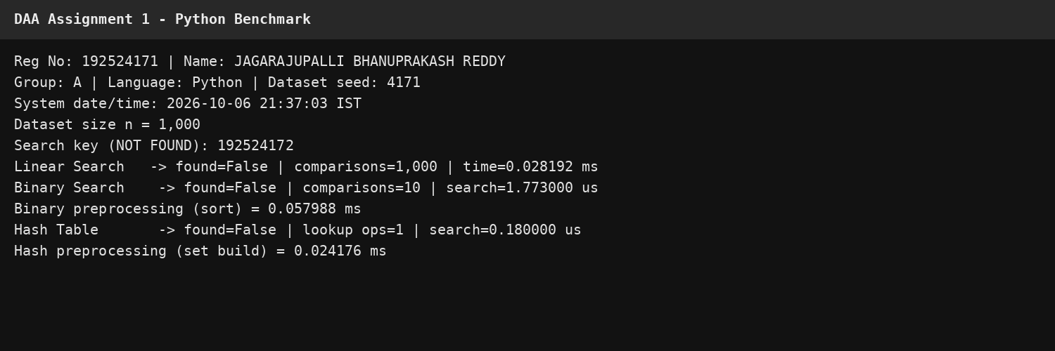
Figure 9.3: Terminal evidence for n = 1,000.
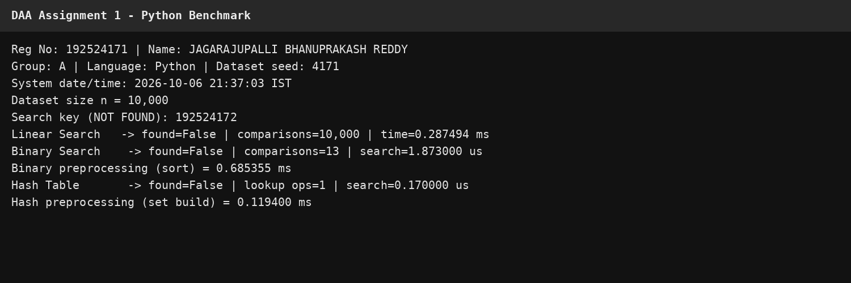
Figure 9.4: Terminal evidence for n = 10,000.
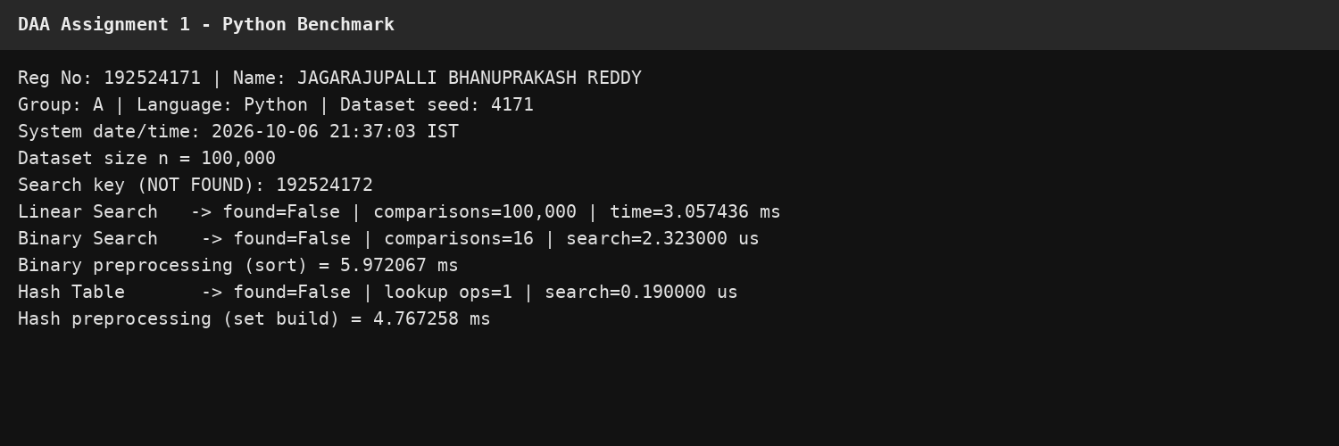
Figure 9.5: Terminal evidence for n = 100,000.
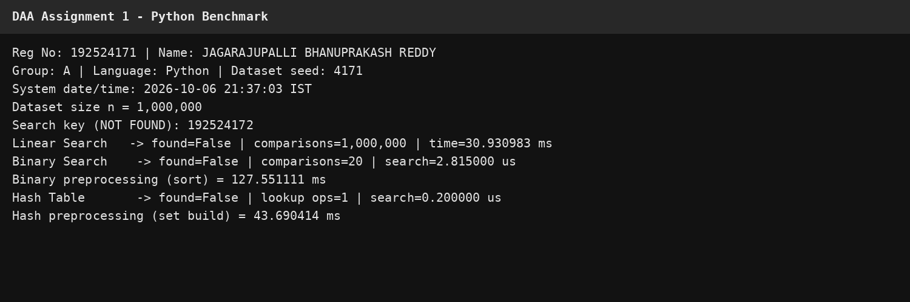
Figure 9.6: Terminal evidence for n = 1,000,000.

Task 10 – Compare Theory with Experimental Behaviour
The experimental trend agrees with the theoretical growth rates. Linear Search shows an approximately proportional increase in search time and exactly n comparisons for the deliberately absent key. Recursive Binary Search performs only about log2(n) comparisons; the measured search time remains in the microsecond range even at one million records. Hash-table lookup remains approximately constant for a single membership operation, while the one-time index construction grows with n.
Observation | Theory | Experimental evidence | Interpretation
Linear | Θ(n) | 1000 → 1000000 comparisons | Direct linear growth is visible.
Binary | Θ(log n) search | 10 → 20 comparisons | Only about 10 additional levels are needed when n grows by 1000×.
Hash | Expected Θ(1) lookup + Θ(n) build | 0.200 µs lookup; build 43.690 ms at 1M | The cost shifts from repeated searching to one reusable index.
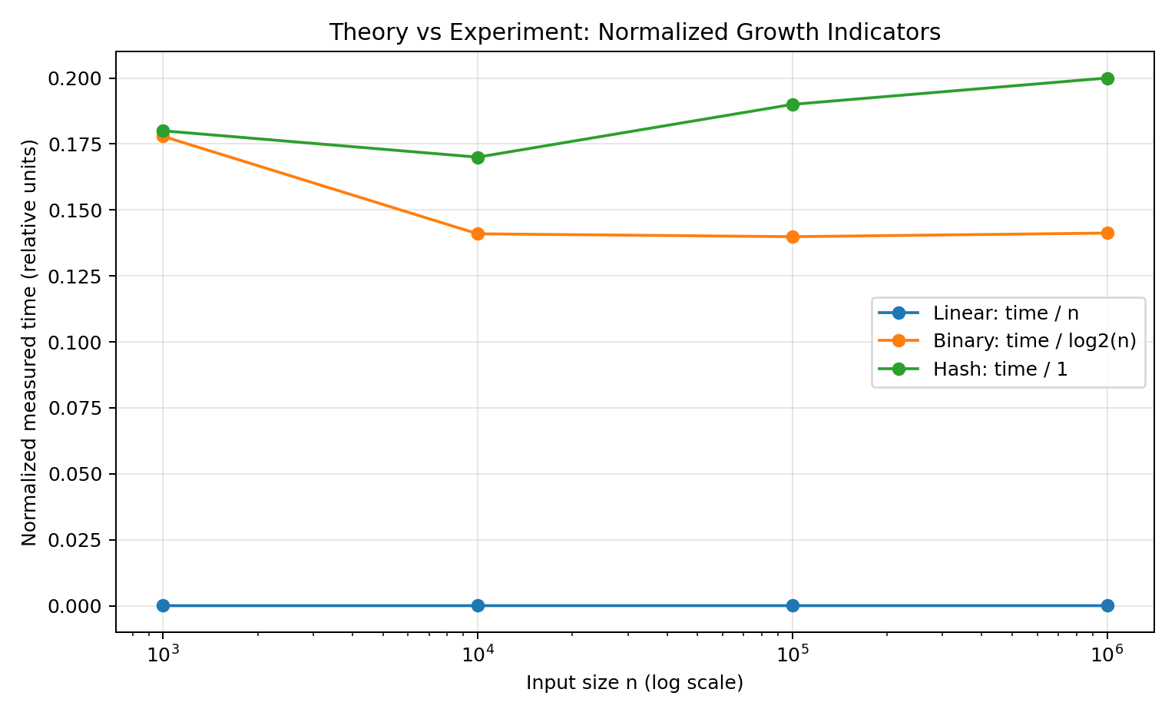
Figure 10.1: Normalized theory-vs-experiment indicators. Normalization is used because raw times have different units and machine-dependent constants.
Differences between theory and measured time are expected because Big-O/Theta analysis abstracts away hardware, Python interpreter overhead, memory locality, caching, allocation, and timer resolution. Therefore the experiment validates the growth trend rather than proving an exact machine-independent constant.

Task 11 – Recommend and Defend the Final Design
Recommendation: use the Group-A Hash Table strategy as the primary search index for the student-record system.
- For a single lookup, the hash-table search has expected Θ(1) time after the index exists.
- The one-time index construction is expected Θ(n), which is acceptable when the same index serves many searches.
- The 1,000,000-record experiment shows a very small lookup time compared with the linear baseline, while the build cost is paid once rather than once per search.
- The system can rebuild or update the hash index when new records are added.
- The main trade-off is additional memory for the hash table and the fact that worst-case hashing can degrade under pathological collision behaviour.
Binary Search is a strong alternative when ordered traversal or range-oriented behaviour is also important, but it requires Θ(n log n) preprocessing for sorting in this implementation. Linear Search is the simplest but does not scale well to repeated searches over a million records.
The recommendation is therefore based on the combination of mathematical complexity, measured performance, preprocessing frequency and the intended workload—not merely on the lowest Big-O label.

Task 12 – Day-4 Design Challenge: Re-evaluate and Adapt the Design

A. Impact Analysis
- The database is fixed at 1,000,000 records for the changed requirement.
- The system must process 50,000 search requests per hour.
- New records arrive only once per day, so the index does not need to be rebuilt after every search.
- The high search-to-update ratio makes reusable preprocessing much more valuable.
50,000 searches/hour corresponds to approximately 13.89 searches per second. This is a sustained workload rather than an isolated lookup.

B. Evaluation of the Original Design
The original recommendation of a hash table remains appropriate. The reason is not simply that hash lookup is O(1); the crucial point is that its Θ(n) expected preprocessing can be amortized over a large number of searches because records are added only once per day.
For comparison, 50,000 linear searches against a 1,000,000-record database could require up to 50,000 × 1,000,000 = 50,000,000,000 key comparisons in the worst case. Binary Search would require approximately 50,000 × 20 ≈ 1,000,000 search comparisons after sorting. The hash index requires the daily build plus approximately 50,000 expected constant-time lookups.

C. Adaptation / Redesign
Decision: RETAIN the Hash Table strategy, with an operational modification: build or update the in-memory hash index once after the daily record update and reuse it for the 50,000 hourly searches.
Daily update:
Receive new records
Rebuild/update hash index: expected Θ(n)
During each hour:
For each of 50,000 requests:
perform hash-table lookup: expected Θ(1)
Hourly search cost:
Expected Θ(50,000)
Combined daily-index + hourly workload:
Expected Θ(n + Q), where Q is the number of searches served
during the measured period.
This design avoids paying a sorting or full sequential scan cost for every query. The trade-off is memory consumption and dependence on expected hash-table behaviour.

D. Evidence-Based Defence
Metric | Result / implication
Database size | 1,000,000 records
Search demand | 50,000 requests/hour
Update frequency | Once per day
50,000-query benchmark | 8.448092 ms median for the batch on this execution environment
Observed successful queries | 25,000 of 50,000
Expected hash workload | Θ(1) per lookup after indexing
Index build | 43.690414 ms in the 1M-record benchmark
Decision | RETAIN hash-table design; rebuild/update index after daily changes
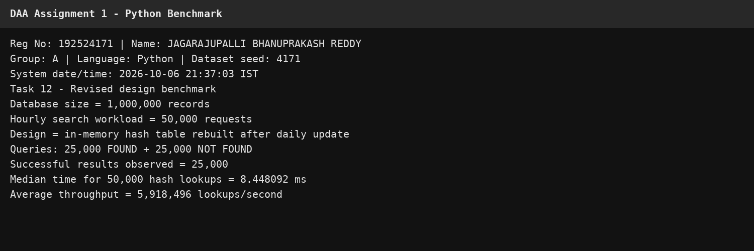
Figure 12.1: Task 12 benchmark for 50,000 searches on 1,000,000 records.

Appendix A – Reproducible Python Benchmark Code
The following is the main benchmark used to produce the experimental results in this report.
import random
import time
from statistics import median
NAME = "JAGARAJUPALLI BHANUPRAKASH REDDY"
REG_NO = 192524171
SEED = 4171
def make_dataset(n):
rng = random.Random(SEED)
# Seed-derived deterministic sequence; the student's registration
# number is forced into the dataset and REG_NO+1 is excluded.
import math
MOD = 900_000_000
start = rng.randrange(MOD)
step = rng.randrange(1, MOD)
while math.gcd(step, MOD) != 1:
step = rng.randrange(1, MOD)
ids = [100_000_000 + ((start + i * step) % MOD) for i in range(n)]
ids[0] = REG_NO
target = REG_NO + 1
if target in ids[1:]:
j = ids.index(target, 1)
ids[j] = 100_000_000 + ((start + (j + 1234567) * step) % MOD)
if n > 1:
ids[1] = 100_000_000 + ((start + step) % MOD)
return ids
def linear_search(a, key):
comparisons = 0
for x in a:
comparisons += 1
if x == key:
return True, comparisons
return False, comparisons
def binary_search_recursive(a, key, lo, hi, comparisons=0):
if lo > hi:
return False, comparisons
mid = (lo + hi) // 2
comparisons += 1
if a[mid] == key:
return True, comparisons
if a[mid] < key:
return binary_search_recursive(a, key, mid + 1, hi, comparisons)
return binary_search_recursive(a, key, lo, mid - 1, comparisons)
def hash_search(h, key):
return key in h, 1
def benchmark():
print(f"Reg No: {REG_NO} | Name: {NAME}")
for n in [1000, 10000, 100000, 1000000]:
data = make_dataset(n)
key = REG_NO + 1
t0 = time.perf_counter()
found, comparisons = linear_search(data, key)
linear_time = time.perf_counter() - t0
t0 = time.perf_counter()
sorted_data = sorted(data)
sort_time = time.perf_counter() - t0
t0 = time.perf_counter()
found_b, bcmp = binary_search_recursive(
sorted_data, key, 0, n - 1
)
binary_time = time.perf_counter() - t0
t0 = time.perf_counter()
h = set(data)
hash_build = time.perf_counter() - t0
t0 = time.perf_counter()
found_h, hop = hash_search(h, key)
hash_time = time.perf_counter() - t0
print(f"\nn = {n:,}")
print(f"Linear : {linear_time*1000:.6f} ms, comparisons={comparisons}")
print(f"Binary : {binary_time*1e6:.6f} us, comparisons={bcmp}, sort={sort_time*1000:.6f} ms")
print(f"Hash : {hash_time*1e6:.6f} us, operations={hop}, build={hash_build*1000:.6f} ms")
if __name__ == "__main__":
benchmark()

Appendix B – GitHub Repository and Submission Plan
The submission rules require one PDF report, a GitHub repository containing code/datasets/results/screenshots, and a Google Classroom upload containing the PDF, code ZIP and GitHub link.
DAA-A1-192524171-JAGARAJUPALLI_BHANUPRAKASH_REDDY/
├── README.md
├── report/
│ └── DAA_A1_192524171.pdf
├── src/
│ ├── linear_search.py
│ ├── binary_search_recursive.py
│ ├── hash_table_search.py
│ ├── dataset_generator.py
│ └── benchmark.py
├── data/
│ └── sample_1000.txt
├── results/
│ ├── results.csv
│ └── graphs/
└── screenshots/
├── task08_correctness_test.png
├── task09_1000.png
├── task09_10000.png
├── task09_100000.png
├── task09_1000000.png
└── task12_50000_searches.png
Required repository actions before submission:
- Use a private repository or the GitHub Classroom repository if instructed.
- Make at least 5 meaningful commits during the assignment week; do not use only one final-upload commit.
- Do not make commits after the deadline.
- Keep the same final report in the repository and Google Classroom.
- Paste the GitHub link into the first page of the PDF.
- Upload the PDF, code ZIP and GitHub link to Google Classroom.

Submission Checklist
- ☐ PDF/report contains all 12 tasks in order.
- ☐ Name and registration number appear on every evidence screenshot.
- ☐ System date/time is visible in the screenshots.
- ☐ 1K, 10K, 100K and 1M datasets are tested.
- ☐ Seed 4171 is used for the personal dataset.
- ☐ Found key 192524171 and not-found key 192524172 are tested.
- ☐ Task 12 includes the 50,000-search / 1M-record benchmark.
- ☐ Tables and graphs are generated from the same results.csv.
- ☐ GitHub repository contains README, source, results and screenshots.
- ☐ At least 5 meaningful GitHub commits are made before the deadline.
- ☐ GitHub link is pasted into the first page before PDF export.
- ☐ Google Classroom receives the PDF and code ZIP before the deadline.
Important authorship note: the course rules require explanations and derivations in the student's own words and include a viva/authorship check. This report is intended as a structured working document; review every task and be prepared to explain the algorithms, code, graphs and design decision during the viva.

