CSA06 – DESIGN AND ANALYSIS OF ALGORITHMS
CO1 – ASSESSMENT TOOL 2
IT APPLICATION-BASED PROBLEM SOLVING SCALABILITY AUDIT OF AN E-COMMERCE PLATFORM
Student Name: JAGARAJUPALLI BHANUPRAKASH REDDY
Registration Number: 192524171
Course: CSA06 – Design and Analysis of Algorithms | Duration: 3 Days | Individual

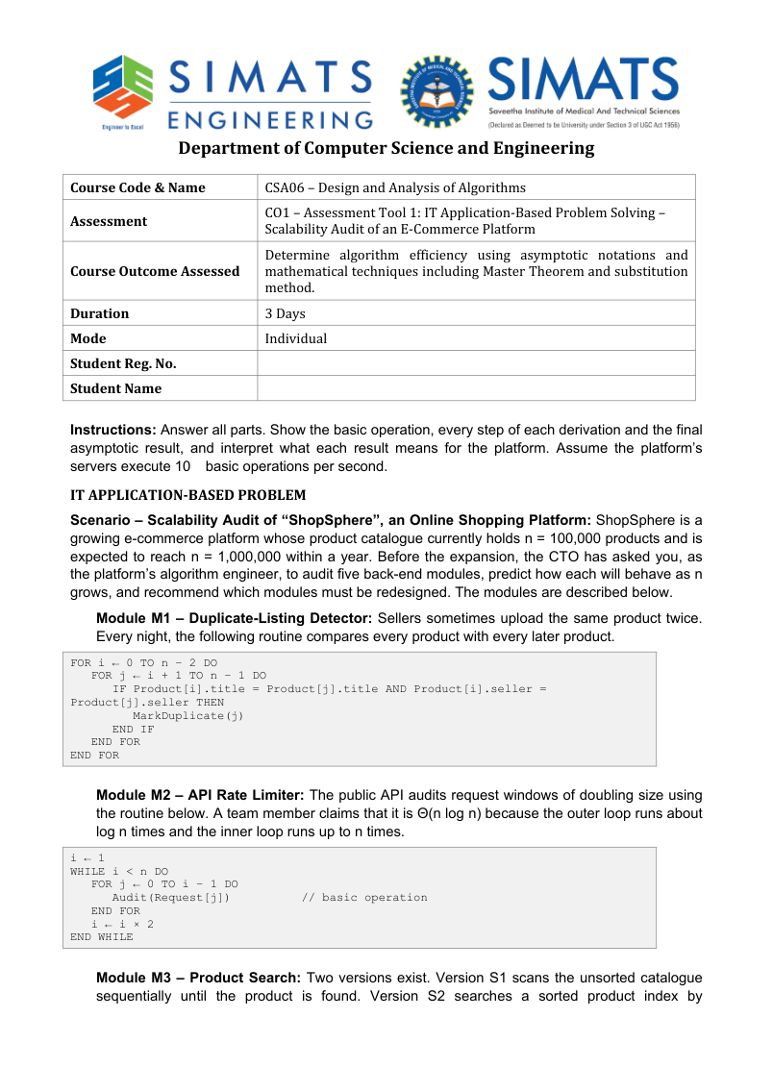
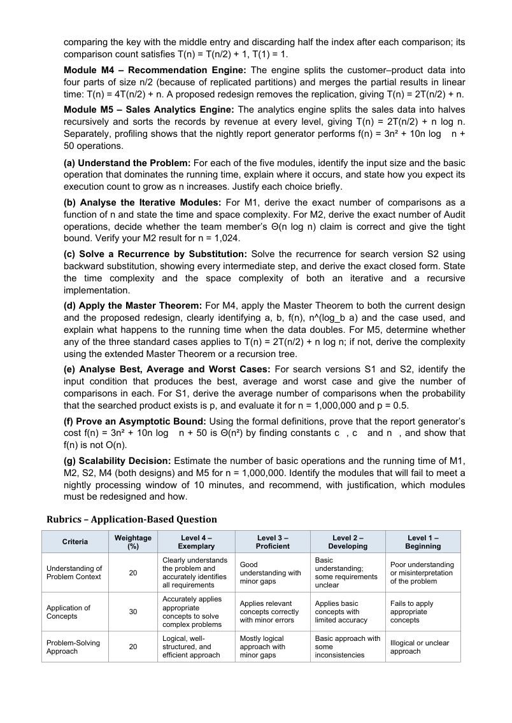


COMPLETE WORKED ANSWERS
The answers follow the attached question paper's exact module labels and parts (a)–(g). The stated server model is 10 basic operations per second and the nightly window is 10 minutes (600 seconds).

(a) Understand the Problem: Input Size and Basic Operation
Module | Input size | Basic operation | Growth and reason
M1 Duplicate detector | n products | Compare title and seller for each pair | n(n−1)/2 comparisons; Θ(n²). Every unordered pair is checked.
M2 API rate limiter | n requests | Audit(Request[j]) | 1+2+4+… geometric sum; Θ(n), not Θ(n log n).
M3 Product search | n products | Compare search key to product key | S1: Θ(n); S2 on sorted index: Θ(log n).
M4 Recommendation engine | n customer–product items | Recursive calls plus linear merge | Current 4T(n/2)+n = Θ(n²); redesign 2T(n/2)+n = Θ(n log n).
M5 Sales analytics | n sales records | Recursive splitting and n log n work per level | T(n)=2T(n/2)+n log n = Θ(n log² n).

(b) Analyse the Iterative Modules

M1 – Exact comparison count
For each i, the inner loop compares product i with each later product, giving n−i−1 comparisons.
C_M1(n) = Σ(i=0 to n−2)(n−i−1)
= 1 + 2 + … + (n−1)
= n(n−1)/2.
Therefore time is Θ(n²). Auxiliary space is Θ(1) if duplicate marks are made in-place and output storage is excluded.
n | Exact comparisons | Time at 10 ops/s | Minutes
1,000 | 499,500 | 49,950 s | 832.5
100,000 | 4,999,950,000 | 499,995,000 s | 8,333,250
1,000,000 | 499,999,500,000 | 49,999,950,000 s | 833,332,500

M2 – Exact Audit count
Let m=ceil(log₂n). The values of i are 1,2,4,…,2^(m−1), since 2^(m−1)<n≤2^m. The inner loop executes i times at each step.
A_M2(n) = Σ(k=0 to m−1) 2^k
= 2^m − 1
= 2^ceil(log₂ n) − 1.
Since n−1 ≤ A_M2(n) < 2n−1, the tight bound is Θ(n). The team member's Θ(n log n) claim is wrong because the inner-loop lengths form a geometric series rather than n operations at every outer iteration.
For n=1,024=2^10, the executed lengths are 1,2,4,…,512. Total = 2^10−1 = 1,023 Audit operations, requiring 102.3 seconds under the simplified 10-operations/second model. This count includes Audit operations only, as requested.

(c) Solve S2 Recurrence by Backward Substitution
Given T(n)=T(n/2)+1, T(1)=1. Assume n is a power of two:
T(n) = T(n/2)+1
= T(n/4)+2
= T(n/8)+3
= ...
= T(n/2^k)+k.
The base case occurs when n/2^k=1, so k=log₂n. Thus T(n)=T(1)+log₂n=1+log₂n for powers of two; the general comparison growth is Θ(log n).
Implementation | Time | Auxiliary space | Reason
Iterative binary search | Θ(log n) | Θ(1) | Loop updates two bounds.
Recursive binary search | Θ(log n) | Θ(log n) | Call stack has one frame per halving level.
Building the sorted index is a separate preprocessing step costing Θ(n log n) with comparison sorting. Repeated searches reuse the index, so the sort cost should not be charged to every query.

(d) Apply the Master Theorem

M4 current: T(n)=4T(n/2)+n
Item | Value
a | 4
b | 2
f(n) | n
n^(log_b a) | n^(log₂4)=n²
Case | Case 1: f(n)=O(n^(2−ε)), ε=1
Result | Θ(n²)
The recursive work dominates. Doubling n multiplies the leading quadratic cost by approximately 4.

M4 redesign: T(n)=2T(n/2)+n
Item | Value
a | 2
b | 2
f(n) | n
n^(log_b a) | n^(log₂2)=n
Case | Case 2: f(n)=Θ(n^(log_b a))
Result | Θ(n log n)
The redesign removes replication and improves growth from quadratic to n log n. Doubling n increases cost by slightly more than 2, approximately 2·(log₂n+1)/log₂n.

M5: T(n)=2T(n/2)+n log n
Here a=2, b=2, n^(log_b a)=n, and f(n)=n log n. The three basic Master Theorem cases in their simplest form do not directly classify this f(n). Use the extended Master Theorem or a recursion tree.
Level k cost = 2^k · (n/2^k) · log₂(n/2^k)
= n(log₂n − k)
T(n) = Σ(k=0 to log₂n−1) n(log₂n − k) + Θ(n)
= Θ(n log²n).
The regularity condition for the extended theorem holds for sufficiently large n: 2f(n/2)=n(log₂n−1)≤c·n log₂n for a constant c<1. Thus the extended Master Theorem also yields Θ(n log²n).
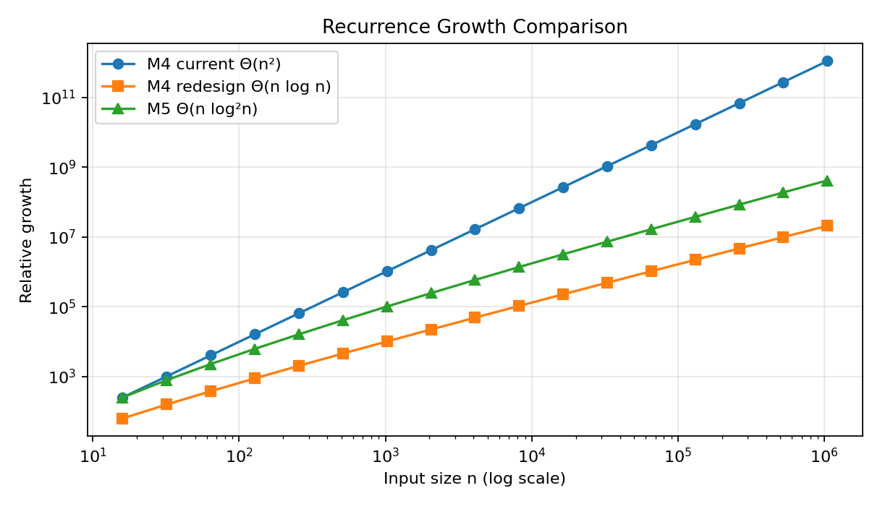
Figure 1. Recurrence growth comparison: current M4, redesigned M4 and M5.

(e) Best, Average and Worst Cases for S1 and S2
Version/case | Condition | Comparisons
S1 best | Target is first | 1
S1 average, successful | Target equally likely at any position | (n+1)/2
S1 worst | Target last or absent | n
S2 best | Target equals first middle entry | 1
S2 average | Typical query on sorted index | Θ(log n)
S2 worst | Target absent or deepest interval | At most floor(log₂n)+1

Expected S1 comparisons when existence probability is p
Assume successful targets are uniformly distributed among n positions and an unsuccessful search scans all n entries.
E[C_S1] = p·(n+1)/2 + (1−p)·n
For n=1,000,000 and p=0.5:
E[C] = 0.5·500,000.5 + 0.5·1,000,000
= 750,000.25 comparisons.
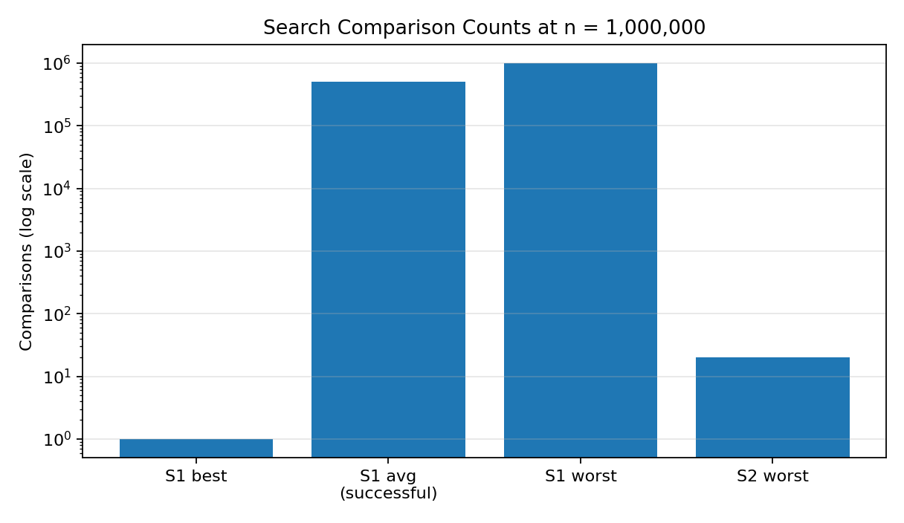
Figure 2. Search comparison counts at one million products (logarithmic y-axis).

(f) Prove f(n)=3n²+10n log n+50 is Θ(n²)
Assume log means log₂; any fixed base changes only a constant. For n≥1, log₂n≤n, so n log₂n≤n², and 50≤50n².
f(n)=3n²+10n log₂n+50
For n≥1: f(n) ≤ 3n²+10n²+50n² = 63n².
Also: f(n) ≥ 3n².
Choose c₁=3, c₂=63, n₀=1. Then 0≤c₁n²≤f(n)≤c₂n² for all n≥n₀. Therefore f(n)=Θ(n²).

Show f(n) is not O(n)
Suppose f(n)≤cn for all n≥n₀. Since f(n)≥3n², this would imply 3n²≤cn and therefore 3n≤c for all sufficiently large n. This is impossible for any fixed c. Hence f(n)∉O(n).

(g) Scalability Decision at n=1,000,000
The processing window is 600 seconds. At 10 basic operations/second, the budget is 6,000 basic operations.
Module | Estimated operations | Time at 10 ops/s | 10-min window
M1 | 499,999,500,000 | 49,999,950,000 s | FAIL
M2 | 1,048,575 | 104,857.5 s | FAIL under literal model
S2 | ≤20 comparisons per query | ≤2 s per query | PASS per query; scale by query volume
M4 current | ≈10^12 (unit-cost asymptotic estimate) | ≈100,000,000,000 s | FAIL
M4 redesign | ≈19,931,569 (n log₂n) | ≈1,993,157 s | FAIL under literal model
M5 | ≈397,267,000 (n log₂²n) | ≈39,726,700 s | FAIL under literal model
For M4 and M5, the question provides recurrences but no exact operation constants, so n², n log n and n log²n are scale estimates rather than exact counts. The budget comparison is still useful, but actual wall-clock time depends on constants and implementation. For M2, the exact count at one million is 1,048,575, or 104,857.5 seconds at 10 operations/second, so it also exceeds the literal 10-minute model despite being Θ(n).
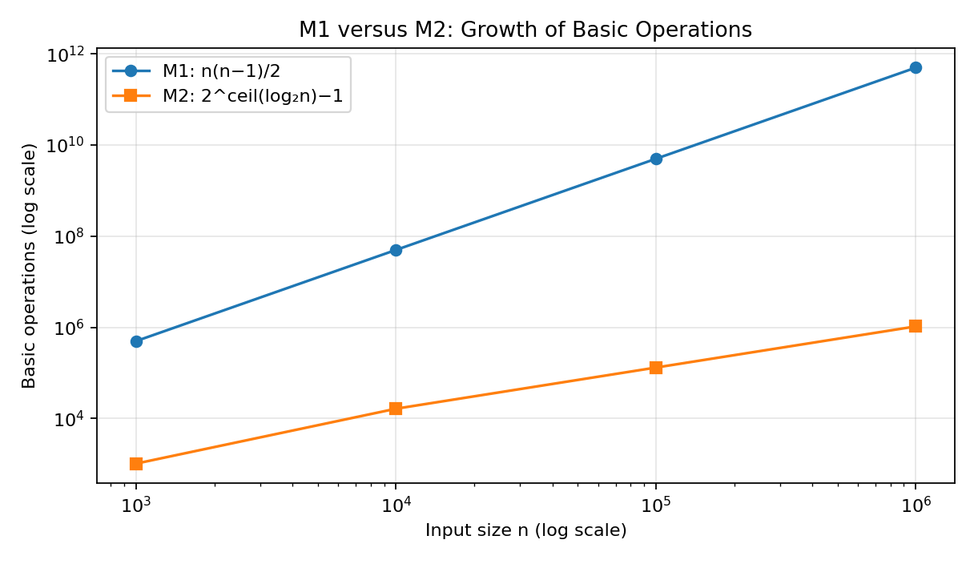
Figure 3. M1 pairwise comparisons grow quadratically while M2 audit operations grow linearly.

Redesign recommendations
- M1 — Redesign urgently. Replace all-pairs comparison with a hash set keyed by (seller, normalized title), giving expected Θ(n) time and Θ(n) extra space; alternatively sort by this composite key and scan adjacent records in Θ(n log n).
- M2 — Correct the analysis and consider operational optimization. Its exact Audit count is Θ(n), not Θ(n log n), but under the unusually strict 10 operations/second assumption, 1,048,575 audits exceed 600 seconds. Batch or parallelize audits if the stated time budget is literal.
- M3 — Prefer S2 for repeated product searches by maintaining a sorted index. Query cost is Θ(log n), while S1 is Θ(n). Include index construction/update costs in the system-level analysis.
- M4 — Adopt the proposed redesign to eliminate replicated subproblems, improving Θ(n²) to Θ(n log n). The literal server model still predicts more than 10 minutes at n=1,000,000, so further parallelization, incremental processing or a faster implementation may be required.
- M5 — Optimize the analytics pipeline. Θ(n log²n) is costlier than Θ(n log n); avoid sorting at every recursive level if the application permits a standard merge-sort-like design.
Final priority: redesign M1 and M4; optimize M5; correct and tune M2; use M3's sorted index for product search. Do not infer that a linear asymptotic bound automatically satisfies a fixed deadline—the coefficient and server throughput matter too.

Conclusion
The audit shows why loop nesting alone does not determine complexity. M1 examines every unordered pair and is Θ(n²). M2's doubling windows sum geometrically to Θ(n), not Θ(n log n). S2 is Θ(log n) per query after sorted-index preprocessing. M4 improves from Θ(n²) to Θ(n log n) when replication is removed. M5 is Θ(n log²n), and the report generator is formally Θ(n²), not O(n). Under the stated 10-operations/second model, the 600-second budget is extremely restrictive; design decisions must combine asymptotic growth with operation counts and real implementation constants.

Code of Conduct
I, JAGARAJUPALLI BHANUPRAKASH REDDY (Registration No. 192524171), certify that I have reviewed this assessment and will submit work that I understand and can explain. I understand that academic-integrity violations may result in disciplinary action.
Student Signature: J .Bhanuprakash Reddy Date: 12-10-2026

