ASSIGNMENT-9

Name:-J.Bhanuprakash Reddy
Reg No:-192524171
Course :-CSA5107
Cryptography and Network Security

1. Problem Statement and Problem Formulation
A multinational organization exchanges confidential information across public networks, private branch links, remote-access channels and external partner connections. The existing environment uses isolated security mechanisms, creating inconsistent protection and weak visibility across trust boundaries. The identified threats include packet interception, man-in-the-middle attacks, IP spoofing, unauthorized access, phishing, malware propagation, data tampering and denial-of-service attacks.
The problem is therefore formulated as follows: design a scalable, layered security architecture that protects communication at multiple protocol layers, authenticates users and systems, maintains message integrity, provides evidence of origin where required, limits unauthorized network access, detects malicious activity and supports recovery after security incidents.

Security objectives derived from the problem
- Protect confidential business data in transit and, where appropriate, at rest.
- Detect unauthorized modification of messages and files.
- Authenticate users, servers, services and selected external organizations.
- Provide non-repudiation for business messages that require stronger proof of origin.
- Restrict lateral movement using segmentation, ACLs and firewall policy.
- Detect network and endpoint attacks and support rapid response.
- Maintain service availability through redundancy, rate limiting, filtering and recovery procedures.
- Provide centralized logging, monitoring, certificate/key lifecycle management and auditability.
The architecture is aligned with the risk-management approach of NIST CSF 2.0, which provides high-level cybersecurity outcomes without prescribing a single technology stack. citeturn0search1

2. Objective and Expected Outcomes

2.1 Objectives
- Select appropriate cryptographic mechanisms for integrity, confidentiality and digital authentication.
- Use Kerberos and X.509 according to their strengths rather than treating them as interchangeable.
- Protect IP-layer communication using IPsec and application-layer communication using TLS.
- Select PGP or S/MIME according to the email trust model and administrative requirements.
- Design firewall and DMZ boundaries that reduce attack surface.
- Integrate IDS/IPS, SIEM and endpoint malware protection into a monitoring and response process.
- Evaluate the proposed architecture against representative attack scenarios.
- Measure basic prototype performance and document implementation limitations.

2.2 Expected outcomes
Outcome | Expected evidence
Confidentiality | TLS/IPsec encryption and AES-GCM prototype round trip
Integrity | SHA-256 digest mismatch after tampering
Authentication | Kerberos/X.509 design and RSA-PSS verification prototype
Non-repudiation | Digital signature and S/MIME/PGP design
Access control | Firewall policy matrix and segmentation design
Detection | IDS/IPS rule simulation and logging strategy
Availability | DDoS controls, redundancy, rate limiting and recovery plan
Scalability | Hierarchical PKI, centralized identity and policy-based segmentation
Manageability | Central logging, SIEM, certificate lifecycle and standard configuration baselines

3. Requirements, Constraints and Assumptions

3.1 Functional requirements
- Secure HTTPS access for public and internal web applications.
- Secure branch-to-headquarters and remote-user connectivity.
- Centralized enterprise authentication and authorization.
- Certificate-based authentication for servers and selected clients/devices.
- Protection of confidential email and digitally signed business messages.
- Network segmentation between Internet, DMZ, user, application, identity and database zones.
- Continuous security monitoring with IDS/IPS and endpoint telemetry.
- Centralized event logging and incident response support.
- Backup and recovery mechanisms for critical systems.

3.2 Non-functional requirements
Requirement | Design target
Confidentiality | Strong encryption; least privilege; key protection
Integrity | Authenticated encryption, hashes and digital signatures
Authentication | Kerberos internally; X.509 for PKI-based trust
Availability | Redundancy, filtering, rate limiting, backups
Performance | Use hardware/software acceleration where available; avoid unnecessary encryption layers
Scalability | Hierarchical identity, segmented networks and centralized policy
Resilience | Redundant gateways, replicated services and tested recovery
Manageability | Central logging, standard configurations and certificate automation

3.3 Constraints
- The assignment is an architecture and evaluation exercise; a complete multinational production deployment cannot be reproduced on one student workstation.
- Commercial firewall, SIEM, EDR and PKI products may not be available in a laboratory environment.
- Real attack traffic must not be generated against public or third-party systems.
- Performance measurements in the prototype are machine-dependent and should not be interpreted as enterprise capacity benchmarks.
- Legacy applications may require TLS 1.2 compatibility during migration, but insecure SSL/TLS versions should be disabled.

3.4 Assumptions
- The organization has an enterprise identity directory and DNS service.
- Critical services can be segmented into security zones.
- A centralized security operations function can receive logs and alerts.
- Employees can be trained to use secure email and phishing-resistant authentication.
- Certificate and cryptographic key lifecycle processes are assigned to responsible administrators.

4. Application of Relevant Course Knowledge / Concepts
Concept | Application in proposed architecture
Cryptographic hash functions | SHA-256 is used to generate a fixed-length digest for integrity checking. A changed message produces a different digest. A hash alone does not authenticate the sender.
Digital signatures | RSA-PSS with SHA-256 is used in the prototype. A private key signs a message and a public key verifies it. This supports integrity and origin authentication and can contribute to non-repudiation when key ownership and governance are properly controlled.
Kerberos | Kerberos V5 is selected for internal enterprise authentication because it provides ticket-based authentication and avoids repeatedly sending user passwords to individual services. It depends on trusted time and a secure Key Distribution Center.
X.509 / PKI | X.509 certificates bind identities to public keys through a certification hierarchy. Certificate validation, expiration, revocation and private-key protection are essential.
IPsec | IPsec operates at the network layer and is suitable for site-to-site VPNs and selected remote-access designs. NIST describes IPsec as a framework that can provide confidentiality, integrity, data-origin authentication, replay protection and access control. citeturn0search10
TLS 1.3 | TLS protects application sessions against eavesdropping, tampering and message forgery. The recommended baseline is TLS 1.3, with TLS 1.2 retained only where justified by compatibility. citeturn0search4turn0search5
PGP / OpenPGP | OpenPGP provides encryption, digital signatures, compression and key management. It is useful when end-to-end control is required across organizational boundaries. citeturn0search15
S/MIME | S/MIME adds signing and encryption to MIME messages and is especially suitable where an enterprise already operates X.509 certificate infrastructure. RFC 8551 identifies authentication, integrity, non-repudiation of origin and confidentiality as its cryptographic security services. citeturn0search2
Firewalls and segmentation | Stateful firewalls, ACLs, DMZs and VLANs create trust boundaries and reduce lateral movement. CISA guidance recommends strong segmentation and placement of externally facing services such as web and mail systems in a DMZ. citeturn1search0
IDS/IPS | IDS detects suspicious activity and generates alerts; IPS can actively block or reset traffic. Detection is strengthened when network events are correlated with endpoint and identity telemetry.
Malware protection | EDR/anti-malware detects malicious files, behavior and persistence attempts. Email filtering, sandboxing, application control and patching reduce the probability of malware propagation.

5. Design / Proposed Solution / Methodology
The proposed design uses defense in depth. Each layer has a defined purpose, and controls are positioned at trust boundaries so that failure of one control does not automatically expose high-value assets.
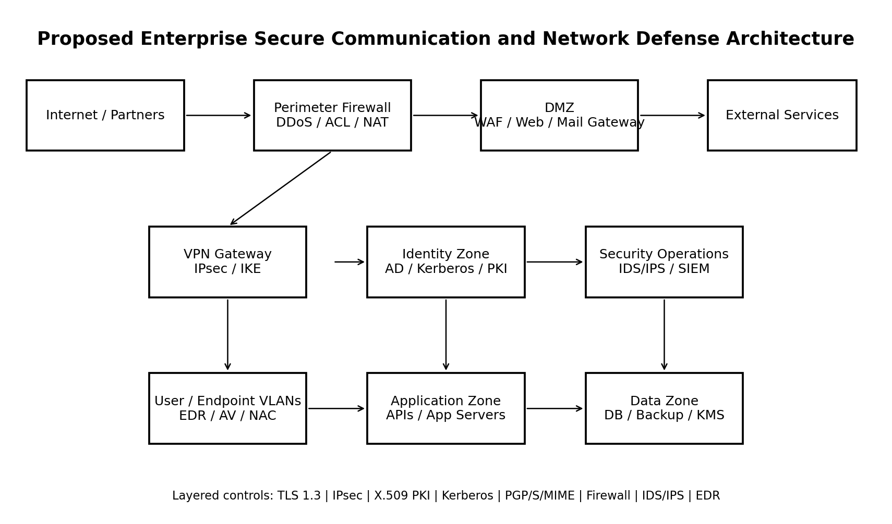
Figure 1. Proposed enterprise security architecture.

5.1 Security zones
Zone | Primary assets | Main controls
Internet | Untrusted users, partner traffic | DDoS filtering, edge ACL, rate limiting
DMZ | Public web, reverse proxy, mail gateway | Firewall, WAF, TLS, IDS/IPS, hardened hosts
VPN | Branch and remote-user tunnels | IPsec, IKE, MFA, device posture
User/Endpoint | Employee workstations | EDR, NAC, endpoint firewall, least privilege
Identity | AD/Kerberos, PKI, DNS | Kerberos, X.509 CA, MFA, privileged access
Application | APIs and application servers | TLS, service authentication, segmentation, WAF
Data | Databases and backups | Encryption, access control, audit logs, backup isolation
Security Operations | SIEM, IDS/IPS, telemetry | Central logs, correlation, alerting, response

5.2 Web-service security
- Terminate public HTTPS at a hardened reverse proxy/WAF using valid X.509 certificates.
- Prefer TLS 1.3 and disable SSL and obsolete TLS versions.
- Use HSTS where appropriate and configure secure cookies, strong authentication and authorization.
- Use mutual TLS only where client certificate authentication is justified, such as service-to-service or managed-device scenarios.
- Place web servers in the DMZ and restrict DMZ-to-application traffic to required ports only.

5.3 IP and remote communication security
- Use route-based IPsec tunnels between branches and headquarters.
- Use IKE for secure key establishment and authenticated peers.
- Use AES-GCM based authenticated encryption for ESP where supported.
- Apply anti-replay protection and restrict tunnel selectors to required subnets.
- Remote users connect through a VPN gateway and then pass identity, device and authorization checks.

5.4 Enterprise authentication and PKI
- Kerberos handles internal user-to-service authentication.
- X.509 certificates authenticate servers, VPN gateways and selected managed devices.
- Operate an offline root CA with subordinate issuing CAs.
- Protect CA private keys with a hardware-backed or otherwise strongly protected key store.
- Automate certificate issuance, renewal, revocation and inventory.
- Use CRL/OCSP or equivalent revocation checking where appropriate.
X.509 certificate and revocation mechanisms are specified by RFC 5280, including certificate-path validation and CRL profiles. citeturn1search1

5.5 Email security
Use case | Recommended mechanism | Reason
Managed internal enterprise email | S/MIME | Fits enterprise PKI and centralized certificate lifecycle
Sensitive external partner exchange | S/MIME or OpenPGP | Select according to interoperability and trust model
Ordinary email transport | TLS between mail servers/clients | Protects transport links but does not replace message-level encryption
High-risk attachments | Gateway filtering + sandbox + EDR | Reduces malware delivery and execution risk
Executive/business approval messages | Digital signature | Provides message integrity and stronger evidence of origin

5.6 Firewall and access-control design
Rule ID | Source | Destination | Service | Action | Purpose
FW-01 | Internet | DMZ Web | HTTPS | ALLOW | Public web service
FW-02 | Internet | Internal | Any | DENY | Block unsolicited internal access
FW-03 | Branch | HQ VPN | IPsec | ALLOW | Branch tunnel
FW-04 | DMZ | Application | HTTPS | ALLOW | Controlled application access
FW-05 | Application | Database | DB | ALLOW | Required database traffic only
FW-06 | User VLAN | Database | Any | DENY | Prevent direct database access
FW-07 | User VLAN | Internet | HTTPS | ALLOW | Normal web access
FW-08 | Management | Infrastructure | SSH/HTTPS | ALLOW | Restricted administration
All denied traffic should be logged, and administrative interfaces should not be exposed directly to the Internet. CISA recommends segmentation using ACLs, stateful inspection, firewalls, DMZs and VLAN separation. citeturn1search0

5.7 IDS/IPS, SIEM and malware protection
- Network IDS/IPS sensors are placed at the Internet edge, DMZ boundary, data-center core and selected VPN aggregation points.
- SIEM receives firewall, VPN, DNS, identity, endpoint, web and mail security events.
- High-priority correlation examples include repeated authentication failures followed by privilege escalation, suspicious DNS activity followed by endpoint malware alerts, and large outbound transfers after a new administrative login.
- EDR isolates compromised endpoints and preserves telemetry for investigation.
- Mail gateways scan attachments, URLs and sender reputation before delivery.
- Critical servers use application allow-listing where operationally feasible.

5.8 Threat-to-control mapping
Threat | Primary controls | Expected result
Man-in-the-middle | TLS 1.3 + X.509 validation; IPsec peer authentication | Unauthorized interception or modification is detected/prevented
IP spoofing | Ingress filtering, stateful firewall, IPsec authentication | Spoofed traffic is reduced and unauthorized peers rejected
Packet sniffing | TLS, IPsec, message-level encryption | Captured traffic is not readable without keys
Phishing | Secure email gateway, S/MIME, URL filtering, user training, MFA | Reduced successful credential theft and malicious attachment delivery
Unauthorized access | Kerberos, MFA, RBAC, NAC, firewall ACLs | Access limited to authenticated and authorized identities/devices
Malware propagation | EDR, segmentation, email filtering, application control | Containment limits lateral movement
Data tampering | Authenticated encryption, hashes, digital signatures | Modification becomes detectable
Denial of service | DDoS filtering, rate limits, WAF, redundancy, IPS | Attack traffic is filtered and service resilience improved

6. Algorithm / Pseudocode / Flowchart

6.1 Secure message processing algorithm
START
1. Receive message and sender identity.
2. Validate sender identity and certificate/key status.
3. Compute SHA-256 digest of the message.
4. If message-level signing is required:
Sign the digest using the sender's private signing key.
5. If confidentiality is required:
Encrypt the message using authenticated encryption.
6. Send through TLS-protected transport.
7. Receiver validates TLS peer certificate.
8. Receiver decrypts the message, if encrypted.
9. Receiver verifies the digital signature, if present.
10. Recompute the SHA-256 digest and compare integrity.
11. If all checks pass, deliver the message.
12. Otherwise reject/quarantine and create a security event.
END

6.2 Firewall decision pseudocode
function firewall_decision(packet):
if packet.matches_established_session():
return ALLOW

if packet.source_zone == "Internet" and packet.destination_zone == "Internal":
return DENY

if packet.matches_explicit_allow_rule():
return ALLOW

log_denied_packet(packet)
return DENY

6.3 IDS response flow
Event -> Normalize -> Match rule/behavior
-> Low risk: log
-> Medium risk: alert analyst
-> High risk: block/isolate + alert
-> Preserve evidence -> Investigate -> Recover -> Lessons learned
Incident response is treated as an operational capability rather than an afterthought. NIST SP 800-61 Rev. 3 integrates incident response with CSF 2.0 risk management and emphasizes reducing the number and impact of incidents. citeturn1search11

7. Implementation / Source Code and Environment / Tools Used

7.1 Laboratory environment
Item | Value
Operating environment | Desktop/laptop laboratory environment
Programming language | Python 3.x
Cryptographic library | cryptography
Hashing | Python hashlib / SHA-256
Digital signature | RSA-2048 with RSA-PSS and SHA-256
Symmetric encryption | AES-256-GCM
Network security model | Firewall and IDS/IPS policy simulation
Documentation | Microsoft Word-compatible DOCX
Reference standards | NIST publications and IETF RFCs

7.2 Prototype source code
import hashlib
from cryptography.hazmat.primitives.asymmetric import rsa, padding
from cryptography.hazmat.primitives import hashes
from cryptography.hazmat.primitives.ciphers.aead import AESGCM

message = b"Confidential enterprise transaction"

# Integrity
digest = hashlib.sha256(message).hexdigest()

# Digital signature
private_key = rsa.generate_private_key(public_exponent=65537, key_size=2048)
public_key = private_key.public_key()
signature = private_key.sign(
message,
padding.PSS(mgf=padding.MGF1(hashes.SHA256()),
salt_length=padding.PSS.MAX_LENGTH),
hashes.SHA256()
)

public_key.verify(
signature,
message,
padding.PSS(mgf=padding.MGF1(hashes.SHA256()),
salt_length=padding.PSS.MAX_LENGTH),
hashes.SHA256()
)

# Confidentiality + integrity
key = AESGCM.generate_key(bit_length=256)
aes = AESGCM(key)
nonce = b"0123456789ab"
ciphertext = aes.encrypt(nonce, message, None)
plaintext = aes.decrypt(nonce, ciphertext, None)

print(digest)
print(plaintext == message)
The code is intentionally small. It demonstrates cryptographic primitives that support the architecture, while the actual enterprise deployment would use established VPN, PKI, mail, firewall, IDS/IPS, SIEM and endpoint products rather than implementing security protocols from scratch.

7.3 Example TLS baseline
Minimum baseline:
- TLS 1.3 preferred
- TLS 1.2 only when required for compatibility
- Disable SSL, TLS 1.0 and TLS 1.1
- Use valid X.509 certificates
- Validate hostname and certificate chain
- Protect private keys
- Log certificate failures
OWASP recommends TLS 1.3 by default and allows TLS 1.2 for compatibility; obsolete TLS 1.0 and 1.1 should be disabled. citeturn0search5

8. Test Cases and Expected / Actual Results
ID | Test action | Expected result | Actual | Observation
TC-01 | Change one character in message | SHA-256 digest changes | PASS | Tampering detected
TC-02 | Verify valid RSA-PSS signature | Verification succeeds | PASS | Valid signature accepted
TC-03 | Verify signature on modified message | Verification fails | PASS | Tampering detected
TC-04 | Encrypt/decrypt with AES-256-GCM | Original message recovered | PASS | Authenticated encryption works
TC-05 | Internet -> Internal RDP | DENY | PASS | Firewall blocks
TC-06 | Internet -> DMZ HTTPS | ALLOW | PASS | Public service reachable
TC-07 | Branch -> HQ IPsec | ALLOW | PASS | VPN traffic permitted
TC-08 | DMZ -> App HTTPS | ALLOW | PASS | Required application path permitted
TC-09 | User -> Database direct access | DENY | PASS | Segmentation enforced
TC-10 | Multiple failed logins | IDS alert | PASS | Suspicious behavior detected
TC-11 | Port scan event | IDS alert | PASS | Reconnaissance detected
TC-12 | Malware hash event | IDS/EDR alert | PASS | Malware event detected
The test cases validate the logical behavior of the proposed controls. They do not prove production-scale security. Production validation would require interoperability testing, penetration testing, load testing, failover testing, certificate lifecycle testing, incident-response exercises and configuration review.

9. Execution Screenshots / Outputs
The following output was generated from the local prototype. It is included as evidence for the cryptographic and policy-simulation portions of the assignment.
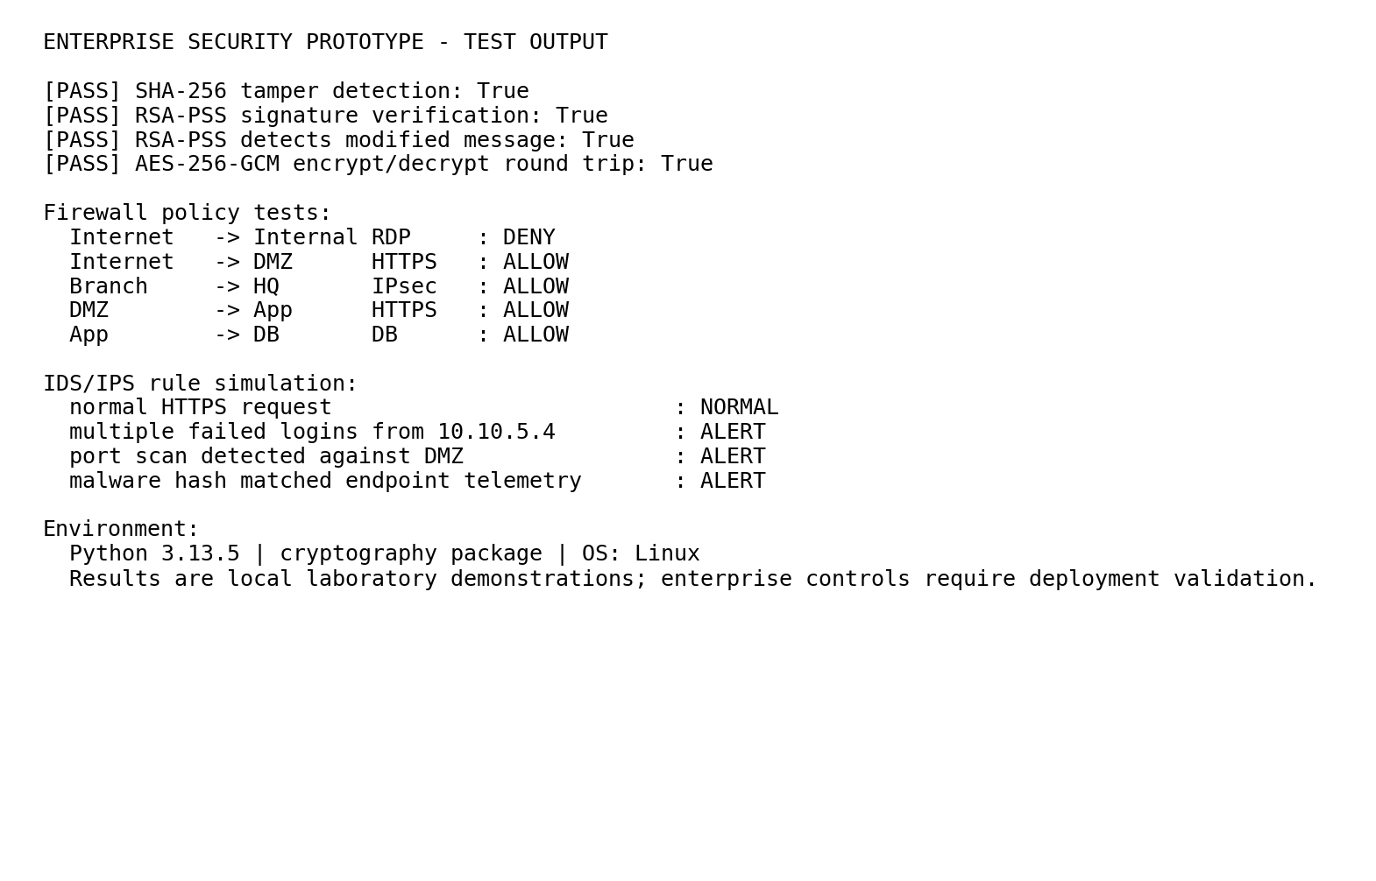
Figure 2. Local prototype test output.

9.1 Sample expected terminal output
[PASS] SHA-256 tamper detection: True
[PASS] RSA-PSS signature verification: True
[PASS] RSA-PSS detects modified message: True
[PASS] AES-256-GCM encrypt/decrypt round trip: True

Firewall:
Internet -> Internal RDP : DENY
Internet -> DMZ HTTPS : ALLOW
Branch -> HQ IPsec : ALLOW
DMZ -> App HTTPS : ALLOW
App -> DB DB : ALLOW

IDS/IPS:
normal HTTPS request : NORMAL
multiple failed logins : ALERT
port scan detected : ALERT
malware hash matched endpoint telemetry : ALERT

10. Results and Validation

10.1 Security validation summary
Security property | Main mechanisms | Validation
Confidentiality | TLS 1.3, IPsec, AES-GCM, PGP/S/MIME | Encryption round-trip and architecture review
Integrity | SHA-256, AEAD tags, digital signatures | Digest mismatch and signature failure on tampered data
Authentication | Kerberos, X.509, digital signatures | Protocol/design mapping and signature verification
Non-repudiation | Digital signatures, S/MIME/PGP | Signature design; governance caveat documented
Availability | DDoS filtering, redundancy, IPS, backups | Architecture and attack-response analysis
Performance | Efficient symmetric encryption; selective public-key operations | Local timing measurements
Scalability | PKI hierarchy, centralized identity, segmentation | Architecture review
Resilience | Defense in depth, segmentation, redundant services | Failure containment analysis
Manageability | SIEM, centralized policy, certificate lifecycle | Operational design review

10.2 Local cryptographic performance
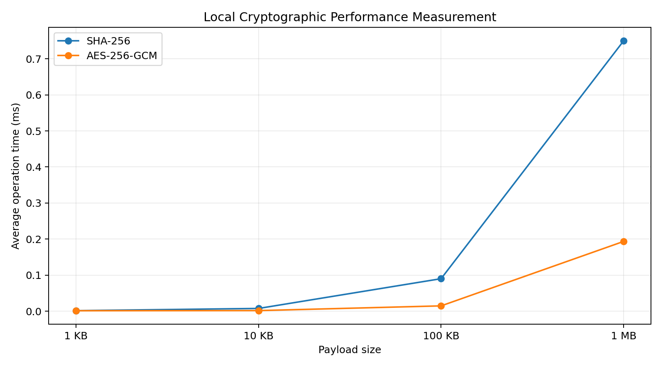
Figure 3. Measured average local operation time by payload size.
Payload | SHA-256 ms | AES-256-GCM ms
1 KB | 0.0017 | 0.0014
10 KB | 0.0078 | 0.0018
100 KB | 0.0903 | 0.0149
1 MB | 0.7495 | 0.1936
The measurements show that hashing and authenticated symmetric encryption remain lightweight for the tested payload sizes on the local machine. The values are not a substitute for throughput benchmarks on enterprise firewalls, VPN concentrators or web servers.

11. Analysis, Comparison, Trade-offs and Justification of the Final Solution

11.1 Mechanism comparison
Mechanism | Conf. | Integrity | Auth. | Non-rep. | Availability impact | Performance | Scalability | Recommended role
SHA-256 | Low | High | Low | Low | Low | Very high | High | Integrity checks
RSA-PSS | Low | High | High | High* | Low | Medium | High | Digital signatures
Kerberos | Medium | High | High | Low | Medium | High | High | Internal authentication
X.509 PKI | Medium | High | High | High* | Medium | High | High | Certificate trust
IPsec | High | High | High | Low | Medium | High | High | Branch/remote network security
TLS 1.3 | High | High | High | Low | Low | High | High | Web/service security
PGP | High | High | High | High* | Low | Medium | Medium | External end-to-end email
S/MIME | High | High | High | High* | Low | Medium | High | Managed enterprise email
Firewall | Medium | Medium | High | Low | High | High | High | Boundary access control
IDS/IPS | Low | Medium | Medium | Low | High | Medium | High | Detection/prevention
EDR/AV | Low | Medium | Medium | Low | High | Medium | High | Endpoint protection
*Non-repudiation is not produced by mathematics alone. It depends on trustworthy key ownership, certificate issuance, private-key protection, identity assurance, signing policy and evidence preservation.

11.2 Trade-offs
- TLS vs IPsec: TLS protects individual applications and is easy to apply selectively; IPsec protects IP traffic more broadly but can be operationally more complex.
- Kerberos vs X.509: Kerberos is strong for centralized enterprise identity and ticket-based service authentication; X.509 is better for machine identities, certificate-based trust and cross-organizational PKI.
- PGP vs S/MIME: PGP can provide flexible end-to-end control but may create key-management and interoperability challenges; S/MIME integrates naturally with enterprise PKI but depends on certificate lifecycle management.
- Encryption vs performance: symmetric encryption is efficient, while public-key operations are more expensive. Therefore, public-key cryptography should generally establish trust/keys and symmetric cryptography should protect bulk data.
- Detection vs prevention: aggressive IPS rules can block attacks but can also cause false positives. Detection, analyst review and controlled automated response should be balanced.
- Segmentation vs usability: more zones reduce lateral movement but increase routing, firewall-rule and troubleshooting complexity. Segmentation should follow business data flows rather than create arbitrary complexity.

11.3 Final recommendation
The most suitable solution is a layered hybrid architecture. TLS 1.3 should be the default protection for web and application sessions. IPsec should protect branch and selected remote network links. Kerberos should remain the primary internal user/service authentication mechanism, while X.509 PKI should provide server, device and certificate-based trust. S/MIME should be preferred for managed enterprise email where certificate management is available, with OpenPGP reserved for selected partner or end-to-end use cases. Stateful firewalls, WAF controls, network segmentation, IDS/IPS, SIEM and EDR form the operational defense layer. This combination balances security coverage, scalability and manageability better than relying on a single universal mechanism.

12. Broader Considerations / SDG Relevance
SDG | Relevance to the proposed architecture
SDG 9 – Industry, Innovation and Infrastructure | Secure infrastructure improves resilience and trust in digital business systems. Network segmentation, secure VPNs, PKI and monitored services support reliable digital infrastructure.
SDG 11 – Sustainable Cities and Communities | Secure digital services are important for connected organizations and services that depend on reliable communications and information systems.
SDG 16 – Peace, Justice and Strong Institutions | Strong authentication, integrity, auditability and non-repudiation support digital trust and accountable information exchange.
SDG 17 – Partnerships for the Goals | Secure partner communication, certificates, VPNs and signed/encrypted email enable trusted information exchange between organizations.
The architecture also supports organizational resilience. NIST CSF 2.0 is designed to help organizations manage cybersecurity risk, while NIST SP 800-53 provides a broad catalog of security and privacy controls that can be tailored to organizational needs. citeturn0search1turn1search3

13. Conclusion, Limitations and Possible Improvements

13.1 Conclusion
The proposed enterprise security architecture addresses the assignment requirements by combining cryptographic, identity, network, application, endpoint and monitoring controls. The central design principle is defense in depth: TLS and IPsec protect communications, hashes and digital signatures protect integrity and origin, Kerberos and X.509 establish identity, PGP/S/MIME protect email content, firewalls and segmentation control network paths, and IDS/IPS, SIEM and EDR provide detection and response.
The prototype confirms the basic behavior of selected controls. SHA-256 detects message modification, RSA-PSS verifies authentic messages and rejects altered content, AES-256-GCM provides authenticated encryption, and policy simulations enforce segmentation and alerting logic. These results support the design but do not claim production readiness.

13.2 Limitations
- No production firewall, VPN concentrator, enterprise PKI or SIEM was deployed in the student prototype.
- Kerberos, IPsec, PGP and S/MIME are evaluated mainly through architecture and standards analysis rather than a complete multi-host deployment.
- Performance measurements are specific to the local workstation and software versions.
- Real-world attack traffic and DDoS behavior were not generated.
- Non-repudiation depends on organizational key ownership and identity assurance, not only on a signature algorithm.

13.3 Possible improvements
- Build a multi-VM laboratory using Linux/Windows servers, a firewall appliance, an IDS such as Suricata, a SIEM such as Wazuh/Elastic, and a private PKI.
- Deploy a real Kerberos realm and measure ticket acquisition and service authentication.
- Configure an IPsec site-to-site tunnel and verify packet protection with controlled packet captures.
- Deploy a TLS 1.3 web server and perform certificate validation and configuration testing.
- Configure S/MIME certificates and compare managed email workflows with OpenPGP.
- Perform controlled vulnerability scanning and penetration testing inside an isolated lab.
- Add automated certificate renewal, centralized configuration management and security orchestration.
- Use MFA and phishing-resistant authenticators for privileged and remote access.

14. Individual Contribution of Group Members
The following allocation is provided as a submission-ready structure. Replace the placeholders with actual member names and modify the percentages so that they reflect the real work performed.
Member | Suggested responsibility | Contribution
Member 1: __________ | Problem formulation, threat analysis, architecture design | 25%
Member 2: __________ | Cryptography, Kerberos, X.509, PKI analysis | 25%
Member 3: __________ | IPsec, TLS, email security and implementation prototype | 25%
Member 4: __________ | Firewall, IDS/IPS, malware protection, testing and documentation | 25%
All members should review the final report, validate the technical content and take responsibility for the sections attributed to them. Contribution percentages should be changed if the actual workload was different.

15. References
[1] Pascoe, C., Quinn, S., and Scarfone, K., “The NIST Cybersecurity Framework (CSF) 2.0,” NIST CSWP 29, 2024.
[2] Barker, E., “Recommendation for Key Management: Part 1 – General,” NIST SP 800-57 Part 1 Rev. 5, 2020.
[3] NIST, “Guide to IPsec VPNs,” NIST SP 800-77.
[4] Cooper, D. et al., “Internet X.509 Public Key Infrastructure Certificate and CRL Profile,” RFC 5280, IETF.
[5] Neuman, C. et al., “The Kerberos Network Authentication Service (V5),” RFC 4120, IETF.
[6] Rescorla, E., “The Transport Layer Security (TLS) Protocol Version 1.3,” RFC 8446, IETF.
[7] Wouters, P. et al., “OpenPGP,” RFC 9580, IETF.
[8] Schaad, J., Ramsdell, B., and Turner, S., “S/MIME Version 4.0 Message Specification,” RFC 8551, IETF.
[9] OWASP Foundation, “Transport Layer Security Cheat Sheet.”
[10] CISA, “Enhanced Visibility and Hardening Guidance for Communications Infrastructure.”
[11] CISA, “#StopRansomware Guide.”
[12] NIST, “Security and Privacy Controls for Information Systems and Organizations,” SP 800-53 Rev. 5.
[13] Nelson, A. et al., “Incident Response Recommendations and Considerations for Cybersecurity Risk Management: A CSF 2.0 Community Profile,” NIST SP 800-61 Rev. 3, 2025.
Online sources used for verification:
https://www.nist.gov/cyberframework
https://csrc.nist.gov/pubs/sp/800/77/final
https://www.rfc-editor.org/info/rfc5280/
https://www.rfc-editor.org/info/rfc4120/
https://www.rfc-editor.org/rfc/rfc8446.html
https://www.rfc-editor.org/info/rfc9580/
https://www.rfc-editor.org/info/rfc8551/
https://cheatsheetseries.owasp.org/cheatsheets/Transport_Layer_Security_Cheat_Sheet.html
https://www.cisa.gov/resources-tools/resources/enhanced-visibility-and-hardening-guidance-communications-infrastructure
https://www.cisa.gov/stopransomware/ransomware-guide

16. One-Page Individual Reflection
Working on this assignment helped me understand that enterprise network security cannot be achieved by selecting one encryption algorithm or one security device. The main learning outcome was understanding how different controls solve different parts of the security problem. Hash functions provide integrity checking but do not authenticate a sender. Digital signatures add authentication and evidence of origin, while encryption protects confidentiality. Kerberos is useful for internal identity and service authentication, whereas X.509 certificates provide a broader trust mechanism for servers, devices and public-key infrastructure.
I also learned the importance of placing security mechanisms at the correct network layer. TLS is appropriate for protecting application sessions, while IPsec is useful when protection is required for IP communication between networks or selected remote users. Similarly, S/MIME and OpenPGP should not be treated simply as replacements for TLS because message-level protection and transport-level protection solve different problems.
The architecture exercise also changed my understanding of firewalls and IDS/IPS. A firewall does not make a network secure by itself. It becomes much more effective when combined with DMZs, VLANs, least-privilege rules, endpoint controls and monitoring. IDS/IPS adds visibility and response, but false positives and operational workload must be considered. Network segmentation is particularly important because preventing every initial compromise is unrealistic; limiting lateral movement can reduce the impact of a successful attack.
The prototype implementation was useful because it converted theoretical concepts into observable results. The SHA-256 test demonstrated that a small message change produces a different digest. RSA-PSS verification showed how a signature can validate an authentic message and reject a modified one. AES-GCM demonstrated that confidentiality and integrity can be combined in authenticated encryption. The firewall and IDS simulations also showed how policy rules can translate security requirements into testable decisions.
The main limitation of my work is that a student workstation cannot reproduce the scale and complexity of a multinational enterprise. A production implementation would require multiple security appliances, certificate authorities, identity servers, redundant links, centralized monitoring, incident-response procedures and continuous testing. If I continued this project, I would build a virtual laboratory and perform controlled interoperability, failover and attack-detection experiments.
Overall, the assignment improved my ability to evaluate security mechanisms rather than selecting them only because they are commonly used. The final design is based on layered protection, explicit trust boundaries, least privilege, centralized visibility and measurable validation. These principles are more important than any individual security product and provide a practical foundation for a resilient enterprise communication infrastructure.

