Name : Jagarajupalli Bhanuprakash Reddy
Reg.No : 192524171
Roll.No :15
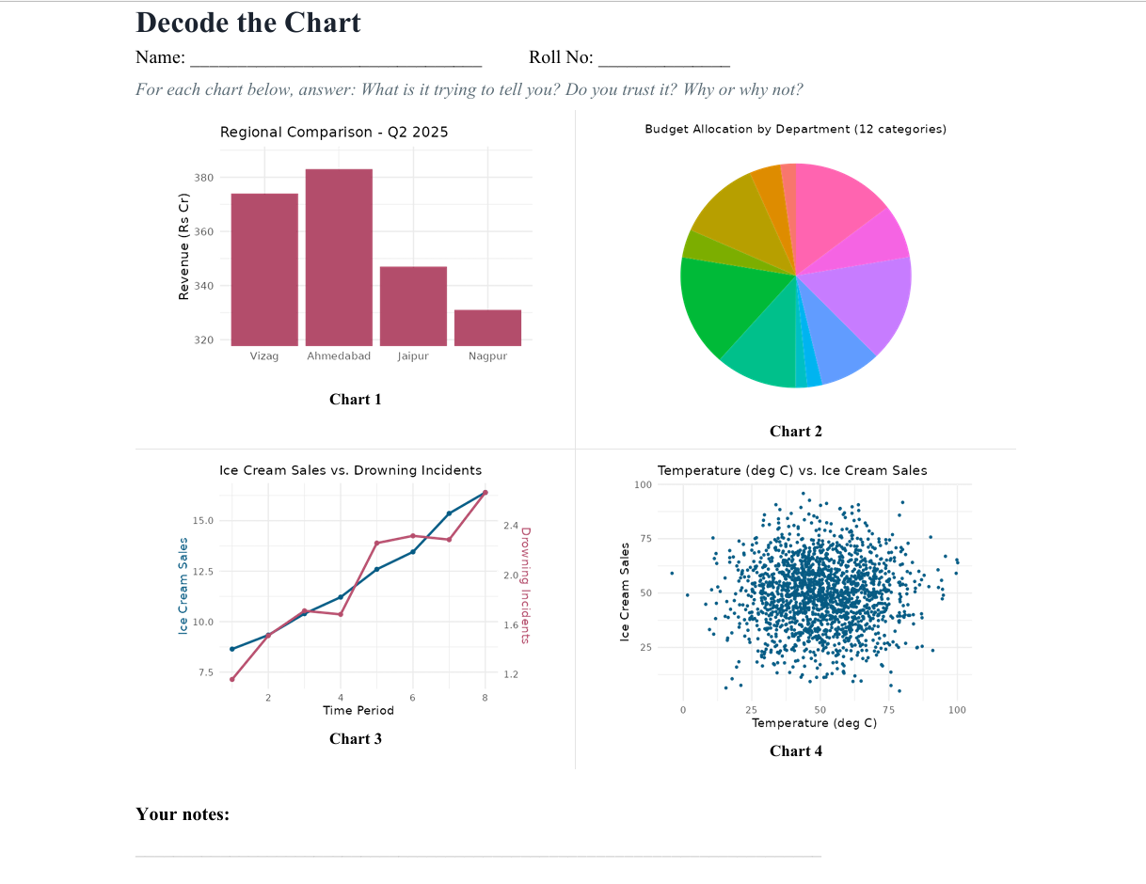
Chart 1: Regional Comparison – Q1 2026
What is it trying to tell you?
The bar chart compares regional revenue (in ₹ crore) for Vizag, Ahmedabad, Jaipur and Nagpur during Q1 2026. Ahmedabad has the highest revenue, while Nagpur has the lowest.
Do you trust it?
No, the chart is potentially misleading because its Y-axis starts at approximately ₹320 crore instead of zero. This truncated scale exaggerates the visual differences between the regions, making relatively small differences appear much larger.
Technical justification:
- The non-zero baseline distorts the proportional representation of the data.
- The apparent differences between bars are magnified.
- The chart may lead to incorrect conclusions about regional revenue performance.
Suggested improvement: Start the Y-axis at zero and use a uniform linear scale to represent the revenue values proportionally.

Chart 2: Budget Allocation by Department
What is it trying to tell you?
The pie chart represents the distribution of the total budget among 12 different departments. Each slice indicates a department's share of the overall budget.
Do you trust it?
Not entirely. The chart contains too many categories, making it difficult to compare the proportions accurately. Similar-sized slices are particularly difficult to distinguish using only their angles and colours.
Technical justification:
- Numerous slices increase visual complexity.
- Small differences in proportions are difficult to identify.
- Similar colours and narrow sectors reduce readability.
- Accurate comparison of individual departmental allocations becomes difficult.
Suggested improvement: Replace the pie chart with a sorted bar chart. Display the department names and their corresponding budget values or percentages directly.
Chart 3: Ice Cream Sales vs. Drowning Incidents
What is it trying to tell you?
The dual-axis line chart compares ice cream sales with drowning incidents over different time periods. Both variables generally increase over time, giving the visual impression of a positive relationship.
Do you trust it?
No. The apparent relationship may be misleading because the two variables use independent Y-axes. Their scales can be adjusted to make unrelated trends appear similar. Furthermore, a visual association does not establish a causal relationship.
Technical justification:
- Independent Y-axis scales can artificially align the two lines.
- Similar trends do not necessarily indicate statistical correlation.
- A third variable, such as temperature or seasonal activity, could influence both quantities.
- The chart does not establish that increased ice cream sales cause more drowning incidents.
Suggested improvement: Use separate charts with clearly labelled axes or analyse the relationship using an appropriate statistical correlation method. A common scale should be used only when the quantities and units are meaningfully comparable.

Chart 4: Temperature vs. Ice Cream Sales
What is it trying to tell you?
The scatter plot represents the relationship between temperature (°C) and ice cream sales. Each point corresponds to an observation, with temperature on the X-axis and sales on the Y-axis.
Do you trust it?
Not completely. The chart contains a large number of overlapping, fully opaque data points. This phenomenon, known as overplotting, makes it difficult to identify the true distribution and density of observations.
Technical justification:
- Overlapping points conceal the number of observations in dense regions.
- Data concentration and distribution patterns become difficult to interpret.
- Outliers and potential relationships may be obscured.
- The visual density of points may not accurately represent the underlying data distribution.
Suggested improvement: Apply partial transparency (alpha), use a two-dimensional histogram or hexbin plot, or use contour lines to represent the density of observations.

