SESSION — ACTIVITY (20 MIN) • STUDENT HANDOUT • SLOT D
Redesign the Misleading Colored Chart
Name: Jagarajupalli Bhanuprakash Reddy
Reg. No: 192524171
R.No: 15
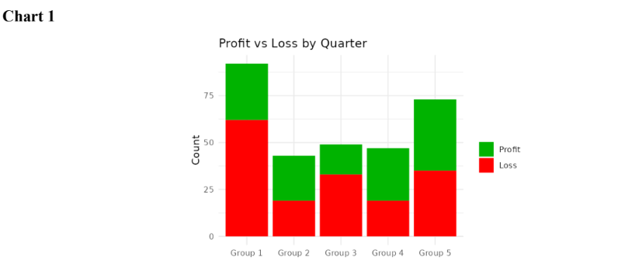
1. What is this chart trying to show?
- The chart shows the profit and loss values for different groups.
- There are five groups shown in the chart, from Group 1 to Group 5.
- The red part of each bar represents the loss.
- The green part of each bar represents the profit.
- The height of the red section shows the amount of loss for each group.
- The height of the green section shows the amount of profit for each group.
- Group 1 has a large loss and also a considerable amount of profit.
- Group 2 has a smaller loss and profit compared with some of the other groups.
- The chart allows us to compare the profit and loss values among the different groups.
- Overall, the chart shows how profit and loss are distributed across the five groups.

2. What's wrong with the colour choice?
- The chart uses red for loss and green for profit.
- These colors are different, but they may not be easy for everyone to distinguish.
- Some people may have difficulty identifying the difference between red and green.
- This can make it harder to understand which part represents profit and which part represents loss.
- The chart depends mainly on the colors to identify the two values.
- If the colors are not clearly visible, the information can become confusing.
- The strong red color may also attract more attention than the green section.
- The colors may therefore affect how a person looks at the different parts of the chart.
- It would be better to use two colors that can be easily distinguished from each other.
- The chart should make the difference between profit and loss clear without creating confusion.
3. Propose a better color scheme (describe it in words):
- I would change the colors used for profit and loss.
- I would use blue for profit and orange for loss.
- These two colors would make the two sections easier to distinguish.
- I would use the same blue color for profit in every group.
- I would also use the same orange color for loss in every group.
- This would make the chart consistent from Group 1 to Group 5.
- I would keep the labels “Profit” and “Loss” clearly shown in the legend.
- The colors should be simple and should not distract from the actual values.
- The viewer should be able to identify the two sections easily by looking at the chart.
- Overall, blue for profit and orange for loss would make the chart clearer and easier to understand.

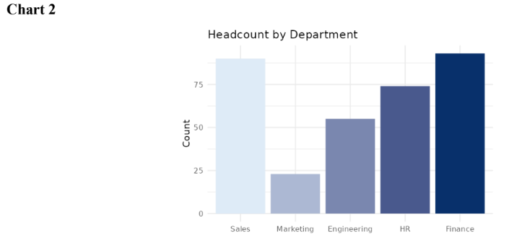
- What is this chart trying to show?
- The chart shows the number of employees in different departments.
- The departments shown are Sales, Marketing, Engineering, HR and Finance.
- The height of each bar represents the headcount of that department.
- Sales has a high number of employees compared with Marketing.
- Marketing has the lowest headcount among the departments shown.
- Engineering has more employees than Marketing.
- HR also has a higher headcount than Engineering and Marketing.
- Finance has the highest headcount among all the departments shown.
- The chart allows us to compare the number of employees in each department.
- Overall, it gives a clear picture of how the employees are distributed among the five departments.

2. What's wrong with the color choice?
- The chart uses a different shade of blue for every department.
- However, all the bars are showing the same type of information, which is headcount.
- The different shades do not represent any different type of data.
- Because of this, the colors do not add much useful information to the chart.
- The darker and lighter shades may make some bars attract more attention than others.
- A viewer may think that the different colors have some special meaning.
- But the chart does not give any meaning to these different shades.
- The actual comparison should mainly be based on the height of the bars.
- Using many shades of the same color can therefore make the chart slightly confusing or unnecessary.
- A simple and consistent color would make the comparison between departments clearer.

3. Propose a better color scheme (describe it in words):
- I would use one consistent color for all the department bars.
- For example, I would use the same blue color for Sales, Marketing, Engineering, HR and Finance.
- This would show that all the bars represent the same type of information.
- The viewer could then focus directly on the height of each bar.
- I would keep the background simple so that the bars are easy to see.
- I would use a slightly different color only if I wanted to highlight a particular department.
- For example, the Finance bar could be highlighted if it is important to point out the highest headcount.
- The remaining departments could continue to use the same basic color.
- The department names should remain clearly visible below the bars.
- Overall, a simple and consistent color scheme would make the chart easier to read and compare.

