A.  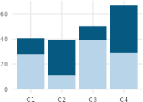 | 1. 1  Shows part-to-whole composition across categories
B.  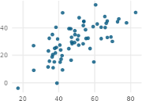 | 2. 10  Shows how parts contribute to a whole
C.  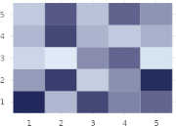 | 3. 5  Shows three variables at once using position and size
D.  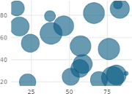 | 4. 3  Shows how a cumulative total changes over time
E.  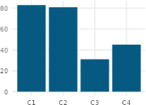 | 5. 8  Shows magnitude across two categories using color intensity
F.  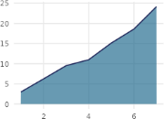 | 6. 4  Shows how a value changes over time
G.  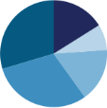 | 7. 2  Shows the distribution of a single continuous variable
H.  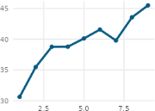 | 8. 6  Compares amounts across separate categories
I.  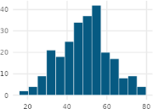 | 9. 7  Compares distributions across groups and highlights outliers
J.  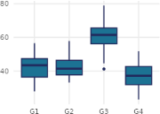 | 10. 9  Shows the relationship between two continuous variables

