DSA06 - Data Handling and Visualization | Activity 5: Normality Detection using Q-Q Plots | Slot D
Name: Jagarajupalli Bhanuprakash Reddy
Reg. No: 192524171
R.No: 15

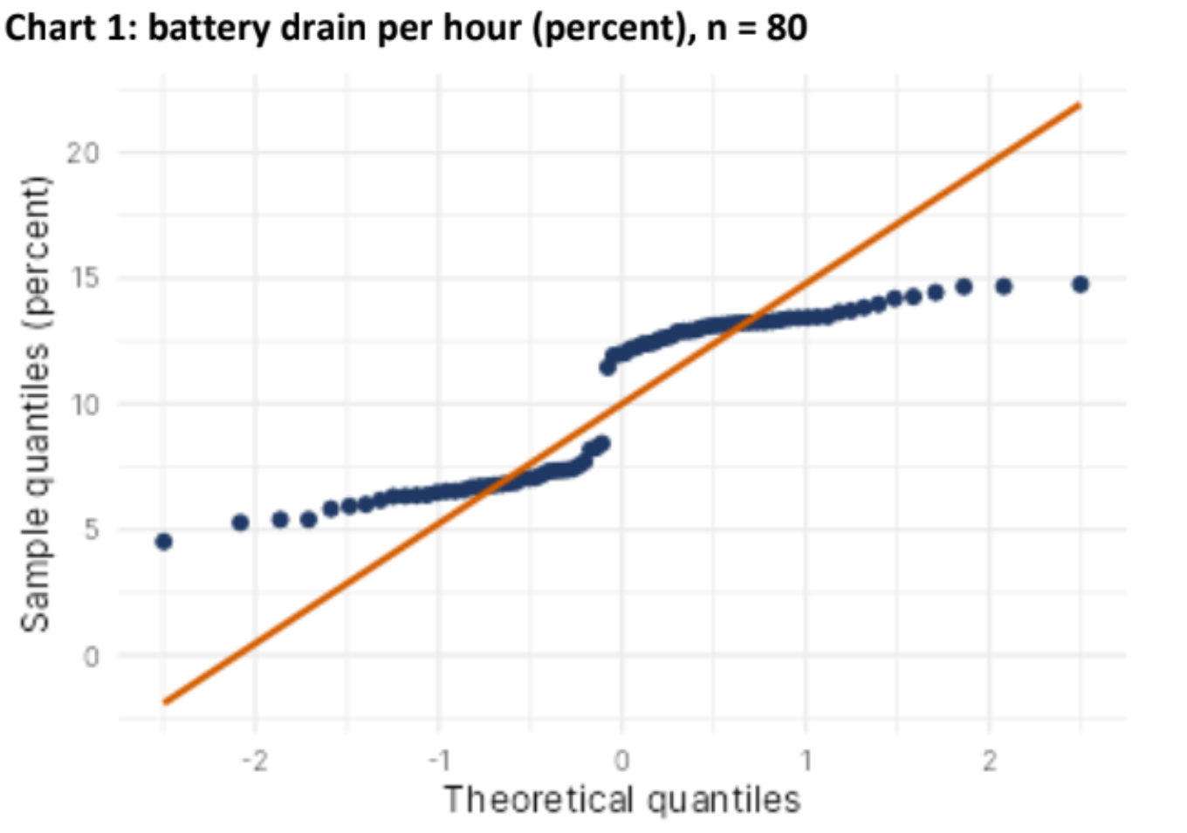
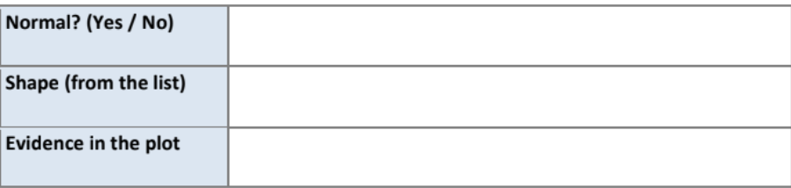
Normal? (Yes / No) | No
Shape (from the list) | Bimodal
Evidence in the plot | The points form two distinct clusters, one around 5–8% and another around 12–15%, with a clear jump between them. They do not follow the reference line, indicating a bimodal distribution.

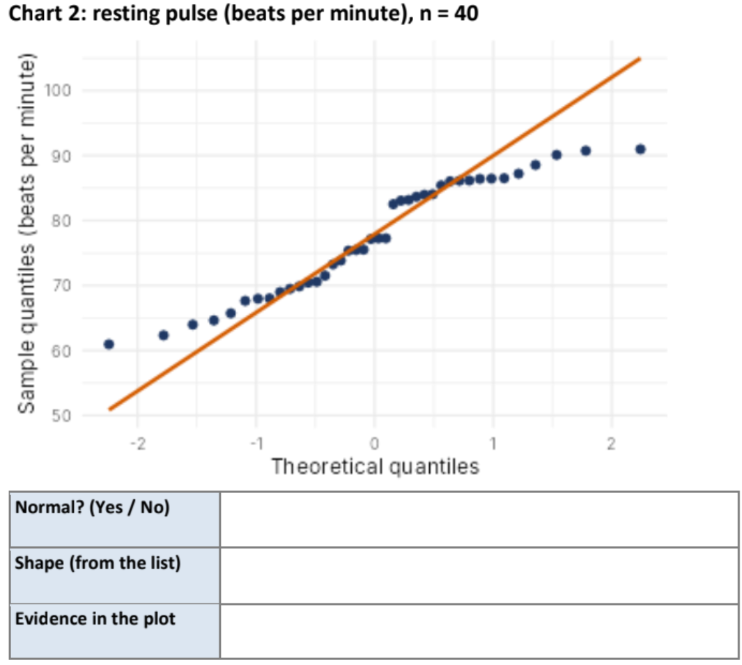
Normal? (Yes / No) | No
Shape (from the list) | Light-tailed
Evidence in the plot | The points deviate systematically from the reference line, especially at both ends. The tails show less extreme values than expected under a normal distribution, suggesting a light-tailed distribution.

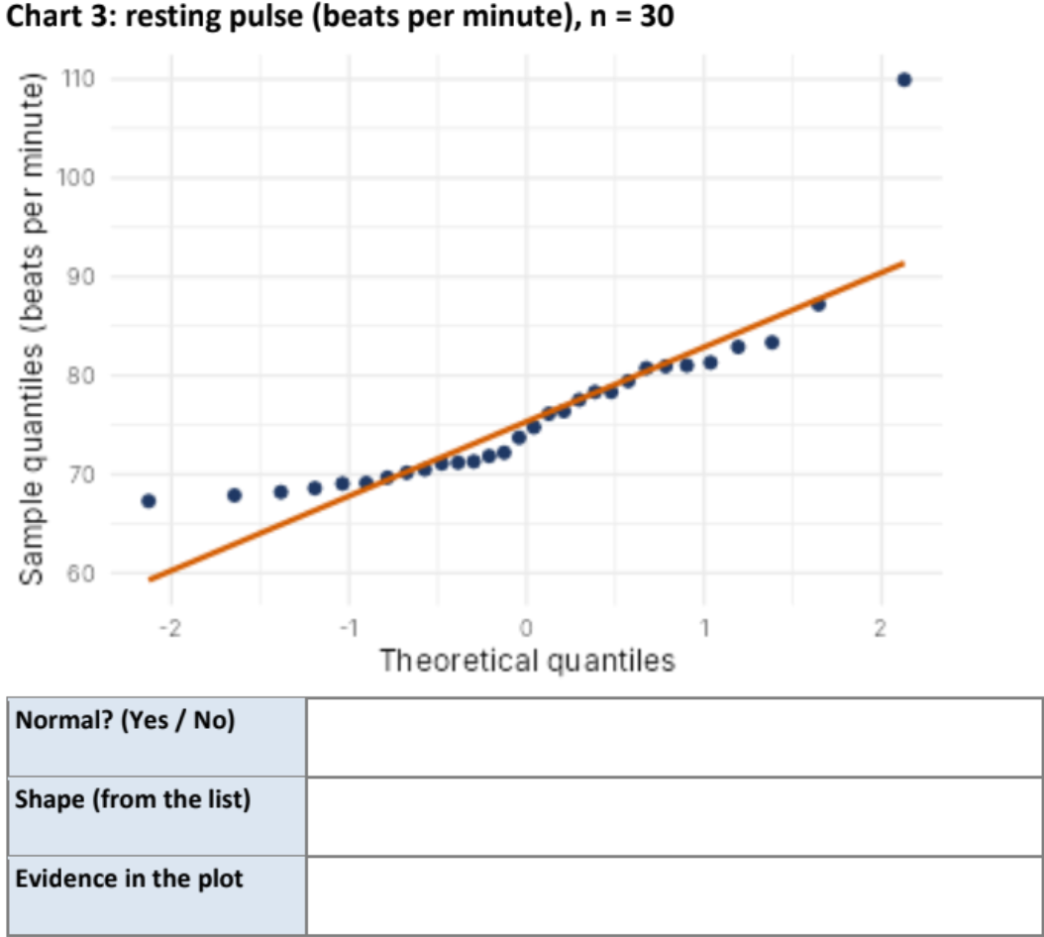
Normal? (Yes / No) | No
Shape (from the list) | Normal with outlier(s)
Evidence in the plot | Most points lie reasonably close to the reference line, but one point in the upper tail lies far above it at approximately 110 beats per minute. This indicates a possible high outlier.

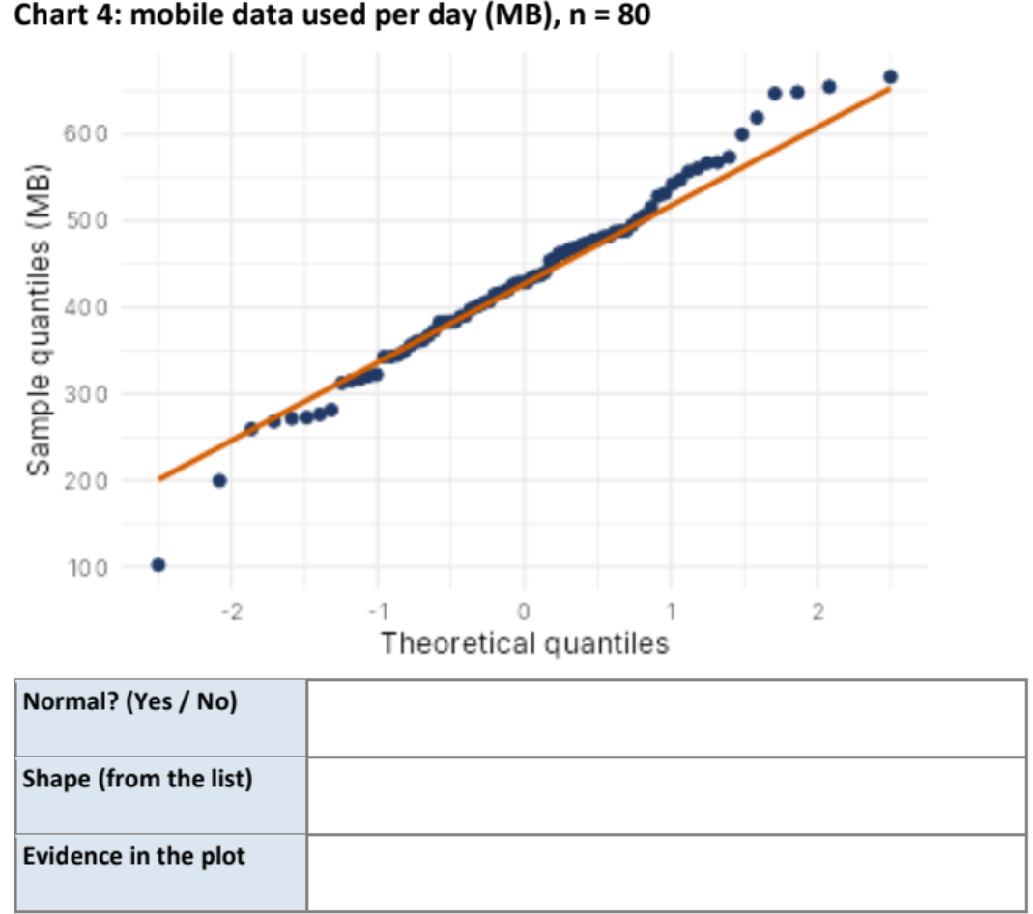
Normal? (Yes / No) | No
Shape (from the list) | Heavy-tailed
Evidence in the plot | The points deviate from the reference line at both extremes, with especially large departures in the tails. The extreme observations are farther from the line than expected under normality, suggesting heavy tails.
Part B (4 marks)
B1. Chart 1 departs from normality. Name the departure and state the remedy you would try before using mean-and-SD methods (for example log transform, square, split the data, robust methods). [2]
Chart 1 represents the distribution of battery drain per hour (percentage), with a sample size of (n = 80). The Q-Q plot shows a clear departure from normality because the points do not follow the straight reference line.
Departure from normality: The distribution is bimodal, meaning that it has two distinct clusters or peaks. One cluster lies approximately between 5% and 8%, while the second lies approximately between 12% and 15%. The noticeable gap or jump between these clusters suggests that the observations may come from two different operating conditions or groups.
Remedy: Before applying statistical methods based on the mean and standard deviation, I would investigate the reason for the two clusters. If they represent different groups, such as different device types or usage conditions, I would separate the data and analyse each group independently. If the groups cannot be separated meaningfully, I would consider robust statistical methods that are less sensitive to departures from normality. A transformation such as a logarithmic transformation may also be tested, although it may not remove bimodality.
Conclusion: The original data should not automatically be treated as normally distributed. The cause of the two clusters should be investigated before selecting an appropriate statistical method.

B2. Fill the blanks to draw a Q-Q plot with its reference line for a data frame df with a column value: ggplot(df, aes(sample = value)) + ________ + ________ [2]
The two required functions are:
- stat_qq() — generates the theoretical quantiles and sample quantiles and displays them as points.
- stat_qq_line() — adds a reference line to help compare the sample distribution with a theoretical normal distribution.
Completed R code:
library(ggplot2)

ggplot(df, aes(sample = value)) +
stat_qq() +
stat_qq_line()
Explanation: The data frame df contains the numerical column value. The aesthetic mapping aes(sample = value) specifies the sample whose distribution is being examined. The function stat_qq() plots the sample quantiles against theoretical normal quantiles, while stat_qq_line() adds the normal reference line. If the points lie approximately along the line, the data are consistent with normality. Systematic curvature, clusters, or extreme deviations may indicate skewness, heavy or light tails, multiple groups, or outliers.
Therefore, the blanks are: stat_qq() and stat_qq_line().

