Assignment-6.1
Name:J.Radha Krishna
HallticketNo:2303A52055
Batch No:39
____________________________________________________________________________________

Experiment 6
AI-Based Code Completion: Working with suggestions for classes, loops, conditionals
LO1. Use AI-based code completion tools to generate Python code involving classes, loops, and conditionals.
LO2. Interpret and explain AI-generated code line-by-line.
LO3. Identify errors, inefficiencies, or logical flaws in AI-suggested implementations.
LO4. Optimize AI-generated code for better readability and performance.
LO5. Demonstrate ethical and responsible use of AI tools in coding tasks.
____________________________________________________________________________________
Task Description #1 (AI-Based Code Completion for Loops)
Task: Use an AI code completion tool to generate a loop-based program.
Code:
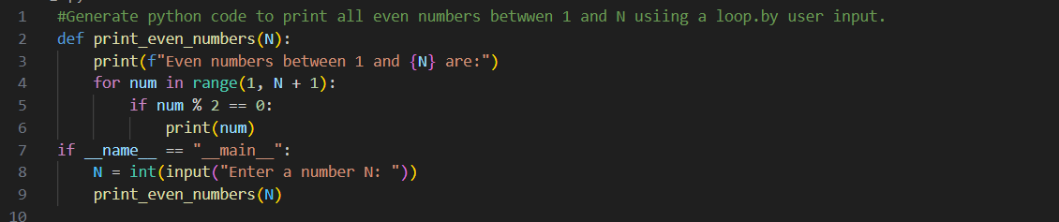
Explanation:
This program defines a function `print_even_numbers` that takes an integer N as input and
prints all even numbers from 1 to N. It uses a for loop to iterate through the range of numbers and checks if each number is even using the modulus operator (%)
If a number is even, it prints that number.
The main block of the code prompts the user to enter a value for N and calls the function to display the even numbers.

Output:
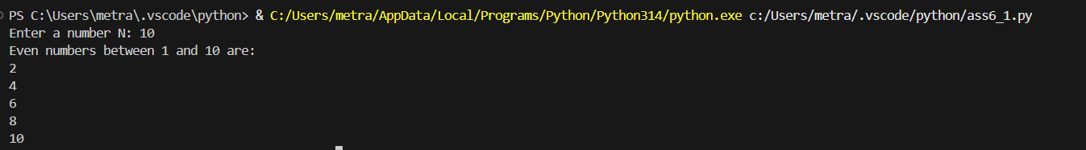
____________________________________________________________________________________

Task Description #2 (AI-Based Code Completion for Loop with Conditionals)
Task: Use an AI code completion tool to combine loops and conditionals.
Code:
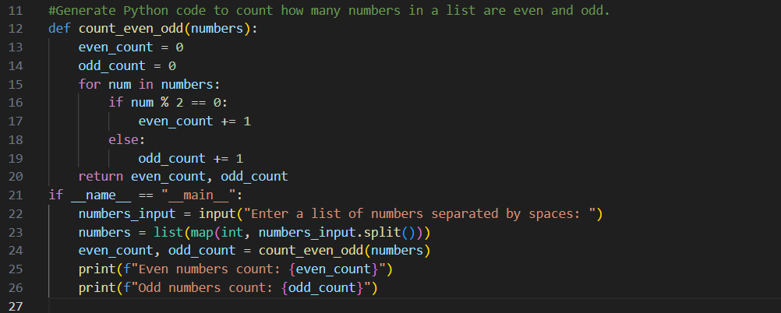
Explanation:
This program defines a function `count_even_odd` that takes a list of numbers as input and counts how many of those numbers are even and how many are odd.
It initializes two counters, `even_count` and `odd_count`, to zero.
It then iterates through each number in the list, checking if it is even or odd using the modulus operator (%).
Depending on the result, it increments the appropriate counter.
The main block of the code prompts the user to enter a list of numbers, splits the input into individual numbers, converts them to integers, and calls the function to get the counts.
Finally, it prints the counts of even and odd numbers.

Output:

____________________________________________________________________________________

Task Description #3 (AI-Based Code Completion for Class Attributes Validation)
Task: Use an AI tool to complete a Python class that validates user input.
Code:
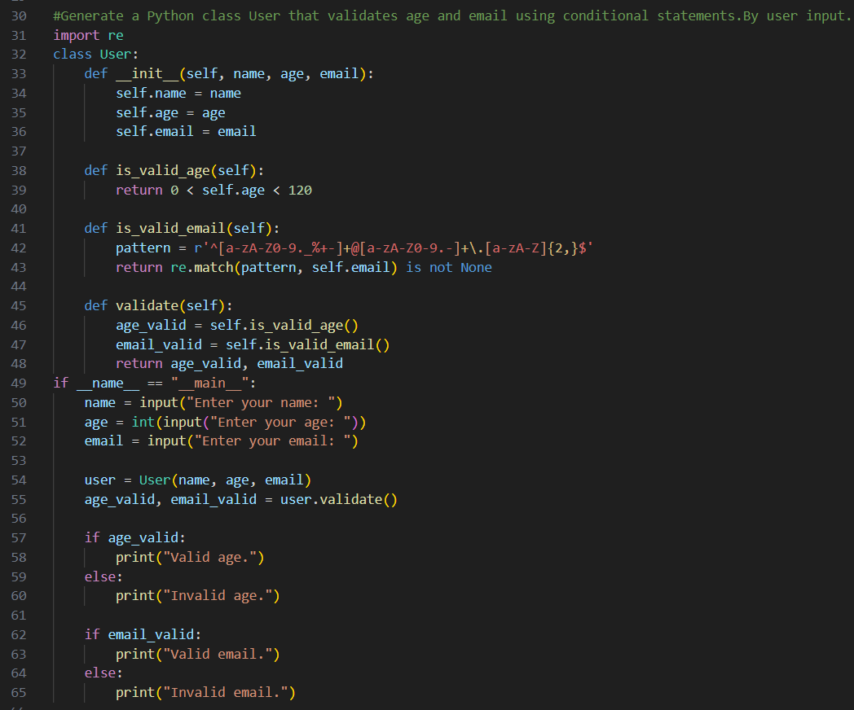
Explanation:
This program defines a `User` class with attributes for name, age, and email.
It includes methods to validate the age and email format using conditional statements and regular expressions.
The `is_valid_age` method checks if the age is within a reasonable range (0 to 120).
The `is_valid_email` method uses a regex pattern to validate the email format.
The `validate` method returns the results of both validations.
The main block of the code prompts the user to input their name, age, and email, creates a `User` object, and calls the `validate` method.
It then prints whether the age and email are valid or not.

Output:
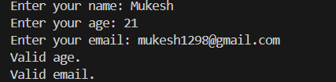

____________________________________________________________________________________

Task Description #4 (AI-Based Code Completion for Classes)
Task: Use an AI code completion tool to generate a Python class for managing student details.
Code:
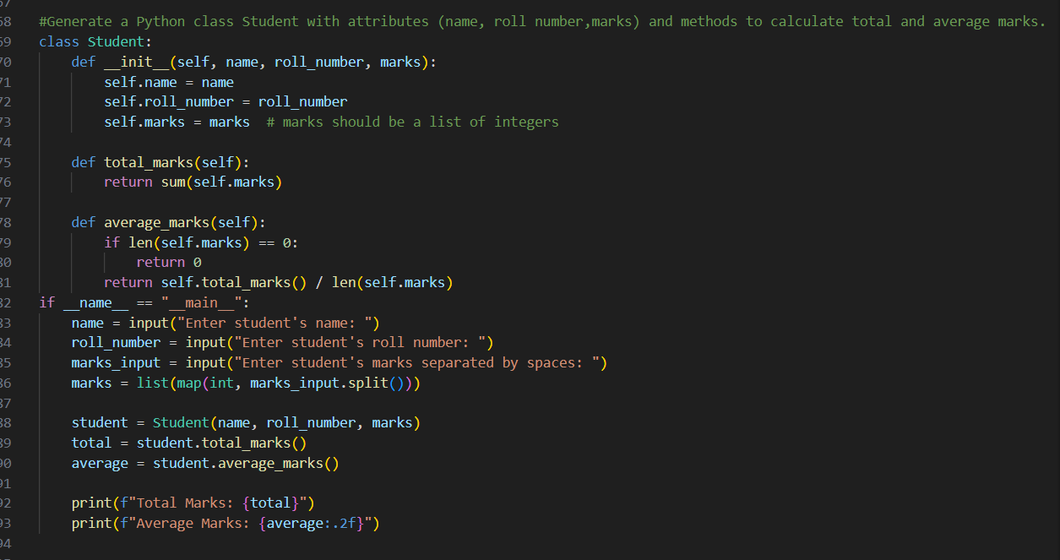
Explanation:
This program defines a `Student` class with attributes for name, roll number, and marks (a list of integers).
It includes methods to calculate the total marks and average marks.
The `total_marks` method sums up all the marks in the list.
The `average_marks` method calculates the average by dividing the total marks by the number of subjects, handling the case where there are no marks to avoid division by zero.
The main block of the code prompts the user to input the student's name, roll number, and marks, creates a `Student` object, and calls the methods to get the total and average marks.
It then prints the total and average marks formatted to two decimal places.

Output:
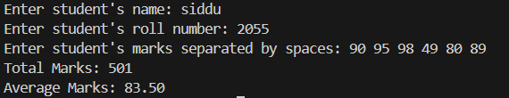
____________________________________________________________________________________

Task Description 5 (AI-Assisted Code Completion Review)
Task: Use an AI tool to generate a complete Python program using classes, loops, and conditionals together.
Code:
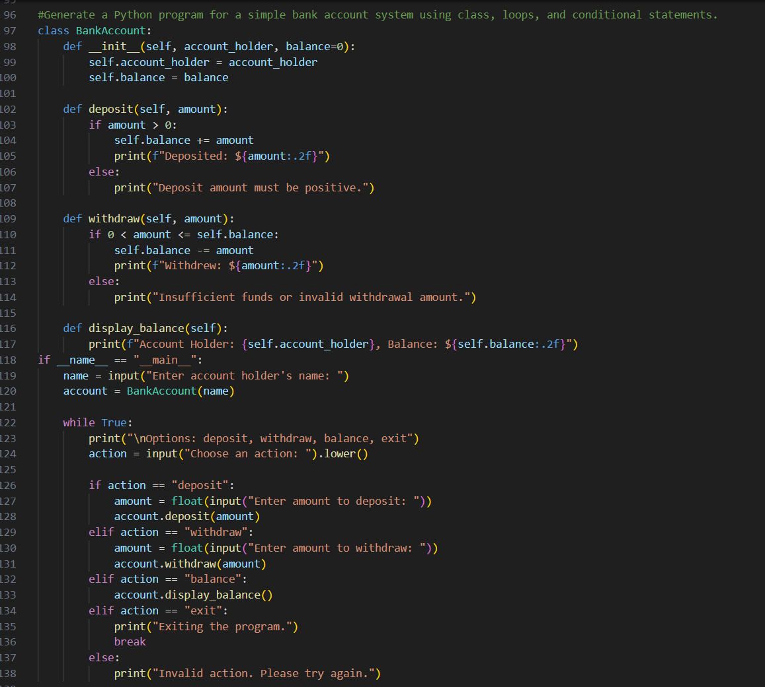
Explanation:
This program defines a `BankAccount` class with methods to deposit, withdraw, and display the account balance.
The `deposit` method adds a specified amount to the balance if the amount is positive.
The `withdraw` method deducts a specified amount from the balance if there are sufficient funds.
The `display_balance` method prints the account holder's name and current balance.
The main block of the code prompts the user to enter the account holder's name and creates a `BankAccount` object.
It then enters a loop where it presents the user with options to deposit, withdraw, check balance, or exit the program.
Based on the user's input, it calls the appropriate method on the `BankAccount` object and
handles invalid actions gracefully.

Output:



