**SAMPLE IEEE PAPER TITLE**

John Doe, Jane Smith

Department of Computer Science, University XYZ; Department of AI, Institute ABC

johndoe@example.com, janesmith@example.com

**Abstract**

**This is the first paragraph of the abstract.**

**This is the second paragraph of the abstract.**

**Keywords**

AI, Machine Learning, Data Science

**I. INTRODUCTION**

This section introduces the topic of AI and machine learning. [*] This is a significant finding in the field of AI. For more information, see [Research Article](https://example.com/research-article).This section introduces the topic of AI and machine learning. [[footnote: This is a significant finding in the field of AI.]] For more information, see Research Article.

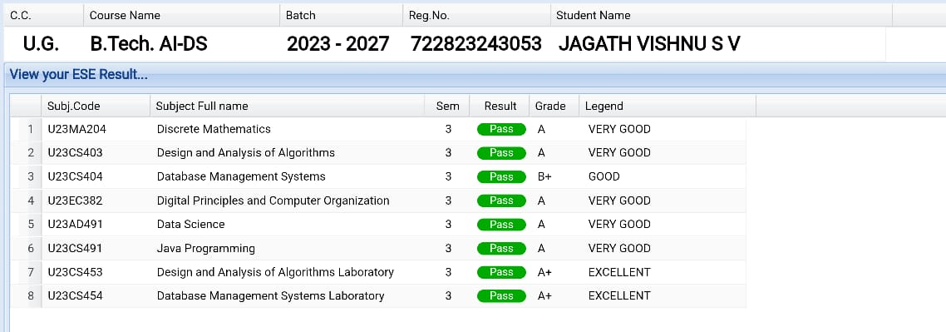

Fig. 1: AI Concept Diagram

|  |  |
| --- | --- |
| Header 1 | Header 2 |
| Data 1 | Data 2 |
| Data 3 | Data 4 |

Table 1: Data Table



Equation 1.1: \frac{a}{b} = c

**I.A Background**

This subsection provides background information on AI.This subsection provides background information on AI.

**II. METHODOLOGY**

This section describes the methodology used in this research. [*] Methodology details are crucial.This section describes the methodology used in this research. [[footnote: Methodology details are crucial.]]



Fig. 2: Methodology Flowchart

|  |  |
| --- | --- |
| Step | Description |
| Step 1 | Data Collection |
| Step 2 | Data Processing |

Table 2: Data Table



Equation 2.1: \int_0^1 x^2 \, dx

References

J. Doe, 'Introduction to AI', AI Journal, 2023.

J. Smith, 'Advances in Machine Learning', ML Journal, 2024.

Appendix

Appendix A: Additional Data and Information.

Appendix B: Extended Methodology.