**COMPREHENSIVE AI PAPER TEST**

Alice Example, Bob Sample

Dept. of Computer Science, Test University; AI Lab, Sample Corp

alice@example.edu, bob@sample.com

***Abstract—***

**This two‑paragraph abstract tests formulas, links, and footnotes.**

**We demonstrate how the system handles multiple lines, citations, and formatting.**

Keywords

Artificial Intelligence, Document Generation, IEEE Style, Hyperlinks

I. INTRODUCTION

Artificial Intelligence (AI) has transformed many fields. See [1] for an example platform, and also check https://arxiv.org/abs/1234.5678 for a research paper. Early AI work dates to the 1950s.[*] Foundational AI research began in the 1950s.

II. BACKGROUND

The mass–energy equivalence formula is given by E=mc^2, which we will render as a formula below.

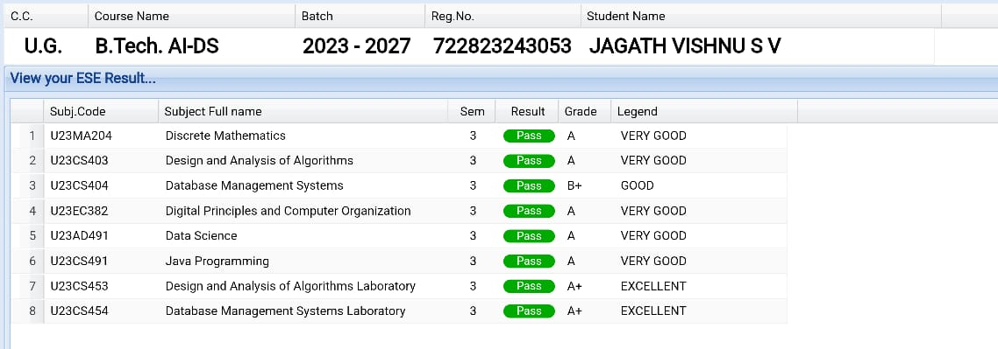

Fig. 1: System Architecture

|  |  |
| --- | --- |
| Algorithm | Accuracy |
| Model A | 91% |
| Model B | 89% |

Table 1: Data Table

|  |  |
| --- | --- |
|  | (1) |

A. Math Preliminaries

We also need the integral ∫₀^∞ e^{-x^2} dx = √π/2 and reference [2].

|  |  |
| --- | --- |
| Symbol | Meaning |
| π | Pi constant |
| e | Euler’s number |

Table 2: Data Table

|  |  |
| --- | --- |
|  | (2) |

III. METHODOLOGY

We fine‑tuned GPT models. See https://openai.com again to test duplicate filtering.

REFERENCES

[1] J. McCarthy, “Programs with Common Sense,” in _Mechanization of Thought Processes_, London: HMSO, 1959.

[2] T. Mikolov et al., “Efficient Estimation of Word Representations,” arXiv preprint arXiv:1301.3781, 2013.

[3] Example Corp, “Sample Whitepaper,” 2020. [Online]. Available: <https://example.org/whitepaper>

[4] [Online]. Available: <https://openai.com>

[5] [Online]. Available: <https://mathworld.wolfram.com>

Appendix

Appendix A: Additional figures and tables are in the supplementary folder.

Appendix B: Full training configuration and hyperparameters.