AI Financial Vigilance: Detecting Anamolies and Anticipating Market Movements

Dr.Satishkumar G   
*AI&DS . Sri Eshwar College   
of Engineering*  
*Anna University*Chennai, India  
---

***Abstract*—** **Traditional risk management techniques have been unable to deal with the rising complexity and volatility that describe financial markets. This proposal is a new AI-based financial risk management system intended at identifying anomalies in and trends of market behaviors for the betterment of decision-making powers for investors and financial institutions. Advanced techniques, for instance, reinforcement learning (RL), LSTMs, Transformers, and graph neural networks (GNNs), are used to face real-time and historical data in large quantities to decrease exposure to fraud and market risks. Here, methodology follows a streamlined process of gathering data, preprocessing, feature engineering, and model selection. All activities on social media plus transactions and credit scores are taken care of through very careful cleaning and transformations to boost accuracy. Credit risk is analysed using Random Forests, Gradient Boosting Machines, and deep learning models that involve temporal dependencies within their computations. The system will be covered by AI-enabling technologies for the detection and mitigation of risks, including autonomous monitoring and natural language processing for the proactive diagnostic of failures. GNNs also analyze systemic risk in financial networks while RL optimizes trading strategies. It includes blockchain to ensure integrity and data privacy since cyber threats, especially ransomware, are getting higher with each passing day. Since performance is monitored, there is feedback to continually adapt the system according to the changing conditions of the market. The AI-based framework gives options to develop the current best practices in financial risk management into further AI-driven advances of financial analytics that make decisions safely and effectively.**

Keywords— AI-powered financial risk management, machine learning, reinforcement learning, LSTM, credit risk assessment, fraud detection, blockchain, cybersecurity risks

**INTRODUCTION**

These are going to increase complexity, volatility, and risk in financial markets. Therefore, methods which have been utilized to manage it for such a long period, although appropriate for traditional settings, are turning out not effective in solving problems faced newly in newly designed systems. This project aims to design an AI-powered financial risk management system, which bases decision-making mechanisms on sophisticated machine learning

techniques and deep learning mechanisms by detecting anomalies in financial data using future market trends prediction for the correct movement of risk analysis-based choices in finance.

The system proposed will assist investors and institutions in taking better decisions by considering the vast volumes of real-time data along with the historic data, thereby reducing market risk exposure and facilitating the identification of fraudulent activities. It would also include machine learning models to help in analyzing credit risk, market risk, fraud detection, and cybersecurity risk management.

Advanced techniques employed are Reinforcement Learning (RL), Long Short-Term Memory (LSTM), Transformers, and Graph Neural Networks (GNNs) applied to build dynamic and adaptive models that transform changing market conditions and risks into actionable leads. The system in this design will constantly be monitored, evaluated, fed back so that it might learn live data to keep predicting beyond long-term accuracy and relevancy.

It will revolutionize the approach of financial institutions towards risk management: by using artificial intelligence, this project predicts not only where risks would likely arise and in what future movements, but also patterns that may signal potential threats before they escalate.

***LITERATURE REVIEW***

Artificial Intelligence and Financial Services: A Perspective

Artificial intelligence will do wonders to the development of financial service because it allows the upgrading and modernization process of fraud detection, risk evaluation, as well as forecasting. The present static and rule-based methods fail to cope with the rapid evolution of complexity in the financial market.

This is a review of the course AI has taken and conquered in financial forecasting and the all-changing AI-driven risk management landscape.

Convention approaches to financing and their limitations. For decades, the traditional statistical method was the only arsenal in the financial forecasting paradigm. Time series and econometric models like ARIMA and regression applied mainly to extract market trends and evaluate financial risk. Even though they relate linearly pretty well, they fail with the complexity of the non-linear types found in financial markets.

The model is not suitable for the ARIMA model since it has high volatility and faster transitions in the market; it strictly depends on historical data. The regression model relies on stable relationships between variables, which puts it at a disadvantage regarding fraud detection since most of the detected frauds happen to be false positives. Such rigid models fail to detect occluded patterns or anomalies in the highly complex data era, with the chance to mitigate risks in real-time being lost.

Artificial intelligence and Predictive Analytics New Paradigm. AI and predictive analytics truly set the world on fire in terms of finance, forecasts because the ML technique does not mimic other classic models but instead considers a giant volume of data and extracts previously hidden relationships.

This led to the development of supervised learning algorithms, like random forests and SVMs, which advanced fraud detection into properly categorizing both history and real-time data. The models continue to evolve with new insights, thus enabling them to evolve with adaptation of the emergence fraud tactics.

The research works show that the AI-based fraud detection system has minimized false positives to a minimum level. Organizations target real threats and avoid disrupting legitimate transactions. Such systems perfectly and promptly identify suspicious activities with real-time data, thereby bringing minimal chances of fraud. Deep learning, which is a subdivision under machine learning, also largely adds biceps to AI abilities.

LSTMs are feasible enough to move beyond the time series to establish their potential worth in the case of financial forecasting. As a case in point, the LSTMs can understand intricate dependencies over time for the stock market and can predict trends and movements much better than usual models.

Interpreting trends is a fundamental part of investment and risk management; thus it is very crucial in the world of economics.

AI fraud detection systems. AI-powered fraud detection systems significantly enhance the fight against financial crimes. Not like a set rule-based logics, AI systems rely on their capabilities of machine learning to identify new methods of frauds. Autoencoders and Isolation forests are some examples of unsupervised models that understand what's called normal transaction behavior and flag those aberrations as potential frauds. Isolation forests identify sophisticated frauds that do not follow pre-established patterns.

Such systems process huge amounts of data in real-time and alert concerning suspicious transactions in real time. This helps restrict financial losses and also enables effective measures to be taken. It reduces false positives, thus improving customer satisfaction and trust with the AI model.

Ethical Issues

Even as AI signals change or revolution in financial services, the challenges of implementation are fraught with major ones. High-quality data is a major problem because biased or incomplete data might yield wrong or irrelevant predictions. For example, if the historical biases-in say, lending practices-noted in the training data feeding the AI models are what their respective histories would perpetuate, then the model is likely to dishing out unfair results in credit risk assessment. The primary reason is that deep learning models are often not transparent. Deep learning methods are highly accurate but often lack functionality as a "black box." This means financial organizations find it hard to understand what AI predicts in such situations, which may create compliance issues, particularly with regard to the explanation of certain decisions of the predictive AI system to stakeholders or regulators. Strengthening data governance by financial institutions will allow them to adopt responsible AI, striking the balance required among concerns about customer privacy, which are actually at the foundation of trust in AI systems. Developmental Predictions The future of AI appears to be hopeful regarding financial forecasting and risk management. Researchers are looking into how blockchain and IoT will intersect with AI in order to detect fraud and improve on risk assessments. Quantum computing can be the future of predictive analytics: allowing AI models to process large datasets in predicting even the smallest variances possible in value with accuracy. This is going to significantly improve on the process of instantaneous financial decision-making through predicting market risks and fluctuations much faster than was possible. With continuous development of AI through some better models, quality data, and safety, this should further create fair and accountable AI-supported financial models.

**PROPOSED METHODOLOGY** The project is aimed at designing an AI-powered financial risk management system that could detect anomalies and predict market trends. The proposal methodology outlines the systematic approach concerning data collection, model selection, training, building, evaluation, and implementing of risk management strategies.  
The unpredictability created in the financial market has significant impacts and risks on investors and institutions. This methodology is trying to reduce these risks by introducing more advanced techniques of machine learning for the detection of anomalies in financial data and the prediction of market movements.

***Data Collection***  
Financial tasks entail gathering huge amounts of data from various sources. Included in these is customers' financial information which would contain credit history, loan amounts, and income levels, access might be necessary by seeking financial institutions or bureaus of credit like Experian or Equifax. Transaction data-the debit/credit card usage and online transactions-will be accessed from banks and payment service providers like Visa and PayPal. Some of the relevant data sources upon which this is built include stock market data such as stock prices, trading volume, and macroeconomic indicators from exchanges like NYSE and NASDAQ as well as databases like Bloomberg and Yahoo Finance. The public sentiment data is derived through NLP from news agencies like Reuters and Bloomberg, social media like Twitter and Reddit, and financial blogs.

***Pre-processing***

Pre-processing refers to the process of obtaining the raw  
Financial time series data to effectively train the model.

Cleaning: Eliminates or replace missing values of data and data anomalies.

Normalization: Scaling the data features to a common scale without distorting differences in the ranges of values to help neural networks converge more quickly. Using Z-score normalization data conforms to a normal distribution 0 or 1.

* Calculate the mean
* Calculate the standard deviation: $σ$
* **Normalize the Data:** For each data point apply the Z-score normalization formula

$$Zi=Xi- μ{}/{}σ$$

This results in a new dataset where each feature has a mean of 0 and a standard deviation of 1

**Feature Engineering**

For time-series data that is market trends lag features such as previous closing prices and moving averages such as 7-day, 30-day to track trends over a period of time.

Credit Features: In credit risk prediction, features like debt-to-income ratio, loan-to-value ratio, and payment history trends are engineered to represent significant credit behavior insights.

For fraud detection, the transaction frequency, size, deviation from the normal are used to identify fraudulent activities.

***Credit Risk Management***  
Machine learning techniques have gained popularity lately, with ensemble methods on top of the list: Random Forests and XGBoost.

Random Forest uses multiple decision trees that culminate into one output for the prediction and does well when different data types are involved..

The training includes multiple decision trees with the model being trained with features such as credit history, income, loan amount. The formula for prediction is given by :

$$Prediction=mode(T1​(x),T2​(x),…,Tn​(x))$$

XGBoost is implemented to optimize the model to minimize the loss function while handling weights based on gradient descent.

Loss function:

$L\left(θ\right)= \sum_{i=1}^{n}{l}\left(Yi, \hat{Y}i\right)+\sum_{k=1}^{k}{Ω(}Fk)$

The final prediction is given by:

$$\hat{Y}=\sum_{k=1}^{k}{Fk(x)}$$

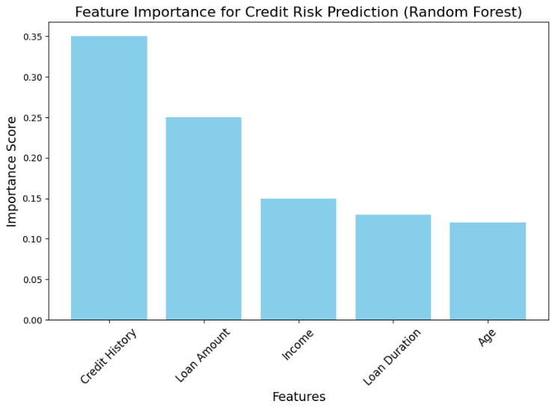

***Market Segmentaion***Market segmentation is an essential technique to identify different customer groups based on their behaviors and preferences. In the current project, K-Means Clustering is applied for grouping customers based on chosen features which include transaction frequency and spending behavior. The exact steps and formulas applied for the implementation of K-Means are given below in detail:

The K-Means algorithm begins with **K** centroids, which represent the centers of the clusters. The centroids can be randomly choosen from the dataset or determined through methods like K-Means++.

Every data point is assigned to the nearest centroid on basis of **Euclidean distance**. This involves calculating the distance between each data point and each centroid.

$$D\left(Xi,Cj\right)= \sqrt{}\sum_{m=1}^{m}{ {(Xim-Cjm)}^{2}}$$

Where m is number of features , Xi is vectors of features and Cj is centroid of clusters.

Having now assigned all points to appropriate clusters, the centroids are now re-computed as a function of assigned data points. That means the feature average of all the points assigned to each cluster is taken.

$$Cj= \frac{1}{Nj} \sum_{Xi∈Cj}{Xi}$$

As algorithm converges would therefore give rise to the clusters found, thereby describing various customer segments in terms of frequency and related spending behavior. Clusters obtained may now be explored to create focused marketing campaigns, applied within consumer profiling, and for customized services. The image visualizes customer segmentation using K-Means clustering, with clusters displayed in different colors.

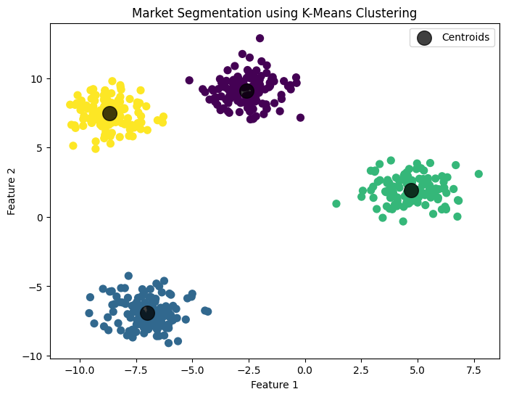

***Market Trend Prediction***  
This is based on the use of three complex machine learning models: namely, LSTM networks, CNN, and transformers. Each model will describe its architecture in order to identify the temporal dependencies and patterns within a historical sequence of data and prices.

1. LSTM Implementation

One of the predispositions of LSTM networks to long-term dependencies makes them suitable for time series forecasting. This has many parts which determine how information flows in the architecture of an LSTM.

The LSTM model is trained using historical stock price data, the LSTM updates its weights based on the gradients of the loss function, optimizing the predictions for future stock prices. Focusing on the two main LSTM formulas for our prediction :

**1.Cell state update** :

2. **Hidden State Update: $h_{t}=o_{t}∙\tan{h}(C_{t})$**

**2.Convolutional Neural Networks**

CNNs can be applied to time series data as well. The convolutional layers capture local dependencies and patterns in the data.

Execution Process:

CNN architecture also contains a number of layers of convolutions with the activation functions ReLU and some pooling layers reduce the dimensions. After some layers, the fully connected layers are utilized to generate the forecasted market trend it may look like a form of either a price or classification of a trend, for instance upward, downward.

The CNN operation for time series data is defined as:

$$\left(I*K\right)\left(x,y\right)= \sum_{m}{\sum_{n}{I\left(x+m,y+n\right) K(m+n)}}$$

***3.* Transformer Implementation**

They are robust architectures which use self-attention mechanisms for identifying relationships within the sequential data, independent of recurrent structures. Their competence in capturing long-range dependencies makes them particularly valuable for the task of time series forecasting.

Attention Mechanism is related to the task of evaluating how different parts of input data might interact. Computing Attention Score:

$$ATTENTION\left(Q,K,V\right)=softmax\left(\frac{{QK}^{t}}{\sqrt{d_{k}}}\right)V$$

This plot showcases the actual stock prices with our predicted prices on the same graph, allowing you to clearly see how well the LSTM is fitting the trend.

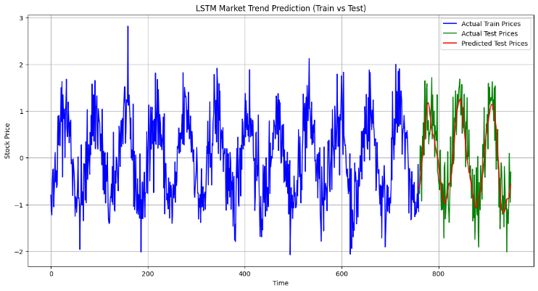

***Fraud Detection***   
Fraud Detection is implemented using autoencoders and isolation forest in detection of anamolies in transaction data.

**Autoencoders :** Autoencoders can only be applied for anomaly detection by acquiring the feature of reconstruction capability for typical transaction data. Basically, it follows the fact that an autoencoder learns typical transactions and may fail in reconstruction of anomalies like fraud. The autoencoder is trained using historical transaction data. Its main objective is to imbibe data into a latent space using the encoder and decode it with maximum fidelity to the original data.

Once learned, an autoencoder attempts to reconstruct new transaction data. For normal data, its reconstruction should be close to the original transaction and potential fraud for anomalous data; there will be a much higher reconstruction error.

 Formula In anomaly detection reconstruction error is defined as follows:

$$Reconstruction error= {\left\|x-\hat{x }\right\|}^{2}$$

This autoencoder is used for detecting fraud by passing the transactions through it and picking out those transactions that have a higher reconstruction error. These transactions with error rates above a threshold are marked suspicious.

**Isolation Forest :** Isolation Forest is yet another anomaly detection algorithm, which works on the idea of isolating the outliers or anomalies from the normal data points by generating random splits in the feature space. Such anomalies are to be isolated quickly because they are rare and deviating from the majority of the data. The algorithm constructs a set of random decision trees. Here, each tree was built recursively by splitting the data based on

randomly selected features and split values.  
After constructing the forests, each data point is given an anomaly score that is described as the average path length through all forests.

The formula for the anomaly score is:

$$s\left(x\right)=2^{-\frac{E(h\left(x\right))}{C(n)}}$$

Random decision trees are created, and anomalies are determined by their average path length in these trees; that is, shorter lengths are identified as suspicious. Those transactions which have a higher score in anomaly are marked suspicious. The image visualizes the reconstruction error of an Autoencoder model that helps detect anomalies in transaction data.

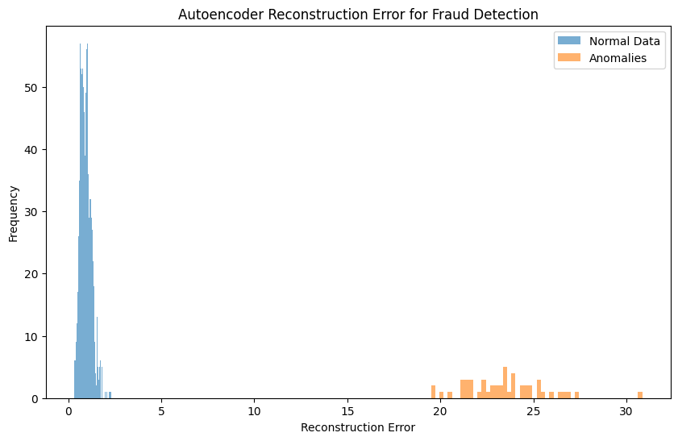

|  |  |  |
| --- | --- | --- |
| Use Case | Key Feature | Algorithms |
| Credit Risk Prediction | Predict credit based on historical data | Random Forest, XGBoost |
| Market Segmentation | Discover patterns in unlabeled data | K-means  Clustering |
| Market Trend  prediction | Learn large datasets, predict sequence | LSTM, CNN  Transformers |
| Fraud  Detection | Identify irregularities in transaction data | Autoencoder  Isolation  forest |

### **Results and Discussion:**

The **Results** section presents the data or findings of the research, while the **Discussion** interprets these results, explaining their significance, implications, and how they relate to the research question and existing knowledge. Both are essential for a full understanding of the study's outcomes and their broader context.

**About the dataset**

The Financial Risk Assessment Dataset provides detailed information on individual financial profiles. It includes demographic, financial, and behavioural data to assess financial risk. The dataset features various columns such as income, credit score, and risk rating, with intentional imbalances and missing values to simulate real-world scenarios.

1. CONFUSION MATRIX

Ac-Accuracy, P-Precision, Rc-Recall, St-Sensitivity

|  |  |  |  |  |  |  |  |
| --- | --- | --- | --- | --- | --- | --- | --- |
|  | TP | TN | FP | FN | Ac | P | Rc |
| DT | 62 | 75 | 4 | 2 | 0.958041958 | 0.939393939 | 0.96875 |
| RF | 87 | 51 | 3 | 2 | 0.965034965 | 0.966666667 | 0.97752809 |
| XGB | 79 | 56 | 0 | 8 | 0.944055944 | 1 | 0.908045977 |
| SVM | 88 | 51 | 2 | 2 | 0.972027972 | 0.97777778 | 0.977777778 |

|  |  |  |  |
| --- | --- | --- | --- |
| St | F1 | Kappa Score | Specificity |
| 0.96875 | 0.953846154 | 0.915401302 | 0.949367089 |
| 0.97752809 | 0.972067039 | 0.925341965 | 0.944444444 |
| 0.908045977 | 0.951807229 | 0.885508407 | 1 |
| 0.977777778 | 0.977777778 | 0.940041929 | 0.962264151 |

**About Performance measure:**

1. Accuracy

Accuracy measures the overall correctness of the model. It is the ratio of correctly predicted observations to the total observations.

**Accuracy=TP+TN/TP+TN+FP+FN**

Where:

* TP = True Positives
* TN = True Negatives
* FP = False Positives
* FN = False Negatives

2. Precision

Precision indicates how many of the positively predicted instances are actually positive.

**Precision=TP/TP+FP**

3. Recall (Sensitivity or True Positive Rate)

Recall measures the model's ability to correctly identify all relevant instances.

**Recall=TP/TP+FN**

4. F1 Score

The F1 score is the harmonic mean of precision and recall. It balances the trade-off between precision and recall.

**F1 Score=2×Precision×Recall/ Precision+ Recall**

5. Kappa Coefficient (Cohen's Kappa)

Cohen's Kappa measures the agreement between two raters (your model and the ground truth), adjusted for the agreement by chance.

**Kappa coefficient = 2×(TP×TN-FN×FP)/(TP+FP) ×(FP+TN) +(TP+FN) ×(FN+TN)**

**Time complexity:**

**1.Decision Tree**

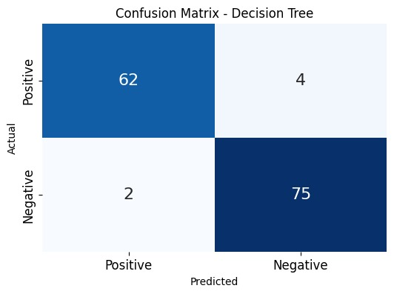

With 62 true positives, 75 true negatives, and only 6 misclassifications (false positives + false negatives), the Decision Tree model performs quite well on this dataset.  
Considering the notable accuracy of 95.8% and precision of 93.9%, the Decision Tree demonstrated efficiency in both training and prediction processes, rendering it an appropriate model for the current dataset.

**2.Random Forest**

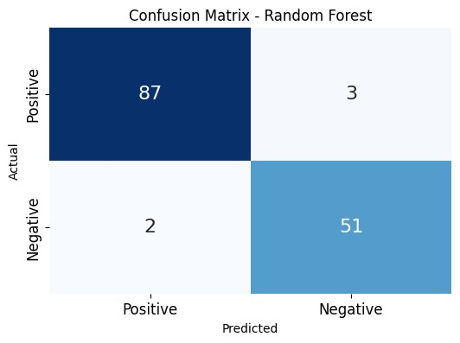

With 87 true positives and 51 true negatives, Random Forest reduced false positives and had a higher accuracy of 96.5% than that of the Decision Tree. This is also a computationally intensive task but rather more than a single Decision Tree, yet improved in performance relative to both accuracy and recall, so makes RF more robust .

**3.XGBoost**

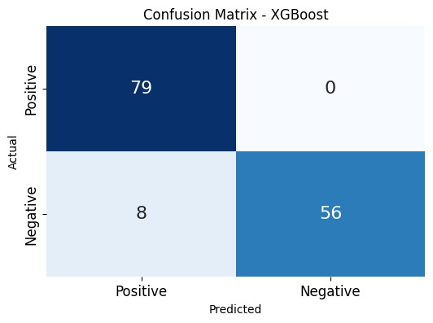

XGBoost attained perfect precision at 1.0; it classified not a single negative sample as positive wrong classification: 0 false positives; a little loss in recall due to 8 false negatives that led to otherwise perfect output at 90.8%. Training is a bit more computationally expensive than the base model due to boosting iterations and tree regularization, but generalization performance is strong. Time for predicting is longer than for Random Forest and Decision Tree, but often better performs on more complex and imbalanced data.

**4.Support Vector Machine (SVM)**

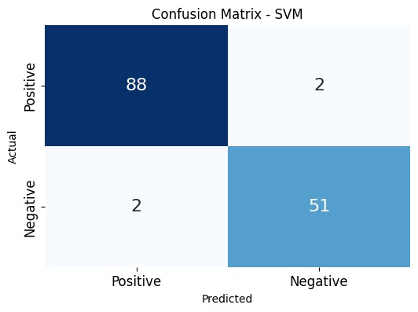

Precision and accuracy reached the highest points with SVM at 97.2% and 97.8%, respectively. However, the training of SVM is very computationally intensive in case a non-linear kernel is used. The model imposes higher computational demands for finding the best suited hyperplane for class separation. SVM has high training time, but predicts very fast especially for fewer support vectors. It balances precision and recall. Thus, it is highly effective in catching frauds in a transaction.

|  |  |  |
| --- | --- | --- |
| Model | Training time | Prediction time |
| Decision tree | $$O(n∙d∙\log{n})$$ | $$O(\log{n)}$$ |
| Random forest | $$O(T∙n∙d∙\log{n)}$$ | $$O(T∙\log{n)}$$ |
| XGBoost | $$O(T∙n∙f∙d)$$ | $$O(T∙d)$$ |
| SVM | Linear: $O(n^{2}∙d)$ RBF: $O(n^{3}∙d)$ | $$O(s∙d)$$ |

The SVM takes the longest training time, especially if a non-linear kernel is used; however it gives the best performance in handling high-dimensional complex datasets. The Decision Tree and Random Forest are faster in prediction than XGBoost and SVM. However, the latter two are better suited to complex fraud detection since it has a natural capability to handle non-linearly related inputs.

##### ***Conclusion***

##### Thus, this paper develops an AI-powered financial risk management system that can especially address the rising complexities and volatilities of the current financial markets. Techniques utilized in real-time as well as historical data in this application are Reinforcement Learning, LSTMs, Transformers, and GNNs, which can be used to incorporate integrations in spot anomalies, market trend understanding, and alleviation of risks. Yet another subtle but effective avenue of grappling with uncertainty in the financial sectors would be the application of AI tools in credit risk evaluation, market risk forecast, fraud detection, and cybersecurity risk management.

##### Real time threat detection is combined with continuous updates of models, monitoring of performance, and feedback loops that assure the validity and appropriateness of the adaptation with respect to conditions changing the market. Indeed, this research represents the transformative nature of artificial intelligence for financial risk management when the tools of decision-making will stand better suited and reduce exposure to market risks among institutions and investors.

##### Then it is possible for future work to then build upon this foundation with higher-level algorithms, integration of secondary data sources, and newly emerging risks within a financial system of ever-growing complexity. This methodology provides the framework by which artificial intelligence might become the big player in determining how the future of financial risk analytics is shaped in pursuit of securing the global financial market.

##### References

1. **Mujtaba, Numan, and Alan Yuille.** “AI-Powered Financial Services: Enhancing Fraud Detection and Risk Assessment with Predictive Analytics.” Research, August 2024. DOI: [10.13140/RG.2.2.23580.09603](https://www.researchgate.net/publication/383532095).
2. Ashraf, Faheem, and Alejandro Schaffer. “Combating Financial Crime: AI and Machine Learning in Anomaly Detection and Risk Management.” Research, August 2024. DOI: 10.13140/RG.2.2.22450.41927.
3. Donepudi, Praveen Kumar. “Machine Learning and Artificial Intelligence in Banking.” Engineering International 5, no. 2 (January 1, 2017): 83–86. <https://doi.org/10.18034/ei.v5i2.490>.
4. Lo Piano, Samuele. “Ethical principles in machine learning and artificial intelligence: cases from the field and possible ways forward.” Humanities and Social Sciences Communications 7, no. 1 (June 17, 2020). <https://doi.org/10.1057/s41599-020-0501-9>.
5. Raschka, Sebastian, Joshua Patterson, and Corey Nolet. "Machine Learning in Python: Main Developments and Technology Trends in Data Science, Machine Learning, and Artificial Intelligence." Information 11, no. 4 (April 4, 2020): 193. <https://doi.org/10.3390/info11040193>.
6. Ionescu, S.-A., and V. Diaconita. "Transforming financial decision-making: the interplay of AI, cloud computing and advanced data management technologies." International Journal of Computers Communications & Control 18, no. 6 (2023).
7. Raschka, Sebastian, Joshua Patterson, and Corey Nolet. “Machine Learning in Python: Main Developments and Technology Trends in Data Science, Machine Learning, and Artificial Intelligence.” Information 11, no. 4 (April 4, 2020): 193. <https://doi.org/10.3390/info11040193>.
8. Huntingford, Chris, Elizabeth S. Jeffers, Michael B. Bonsall, Hannah M. Christensen, Thomas Lees, and Hui Yang. “Machine learning and artificial intelligence to aid climate change research and preparedness.” Environmental Research Letters 14, no. 12 (November 22, 2019): 124007. <https://doi.org/10.1088/1748-9326/ab4e55>.
9. Shaikh, Tawseef Ayoub, Tabasum Rasool, and Faisal Rasheed Lone. “Towards leveraging the role of machine learning and artificial intelligence in precision agriculture and smart farming.” Computers and Electronics in Agriculture 198 (July 1, 2022): 107119. <https://doi.org/10.1016/j.compag.2022.107119>.
10. Zacharov, Igor, Rinat Arslanov, Maksim Gunin, Daniil Stefonishin, Andrey Bykov, Sergey Pavlov, Oleg Panarin, Anton Maliutin, Sergey Rykovanov, and Maxim Fedorov. “‘Zhores’ — Petaflops supercomputer for data-driven modeling, machine learning and artificial intelligence installed in Skolkovo Institute of Science and Technology.” Open Engineering 9, no. 1 (January 1, 2019): 512–20. <https://doi.org/10.1515/eng-2019-0059>.
11. Tatineni, S., & Mustyala, A. “Enhancing Financial Security: Data Science's Role in Risk Management and Fraud Detection.” ESP International Journal of Advancements in Computational Technology, 2(2), 94-105 (May 2024). <https://doi.org/10.56472/25838628/IJACT-V2I2P113>.
12. Zhan, X., Ling, Z., Xu, Z., Guo, L., & Zhuang, S. “Driving Efficiency and Risk Management in Finance through AI and RPA.” Unique Endeavor in Business & Social Sciences, 3(1), (2024).
13. Ouyang, X. “Risks and Opportunities Brought by Artificial Intelligence Empowering the Financial Industry.” Highlights in Business, Economics and Management, FTMM 2024, Volume 40 (2024).
14. Donepudi, P. K. “Machine Learning and Artificial Intelligence in Banking.” Engineering International, 5(2) (January 1, 2017): 83-86. <https://doi.org/10.18034/ei.v5i2.490>.
15. N. Syam and A. Sharma, "Waiting for a sales renaissance in the fourth industrial revolution: Machine learning and artificial intelligence in sales research and practice," Industrial Marketing Management, vol. 69, pp. 135–146, Feb. 2018. doi: 10.1016/j.indmarman.2017.12.019.