The very first look of Postgres as below.

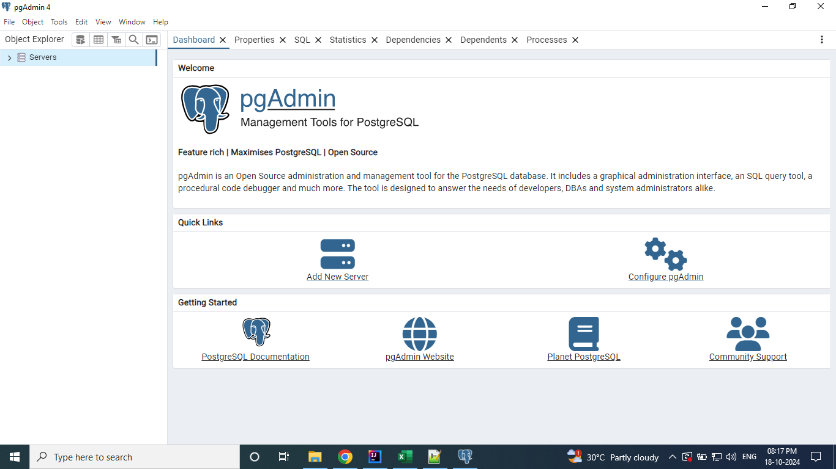

When you click on Servers. You will be prompted for the password provided during the installation.

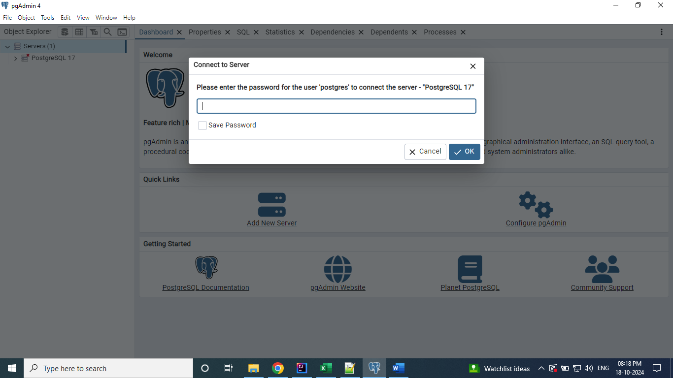

Enter the password and click Ok.

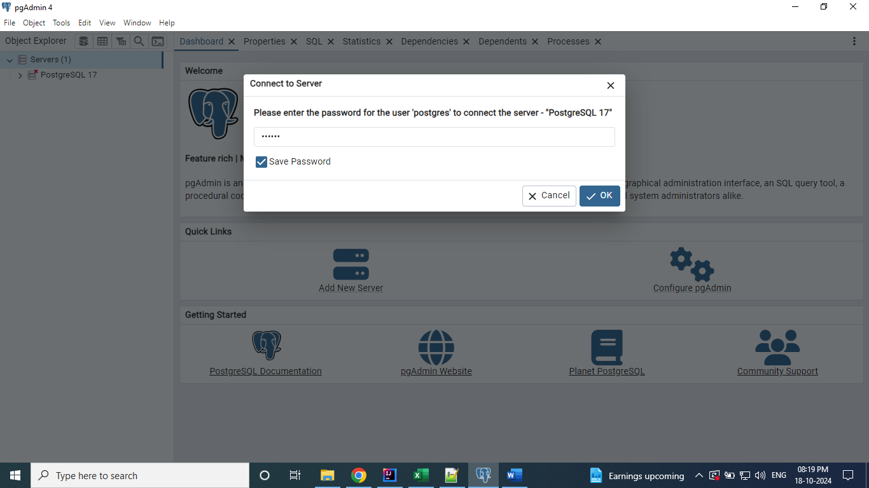

After click on Ok. The screen looks like below. It has default Database.

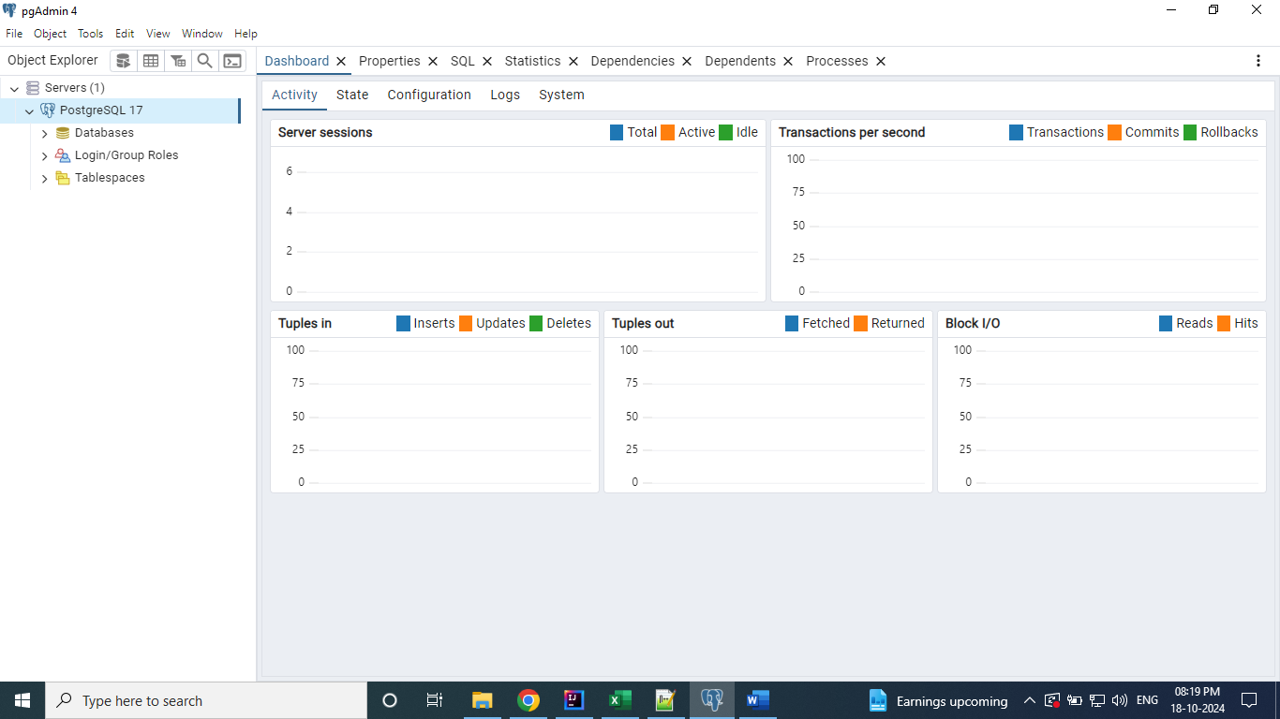

Right click on Database and select Query Tool.

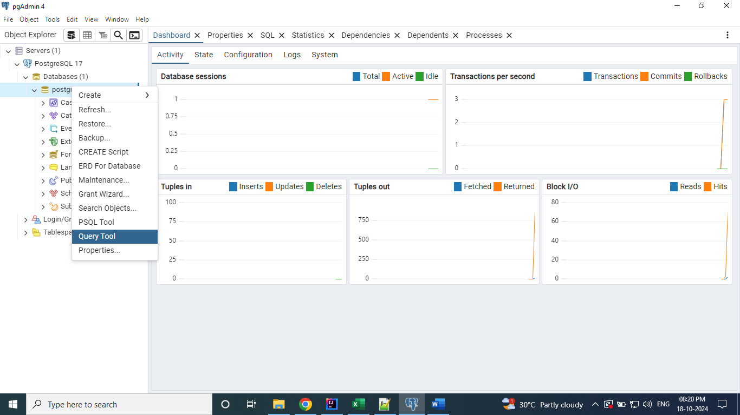

Query Tool Looks like below.

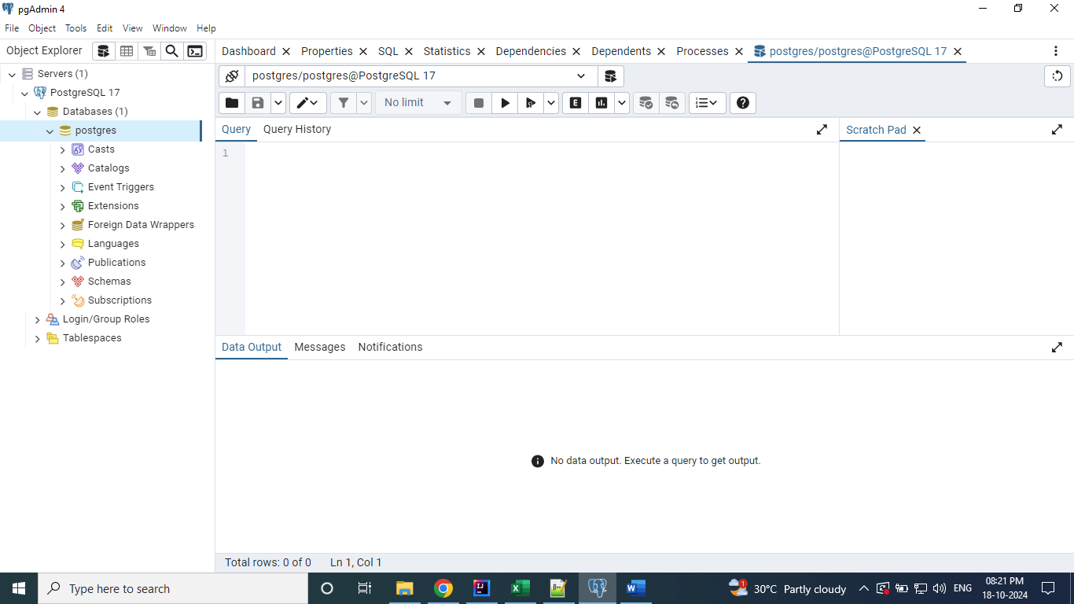

Executed the below query to know the tables details available on the default Database.

**Select * from information_schema.tables;**

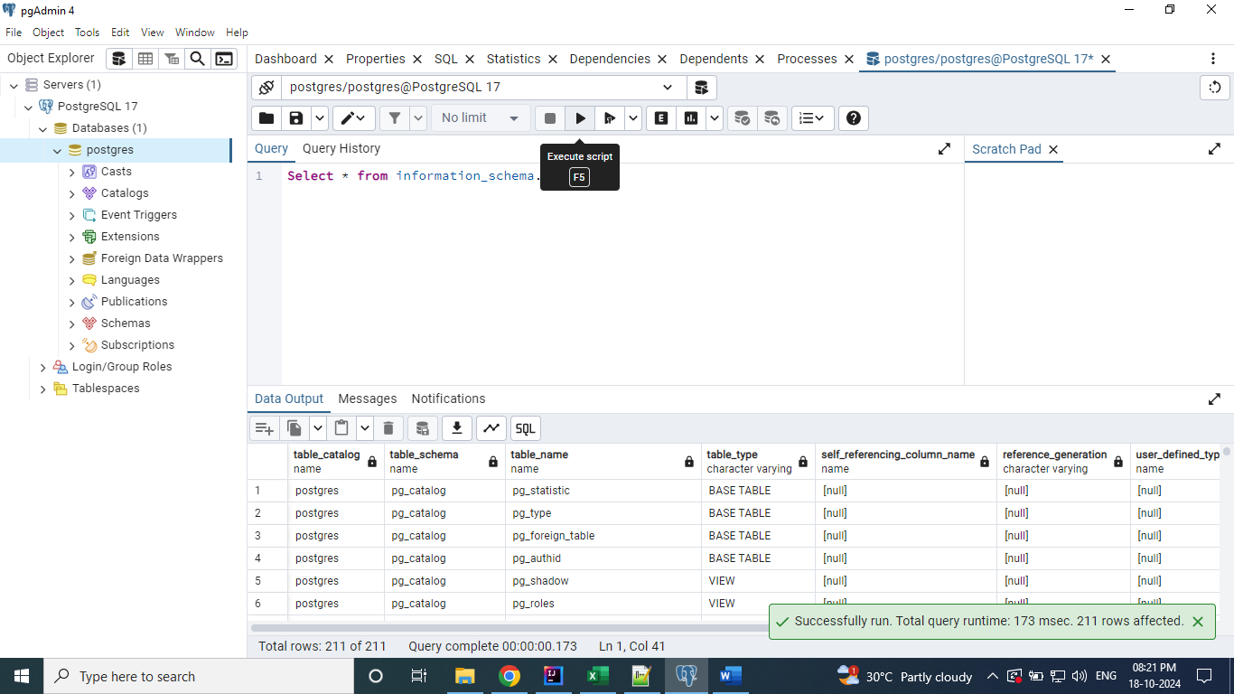

Have created the new Database with name “demo”

**Create database demo;**

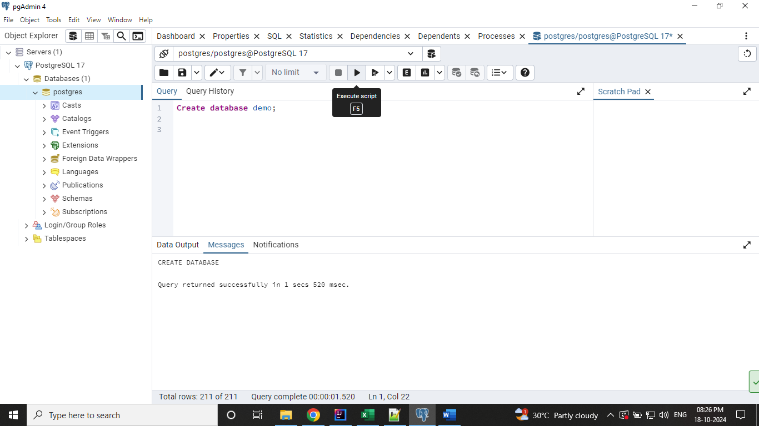

Right click on the Databases and click on Refresh to see the newly created Database.

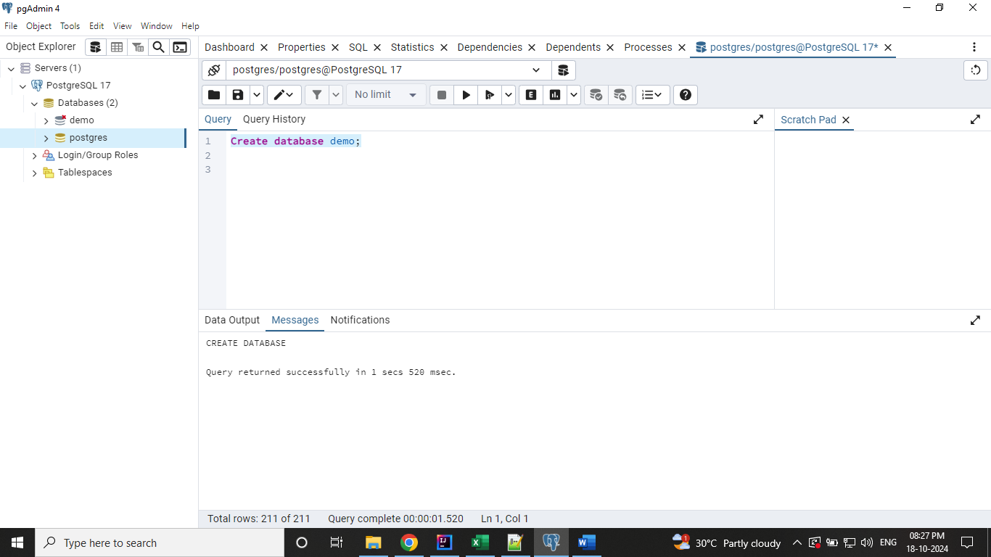

By default, the connection to the new Database is not established. You can click on it, then the connection will be established and the ‘x’ mark will be removed.

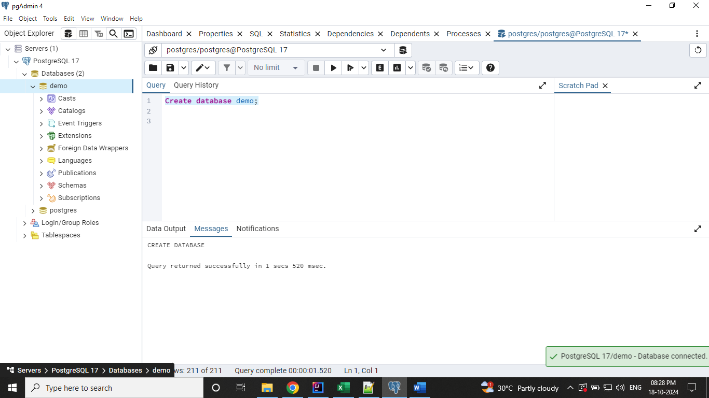

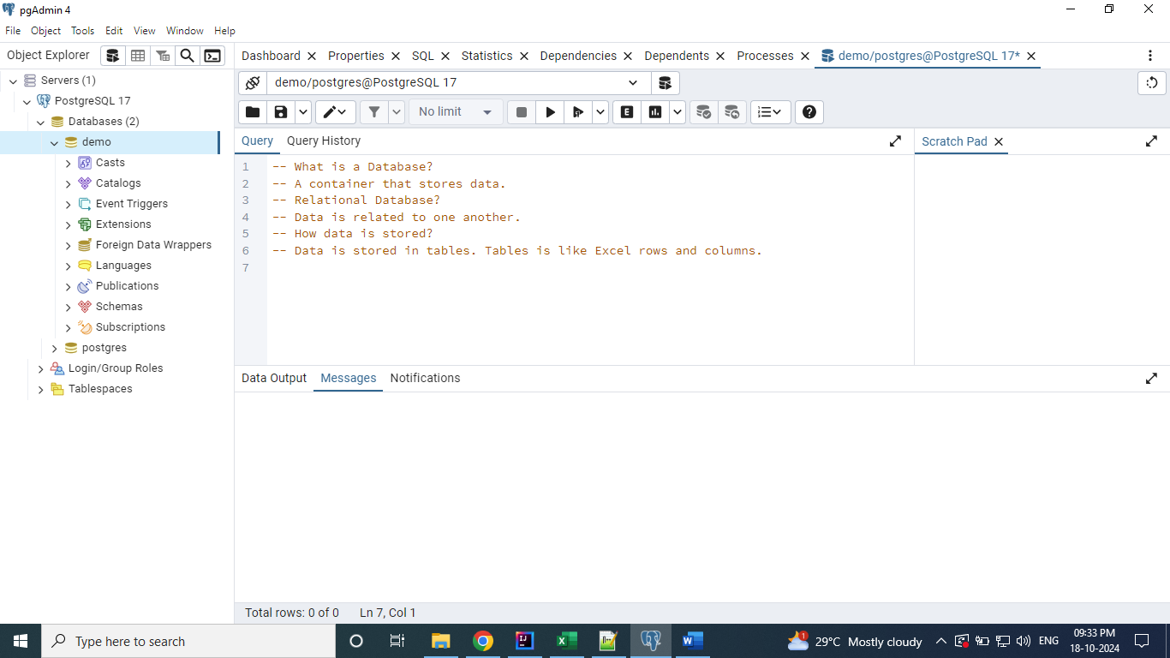

Created a table with name “Products” on the demo database.

**create table products (**

**product_code int,**

**product_name varchar(50),**

**price float,**

**released_date date**

**);**

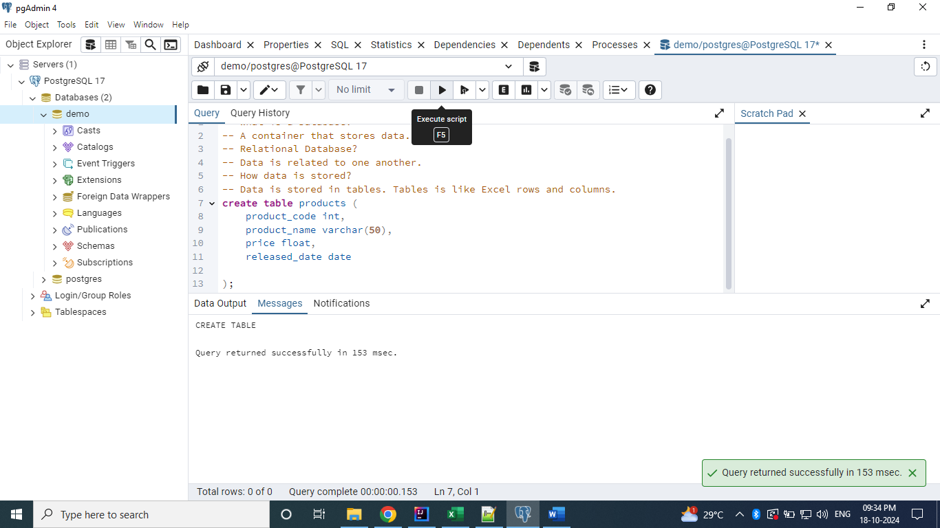

Query the created table.

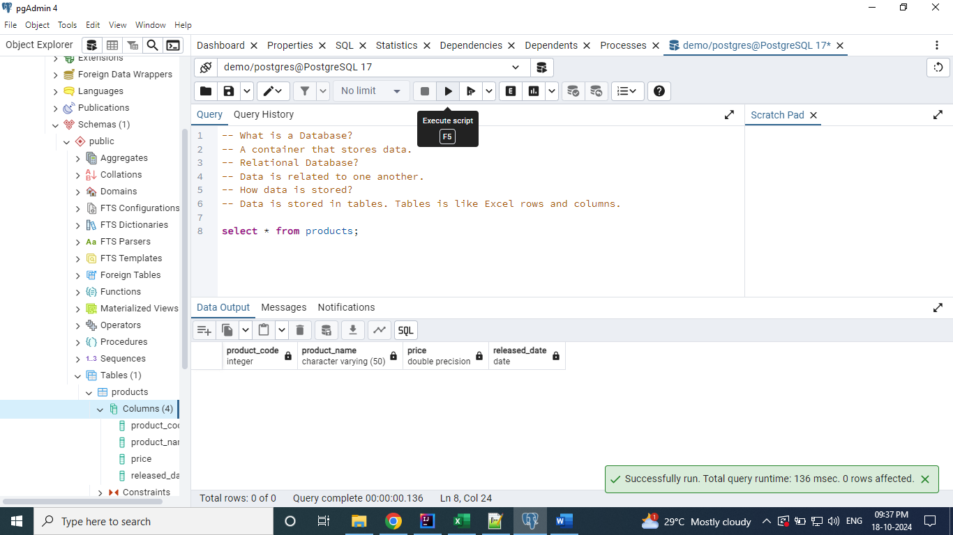

We can add the data into the table as below.

**insert into products (product_code, product_name, price, released_date)**

**values (1, 'Samsung M04', 999.5, to_date('25-07-2022', 'dd-mm-yyyy'));**

