**Sales Order Case Study**

# Total available Tables

**SELECT * FROM products;**

**SELECT * FROM customers;**

**SELECT * FROM employees;**

**SELECT * FROM sales_order;**

# Problems

## Identify the total number of products sold.

**We can get the total number of products details from the Products table. But the twist here is we need to get the total number of Products sold. The Sales_Order is the only table which has the quantity of all products sold.**

**select sum(quantity) from sales_order;**

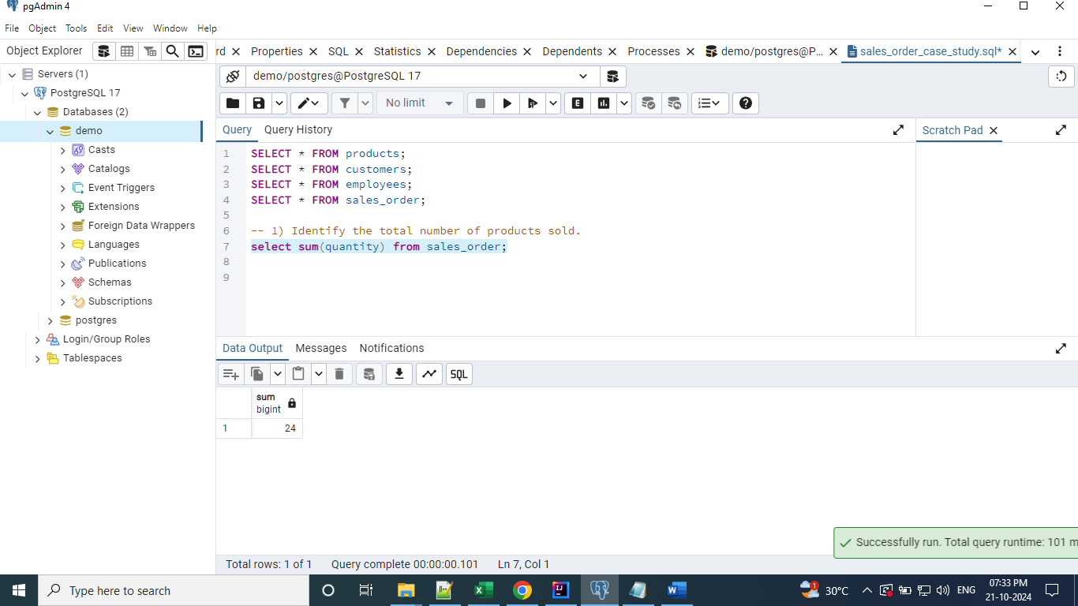

## Other than completed, display the available delivery status.

**We can get the details of order status from the Sales_Order table.**

**# Approach 1**

**select status from sales_order where status <> 'Completed';**

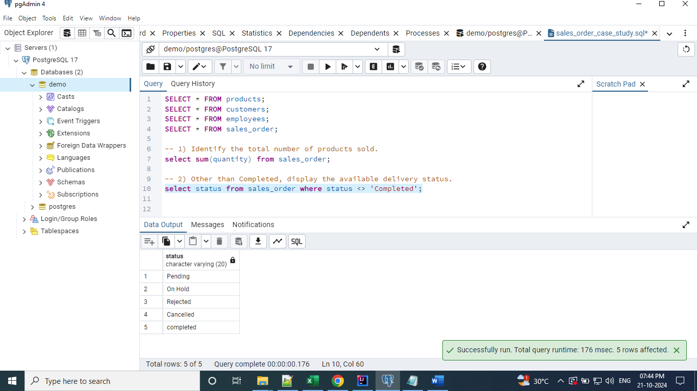

**# Approach 2**

**select status from sales_order where status != 'Completed';**

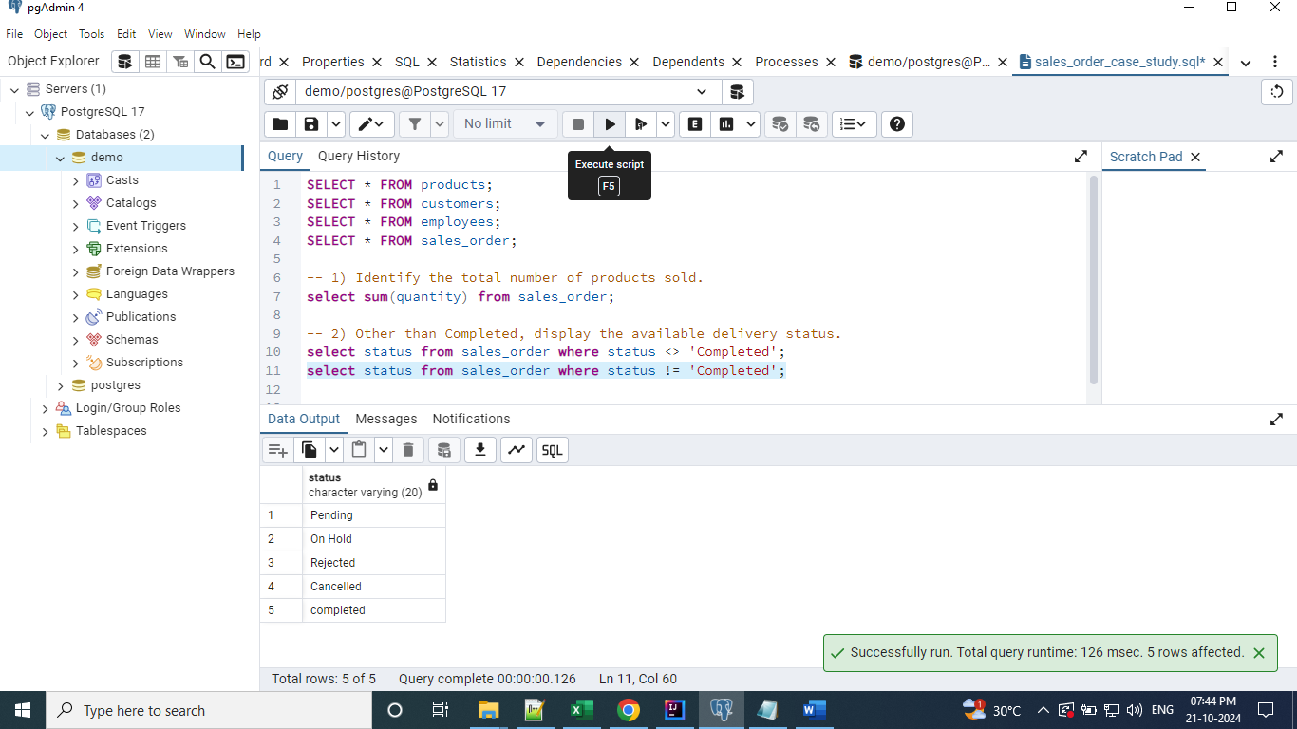

**# Approach 3**

**select status from sales_order where status not in ('Completed', 'completed');**

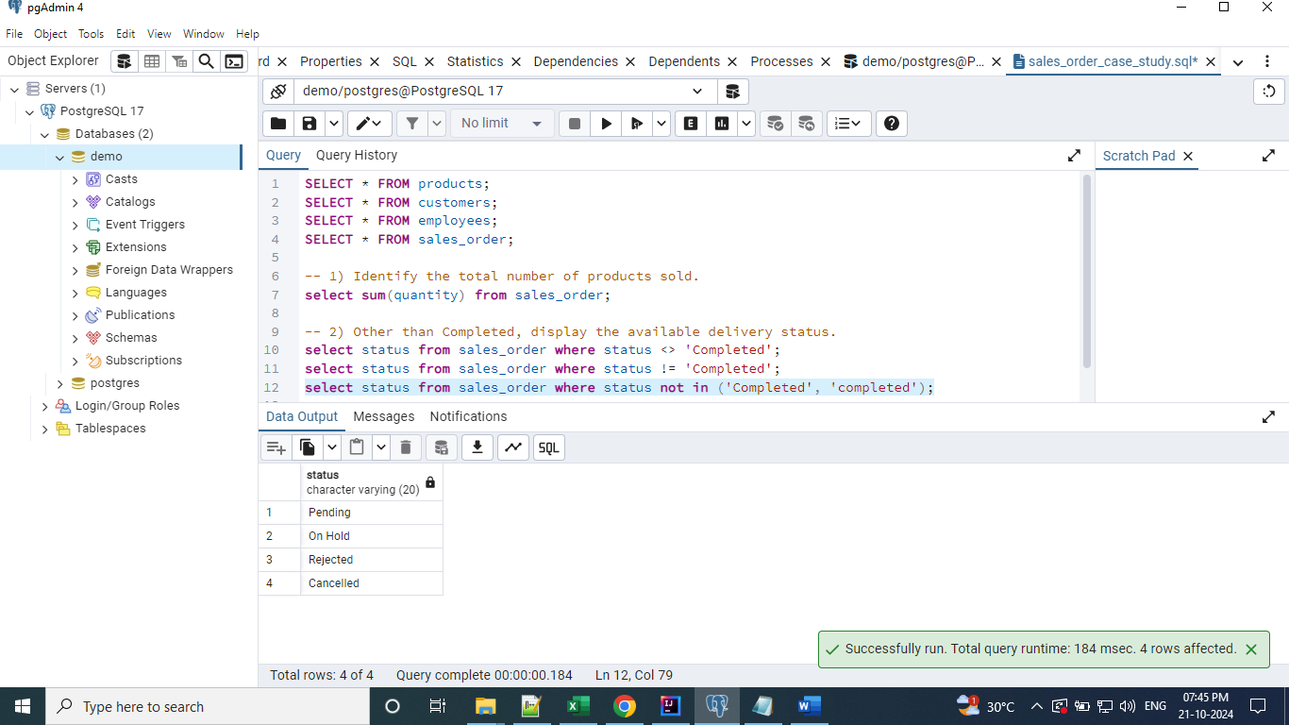

**# Approach 4**

**select status from sales_order where lower(status) <> 'completed';**

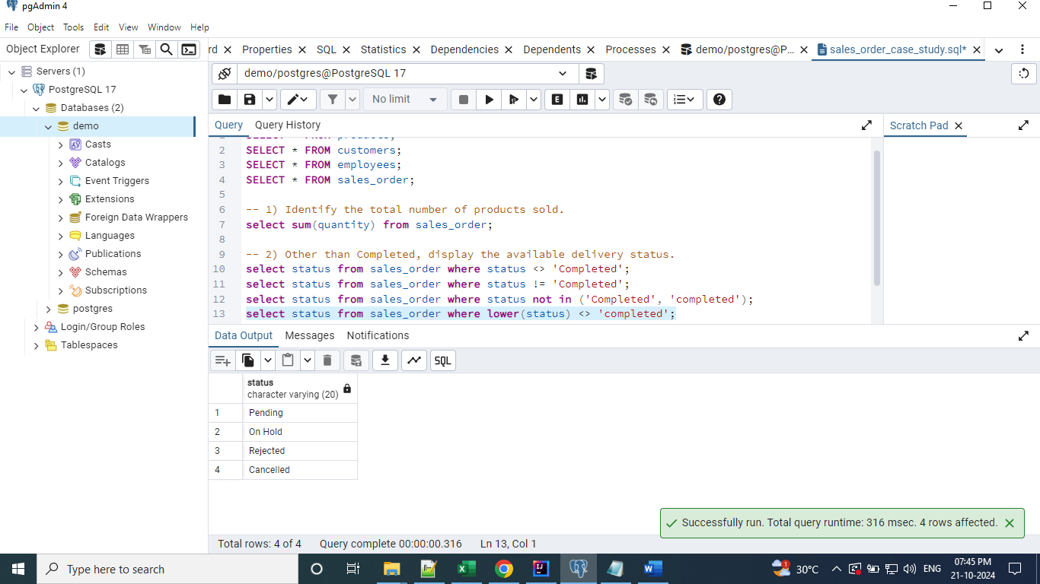

**# Approach 5**

**select status from sales_order where upper(status) <> 'COMPLETED';**

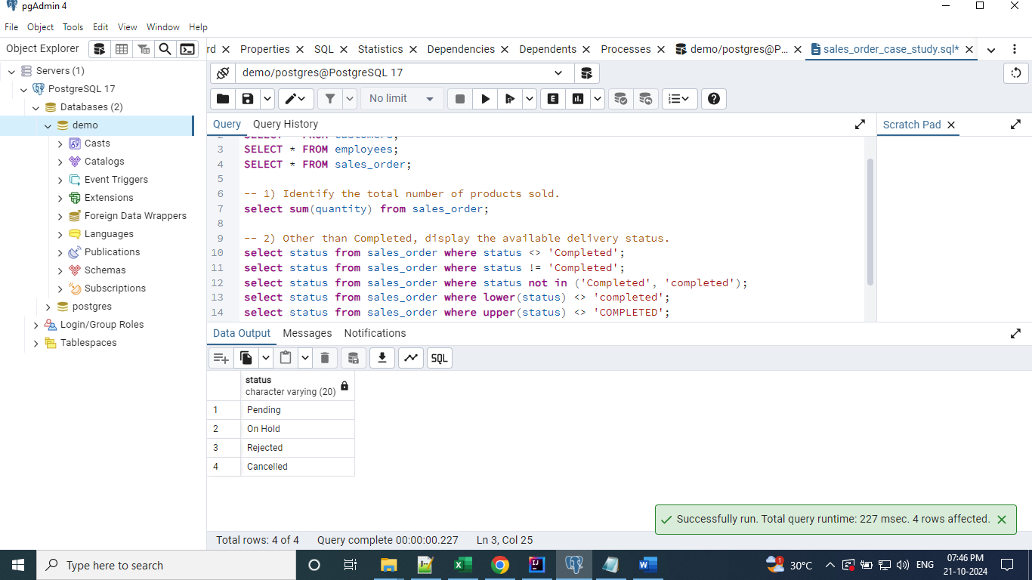

## Display the order id, order date, and product name for all the completed orders.

**Here, we have to fetch the column values from two tables, so need to use the join function. Inner Join is used here to fetch the records.**

**select order_id, order_date, name**

**from sales_order so inner join products p on p.id = so.prod_id**

**where lower(so.status) = 'completed';**

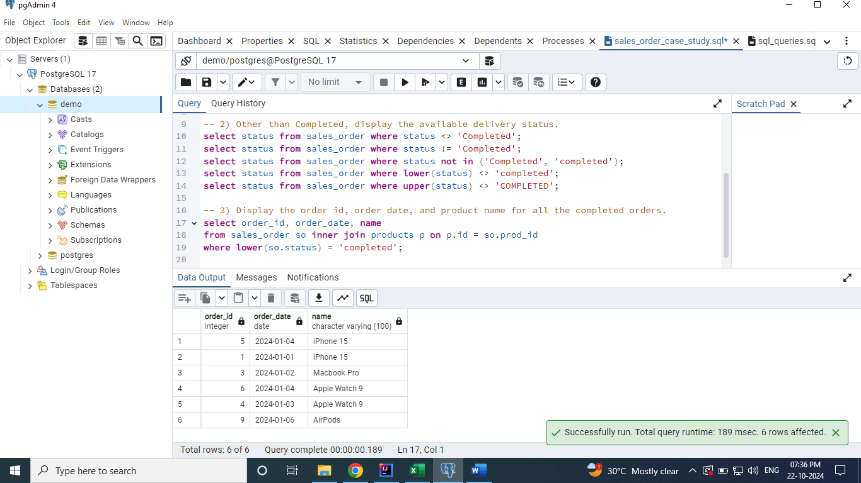

## Sort the above query to show the earliest orders at the top. Also display the customer who purchased these orders.

**Here, we need to print the customer details too. So, we have joined the customer table along with previous join and sorted using the order by clause.**

**select order_id, order_date, p.name, c.name**

**from sales_order so**

**inner join products p on p.id = so.prod_id**

**inner join customers c on so.customer_id = c.id**

**where lower(so.status) = 'completed'**

**order by order_date asc;**

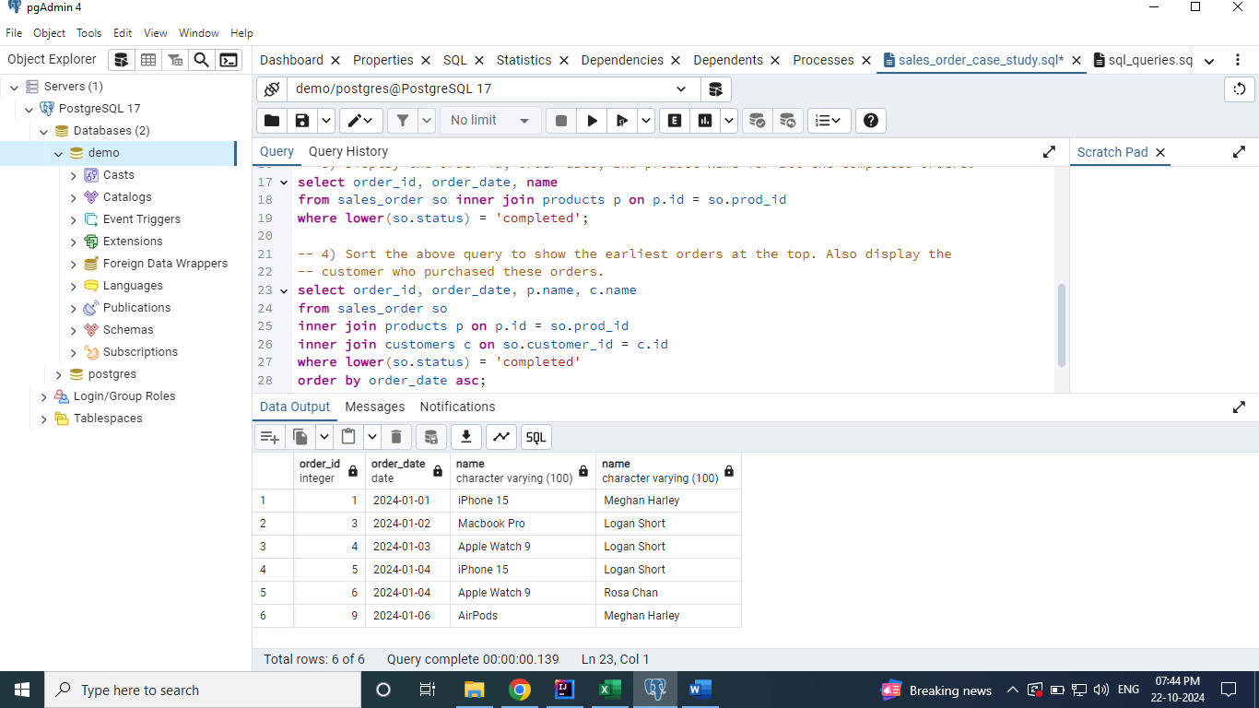

## Display the total number of orders corresponding to each delivery status.

**We can use the group by clause to group the orders based on the status.**

**select status, count(*)**

**from sales_order**

**group by status**

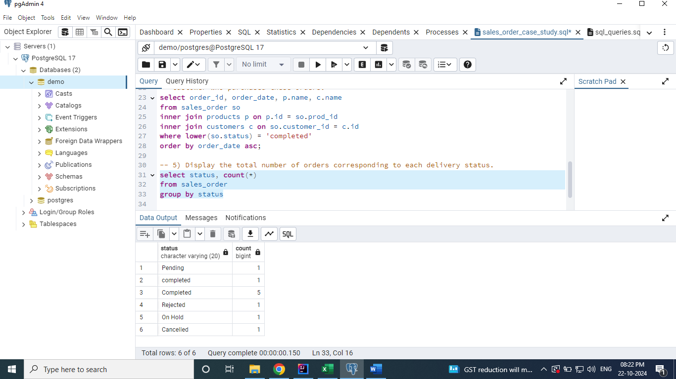

## For Orders purchased more than 1 item, how many are still not completed.

**select count(*) as not_completed_orders**

**from sales_order**

**where quantity > 1**

**and lower(status) <> 'completed';**

7. 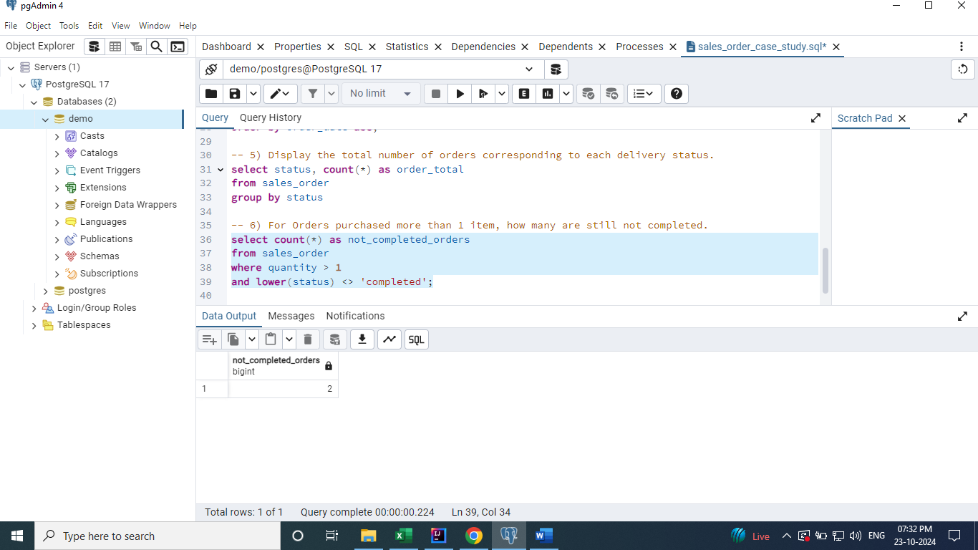

## 7. Find the total number of orders corresponding to each delivery status by ignoring the case in delivery status with highest number of orders should be at the top.

**Approach 1 [Sub Query]**

**select status,**

**case when status = 'completed'**

**then 'Completed'**

**else status**

**end as updated_status from sales_order;**

**select updated_status, count(*) as order_total**

**from (select status,**

**case when status = 'completed'**

**then 'Completed'**

**else status**

**end as updated_status from sales_order)**

**group by updated_status**

**order by order_total desc;**

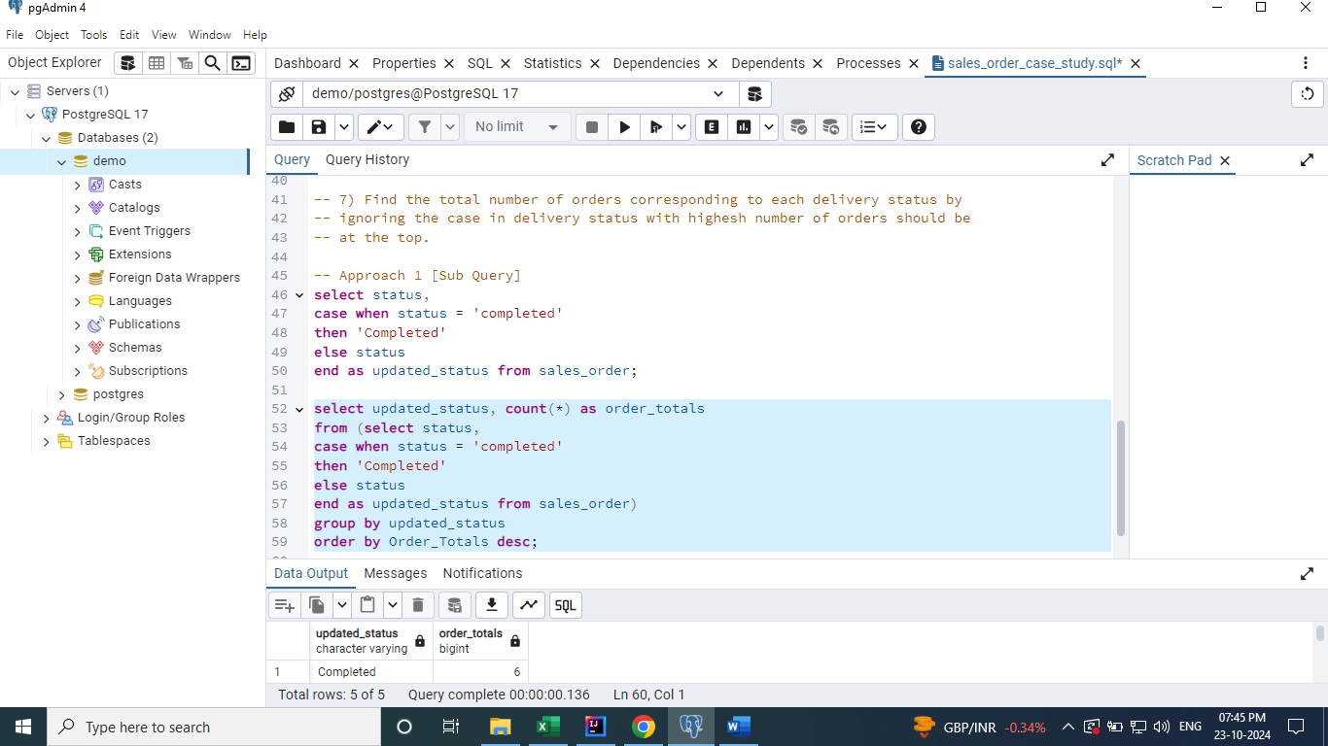

**Approach 2**

**select lower(status) as status, count(*) as order_total**

**from sales_order**

**group by lower(status)**

**order by order_total desc;**

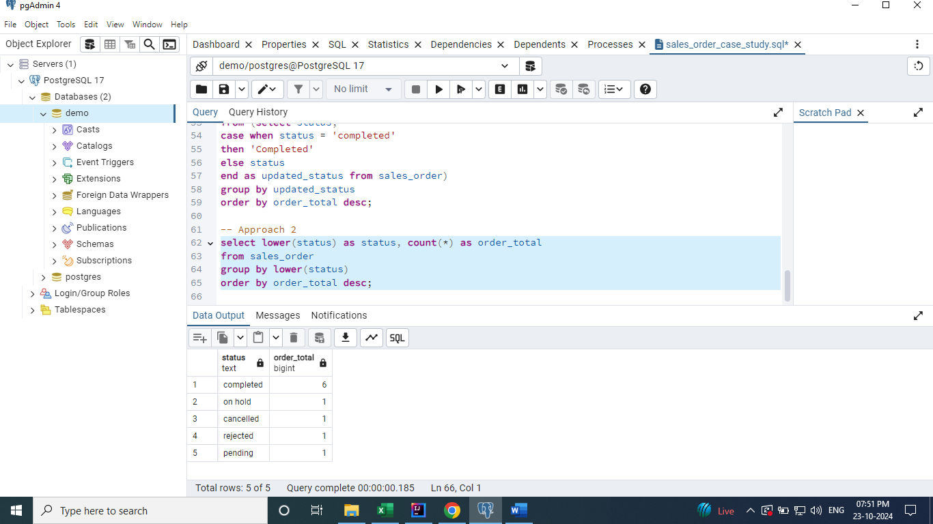

## Write a query to identify the total products purchased by each customer.

**select c.name as customer_name, sum(so.quantity)**

**from sales_order so**

**join customers c on c.id = so.customer_id**

**group by c.name;**

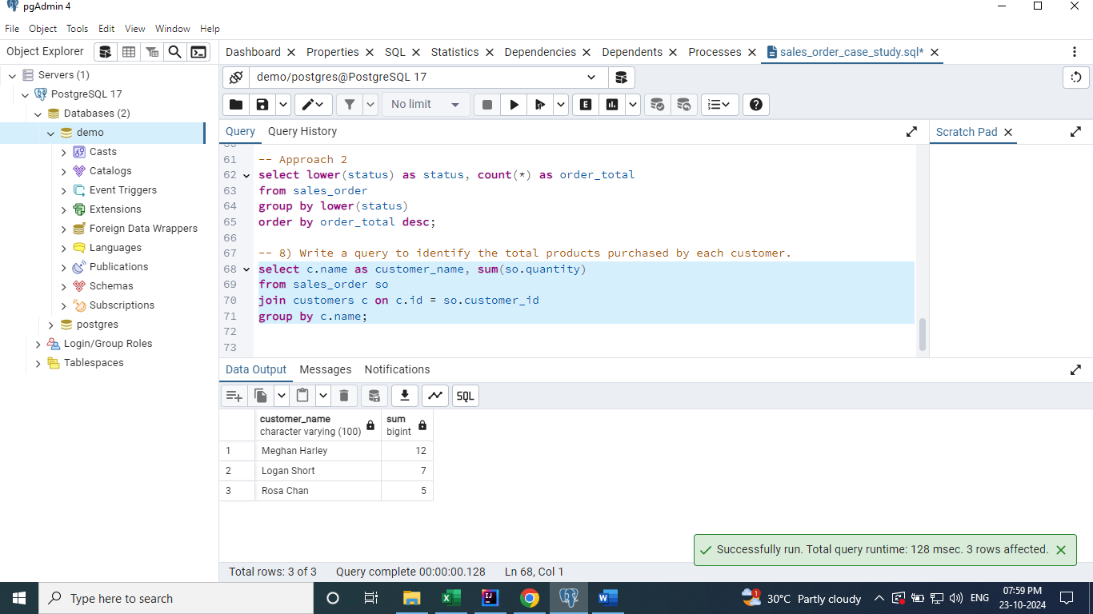

## Display the total sales and average sales done for each day.

**select order_date, sum(price * quantity) as total_sales, avg(price * quantity) as average_sales**

**from sales_order so**

**join products p on p.id = so.prod_id**

**group by order_date**

**order by order_date;**

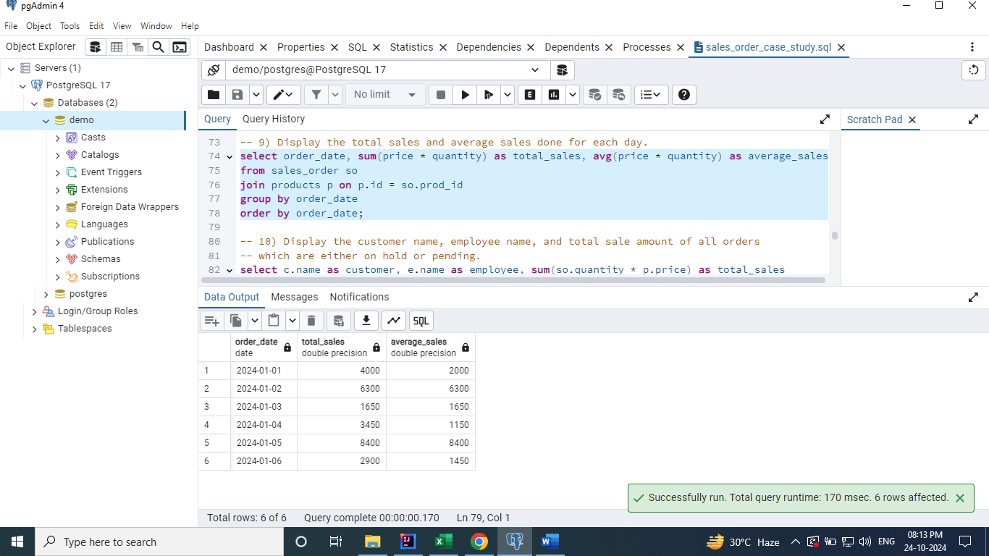

## Display the customer name, employee name, and total sale amount of all orders which are either on hold or pending.

**select c.name as customer, e.name as employee, sum(so.quantity * p.price) as total_sales**

**from sales_order so**

**join employees e on so.emp_id = e.id**

**join products p on so.prod_id = p.id**

**join customers c on so.customer_id = c.id**

**where so.status in ('On Hold', 'Pending')**

**group by c.name, e.name;**

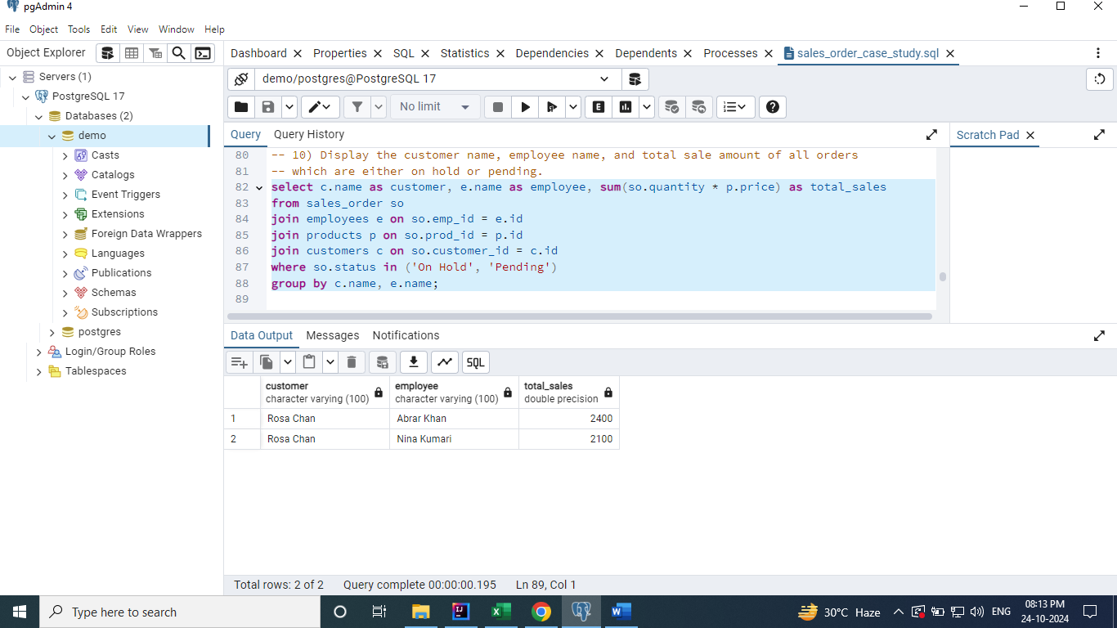

## Fetch all the orders which were neither completed / pending or were handled by the employee Abrar. Display employee name and all details of order.

**select e.name, so.\***

**from sales_order so**

**join employees e on e.id = so.emp_id**

**where lower(so.status) not in ('completed', 'pending')**

**or e.name like '%Abrar%';**

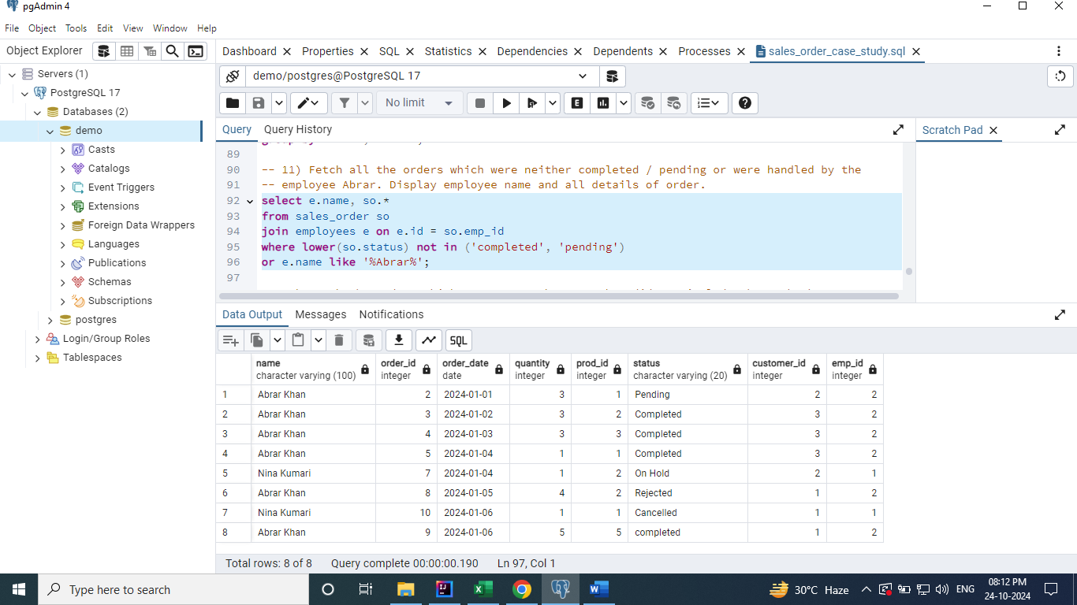

## Fetch the orders which costs more than 2000 but did not include the Mac book pro. Print the total sale amount as well.

**select so.*, p.name, (quantity * price) as total_cost**

**from sales_order so**

**join products p on p.id = so.prod_id**

**where (quantity * price) > 2000**

**and lower(p.name) not like '%macbook%';**

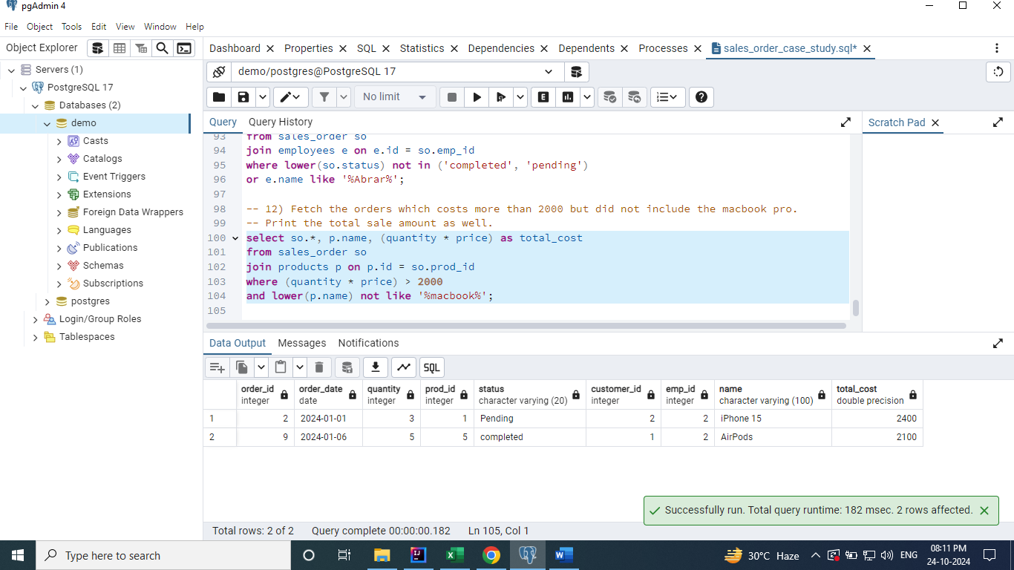

## **Identify the customers who have not purchased any product yet.**

**Approach 1 [Sub Query]**

**select \***

**from customers**

**where id not in (select distinct customer_id from sales_order);**

**Approach 2 [Left Join]**

**select c.\***

**from customers c**

**left join sales_order so**

**on c.id = so.customer_id**

**where so.order_id is null;**

**Approach 3 [Right Join]**

**select c.\***

**from sales_order so**

**right join customers c**

**on c.id = so.customer_id**

**where so.order_id is null;**

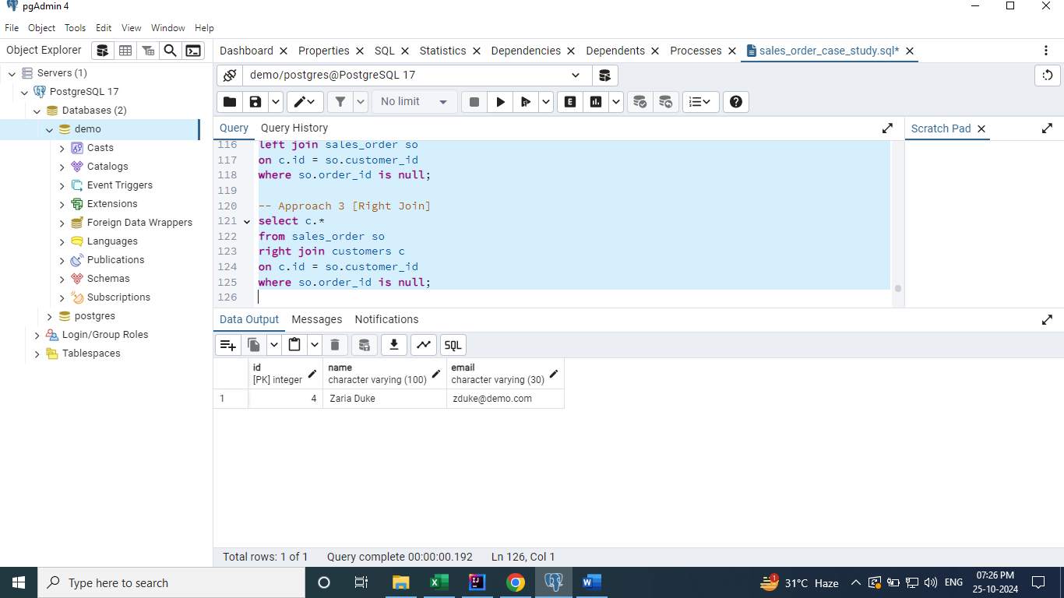

## **Write a query to identify the total products purchased by each customer. Return all customers irrespective of whether they have made a purchase or not. Sort the result with highest number of orders at the top.**

**select c.name, coalesce(sum(so.quantity), 0) as total_products_purchased**

**from customers c**

**left join sales_order so**

**on c.id = so.customer_id**

**group by c.name**

**order by total_products_purchased desc;**

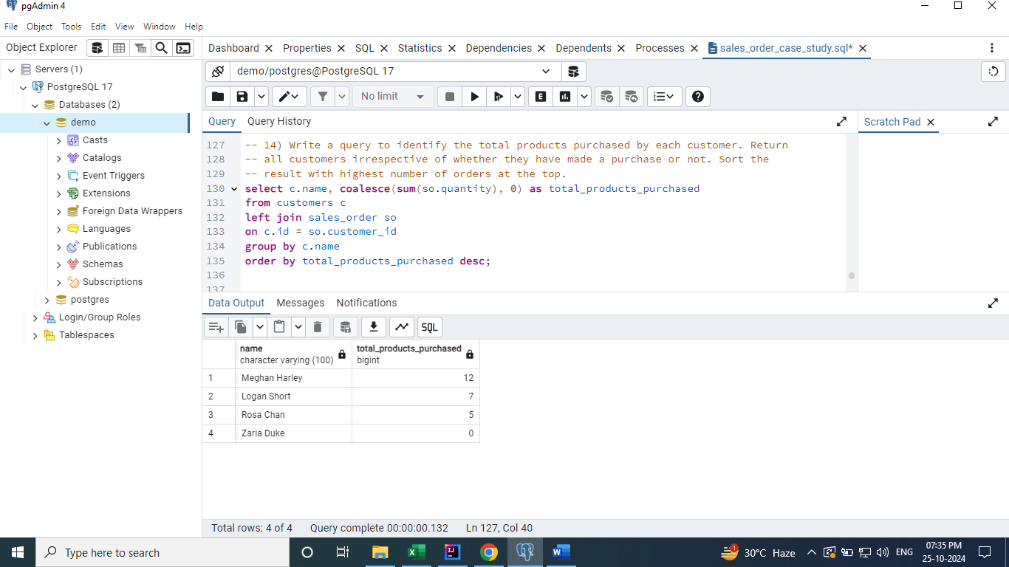

## **Corresponding to each employee, display the total sales they made of all the completed orders. Display the total sales as 0 if an employee made no sales yet.**

**select e.name as employee, coalesce(sum(quantity * price),0) as total_sales**

**from sales_order so**

**join products p on p.id = so.prod_id**

**right join employees e on e.id = so.emp_id**

**and lower(so.status) = 'completed'**

**group by e.name;**

