**ANSI & Non-ANSI JOINS**

# ANSI JOIN

1. **ANSI Join uses the Join Key word.**
2. **In ANSI Join, the join condition is provided under On clause.**
3. **In ANSI Join, the filter condition is provided under Where clause.**
4. **In PostgreSQL, we can write Outer Join only with ANSI Form.**

**Example**

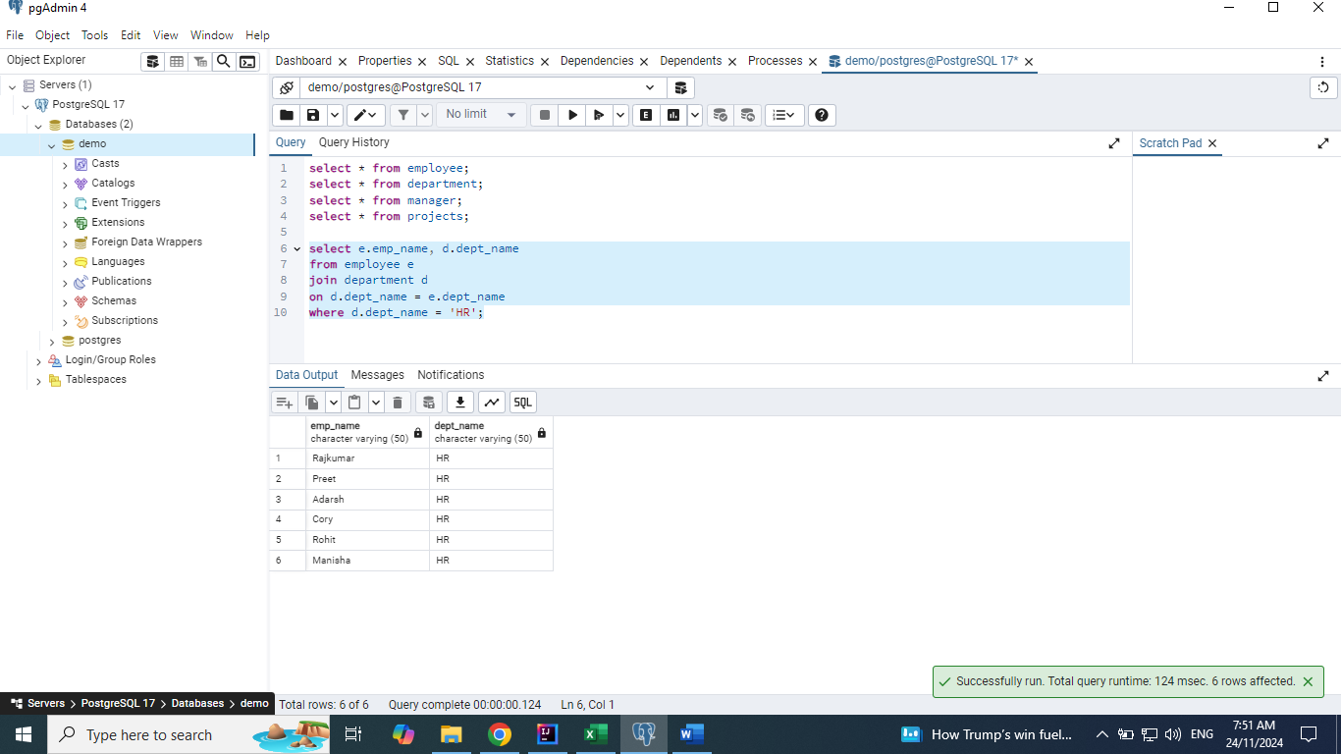

# NON-ANSI JOIN

1. **NON-ANSI Join *don’t* use the Join Key word.**
2. **In NON-ANSI Join, the join condition and filter condition are provided under Where clause.**
3. **In PostgreSQL, we *can’t* write Outer Join with NON-ANSI Form whereas its possible with Oracle.**
4. **In Oracle, the (+) operator is used to denote the Left / Right Outer Join based on where we place the operator.**

**Example**

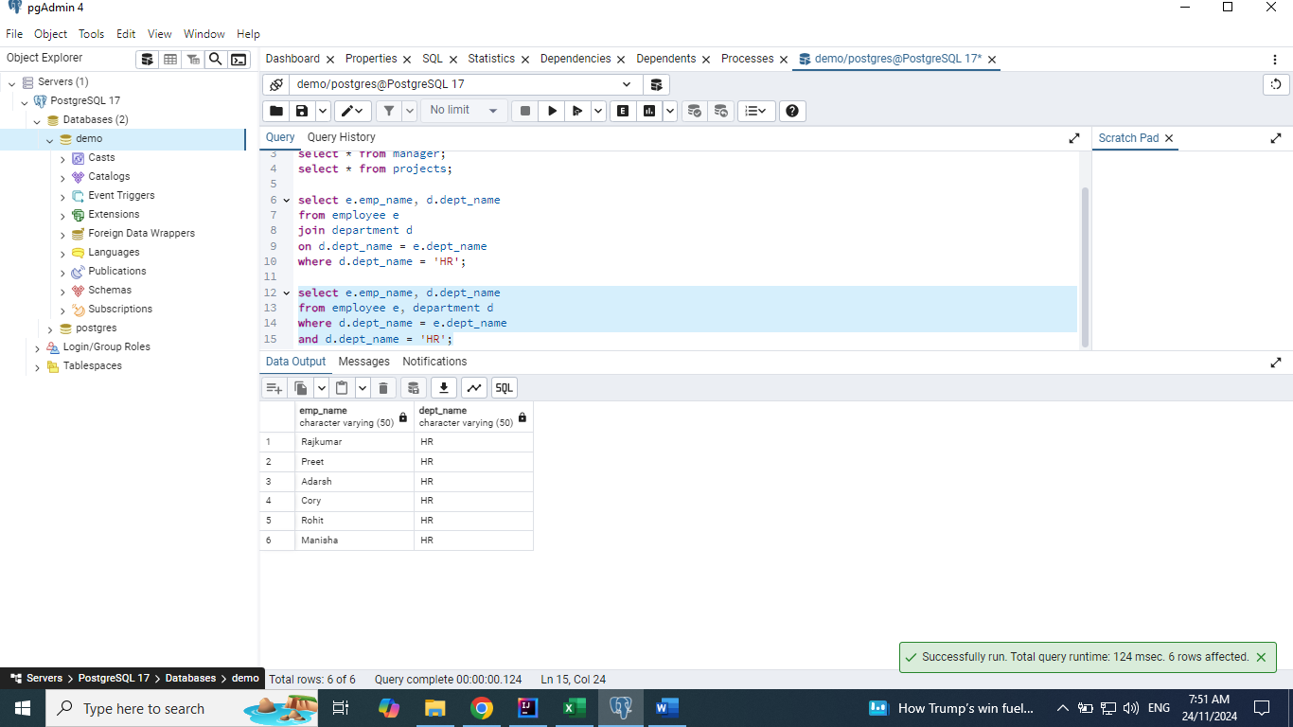

# ANSI Way Advantages

1. Queries will be shorter, cleaner, and easier to read, understand and debug.

2. Join condition and the Filter condition can be separated.

3. Avoid accidental Cross Joins.

4. ANSI is universally accepted by all RDBMS and Systems.