**Materialized View**

# Materialized View

**It is a database object.**

**It is created over a query.**

**Whenever we create MView, it will do 2 things.**

**1. Store the SQL query used to create it.**

**2. Store the data returned by the SQL query.**

**Whenever we execute/call MView, it will not execute the query instead it will return the data it stores, this way it improves the performance.**

# Scenario for MView

**create table random_tab (id int, val decimal);**

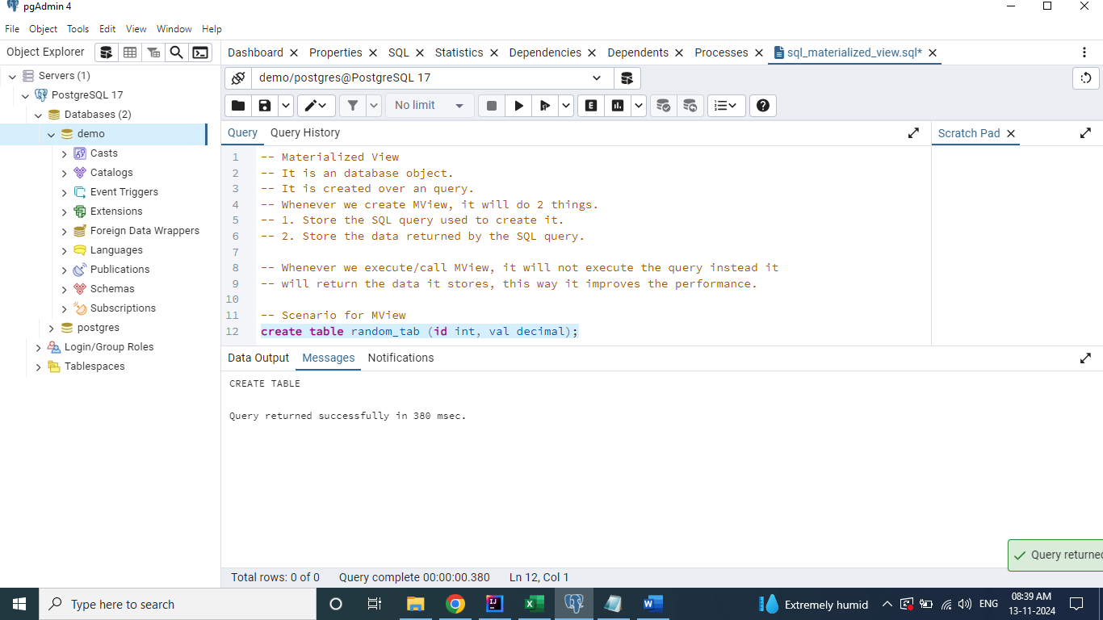

**insert into random_tab**

**select 1, random() from generate_series(1, 10000000);**

**insert into random_tab**

**select 2, random() from generate_series(1, 10000000);**

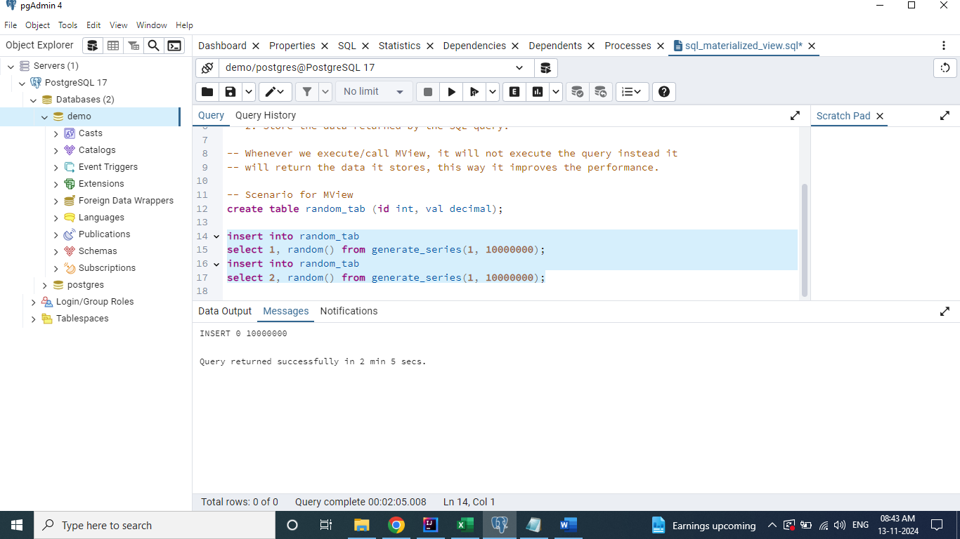

**select id, avg(val), count(*)**

**from random_tab**

**group by id;**

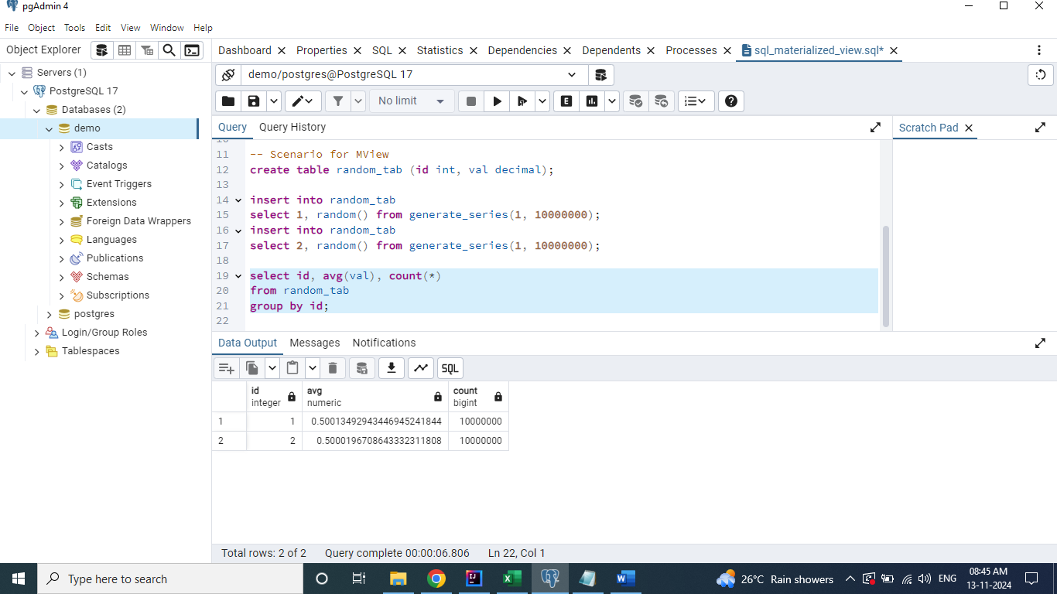

**create materialized view mv_random_tab**

**as**

**select id, avg(val), count(*)**

**from random_tab**

**group by id;**

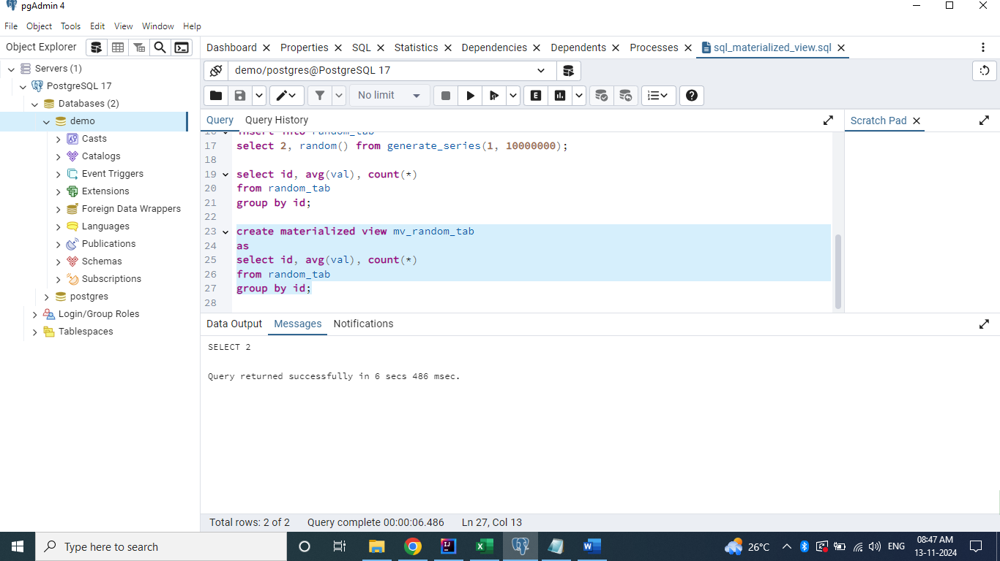

**select * from mv_random_tab;**

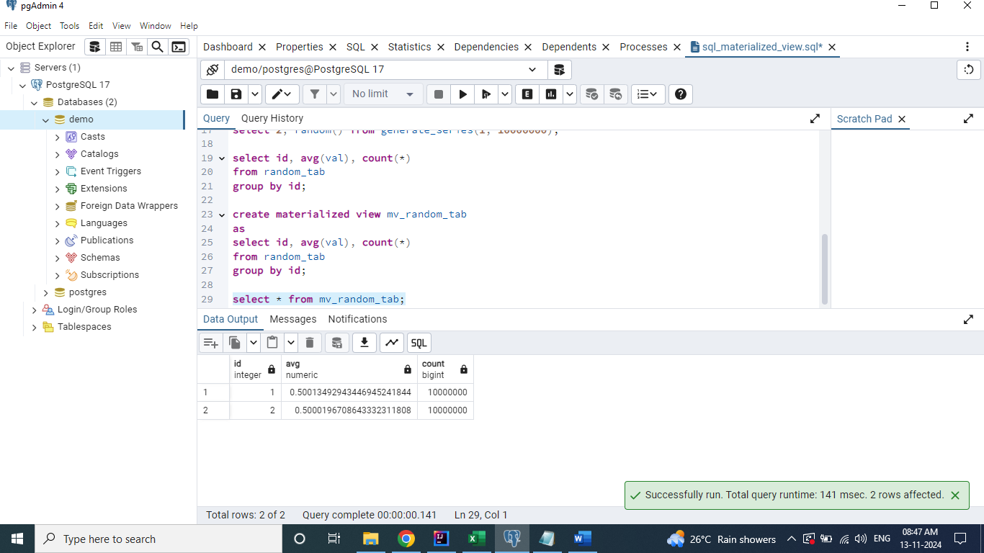

# Note

**The materialized view data won't be updated automatically. It has to be updated manually. So, whenever any update is done on the base table, to have that change on the MView, we need to refresh it.**

## Let's consider below scenario

**Deleting one of the records from the random_tab.**

**delete from random_tab where id = 1;**

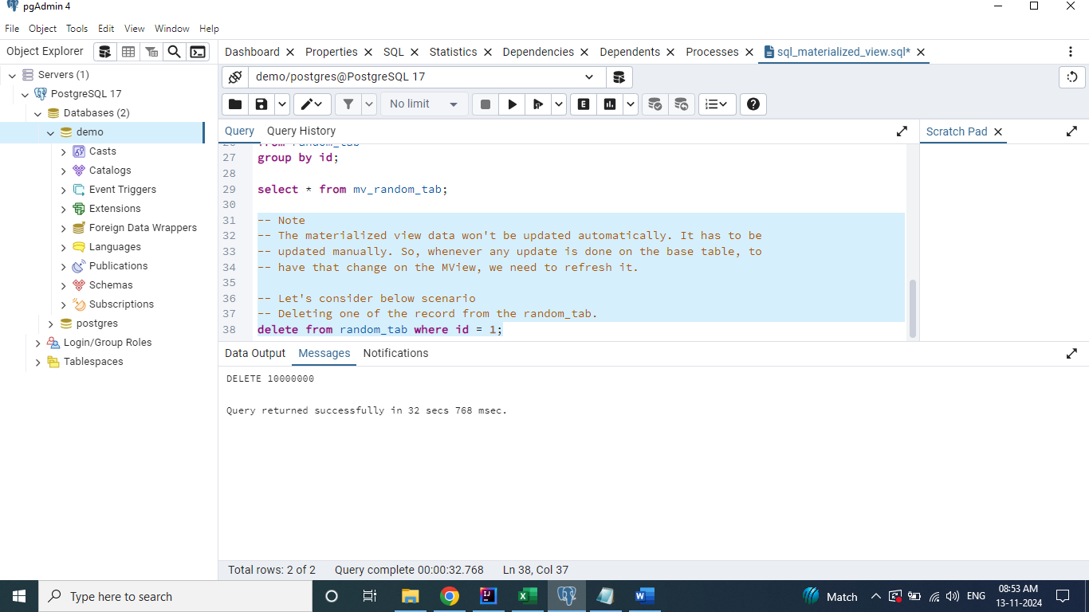

**After deletion, base table has only one record.**

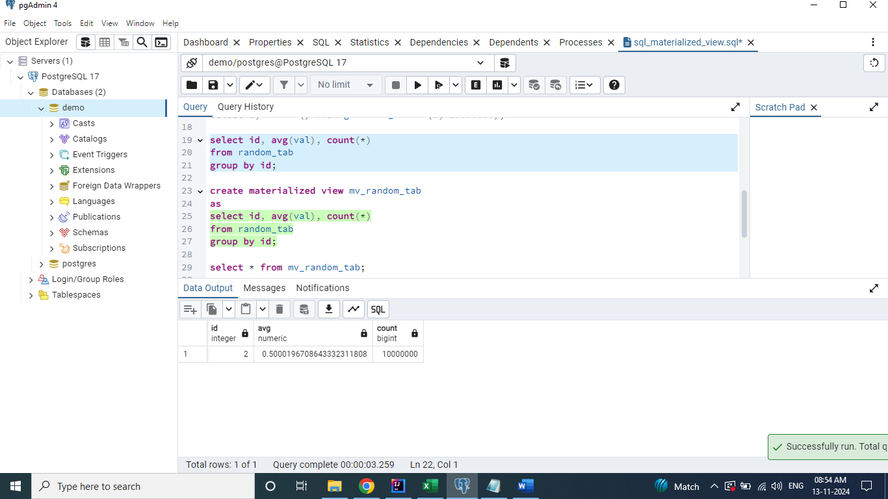

**MView still has 2 records.**

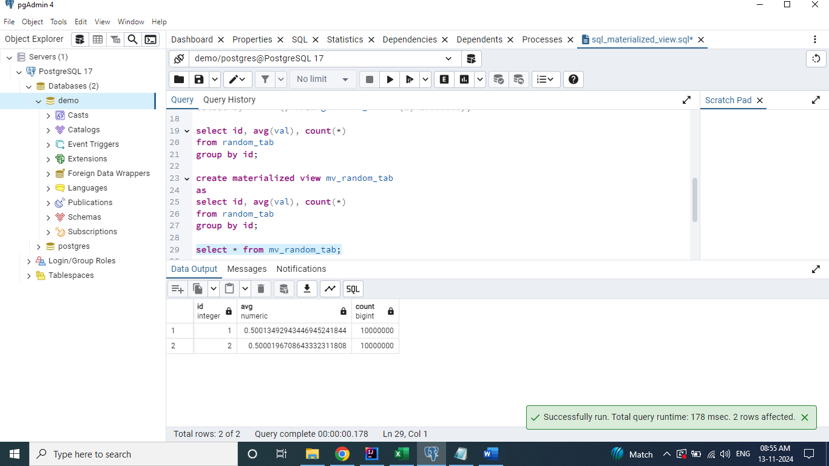

# Refresh MView

**refresh materialized view mv_random_tab;**

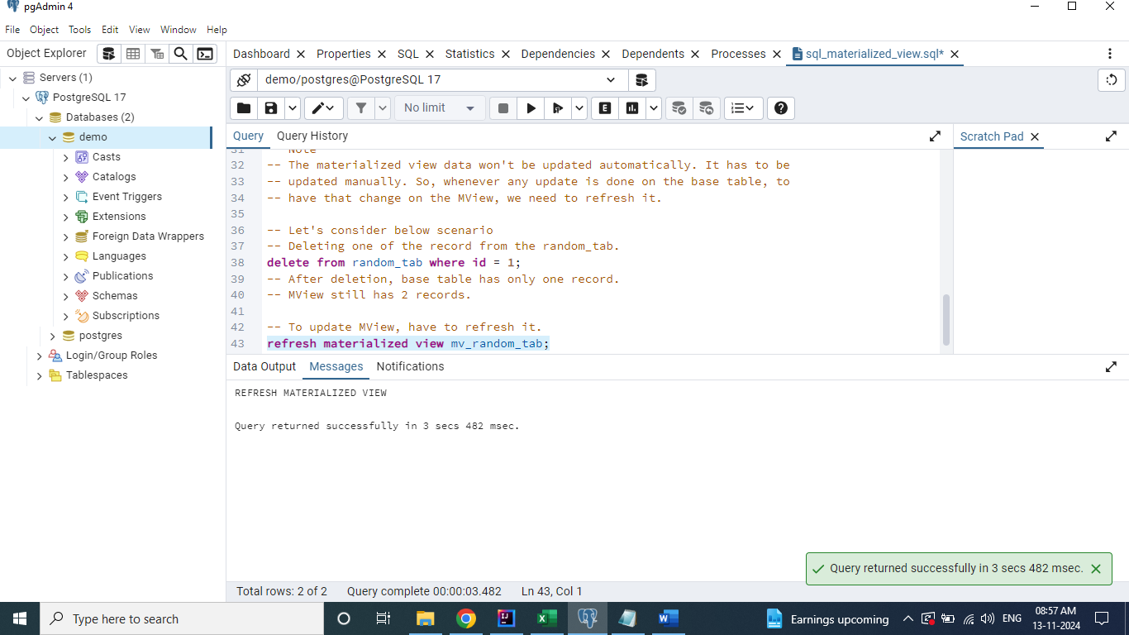

**After refresh**

