**Pivot Function**

# Oracle

**Syntax**

**Select * from Sales_Data;**

**Select \***

**from (**

**Base Query**

**)**

**pivot**

**(**

**aggregate function**

**for column value in (‘Jan-21’, ‘’, ‘’)**

**)**

**Note: The base query should at least have 3 columns.**

1. **First column should be the unique identifier.**
2. **Second column should provide the list of categories.**
3. **Third column value should be loaded into each of the category mentioned in column 2.**

**-- With Clause is used to transform the NULL values into 0 for calculation of sum**

**-- amount for the each customer for 12 months.**

**with pivot_data as**

**(select \***

**from**

**(**

**-- Base Query -- Provides Raw Data**

**select customer_id as customer,**

**to_char(sales_date, 'Mon-YY') as sales_order,**

**cast(replace(amount, '$', '') as int) as amount**

**from sales_data**

**)**

**pivot**

**(**

**-- Here, SQL will do sum(amount) using aggregate function --**

**-- SQL will create multiple columns based on the value that returned**

**-- from sales_date and what we have mentioned here for sales_date.**

**-- Also, each of the below values are correspond to the base query's**

**-- sales_date column**

**-- The aggregation of the amount is happening based on each customer.**

**sum(amount)**

**for sales_date in ('Jan-21' as Jan_21, 'Feb-21' as Feb_21, 'Mar-21' as Mar_21,**

**'Apr-21' as Apr_21, 'May-21' as May_21, 'Jun-21' as Jun_21, 'Jul-21' as Jul_21,**

**'Aug-21' as Aug_21, 'Sep-21' as Sep_21, 'Oct-21' as Oct_21, 'Nov-21' as Nov_21,**

**'Dec-21' as Dec_21)**

**)**

**-- Union is used to merge the specific customer rows with the below Total row**

**UNION**

**select \***

**from**

**(**

**-- Here instead of customer_id, its replaced by 'Total' because we need**

**-- the total amount irrespective of the customers.**

**select 'Total' as customer,**

**to_char(sales_date, 'Mon-YY') as sales_order,**

**cast(replace(amount, '$', '') as int) as amount**

**from sales_data**

**)**

**pivot**

**(**

**-- Here, SQL will do sum(amount) using aggregate function --**

**-- SQL will create multiple columns based on the value that returned**

**-- from sales_date and what we have mentioned here for sales_date.**

**-- Also, each of the below values are correspond to the base query's**

**-- sales_date column**

**-- The aggregation of the amount is happening based on each customer.**

**sum(amount)**

**for sales_date in ('Jan-21' as Jan_21, 'Feb-21' as Feb_21, 'Mar-21' as Mar_21,**

**'Apr-21' as Apr_21, 'May-21' as May_21, 'Jun-21' as Jun_21, 'Jul-21' as Jul_21,**

**'Aug-21' as Aug_21, 'Sep-21' as Sep_21, 'Oct-21' as Oct_21, 'Nov-21' as Nov_21,**

**'Dec-21' as Dec_21)**

**),**

**final_data as**

**(select customer_id,**

**-- Actual code which transforms Null into 0**

**NVL(Jan_21, 0) as Jan_21,**

**NVL(Feb_21, 0) as Feb_21,**

**NVL(Mar_21, 0) as Mar_21,**

**NVL(Apr_21, 0) as Apr_21,**

**NVL(May_21, 0) as May_21,**

**NVL(Jun_21, 0) as Jun_21,**

**NVL(Jul_21, 0) as Jul_21,**

**NVL(Aug_21, 0) as Aug_21,**

**NVL(Sep_21, 0) as Sep_21,**

**NVL(Oct_21, 0) as Oct_21,**

**NVL(Nov_21, 0) as Nov_21,**

**NVL(Dec_21, 0) as Dec_21**

**from pivot_data)**

**select customer,**

**case when Jan_21 < 0 then '(' || Jan_21 * -1 ||')$' else Jan_21 || '$' end as "Jan_21",**

**case when Feb_21 < 0 then '(' || Feb_21 * -1 ||')$' else Feb_21 || '$' end as "Feb_21",**

**case when Mar_21 < 0 then '(' || Mar_21 * -1 ||')$' else Mar_21 || '$' end as "Mar_21",**

**case when Apr_21 < 0 then '(' || Apr_21 * -1 ||')$' else Apr_21 || '$' end as "Apr_21",**

**case when May_21 < 0 then '(' || May_21 * -1 ||')$' else May_21 || '$' end as "May_21",**

**case when Jun_21 < 0 then '(' || Jun_21 * -1 ||')$' else Jun_21 || '$' end as "Jun_21",**

**case when Jul_21 < 0 then '(' || Jul_21 * -1 ||')$' else Jul_21 || '$' end as "Jul_21",**

**case when Aug_21 < 0 then '(' || Aug_21 * -1 ||')$' else Aug_21 || '$' end as "Aug_21",**

**case when Sep_21 < 0 then '(' || Sep_21 * -1 ||')$' else Sep_21 || '$' end as "Sep_21",**

**case when Oct_21 < 0 then '(' || Oct_21 * -1 ||')$' else Oct_21 || '$' end as "Oct_21",**

**case when Nov_21 < 0 then '(' || Nov_21 * -1 ||')$' else Nov_21 || '$' end as "Nov_21",**

**case when Dec_21 < 0 then '(' || Dec_21 * -1 ||')$' else Dec_21 || '$' end as "Dec_21",**

**case when customer = 'Total' then ''**

**else case when (Jan_21+Feb_21+Mar_21+Apr_21+May_21+Jun_21+Jul_21+Aug_21+Sep_21+Oct_21+Nov_21+Dec_21) < 0**

**then '(' || (Jan_21+Feb_21+Mar_21+Apr_21+May_21+Jun_21+Jul_21+Aug_21+Sep_21+Oct_21+Nov_21+Dec_21) * -1 || ')$'**

**else (Jan_21+Feb_21+Mar_21+Apr_21+May_21+Jun_21+Jul_21+Aug_21+Sep_21+Oct_21+Nov_21+Dec_21)||'$'**

**end**

**end as Total**

**from final_data;**

# Postgres SQL

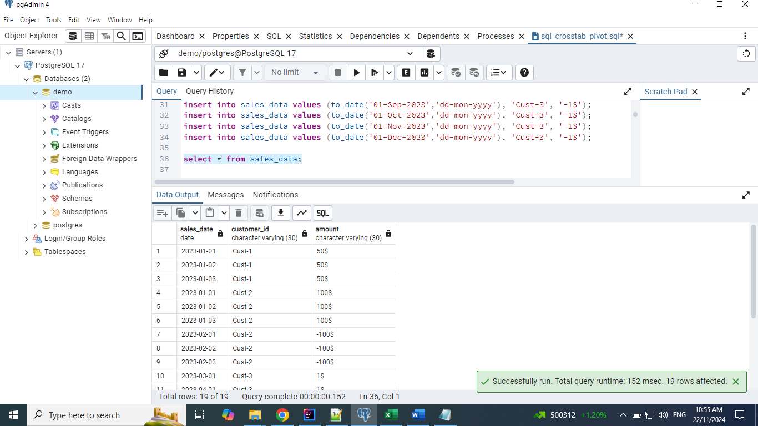

## Notes

**1. In PostgresSQL, we don't have pivot function.**

**2. We have to use the tablefunc extension.**

**3. Crosstab function takes 2 arguments.**

**1. First argument is base query**

**2. Second argument is list of values**

**create extension tablefunc;**

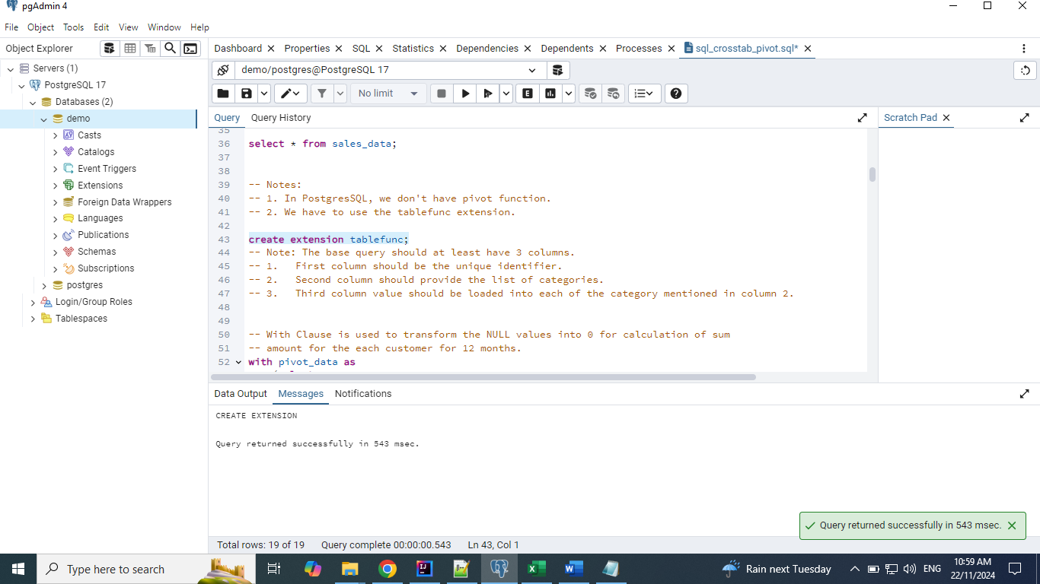

**with pivot_data as**

**(select \***

**from crosstab('select customer_id as customer,**

**to_char(sales_date, ''Mon-YY'') as sales_order,**

**sum(cast(replace(amount, ''$'', '''') as int)) as amount**

**from sales_data**

**group by customer_id, to_char(sales_date, ''Mon-YY'')**

**order by 1',**

**'values (''Jan-23''),(''Feb-23''),(''Mar-23''),(''Apr-23''),(''May-23''),(''Jun-23''),**

**(''Jul-23''),(''Aug-23''),(''Sep-23''),(''Oct-23''),(''Nov-23''),(''Dec-23'')')**

**as (customer varchar, Jan_23 bigint, Feb_23 bigint, Mar_23 bigint, Apr_23 bigint, May_23 bigint, Jun_23 bigint,**

**Jul_23 bigint, Aug_23 bigint, Sep_23 bigint, Oct_23 bigint, Nov_23 bigint, Dec_23 bigint)**

**union**

**select \***

**from crosstab('select ''Total'' as customer,**

**to_char(sales_date, ''Mon-YY'') as sales_order,**

**sum(cast(replace(amount, ''$'', '''') as int)) as amount**

**from sales_data**

**group by to_char(sales_date, ''Mon-YY'')**

**order by 1',**

**'values (''Jan-23''),(''Feb-23''),(''Mar-23''),(''Apr-23''),(''May-23''),(''Jun-23''),**

**(''Jul-23''),(''Aug-23''),(''Sep-23''),(''Oct-23''),(''Nov-23''),(''Dec-23'')')**

**as (customer varchar, Jan_23 bigint, Feb_23 bigint, Mar_23 bigint, Apr_23 bigint, May_23 bigint, Jun_23 bigint,**

**Jul_23 bigint, Aug_23 bigint, Sep_23 bigint, Oct_23 bigint, Nov_23 bigint, Dec_23 bigint)**

**order by 1),**

**final_data as**

**(select customer,**

**-- Actual code which transforms Null into 0**

**coalesce(Jan_23, 0) as Jan_23,**

**coalesce(Feb_23, 0) as Feb_23,**

**coalesce(Mar_23, 0) as Mar_23,**

**coalesce(Apr_23, 0) as Apr_23,**

**coalesce(May_23, 0) as May_23,**

**coalesce(Jun_23, 0) as Jun_23,**

**coalesce(Jul_23, 0) as Jul_23,**

**coalesce(Aug_23, 0) as Aug_23,**

**coalesce(Sep_23, 0) as Sep_23,**

**coalesce(Oct_23, 0) as Oct_23,**

**coalesce(Nov_23, 0) as Nov_23,**

**coalesce(Dec_23, 0) as Dec_23**

**from pivot_data)**

**select customer,**

**case when Jan_23 < 0 then '(' || Jan_23 * -1 ||')$' else Jan_23 || '$' end as "Jan_23",**

**case when Feb_23 < 0 then '(' || Feb_23 * -1 ||')$' else Feb_23 || '$' end as "Feb_23",**

**case when Mar_23 < 0 then '(' || Mar_23 * -1 ||')$' else Mar_23 || '$' end as "Mar_23",**

**case when Apr_23 < 0 then '(' || Apr_23 * -1 ||')$' else Apr_23 || '$' end as "Apr_23",**

**case when May_23 < 0 then '(' || May_23 * -1 ||')$' else May_23 || '$' end as "May_23",**

**case when Jun_23 < 0 then '(' || Jun_23 * -1 ||')$' else Jun_23 || '$' end as "Jun_23",**

**case when Jul_23 < 0 then '(' || Jul_23 * -1 ||')$' else Jul_23 || '$' end as "Jul_23",**

**case when Aug_23 < 0 then '(' || Aug_23 * -1 ||')$' else Aug_23 || '$' end as "Aug_23",**

**case when Sep_23 < 0 then '(' || Sep_23 * -1 ||')$' else Sep_23 || '$' end as "Sep_23",**

**case when Oct_23 < 0 then '(' || Oct_23 * -1 ||')$' else Oct_23 || '$' end as "Oct_23",**

**case when Nov_23 < 0 then '(' || Nov_23 * -1 ||')$' else Nov_23 || '$' end as "Nov_23",**

**case when Dec_23 < 0 then '(' || Dec_23 * -1 ||')$' else Dec_23 || '$' end as "Dec_23",**

**case when customer = 'Total' then ''**

**else case when (Jan_23+Feb_23+Mar_23+Apr_23+May_23+Jun_23+Jul_23+Aug_23+Sep_23+Oct_23+Nov_23+Dec_23) < 0**

**then '(' || (Jan_23+Feb_23+Mar_23+Apr_23+May_23+Jun_23+Jul_23+Aug_23+Sep_23+Oct_23+Nov_23+Dec_23) * -1 || ')$'**

**else (Jan_23+Feb_23+Mar_23+Apr_23+May_23+Jun_23+Jul_23+Aug_23+Sep_23+Oct_23+Nov_23+Dec_23)||'$'**

**end**

**end as Total**

**from final_data;**

