**Procedures**

# Procedures

**Procedure is a block of code which is given a name and stored in the database.**

# Procedure can include

**1. SQL queries**

**2. DML,DDL, DCL, and TCL commands**

**3. Collection Types**

**4. Cursors**

**5. Loop & If Else statements**

**6. Variables**

**7. Exception Handling, etc.**

# What is the purpose of using a Procedure?

**Procedures are generally used to do things which is not possible in SQL queries.**

**Depending on the project requirement, we can bundle multiple queries into Procedures or We may build entire software logic inside Procedure which may include validation checks, processing and querying of data, and much more.**

# Syntax for Procedure Creation

## PostgresSQL

**create or replace procedure pr_name(p_name varchar, p_age int)**

**language plpgsql**

**as $$ -- It is used to print the values with single quotes without using escape chars.**

**declare**

**variable**

**begin**

**procedure body - All logics**

**end;**

**$$**

## Oracle

**create or replace procedure pr_name(p_name varchar, p_age int)**

**as**

**variable**

**begin**

**procedure body - All logics**

**end;**

# Simple Procedure Sample

## For every iPhone 13 Pro Max sales, modify the database tables accordingly

**create or replace procedure pr_buy_product()**

**language plpgsql**

**as $$**

**declare**

**v_prod_code varchar(20);**

**v_price int;**

**begin**

**select prod_code, price**

**into v_prod_code, v_price**

**from p_products**

**where prod_name = 'Iphone 13 Max Pro';**

**insert into p_sales(order_date, prod_code, qty_ordered, sale_price)**

**values (current_date, v_prod_code, 1, (v_price * 1));**

**update p_products**

**set qty_remaining = (qty_remaining - 1),**

**qty_sold = (qty_sold+1)**

**where prod_code = v_prod_code;**

**raise notice 'Product Sold!';**

**end;**

**$$**

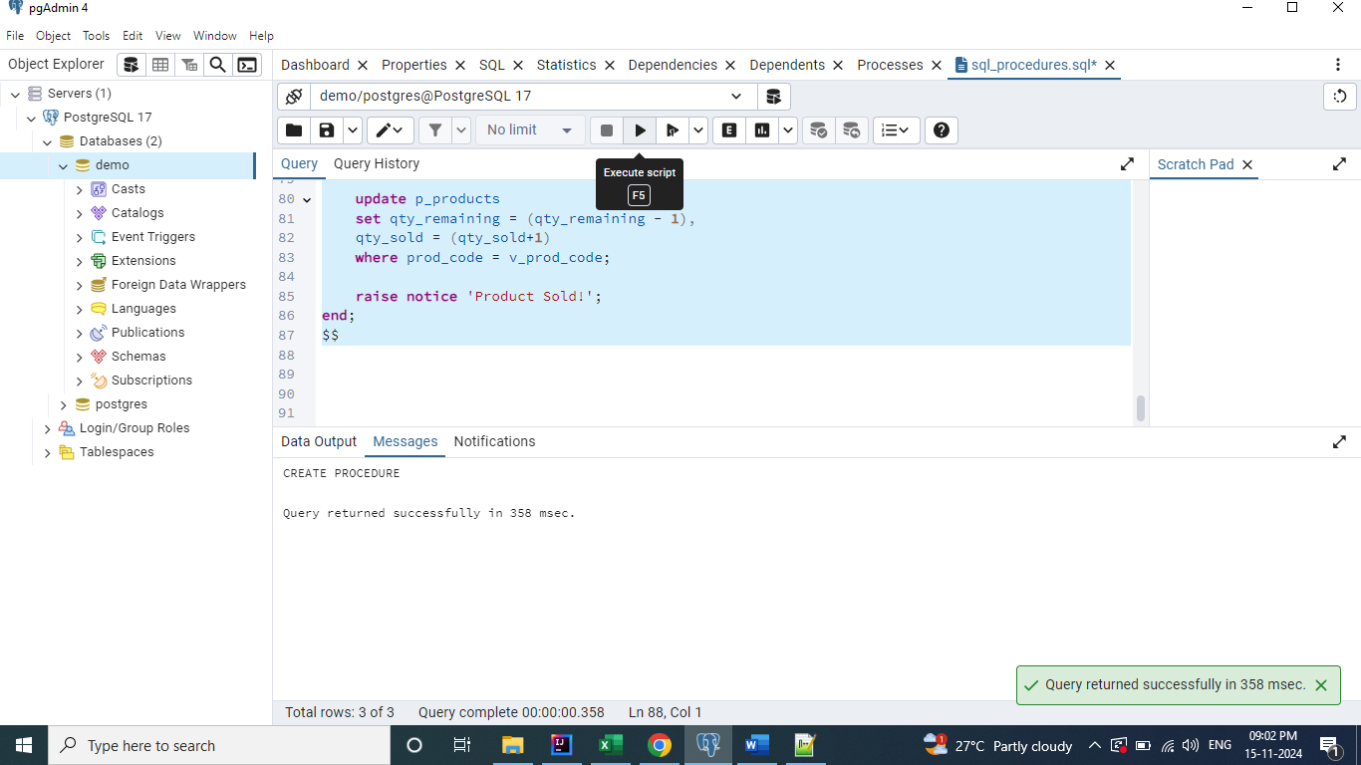

**call pr_buy_product();**

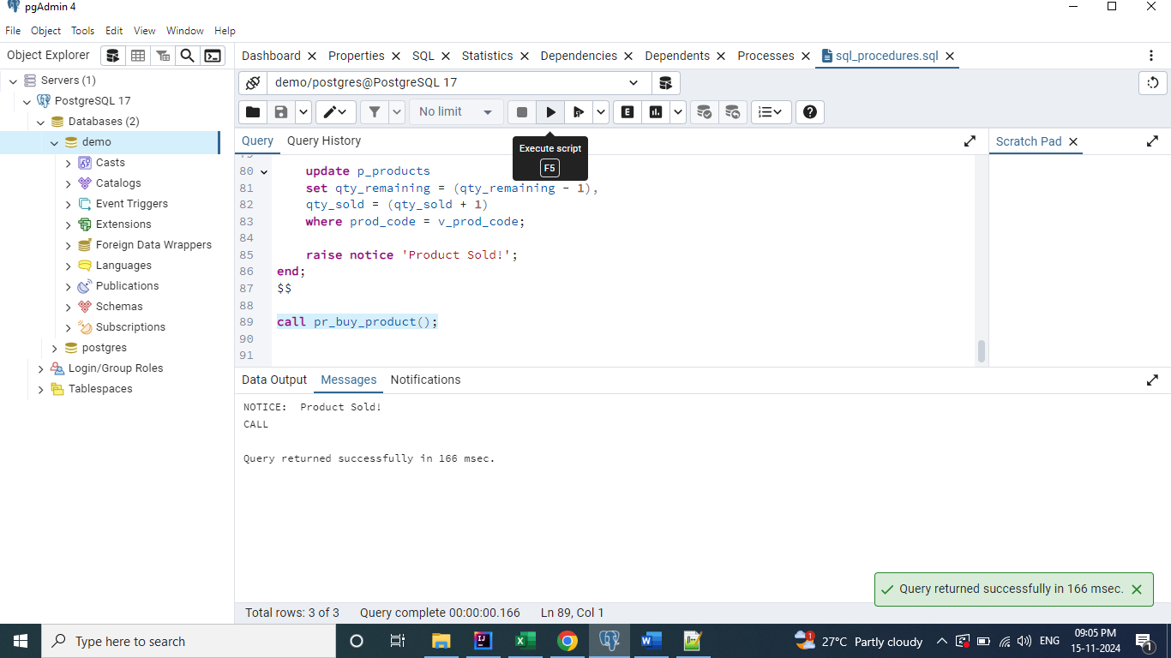

**select * from p_products;**

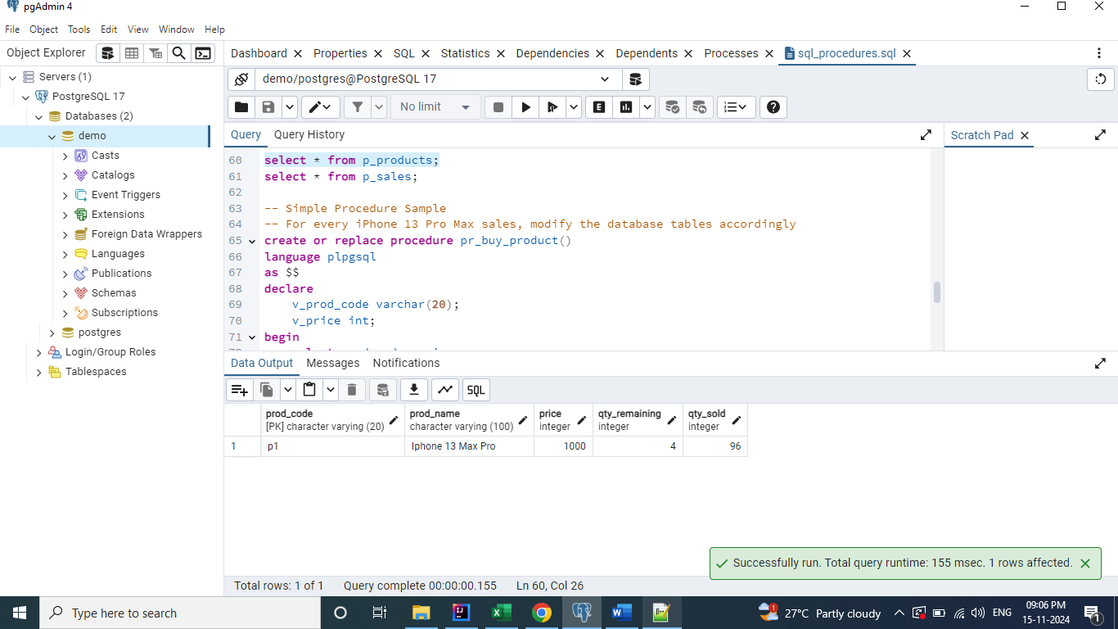

**select * from p_sales;**