**Recursive SQL Script**

# Recursive SQL Syntax

**WITH [RECURSIVE] CTE_Name AS**

**(SELECT query (Non Recursive query or the Base query)**

**UNION [ALL]**

**SELECT query (Recursive query using CTE_Name [with a termination condition])**

**)**

**SELECT * FROM CTE_Name;**

**Things we need for Recursive SQL query,**

**1. With clause**

**2. Recursive keyword**

**3. Base Query**

**4. UNION [ALL] operator**

**5. Recursive query**

**6. Terminate condition**

**7. Main query.**

## Notes

**As soon as the recursive SQL query got executed. The first thing, the SQL will do is, it will come to know that its a Recursive SQL query, then it will find for the base query and execute the same. Since, its a Recursive SQL query, the same query will be executed multiple times until the termination condition met. On the very first iteration, the base query will get executed and the output of the base query comes from the first iteration will become the input for the Recursive query defined. In the second iteration of the query, the Recursive part of the query will get executed, here it will use the data retrieved from the previous iteration and also it checks for the termination condition. If the termination condition not met, then the next iteration will execute by taking the output of the previous iteration.**

**Queries**

# 1) Display number from 1 to 10 without using any built in functions.

**with recursive numbers as**

**(select 1 as num_list**

**union**

**select num_list + 1**

**from numbers where num_list < 10)**

**select * from numbers;**

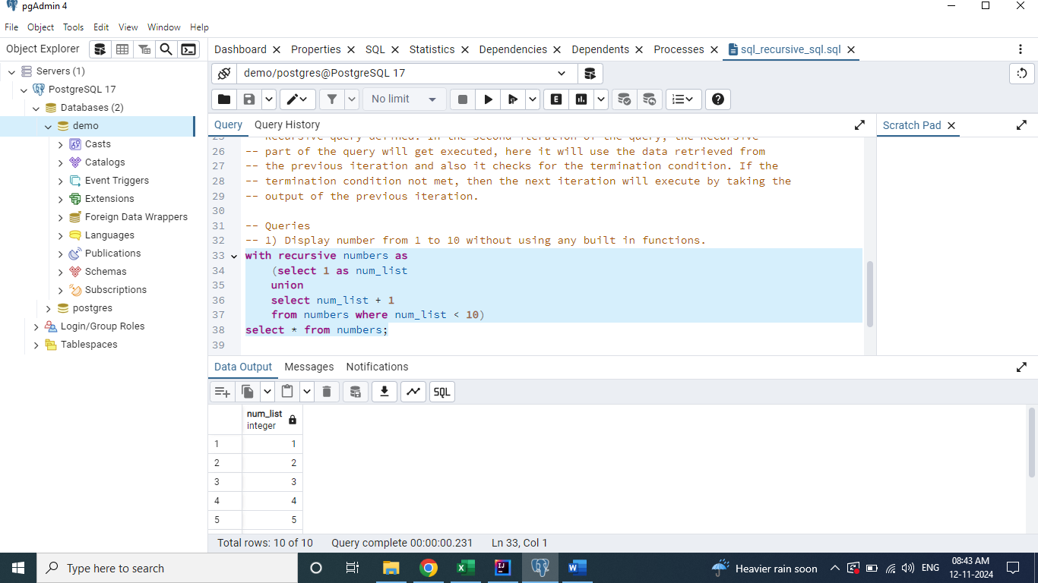

# 2) Find the hierarchy of employees under a given manager "Asha".

**with recursive employee_hierarchy as**

**(select id, name, manager_id, designation, 1 as org_level**

**from emp_details where name = 'Asha'**

**union**

**select e.id, e.name, e.manager_id, e.designation, h.org_level+1 as org_level**

**from employee_hierarchy h**

**join emp_details e on h.id = e.manager_id**

**)**

**select * from employee_hierarchy;**

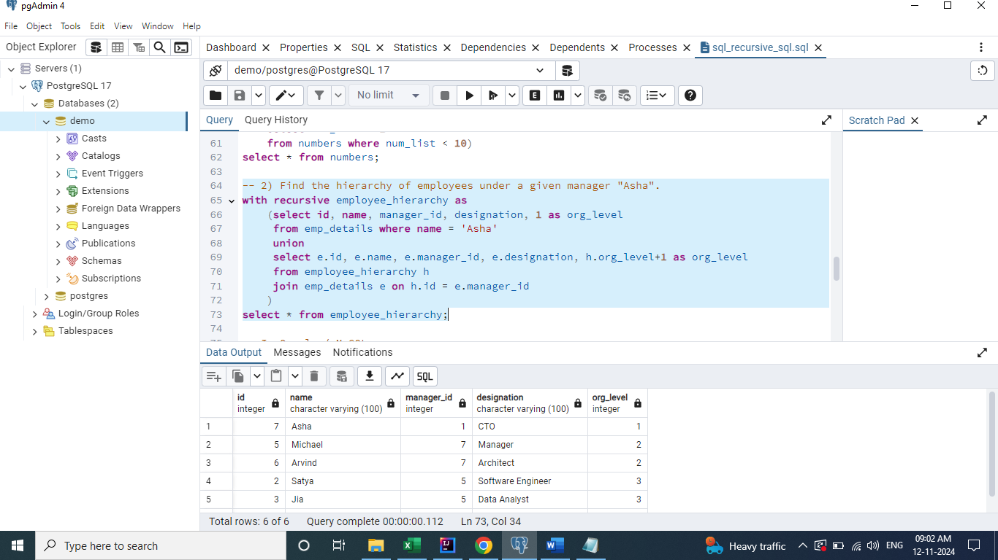

**To get Manager Detail along with above details**

**with recursive employee_hierarchy as**

**(select id, name, manager_id, designation, 1 as org_level**

**from emp_details where name = 'Asha'**

**union**

**select e.id, e.name, e.manager_id, e.designation, h.org_level+1 as org_level**

**from employee_hierarchy h**

**join emp_details e on h.id = e.manager_id**

**)**

**select h2.id as emp_id, h2.name as emp_name, e2.name as manage_name, h2.org_level**

**from employee_hierarchy h2**

**join emp_details e2 on e2.id=h2.manager_id;**

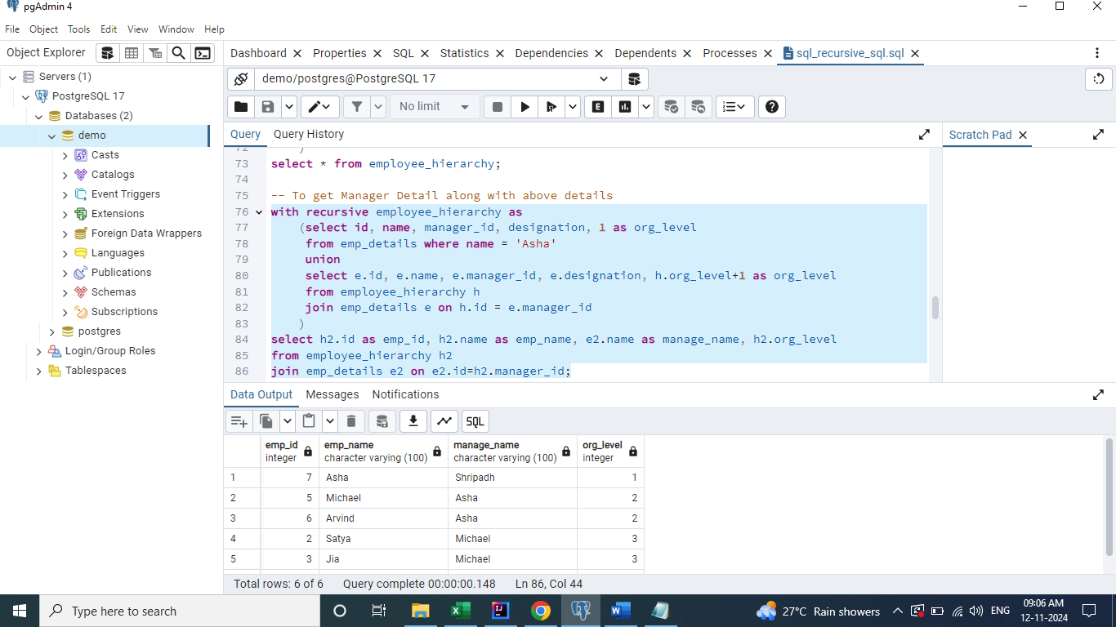

# 3) Find the hierarchy of managers for a given employee "David".

**with recursive employee_hierarchy as**

**(select id, name, manager_id, designation, 1 as org_level**

**from emp_details where name = 'David'**

**union**

**select e.id, e.name, e.manager_id, e.designation, h.org_level+1 as org_level**

**from employee_hierarchy h**

**join emp_details e on h.manager_id = e.id**

**)**

**select h2.id as emp_id, h2.name as emp_name, e2.name as manage_name, h2.org_level**

**from employee_hierarchy h2**

**join emp_details e2 on e2.id=h2.manager_id;**

