**SQL Views**

# Fetch the order summary (to be given to client / vendor)

**create view order_summary as**

**select od.ord_id, od.date, pi.prod_name, cd.cust_name,**

**(pi.price * od.quantity) - ((pi.price * od.quantity) * disc_percent::float/100) as cost**

**from tb_customer_data cd**

**join tb_order_details od on od.cust_id = cd.cust_id**

**join tb_product_info pi on pi.prod_id = od.prod_id;**

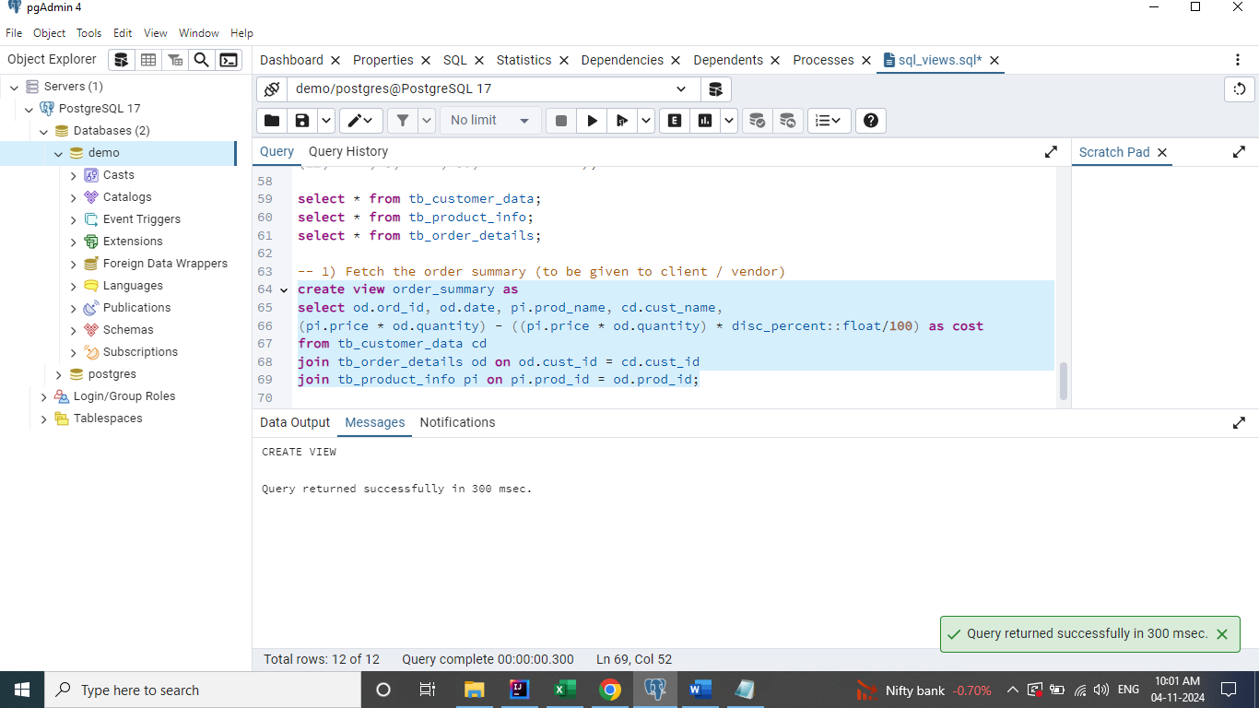

**select * from order_summary;**

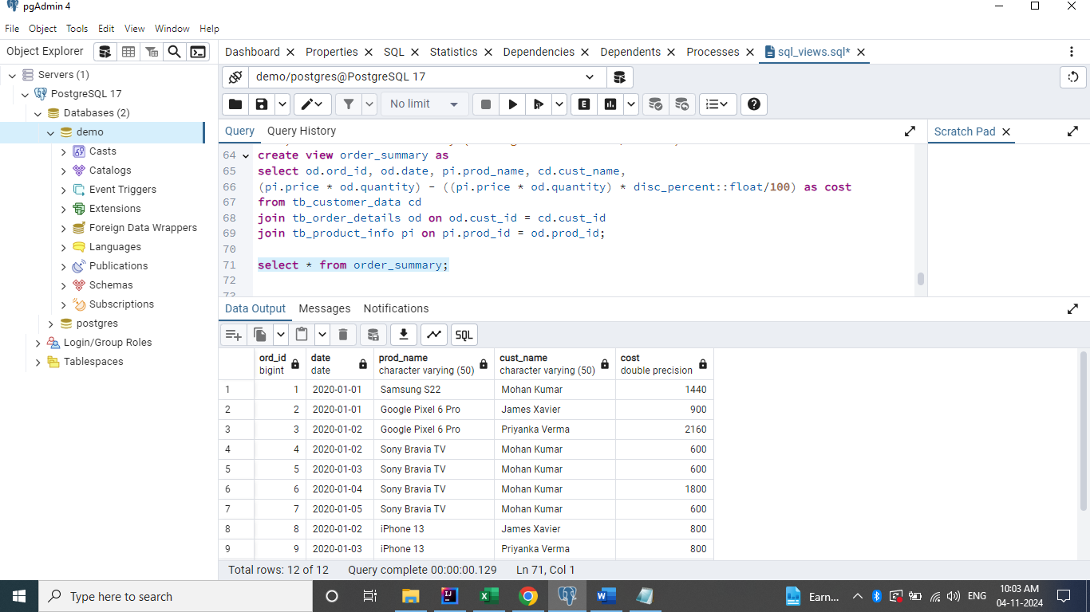

# 2. What is the main purpose of using a view / advantage of view.

**-- 1) Security**

**-- 2) To simplify the complex sql queries.**

## Create User

**create role john**

**login**

**password 'john';**

## Provide Access to Order Summary View

**grant select on order_summary to john;**

## 1) Security

**In this scenario, we have created a new user 'John' and gave him the read access to the order summary view. By hiding the query used to generate the view.**

## 2) To simplify the complex sql queries.

**i. Sharing a view is better than sharing a complex query.**

**ii. Avoid rewriting the same complex query multiple times.**

# Create or Replace View

Whenever we are using the Create or Replace View command, we have to follow below rules.

1. Cannot change the column name.
2. Cannot change the column data type.
3. Cannot change the order of columns. But we can add new column at the end.

**create or replace view order_summary as**

**select od.ord_id, od.date, pi.prod_name, cd.cust_name,**

**(pi.price * od.quantity) - ((pi.price * od.quantity) * disc_percent::float/100) as cost**

**from tb_customer_data cd**

**join tb_order_details od on od.cust_id = cd.cust_id**

**join tb_product_info pi on pi.prod_id = od.prod_id;**

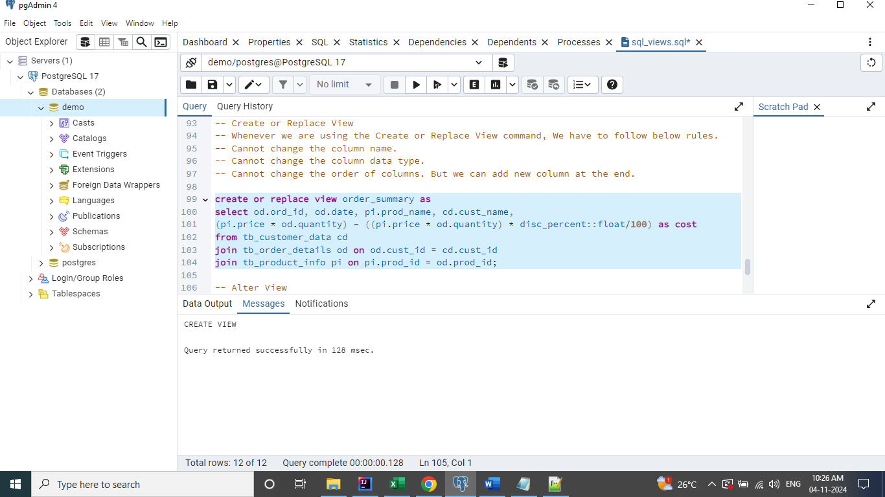

# Alter View

**alter view order_summary rename column date to order_date;**

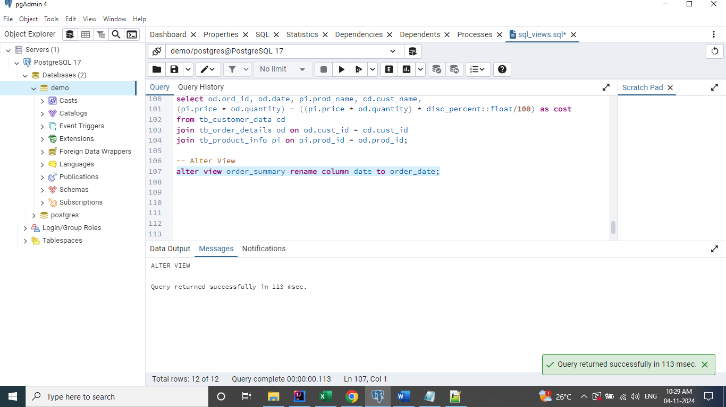

We can also rename the view using the alter command.

**alter view order_summary rename to order_summary_2;**

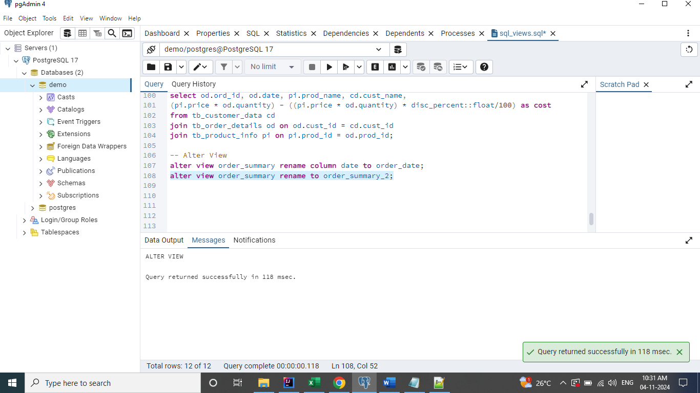

# Drop View

**drop view order_summary_2;**

