# Find the employees whose salary is more than the avg salary earned by all employees.

**select * -- Main / Outer Query**

**from employee**

**where salary > (select avg(salary) from employee -- Sub / Inner Query**

**);**

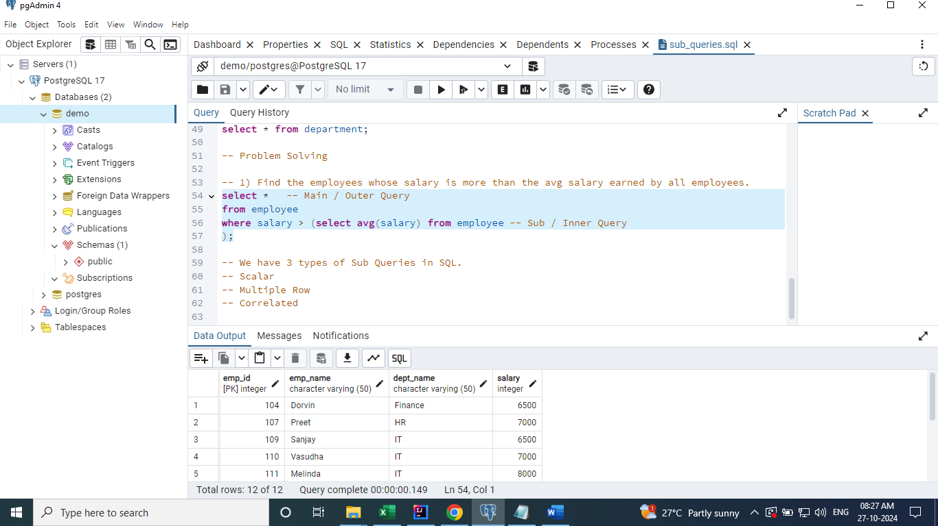

-- We have 3 types of Sub Queries in SQL.

-- Scalar

-- Multiple Row

-- Correlated

-- Scalar SubQuery

-- It will return one row and one column. It can be used in from and where clauses.

-- Above query is modified to have subquery in from clause.

**select e.\***

**from employee e**

**join (select avg(salary) sal from employee) avg_sal**

**on e.salary > avg_sal.sal;**

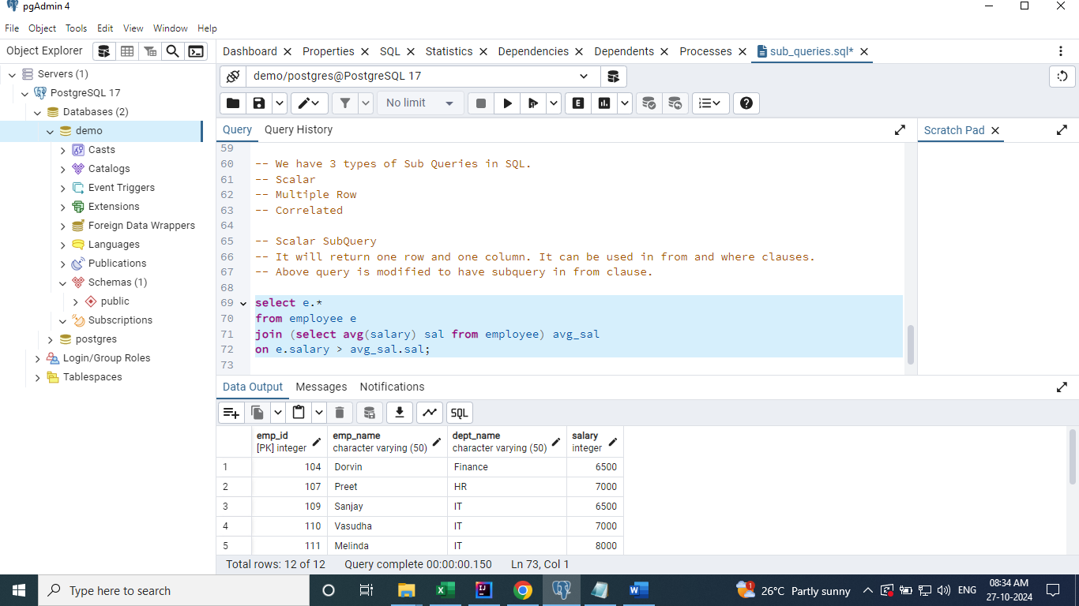

-- Multiple Row SubQuery

-- Subquery which returns multiple rows and columns.

-- Subquery which returns single column and multiple rows.

# Find the employees who earn the highest salary in each department.

**select \***

**from employee**

**where (dept_name, salary) in ( select dept_name, max(salary)**

**from employee**

**group by dept_name**

**);**

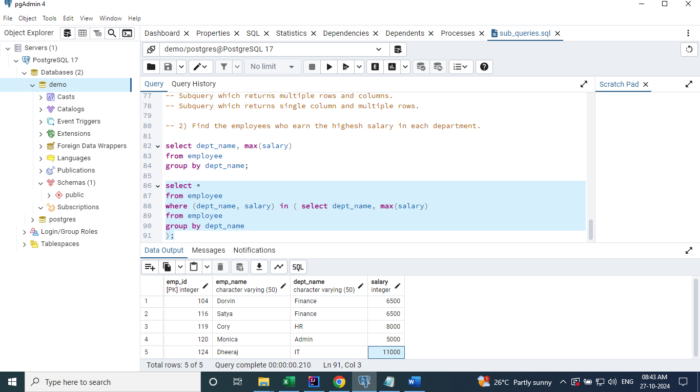

# Find the department who do not have any employees.

-- Single column and multiple rows

select distinct dept_name from employee;

**select \***

**from department**

**where dept_name not in (select distinct dept_name from employee**

**);**

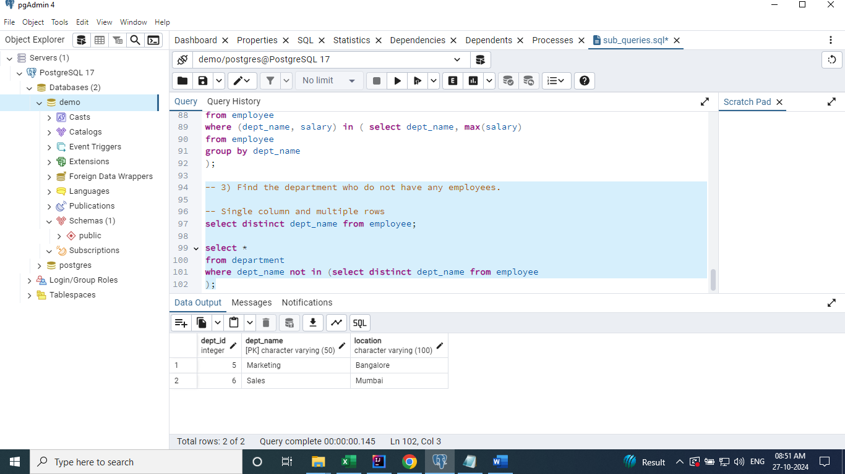

# Find the employees in each department who earn more than the average salary in that department

**-- Correlated SubQuery**

**-- A Subquery which is related to the outer query.**

**select avg(salary) from employee where dept_name = "specific_department";**

**select \***

**from employee e1**

**where salary > ( select avg(salary)**

**from employee e2**

**where e2.dept_name = e1.dept_name);**

