API Session – Chapter 2

- Postman -

# Postman

Postman is a popular API development and testing tool. It provides a user-friendly interface to create, test, and manage APIs. With Postman, you can send HTTP requests to your APIs, inspect responses, and automate testing through scripting. It's widely used for API development, debugging, and collaboration, making it easier for developers to ensure their APIs work correctly and efficiently.

# Download

The below link can be used to download and install the Postman on your system.

<https://www.postman.com/downloads/>

# Creating Your Postman Account

Before diving into the world of API development with Postman, you'll need to set up your account.

**Install Postman:** Download and install the Postman application on your computer.

**Launch Postman:** Once installed, open the Postman application.

**Create an Account:** You'll be prompted to create a new Postman account. Alternatively, you can conveniently sign in using your existing Google account.

# Building Your Workspace

Think of a workspace as a container for your API projects. Let's create one to get started.

**Access the Workspace Menu:** Locate the Workspace menu at the top of the Postman interface.

**Create a New Workspace:** Click on the "Create Workspace" button.

**Workspace Settings:** Choose "Personal" visibility for now to keep your workspace private.

**Save Your Workspace:** Give your workspace a descriptive name and click "Create".

With your account and workspace ready, you're now prepared to explore the exciting realm of API development and testing using Postman.

# Collections

**A Postman Collection is like a folder for your API requests.**

It allows you to group related requests together, making it easier to organize, share, and manage your API interactions. You can think of it as a digital notebook for your API work.

For example, you might create a collection for all the requests related to user management, another for product APIs, and so on.

Collections make it easy to manage, run, and share your API tests. Each collection can include pre-request scripts, test scripts, and environment variables to automate and streamline the testing process. Collections are useful for grouping requests related to a specific project or functionality, making your API development and testing more structured and efficient.

We can create any number of collections inside the Workspace.

# Creating a Collection in Postman

There are primarily two ways to create a collection in Postman:

## 1. Creating a New Collection Directly

* **Navigate to the Collections Tab:** Open Postman and click on the "Collections" tab on the left sidebar.
* **Create a New Collection:** Click on the "+" icon next to "Collections" and select "New Collection".
* **Provide Details:** Give your collection a name, description (optional), and select a workspace.
* **Create:** Click "Create" to finalize the process.

## 2. Creating a Collection from an Existing Request

* **Create a New Request:** Create a new HTTP request in Postman.
* **Save the Request:** Click on the "Save" button and choose "Save as Collection".
* **Create a New Collection:** You'll be prompted to create a new collection. Provide a name, description, and workspace.
* **Save:** Click "Save" to create the collection and add the request to it.

# Exporting a Collection in Postman

**Exporting a collection** in Postman allows you to share or backup your API requests and related information. Here's how to do it:

## Steps

1. **Navigate to the Collections Tab:** Open Postman and go to the "Collections" tab on the left sidebar.
2. **Select the Collection:** Choose the collection you want to export.
3. **Access Export Options:** Click on the three dots (ellipsis) icon next to the collection name.
4. **Choose Export Format:** Select "Export" from the dropdown menu.
5. **Save the File:** Choose the desired location on your computer to save the exported file.

## Additional Notes

* **JSON format** is the most commonly used format for exporting collections. It preserves all the details of your requests, including headers, parameters, body, and responses.

**Once exported, you can:**

* Share the collection with other team members.
* Import the collection into another Postman instance.
* Use the collection with tools like Newman for command-line testing.

# Creating the Requests

1. **Create a New Collection:** As you know, create a new collection to group your requests.
2. **Add a New Request:** Within your collection, click the "+" icon to add a new request.

## GET Request

* **Set the Method:** Select "GET" from the dropdown menu.
* **Enter the URL:** Input the API endpoint you want to retrieve data from.
* **Add Parameters (Optional):** If needed, add query parameters to the URL.
* **Send the Request:** Click the "Send" button.

## POST Request

* **Set the Method:** Select "POST" from the dropdown menu.
* **Enter the URL:** Input the API endpoint to create a new resource.
* **Set Request Body:** Define the data you want to send in the request body. Postman supports various body formats (raw, JSON, form-data, etc.).
* **Add Headers (Optional):** Include necessary headers for the request.
* **Send the Request:** Click the "Send" button.

## PUT Request

* **Set the Method:** Select "PUT" from the dropdown menu.
* **Enter the URL:** Input the API endpoint to update an existing resource.
* **Set Request Body:** Define the updated data in the request body.
* **Add Headers (Optional):** Include necessary headers for the request.
* **Send the Request:** Click the "Send" button.

## DELETE Request

* **Set the Method:** Select "DELETE" from the dropdown menu.
* **Enter the URL:** Input the API endpoint to delete a resource.
* **Add Parameters (Optional):** Include necessary parameters in the URL.
* **Send the Request:** Click the "Send" button.

# HTTP Status Codes

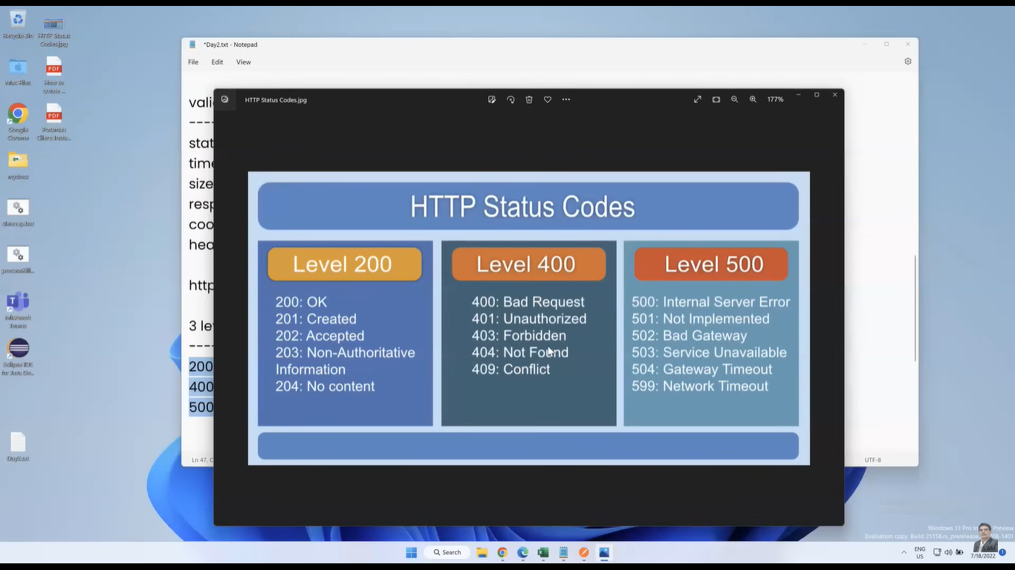

# Run Collection

**Postman's Collection Runner** is the tool for this job. Here's how to use it:

1. **Navigate to the Collection:** In Postman, select the collection you want to run.
2. **Open the Runner:** Click the "Run" button in the collection's header.
3. **Configure the Run (Optional):**
   * **Iterations:** Specify how many times you want to run the collection.
   * **Data Files:** If you need to pass data to your requests, you can import CSV or JSON files.
   * **Environment:** Select the appropriate environment for your API calls.
   * **Delay:** Set a delay between requests if needed.
4. **Start the Run:** Click the "Run" button to initiate the collection run.

**Postman will execute each request in the collection sequentially.** You can monitor the progress, view results, and analyze performance metrics in the Runner interface.