API Session – Chapter 1

- Introduction -

# Understanding Clients and Servers: The Backbone of Modern Applications

Imagine you're at a restaurant. You (the client) raise your hand to flag down the waiter (the server). You tell them what you'd like to order (your request), and they relay that information to the kitchen (the server behind the scenes). The kitchen prepares your food (processes the request) and sends it back with the waiter (the response).

In the world of computers, this interaction between you and the waiter translates to **client-server architecture**. Here's a breakdown of the key players:

* **Client:** This is the software application or device you use to access a service. It could be your web browser, a mobile app, or even another computer program. The client initiates requests for information or actions.
* **Server:** This is a dedicated computer program or machine that runs services for other computers. These services can be anything from storing files and databases to running websites and processing emails. The server receives requests from clients, performs the necessary actions, and sends back a response.

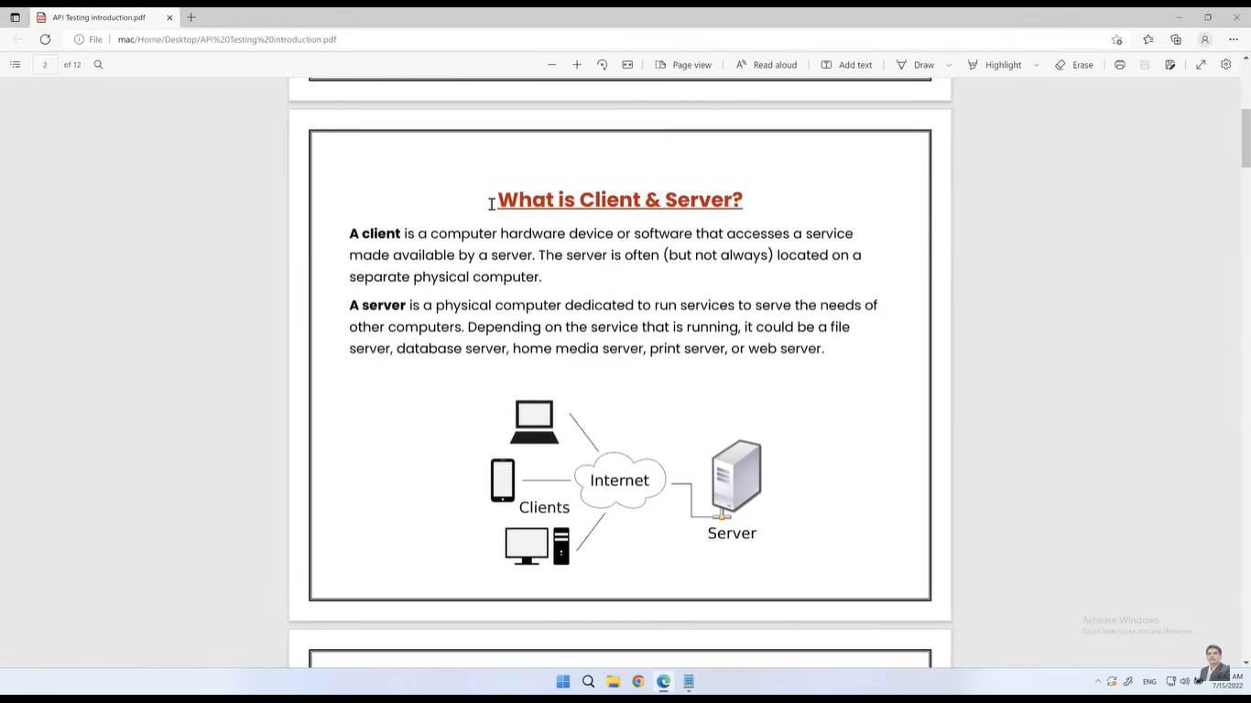

# How They Work Together: Client-Server Architecture

There are three main ways clients and servers can be structured:

1. **1-Tier Architecture:** Think of a simple calculator app. Both the user interface (where you see the buttons) and the processing logic (that performs the calculations) reside on a single device. This is a simple setup suitable for basic applications.
2. **2-Tier Architecture:** This is like a traditional bank application. The user interface (client software) runs on your computer, while the data storage and processing happen on a separate bank server. This allows for centralized management of information.
3. **3-Tier Architecture:** Imagine a complex online shopping website. Here, you have three layers:
   * **Client Tier (Presentation Layer):** This is your web browser displaying the product information and shopping cart.
   * **Business Logic Tier (Application Layer/Middle Layer):** This is the "behind-the-scenes" layer that handles tasks like managing user accounts and processing orders. It sits between the client and the server.
   * **Database Tier (Data Layer):** This is where all the product information, customer details, and order history are stored.

By separating these layers, developers can create more scalable and flexible applications.

**This client-server dance ensures smooth information flow and efficient service delivery in the digital world!**

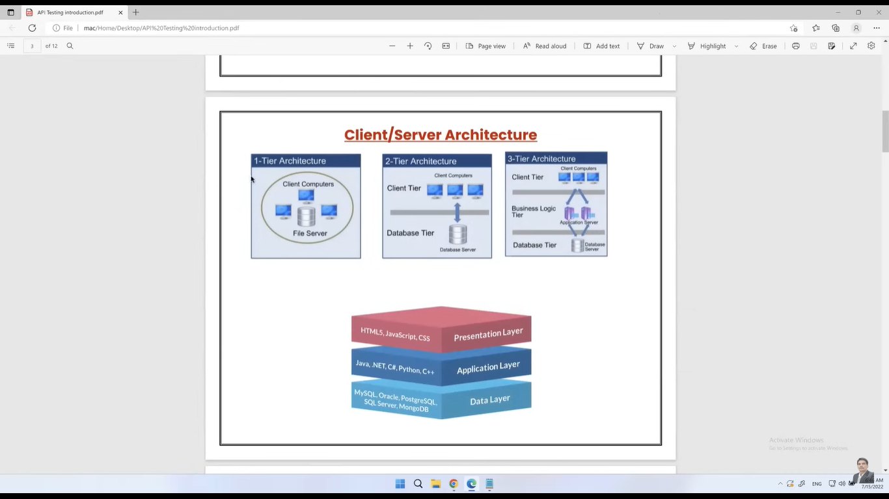

# APIs: The Intermediary of the Digital World

## What is an API?

Imagine you're ordering food at a restaurant. You (the customer) communicate your order to the waiter (the API), who then communicates it to the kitchen (the backend system). The waiter then brings you the food (the response). This is essentially how APIs work.

An API, or Application Programming Interface, is a set of rules and protocols that allow different software applications to communicate and interact with each other. It's like a translator, converting requests from one application into a language that another application can understand.

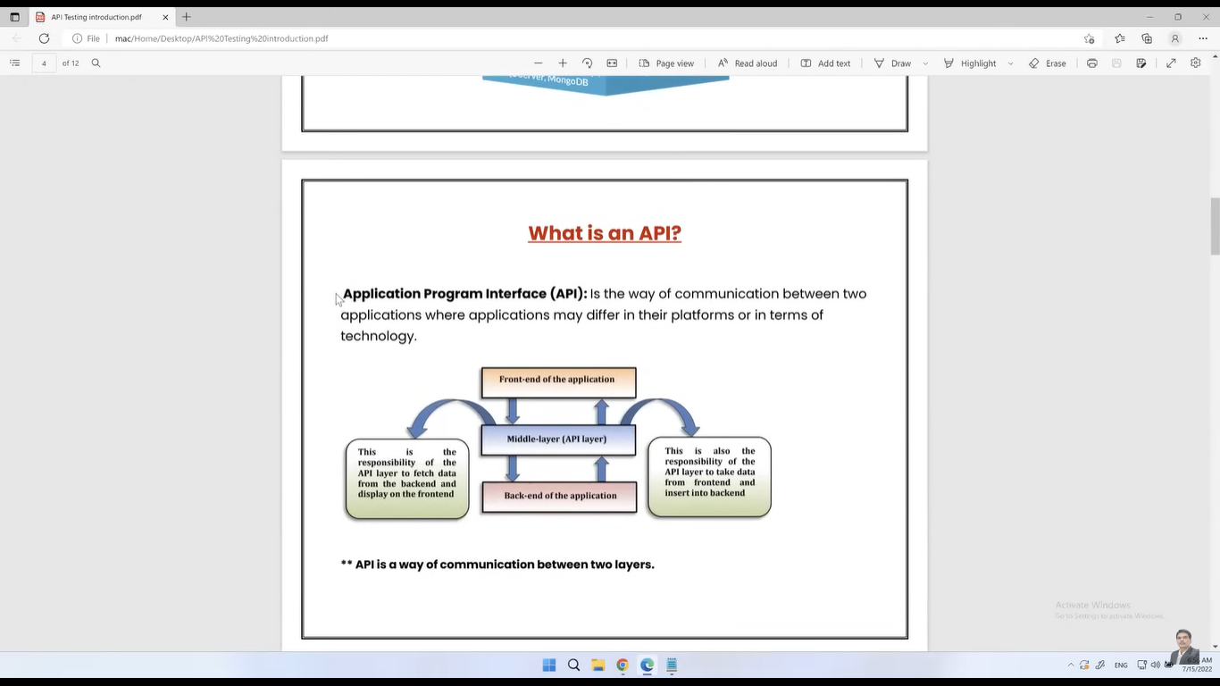

## How APIs Work

At its core, an API acts as a bridge between different software components. It typically operates between a user interface (frontend) and a database (backend).

### Data Fetching:

An API can retrieve data from a database and present it on a user interface. For example, when you search for a product on an online store, the API fetches product details from the database and displays them on your screen.

### Data Manipulation:

APIs can also allow users to modify data in a database. When you add a product to your shopping cart, the API updates the database to reflect the change.

# Why API Testing is Crucial

**API testing is crucial for ensuring the overall quality and reliability of an application.**

Since APIs act as the intermediary between the database and the user interface, they play a vital role in data exchange. By testing APIs, we can:

## Identify issues early:

API testing allows us to detect problems in the application's core functionality before the user interface is even complete. This proactive approach saves time and resources.

## Improve test efficiency:

Because APIs bypass the user interface, tests can be executed more rapidly and comprehensively. This means more test coverage in less time.

## Ensure data integrity:

By directly interacting with the API, we can verify that data is being stored, retrieved, and modified correctly in the database.

## Focus testing efforts:

By thoroughly testing the API, we can reduce the need for extensive testing on the user interface. This optimization of testing resources leads to increased efficiency.

In essence, API testing provides a solid foundation for the application, helping to deliver a higher quality product. By focusing on API testing early in the development process, you can identify and fix issues before they impact the user interface, saving time and resources.

# Real-World API Examples

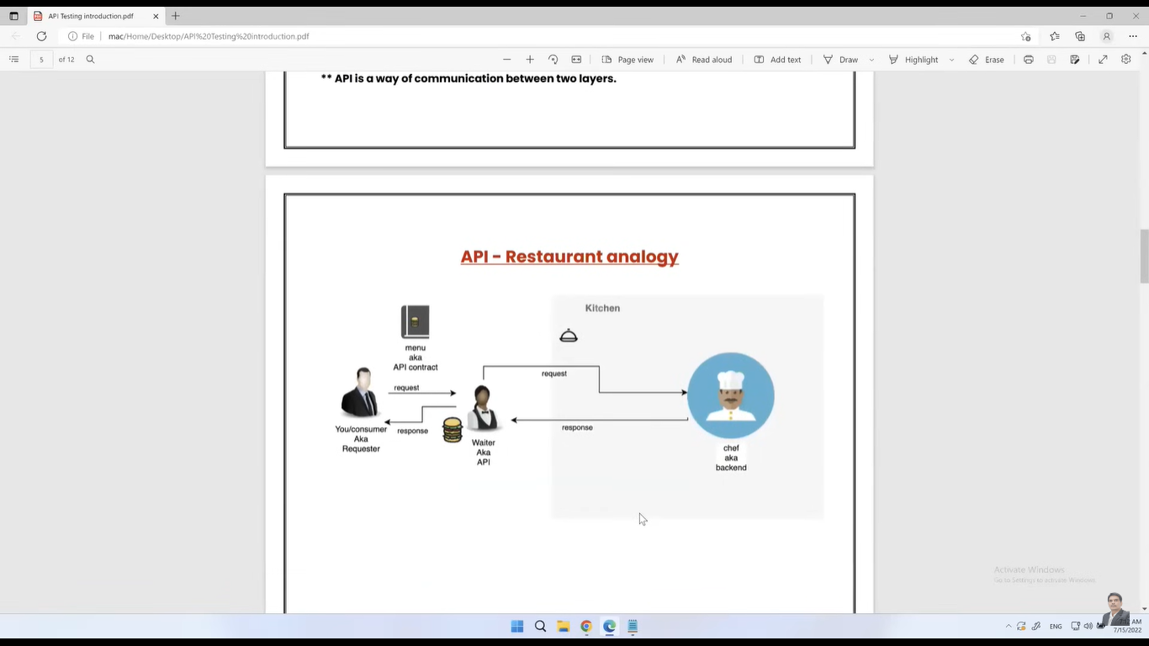

## Google Maps API: A Location Powerhouse

Google Maps is a prime example of a powerful API. Rather than building their own mapping technology, companies like Ola and Uber leverage Google's expertise by integrating the Google Maps API into their applications. This allows them to access detailed maps, calculate routes, and provide location-based services to their users without having to develop these features from scratch.

## APIs in Travel and Booking: A Collaborative Ecosystem

Online travel platforms like MakeMyTrip rely heavily on APIs to connect with various airlines, hotels, and other travel providers. When you search for flights on MakeMyTrip, the platform interacts with multiple airline APIs to fetch flight schedules, pricing, and availability. This collaborative approach enables users to compare options from different airlines in one place.

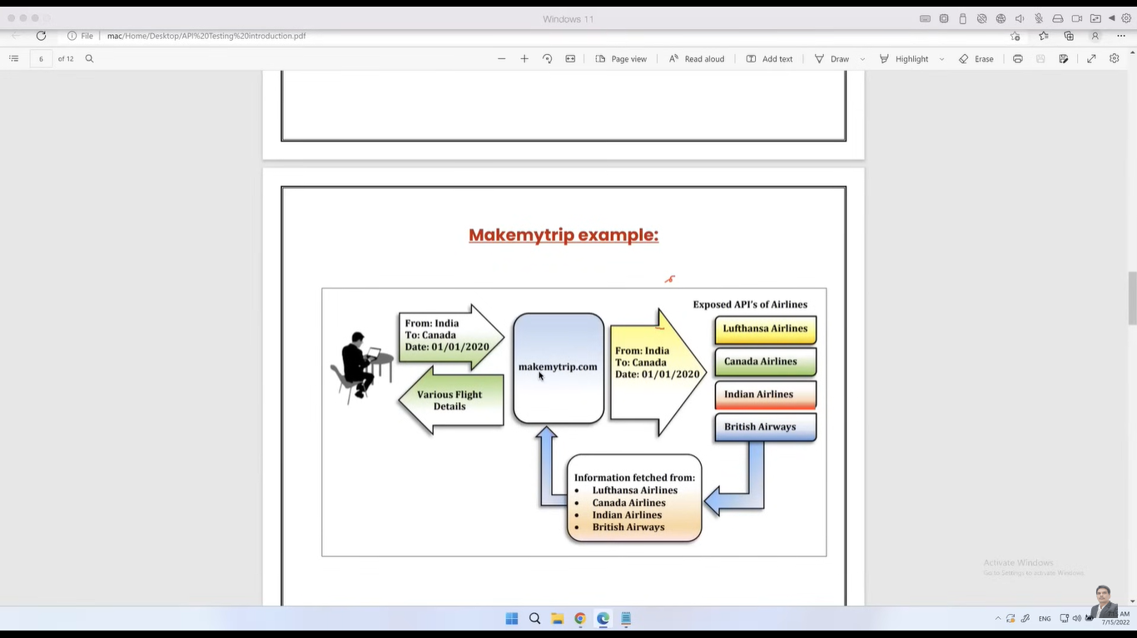

## APIs for User Authentication: Simplifying Logins

Many applications offer the convenience of signing in using Google or other social media accounts. This is made possible through authentication APIs provided by these platforms. For instance, when you choose to log in to a website using your Google account, the website interacts with Google's API to verify your identity and grant access to your information. This streamlined process saves users time and effort.

These examples illustrate how APIs serve as the connective tissue between different software applications, enabling efficient data exchange and enhanced user experiences.

In essence, APIs are the unsung heroes of the digital world, facilitating seamless interactions between various software applications. By understanding their role and importance, you can appreciate the complex systems that power our everyday digital experiences.

# Types of APIs: SOAP and REST

There are two primary types of APIs that have shaped the way applications interact:

## SOAP (Simple Object Access Protocol)

SOAP is a more structured and complex protocol that uses XML to format messages. It offers robust features like security, reliability, and transaction support. However, its verbosity and overhead have led to its decline in popularity. While SOAP is still used in some enterprise environments, it's less common in modern applications.

## REST (Representational State Transfer)

REST has emerged as the dominant API architecture due to its simplicity, flexibility, and scalability. It leverages HTTP methods (GET, POST, PUT, DELETE, etc.) and typically uses JSON for data exchange. RESTful APIs are stateless, meaning each request contains all necessary information, making them easier to develop, test, and maintain.

# Web Services: APIs Over the Network

A web service is essentially an API that is accessible over the internet using HTTP protocols. It's like exposing an API to the public, allowing external applications to consume its functionality. While all web services are APIs, not all APIs are web services. An API can exist within a private network or be used internally without being a web service.

In summary, RESTful APIs have become the preferred choice for most modern applications due to their ease of use and efficiency. While SOAP still has its place in specific scenarios, REST's dominance is undeniable. Understanding the differences between these two types is crucial for selecting the right API architecture for your project.

## HTTP Methods: The Verbs of the Web

HTTP methods are the actions a client can perform on a server resource. They provide a standardized way for clients and servers to interact. Let's explore the most common ones:

## GET:

Retrieves data from a specified resource. It's idempotent, meaning it can be executed multiple times without changing the result.

## POST:

Creates a new resource on the server. It's not idempotent.

## PUT:

Updates an entire existing resource. It's idempotent.

## PATCH:

Updates a specific part of an existing resource. It's not idempotent.

## DELETE:

Removes a resource from the server. It's idempotent.

# HTTP and HTTPS: Security Matters

## HTTP (Hypertext Transfer Protocol):

This is the foundation for communication on the web, enabling the transfer of data between clients and servers. However, it's not secure, meaning data is transmitted in plain text.

## HTTPS (Hypertext Transfer Protocol Secure):

This is the encrypted version of HTTP. It ensures data is transmitted securely using SSL/TLS encryption, protecting sensitive information like passwords and credit card details.

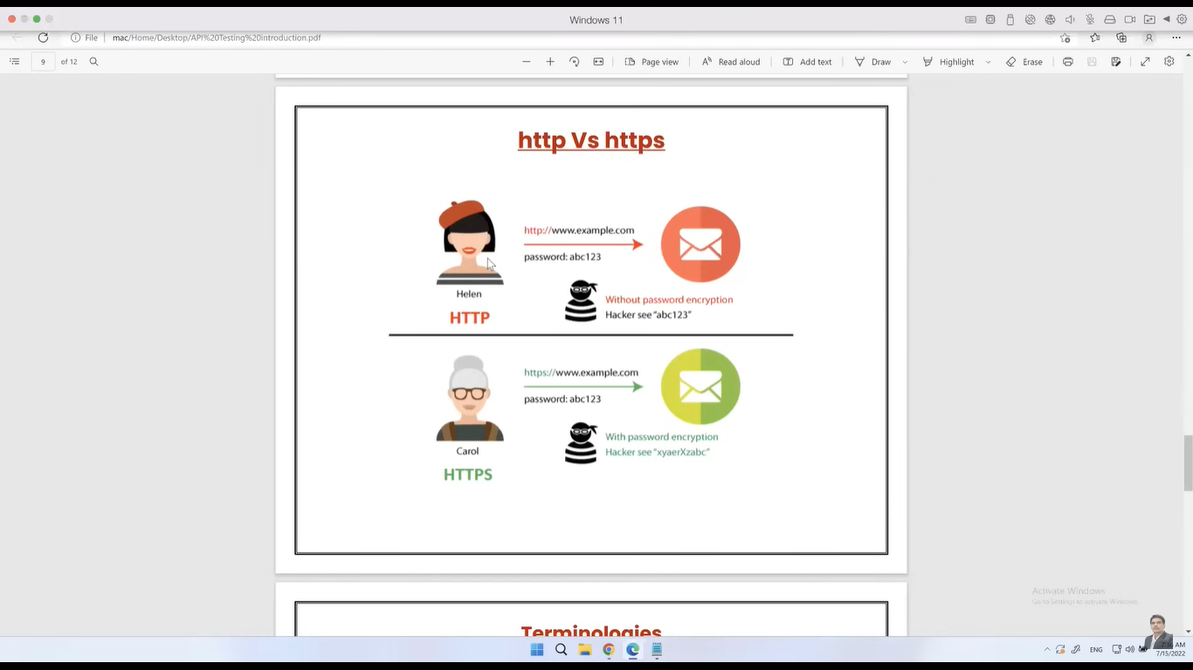

# Understanding URIs

To locate resources on the web, we use URIs (Uniform Resource Identifiers). There are three main types:

## URL (Uniform Resource Locator):

Specifies the exact location of a resource on the internet, including the protocol, domain name, and path.

## URN (Uniform Resource Name):

Identifies a resource independently of its location. It's more like a persistent alias.

## URI (Uniform Resource Identifier):

This is a general term encompassing both URLs and URNs. It's a standard way to identify resources.

By understanding these core concepts, you'll have a solid foundation for building and interacting with web applications.

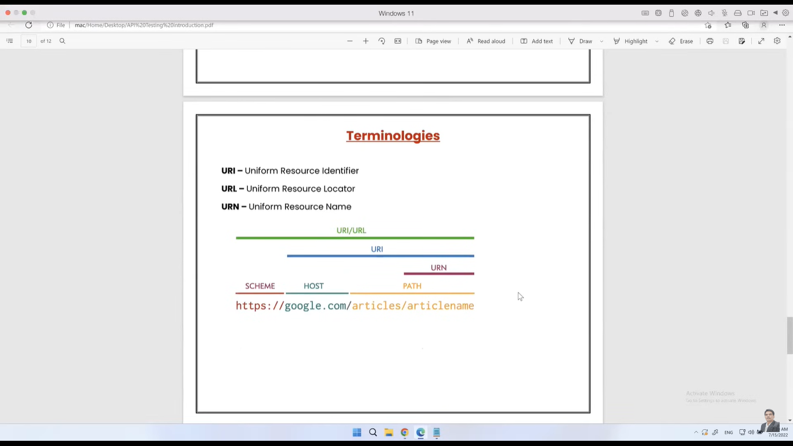

# Breaking Down a Web Address: Understanding URIs

Imagine you're giving directions to a friend's house. Here's how a web address functions similarly:

## Scheme (https):

This is like the delivery method. Just like you might tell your friend "drive" or "walk," https indicates a secure connection.

## Host ([**www.google.com**](https://www.google.com)):

This is the destination address, similar to the street address of your friend's house.

## Path (/articles/articleName):

This specifies the specific location within the address, like the house number or apartment number.

Here's a breakdown of the different terms:

* **URL (Uniform Resource Locator):** This is the complete address, including the scheme, host, and path. It tells you exactly how to find a specific resource on the web. Think of it as the full written address you give your friend.
* **URI (Uniform Resource Identifier):** This is a more general term encompassing both URLs and URNs. It simply identifies a resource, but it doesn't necessarily specify its location.
* **URN (Uniform Resource Name):** This is like a nickname for a resource. It identifies the resource itself, but not where to find it. Imagine a nickname for your friend's house, like "the red brick place."

## Example:

* **URL:** <https://www.google.com/articles/articleName> - This is the complete web address.
* **URI:** [www.google.com/articles/articleName](https://www.google.com/articles/articleName) - This can be interpreted as a URI because it identifies a resource on Google, but it's missing the scheme (https) to be a complete URL.
* **URN (Endpoint):** articles/articleName - This is the most specific part, identifying the specific article within the Google website. It doesn't tell you how to get there (https), just what it is (articles/articleName).

By understanding these components, you can navigate the web more effectively and build applications that interact with resources precisely.

# Payload, Path Parameters, and Query Parameters

## Payload: The Content of the Message

The payload is the actual data being transmitted within an HTTP request or response. It's like the contents of a letter.

### Request Payload:

This is the data sent from the client to the server. It often contains information needed to create or modify a resource.

### Response Payload:

This is the data sent from the server to the client. It typically contains the requested resource or the result of an operation.

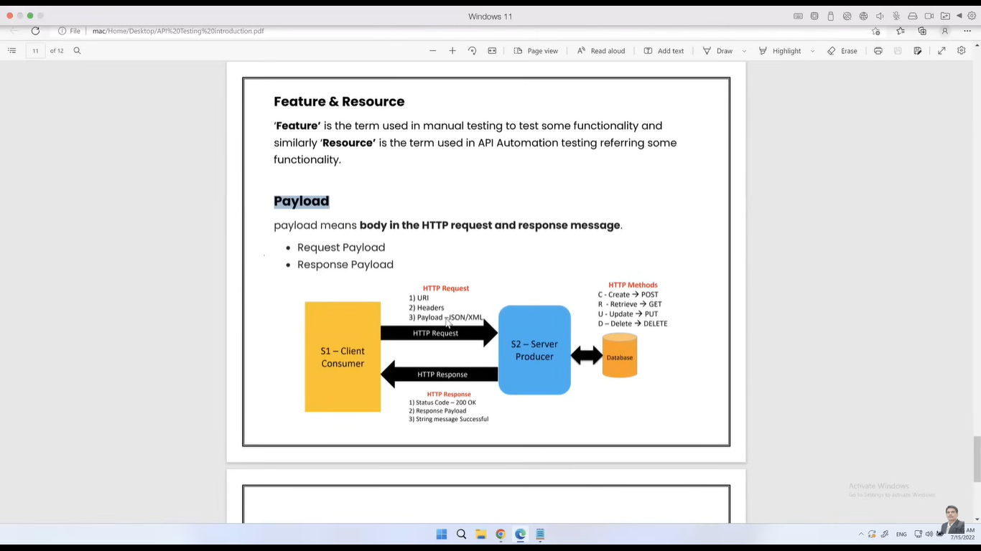

## Path Parameters: Specifying the Resource

Path parameters are used to identify a specific resource within a URI. They are dynamic parts of a URL that help pinpoint the target of a request. Imagine a file system where you specify the folder and file name to access a particular document. Path parameters work similarly.

**Example:** https://api.example.com/users/123

In this example, users is a resource, and 123 is the path parameter specifying a particular user.

## Query Parameters: Filtering and Sorting Data

Query parameters are used to provide additional information to the server, often for filtering, sorting, or paginating data. They are typically appended to the URL after a question mark (?).

**Example:** https://api.example.com/products?category=electronics&sort=price

In this example, category=electronics and sort=price are query parameters used to filter products by category and sort them by price.

By understanding these components, you can effectively construct and interpret HTTP requests and responses.

# Understanding HTTP Requests and Responses

## HTTP Requests

When a client communicates with a server, it sends an HTTP request. This request typically consists of three main components:

### URL (Uniform Resource Locator):

This specifies the exact address of the resource the client is trying to access on the server.

### Headers:

These provide additional information about the request, such as the type of data being sent (content-type), the expected response format (accept), and authentication credentials.

### Payload (Body):

This optional component contains the data being sent to the server, often in formats like JSON or XML. It's commonly used for creating or updating resources.

## HTTP Responses

The server responds to a request with an HTTP response, which also contains essential components:

### Status Code:

This numeric code indicates the outcome of the request. For example, 200 OK indicates success, while 404 Not Found signifies that the resource was not found.

### Headers:

Similar to request headers, response headers provide additional information about the response, such as the content type of the response body, caching directives, and cookies.

### Response Body (Payload):

This contains the data returned by the server in response to the request. It could be HTML, JSON, XML, or other formats depending on the request and the server's configuration.