**FLOOD MONITORING AND EARLY WARNING**

**Project Definition :**

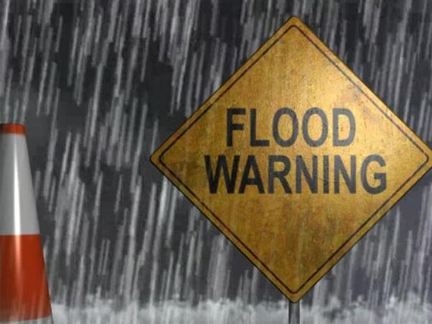The purpose of this study is to develop a real-time flood monitoring and early warning system in the northern portion of the province of Isabela, particularly the municipalities near Cagayan River. Ultrasonic sensing techniques have become mature and are widely used in the various fields of engineering and basic science. One of advantage of ultrasonic sensing is its outstanding capability to probe inside objective non-destructively because ultrasound can propagate through any kinds of media including solids, liquids and gases. This study focuses only on the water level detection and early warning system (via website and/or SMS) that alerts concern agencies and individuals for a potential flood event. Furthermore, inquiry system is also included in this study to become more interactive wherein individuals in the community could inquire the actual water level and status of the desired area or location affected by flood thru SMS keyword. The study aims in helping citizens to be prepared and knowledgeable whenever there is a flood. The novelty of this work falls under the utilization of the Arduino, ultrasonic sensors, GSM module, web-monitoring and SMS early warning system in helping stakeholders to mitigate casualties related to flood. The paper envisions helping flood-prone areas which are common in the Philippines particularly to the local communities in the province. Indeed, it is relevant and important as per needs for safety and welfare of the community.

**Design Thinking:**

Project Objectives: The study aims in helping citizens to be prepared and knowledgeable whenever there is a flood. The novelty of this work falls under the utilization of the Arduino, ultrasonic sensors, GSM module, web-monitoring and SMS early warning system in helping stakeholders to mitigate casualties related to flood.

IoT Sensor Network Design: The two monitoring devices are composed of Ultrasonic sensor to measure the distance of the water level, Arduino micro-controller that process the signal from the sensor, GSM module to send the data or information from the micro-controller to the computer server and a power source using Solar Panel, Regulator and Battery. Once a sensor is triggered, an output signal will be relayed to the micro-controller which serves as a switch that triggers the connected GSM module to send an alert message or water level status to another GSM modem connected to a computer server. Then, the developed program installed in the computer server will interpret and analyze the message received then automatically send a text message to the concern agencies’ numbers stored in a database. Also, the developed program will then automatically relay the alert message or status by uploading to the developed website. Furthermore, concern agencies, local officials and the local communities could inquire about the current status by sending a message that contains keywords.

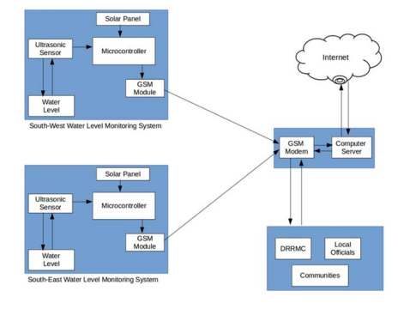

Early Warning: The researchers developed two different platforms in disseminating information to the concern stakeholders for a possible flood event. One would be the real-time monitoring through a web-based system that can be access through the Internet. Another one is the SMS notification system wherein an automatic communication between the system and the local communities and other concern agencies in the province of Isabela. The web-based monitoring system was written in PHP programming language and used MySQL as back-end to store information uploaded by the SMS notification system. The web-based monitoring system also contains the different information for monitoring flood such as level of water, alert level, flood warning status, affected areas and update logs. Also the web application automatically updated when new information was uploaded.

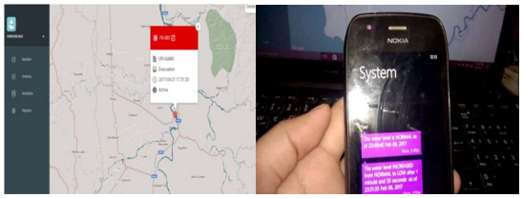

Integration Approach: The researchers played out a model, test the ease of use and dependability of the developed prototype. It was tried first in a prototype environment that the researchers made and played out the trial. The test decided whether it meets the necessities of the client. The figure below shows the prototype assembled and the connection of the different hardware components.