EX.NO:04 REG.NO:210701701

DATE:

**PUBLIC CLOUD CREATING AN INSTANCE IN SALESFORCE**

**AIM:**

Develop a simple application to understand the concept of PAAS using Sales force

**PROCEDURE:**

1.Log in to your Salesforce account.

2.Click Setup at the upper-right corner.

3.Under the Build section, click Create and select Objects.

4.To create a custom object, click New Custom Object.

5.Enter the name of the Custom Object in Label, Plural Label, and Object Name.

6.Choose the custom apps for which the new Custom tab is required and click Save.

7.Select whether you want to define a custom app or a Salesforce console.

8.Give the app a name and description. An app name can have a maximum of 40 characters, including spaces. Click Save.

**OUTPUT:**

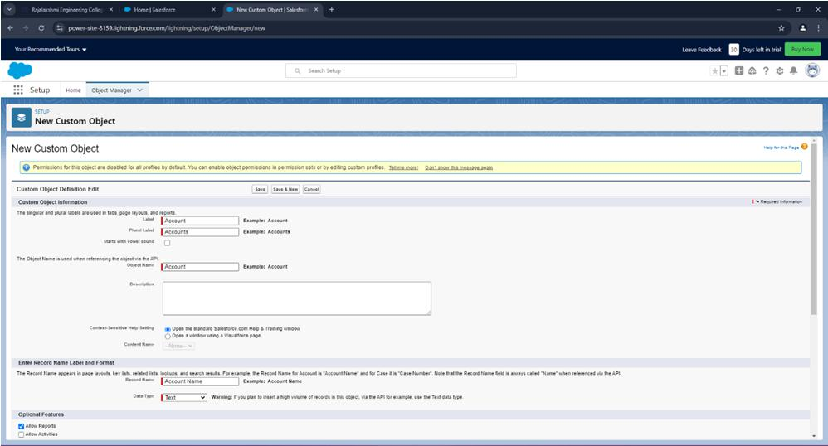

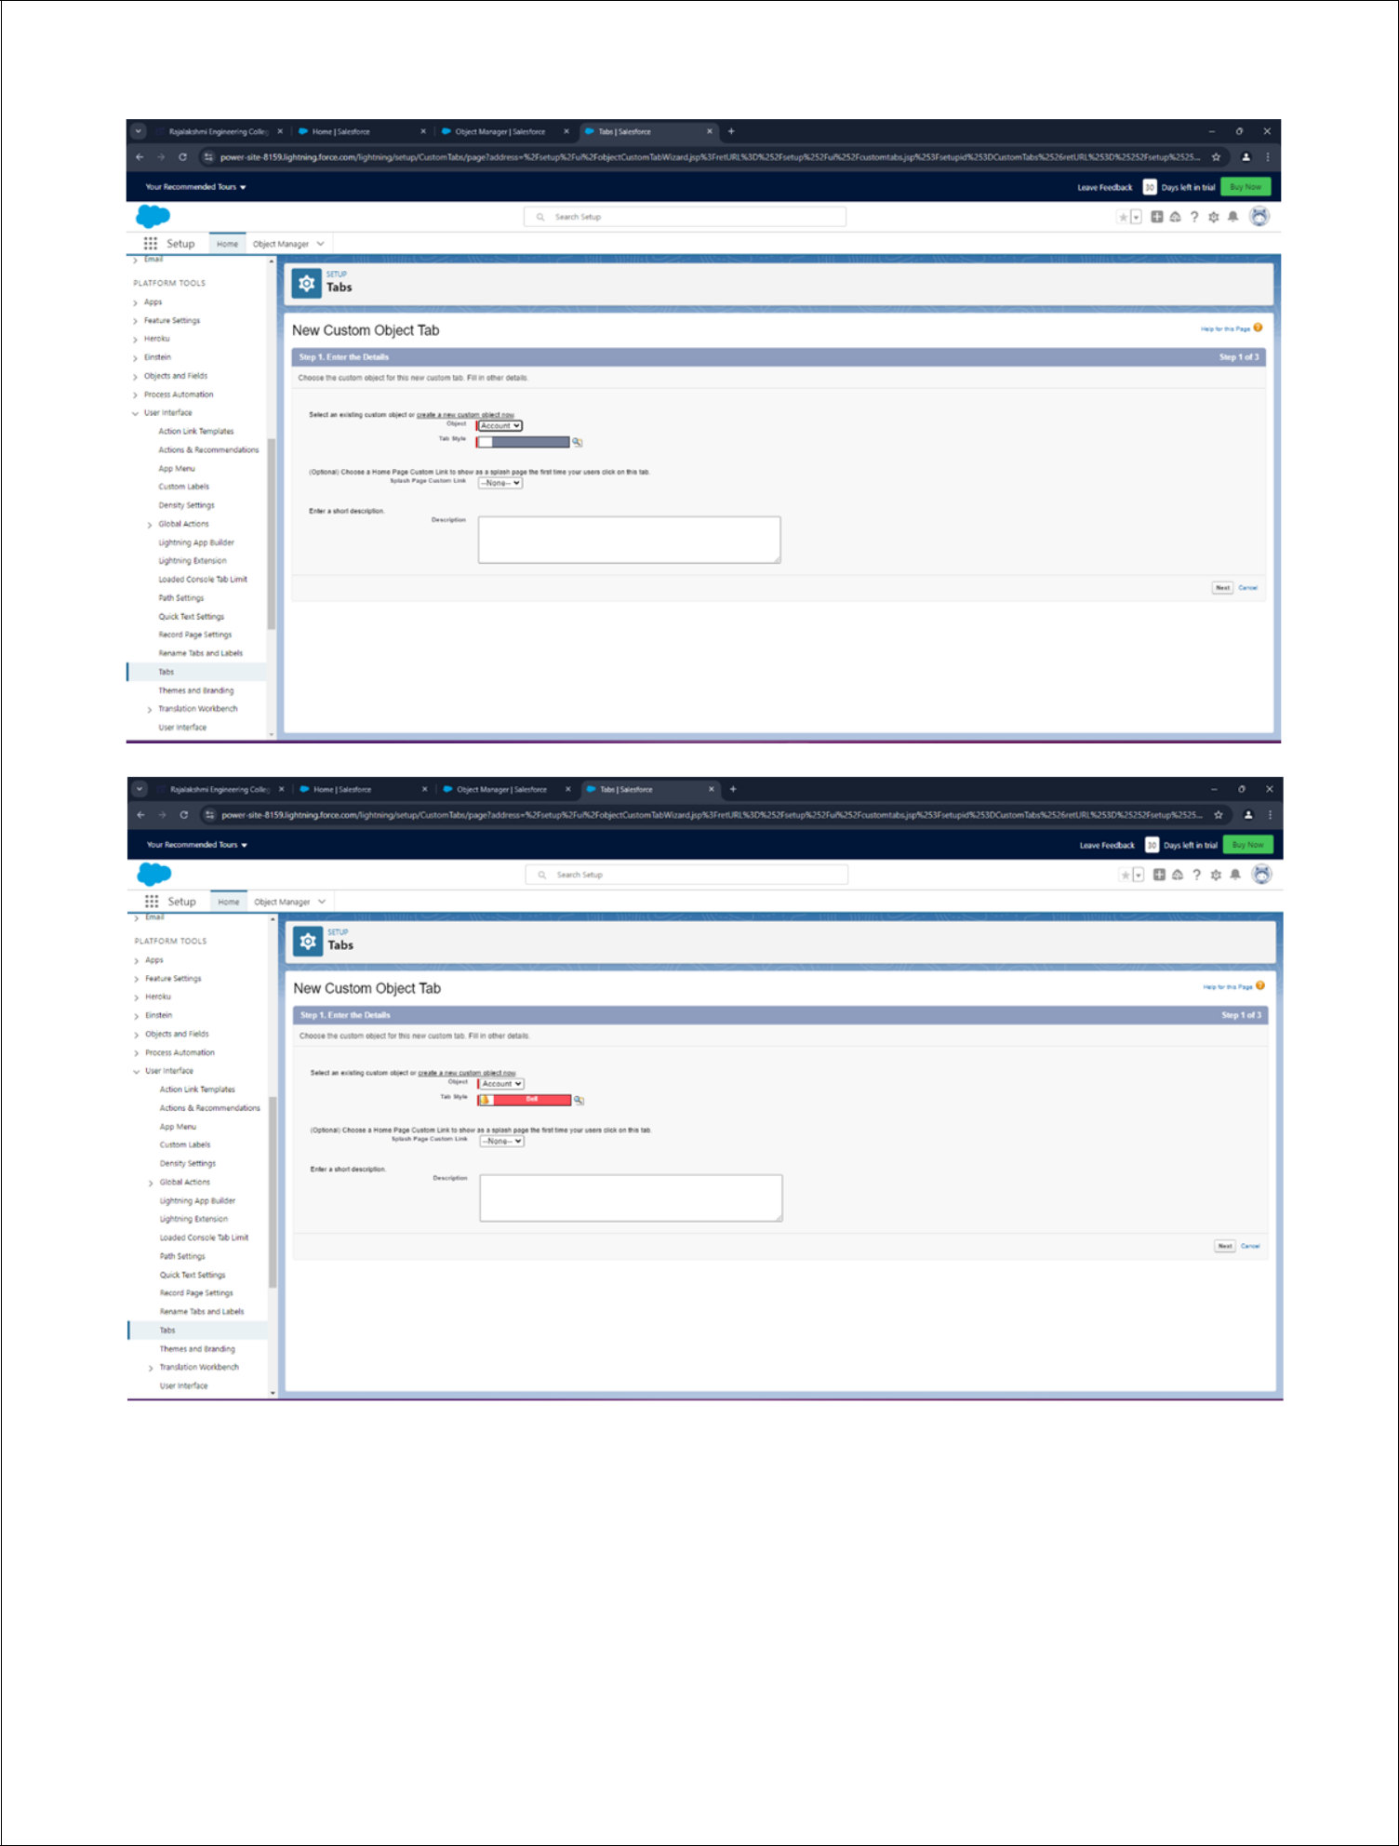

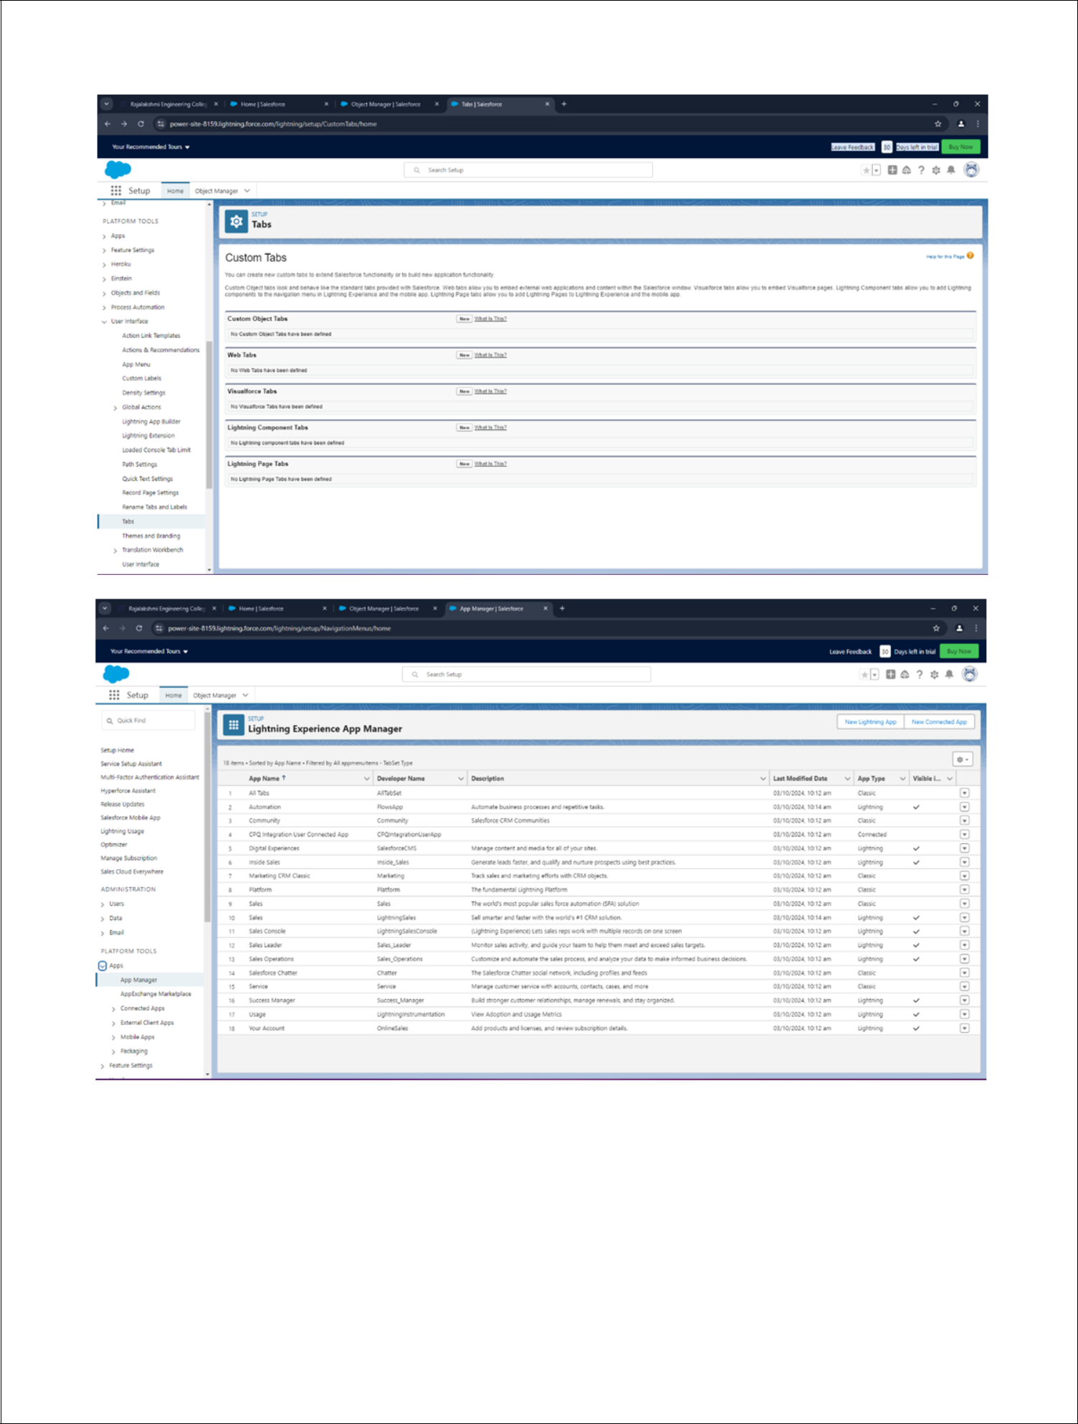

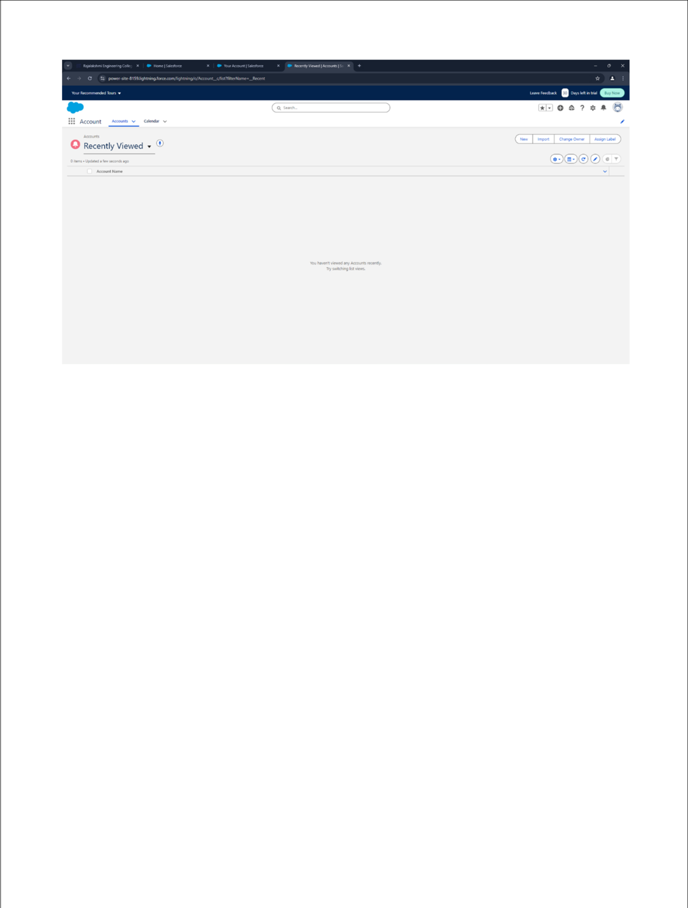

**RESULT:**

Thus to develop a simple application to understand the concept of PAAS using Sales force has been executed successfully.