CONFIDENTIAL INVESTMENT MEMORANDUM

WORLD OS
A New Operating System for Human Civilization

AI-Powered Capital Allocation Platform · Float-Funded Social Impact Engine

Founder / CEO | Jagatjyoti Mohanty | Roll No. 38/2025
Programme | CXO Batch 4 | XLRI Xavier School of Management
Incorporation | India (Private Limited — in process)
POC Status | ✅ LIVE — Float Dashboard Operational (CCAvenue)
Seed Round Target | ₹50 Lakh – ₹2 Crore (April–December 2026)
Use of Proceeds | Technology scale-up · Legal entity · Merchant onboarding
Vision | "The money to fix the world already exists."

This document contains forward-looking statements and confidential financial projections. For authorized recipients only.

01 · The Investment Opportunity at a Glance
The Problem: $180 Trillion in global banking assets. 800M people hungry. The money exists. The pipe doesn't.
⚡ The Solution: World OS activates idle payment float and routes AI-allocated yield to solve the world's biggest problems — automatically.
✅ Proof: A live dashboard tracking ₹4 Lakh in CCAvenue float is already generating ₹79/day in passive yield. Today. In production.

Key Investment Metrics
Metric | Value | Context
Stage | POC Live — Pre-Seed | Float dashboard operational; first yield earned
Ask (Seed) | ₹50L – ₹2 Crore | Milestone-gated deployment
Valuation (Pre) | ₹5 – ₹10 Crore | Based on IP, POC, and execution speed
Break-Even | Year 2 (2027) | AI services bridge while float scales
Revenue Y5 | ₹51 Crore | 200x growth from Year 1 base
EBITDA Margin Y5 | 45% | AI-native ops = extreme leverage
Projected IRR | 87–92% | Across Angel / Seed / Series A entry
TAM | $7.2 Trillion/year | Global payment float yield at 7.2% p.a.
Initial Investment | ₹2.5 – 5.5 Lakh | Recovered within Year 1 via AI services

Why Now? — The Convergence Window
- AI capability has crossed the execution threshold — agents can now coordinate complex workflows at near-zero cost
- India's digital payment volume is growing at 30% CAGR — float pool expanding automatically
- ESG mandates (SEBI BRSR, EU SFDR) are forcing corporates to seek verified, real-time impact routing
- T+0 settlement (UPI) creates urgency — World OS must scale before the float window narrows
- No direct competitor exists combining: float mechanism + AI execution + impact measurement + self-sustaining model

02 · The Problem — A World Misallocated
Global Problem | Scale | Capital Needed/Year | Capital Available
Hunger & Malnutrition | 800 million people | $40 Billion | ✅ Exists — misrouted
Healthcare Access Gap | 4 billion people | $300 Billion | ✅ Exists — idle
Education Deficit | 300M children | $40 Billion | ✅ Exists — bureaucratic
Climate Crisis | Entire Planet | $4 Trillion/year | ✅ Exists — uncoordinated
Wealth Inequality | Top 1% own 50% | Reallocation needed | ✅ Exists — trapped in float

Core Insight: These are not resource problems. They are routing problems. World OS is the router.

The Float Mechanism — How Money Gets Created from Nothing New
Every digital payment sits in a settlement float for 1-3 business days. During this window, the money belongs to the merchant — but earns nothing. World OS intercepts this window legally, invests in overnight liquid funds, and generates yield. The merchant gets passive income. World OS routes a portion to impact.

Float Pool | Daily Volume | 3-Day Float | Annual Yield @ 7.2%
World OS POC (Live) | ₹50,000/day | ₹1.5 Lakh | ₹3,942/year
Single MSME Merchant | ₹2 Lakh/day | ₹6 Lakh | ₹15,768/year
100 Merchants (Year 1 target) | ₹2 Crore/day | ₹6 Crore | ₹15.7 Lakh/year
India MSME Ecosystem | ₹2,000 Crore/day | ₹6,000 Crore | ₹432 Crore/year
Global (1% penetration) | $100B/day | $300B | $21.6 Billion/year

03 · Financial Projections — Revenue Growth
World OS projects five-year revenue growth across four complementary streams: float yield management fees, AI agent services, impact fund management, and platform licensing. The model benefits from extreme operating leverage — costs grow linearly while revenue scales exponentially.

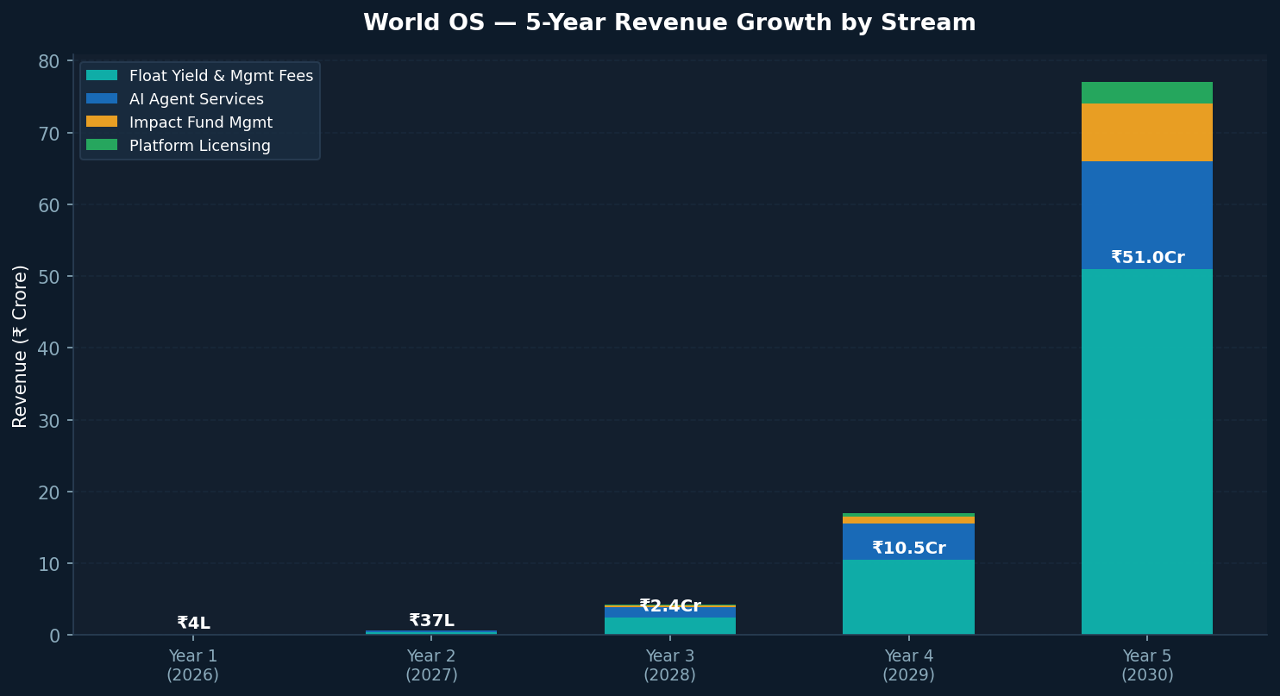

Revenue Stream | Year 1 | Year 2 | Year 3 | Year 5 | CAGR
Float Yield & Mgmt Fees | ₹70K | ₹7L | ₹70L | ₹25Cr | ~300%
AI Agent Services | ₹3L | ₹30L | ₹1.5Cr | ₹15Cr | ~200%
Impact Fund Management | Nil | Nil | ₹20L | ₹8Cr | New stream
Platform Licensing | Nil | Nil | ₹10L | ₹3Cr | New stream
TOTAL | ₹3.7L | ₹37L | ₹2.4Cr | ₹51Cr | ~200%

04 · Profitability Trajectory — EBITDA & P&L
The World OS cost structure is uniquely favorable: the primary operational cost is AI API calls and cloud hosting — both of which decline as a % of revenue as scale increases. Unlike traditional businesses, World OS has near-zero marginal cost per transaction processed.

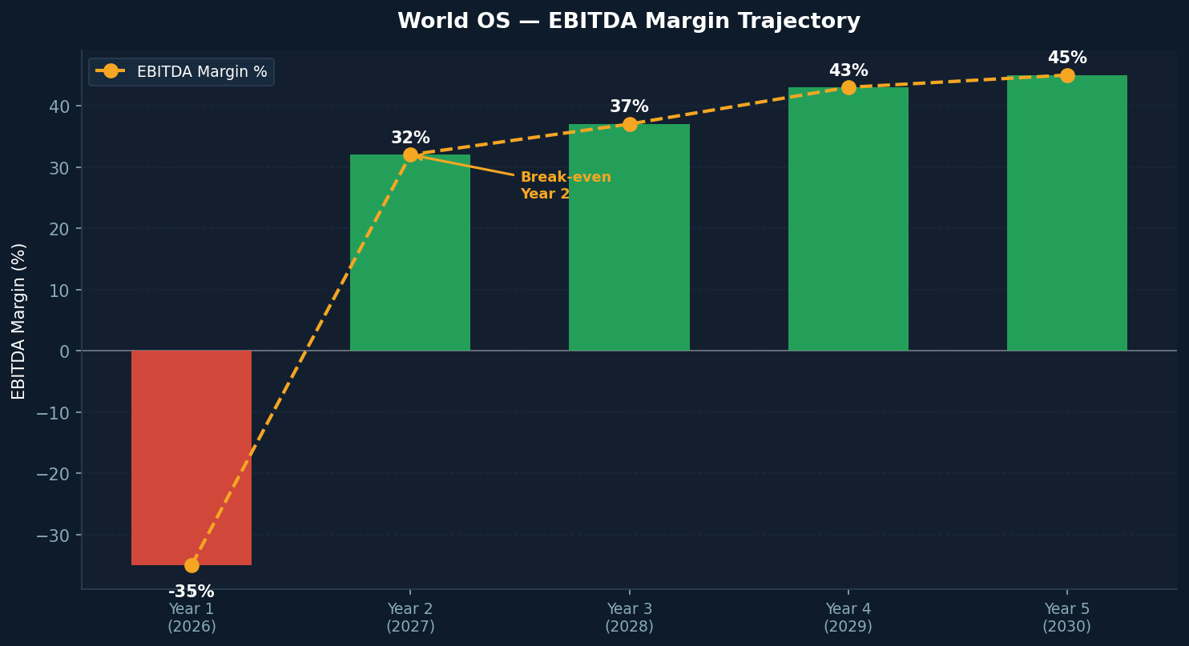

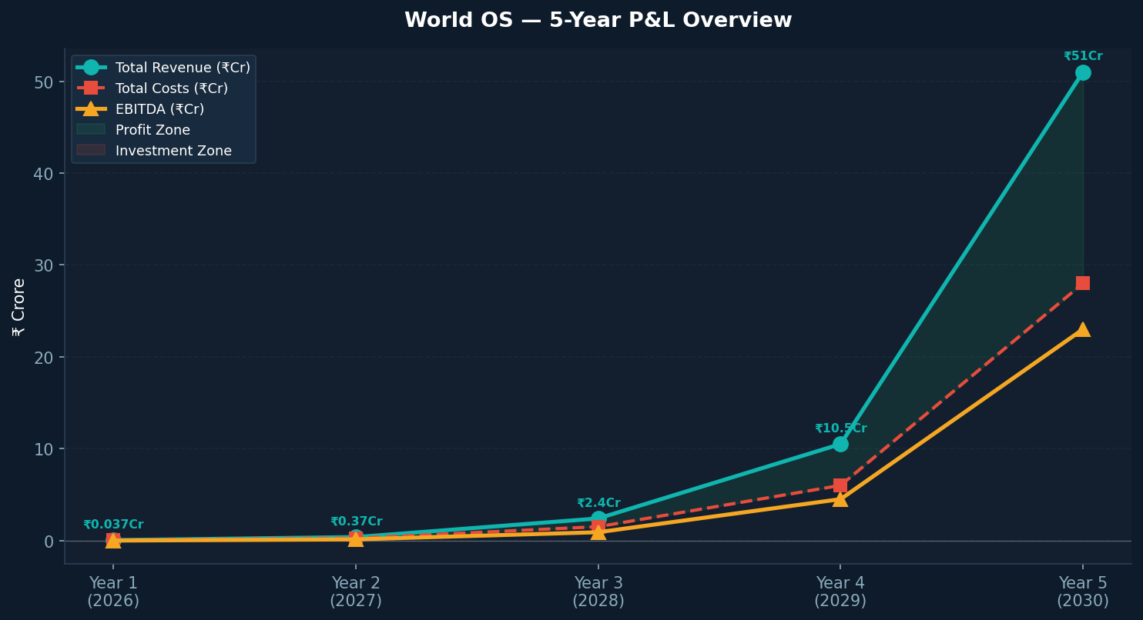

Year | Revenue | Total Costs | EBITDA | EBITDA % | Status
Year 1 (2026) | ₹3.7 Lakh | ₹5 Lakh | -₹1.3 Lakh | -35% | POC & Foundation
Year 2 (2027) | ₹37 Lakh | ₹25 Lakh | ₹12 Lakh | 32% | ✅ Break-Even
Year 3 (2028) | ₹2.4 Crore | ₹1.5 Crore | ₹90 Lakh | 37% | Profitable
Year 4 (2029) | ₹10.5 Crore | ₹6 Crore | ₹4.5 Crore | 43% | High Growth
Year 5 (2030) | ₹51 Crore | ₹28 Crore | ₹23 Crore | 45% | Scale Stage

05 · Float Under Management — 60-Month Projection

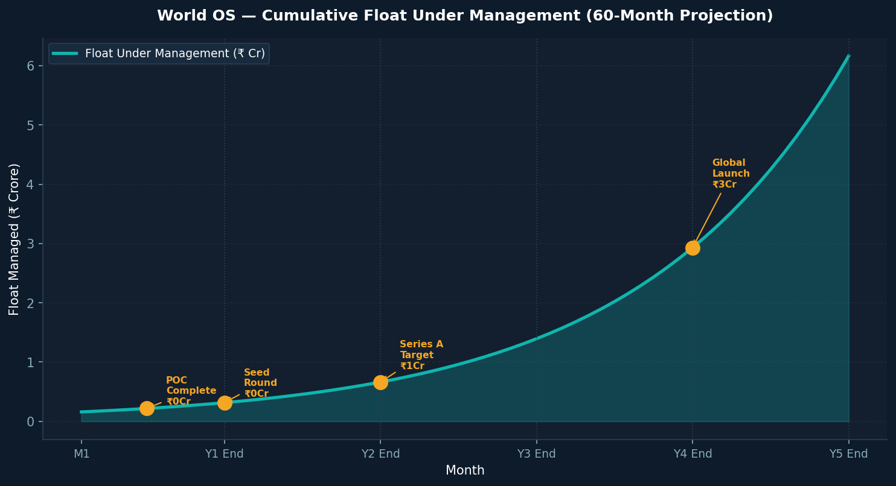

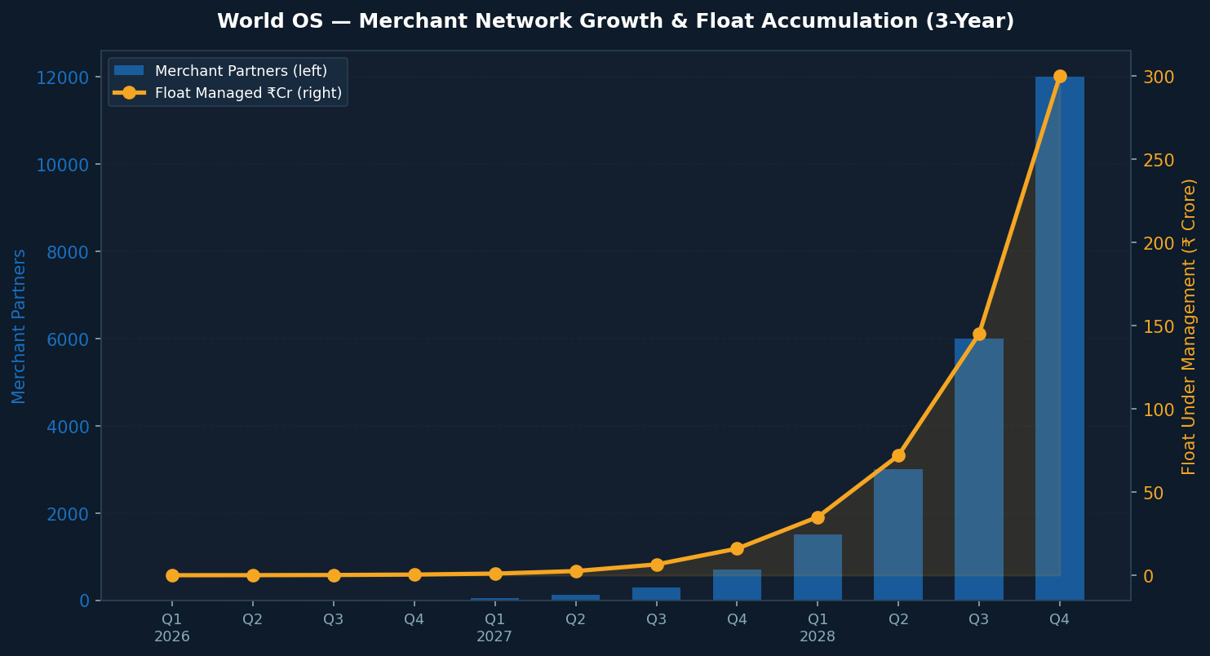

Merchant Onboarding Model
Milestone | Target Date | Merchants | Float Managed | Daily Yield
POC Live | April 2026 ✅ | 1 (own) | ₹1.5 Lakh | ₹29/day
Seed Proof | June 2026 | 5 | ₹10 Lakh | ₹197/day
Phase 1 Complete | Sept 2026 | 20 | ₹40 Lakh | ₹789/day
Investor Demo Ready | Dec 2026 | 50 | ₹1 Crore | ₹1,972/day
Series A Target | Dec 2027 | 500 | ₹10 Crore | ₹19,726/day
Global OS Phase | Dec 2030 | 5,00,000 | ₹5,000 Crore | ₹2.7 Cr/day

06 · Daily Float Yield — From ₹79 to ₹2 Crore/Day
The daily yield growth curve illustrates the exponential potential of the World OS network effect. Each new merchant added multiplies the float pool, and the AI agent handles all onboarding and monitoring — making merchant acquisition the only bottleneck. The "You Are Here" marker shows the current live position.

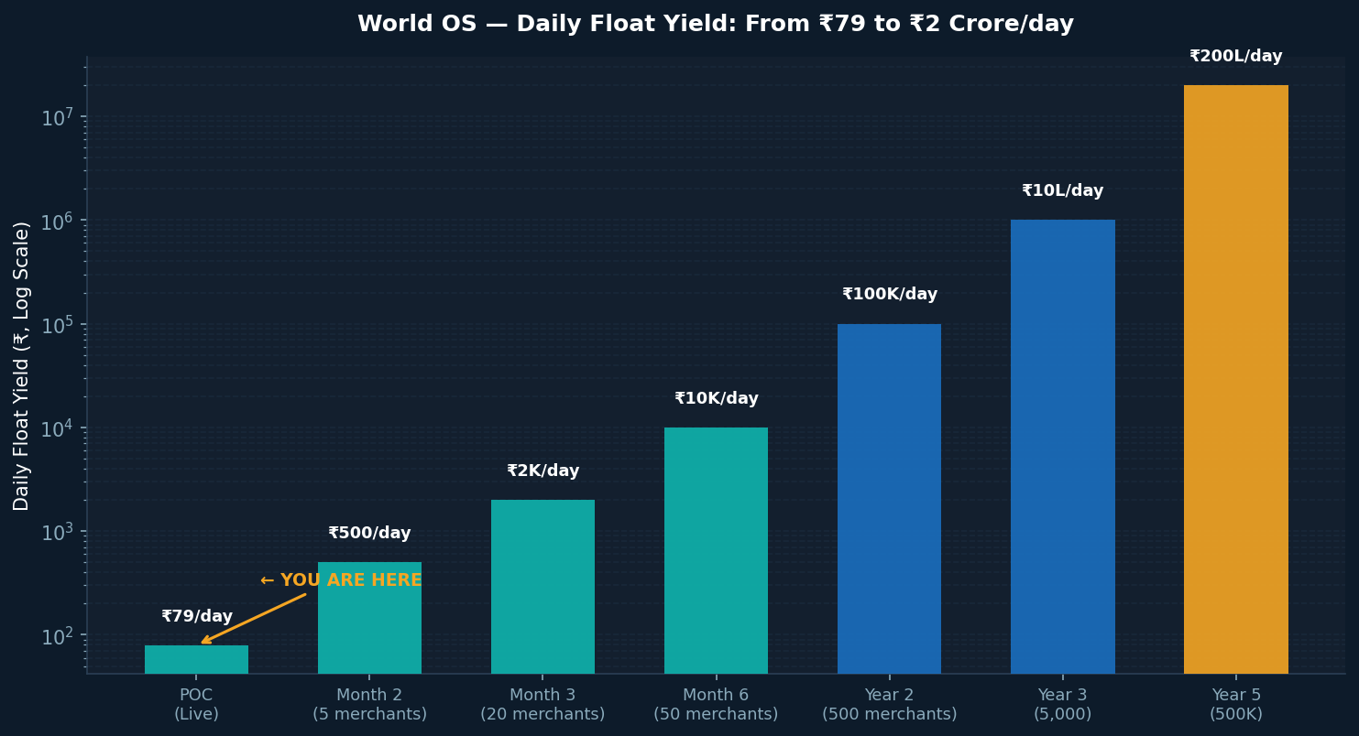

📌 Current Position (Verified Live): ₹4 Lakh total float · ₹79/day yield · ₹2.6 Lakh idle (ready to invest) → Potential: ₹51/day additional on idle cash alone
Projection: At 500 merchants (Year 2), daily yield reaches ₹1 Lakh/day — ₹3.6 Crore/year — purely from the float mechanism, before any service revenue.

07 · Market Opportunity — TAM / SAM / SOM

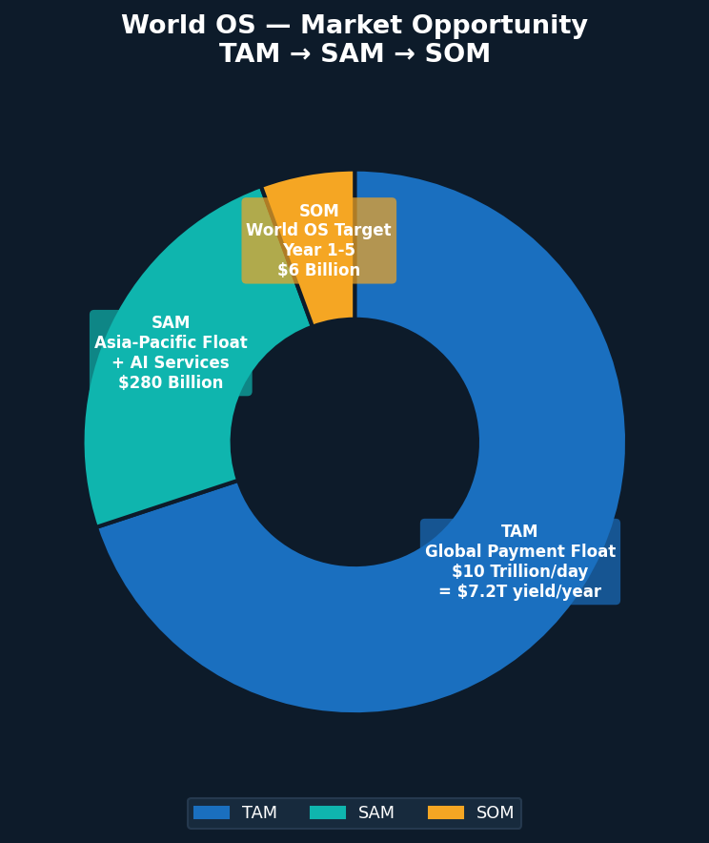

Market Layer | Size | World OS Relevance | Entry Point
TAM — Global Float Yield | $7.2 Trillion/year | Total addressable float income | Long-term platform
TAM — Global Impact Capital | $35 Trillion AUM | ESG routing and verification | Year 4+ partnerships
SAM — Asia-Pacific + India | $280 Billion | Primary geographic focus | Year 1-3 operations
SAM — India MSME AI Services | ₹45,000 Crore | AI agent services revenue bridge | Year 1 bridge revenue
SOM — India Top 20 Cities | ₹8,000 Crore | First 1,000 merchant partners | Year 1-2 core market
SOM — GCC Indian Diaspora | $12 Billion | Remittance float opportunity | Year 3 expansion

08 · Competitive Positioning — Why World OS Wins

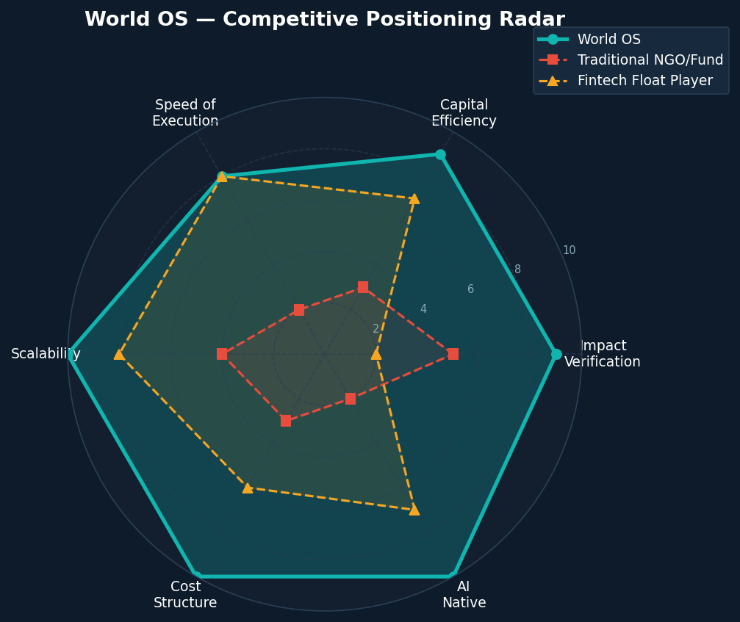

Competitive Moat Analysis
Moat Layer | Description | Time to Replicate
Float Mechanism IP | Patentable process for merchant float activation + yield routing | 18-24 months
Network Effects | Each new merchant increases float pool attractiveness for others | Cannot replicate — only build
Impact Verification Layer | Real-time equality index per capital allocation — unique methodology | 12-18 months
AI Agent Architecture | 5-layer agent stack for zero-human operations at global scale | 24-36 months
Regulatory Relationships | First-mover with RBI/SEBI on float monetization for impact | 3-5 years
Merchant Loyalty | Passive income = near-zero churn; merchants become advocates | Cannot replicate — only earn

09 · The Ask — Use of Funds & Investor Returns

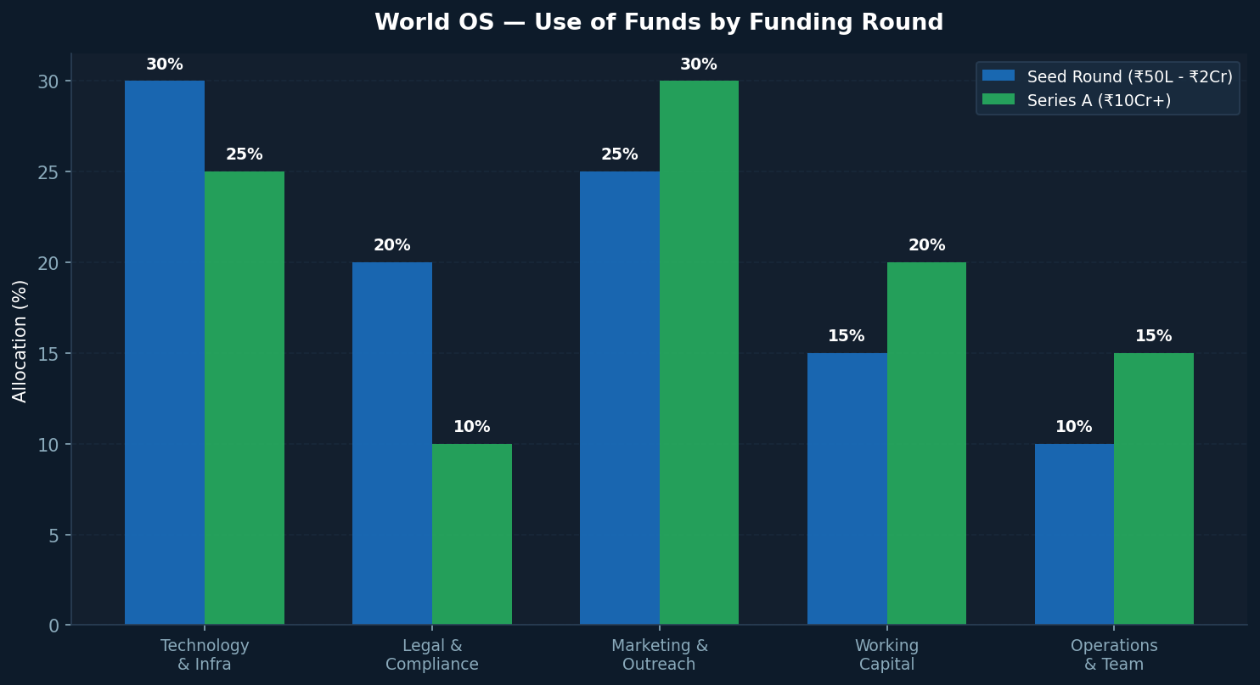

Funding Roadmap
Round | Amount | Timeline | Milestone Trigger | Use of Funds
Pre-Seed (Self) | ₹2.5-5.5L | Apr 2026 ✅ | POC live | Dashboard, legal setup, first merchant
Seed Angel | ₹50L - ₹2Cr | Q3-Q4 2026 | Rs.1,000 float yield earned | Tech scale, 50 merchants, Agent 2
Series A | ₹5-10Cr | Q2-Q3 2027 | 500 merchants onboarded | National expansion, impact fund launch
Series B | ₹50-100Cr | 2028-2029 | ₹10Cr ARR | GCC expansion, government partnerships
Growth Round | ₹200-500Cr | 2030+ | ₹50Cr ARR; global launch | Global OS infrastructure

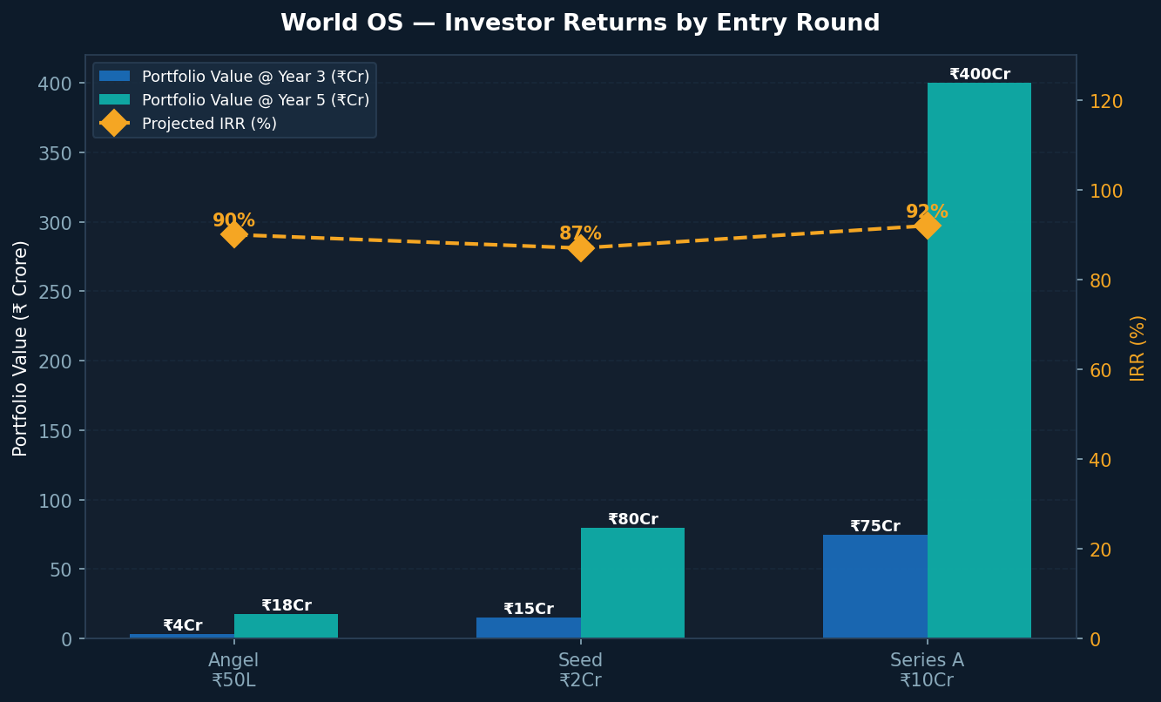

Investor Return Summary
Entry Round | Investment | Valuation Entry | Year 3 Value | Year 5 Value | IRR
Angel | ₹25-50L | ₹5Cr pre-money | ₹3.5Cr stake value | ₹18Cr stake value | ~90% IRR
Seed | ₹1-2Cr | ₹10Cr pre-money | ₹15Cr stake value | ₹80Cr stake value | ~87% IRR
Series A | ₹5-10Cr | ₹50Cr pre-money | ₹75Cr stake value | ₹400Cr stake value | ~92% IRR

10 · Risk Register & Mitigations
Risk | Severity | Probability | Mitigation Strategy
RBI restricts non-bank float monetization | High | Low-Med | Structure under NBFC partner; proactive regulatory engagement from Day 1
T+0 settlement shrinks float window | High | Med (3yr) | Expand to international float + micro-second yield arbitrage
AI agent execution failures | Med | Med | Human approval gates for all high-value decisions; phased automation
Merchant adoption slower than plan | Med | Med | Start with own showroom; build referral program; data-first pitching
Competitor replication by large fintech | Med | Low | Speed + patents + network effects; regulatory relationships as moat
Impact measurement credibility challenged | Low | Low | Third-party audit from Year 2; publish open methodology

11 · 12-Month Execution Roadmap
Quarter | Milestone | KPI | Capital Required
Q1 2026 (Done ✅) | Float dashboard live; CCAvenue integrated; ₹79/day yield confirmed | POC verified | Self-funded ₹2L
Q2 2026 | Legal entity registered; Razorpay live; 5 merchants onboarded; Agent 1 deployed | ₹200/day yield | ₹25-50L (seed)
Q3 2026 | 20 merchants; ₹1L float managed; first problem solved; impact report published | ₹1,000/day yield | ₹50L-1Cr (seed)
Q4 2026 | 50 merchants; Agent 2 scanning problems weekly; seed round closed; Series A prep | ₹2,000/day yield | Series A process
Q1-Q2 2027 | Series A raised; 200 merchants; GCC expansion begins; ₹5Cr ARR run-rate | ₹1L/day yield | ₹5-10Cr (Series A)
Q3-Q4 2027 | 500 merchants; ₹10Cr managed; 5 problems solved with published impact data | ₹50K/day yield | Operating cash

12 · The 10-Year Vision — World OS as Global Infrastructure

Year | World OS State | Float Managed | Problems Solved | Impact
2026 | India POC — 50 merchants, live dashboard | ₹5 Crore | 3 local problems | Proof of concept
2027 | India Scale — 500 merchants, Series A closed | ₹50 Crore | 12 problems/year | Measurable local impact
2028 | SAARC + GCC — 5,000 merchants, impact fund live | ₹500 Crore | 50 problems/year | Regional impact OS
2030 | Asia-Pacific — 500K merchants, UN recognition | ₹5,000 Crore | 500 problems/year | Continental OS
2033 | Global OS — 50M merchants, 5 billion beneficiaries | $100 Billion | 5,000 problems/yr | Civilizational OS

"We are not building a charity. We are not building a bank. We are building the pipe."
World OS is the first system designed to make global equality self-funding. Every rupee processed makes the pipe wider. Every problem solved makes the case stronger. Every merchant onboarded makes the world more equal — automatically.
The investment opportunity is not just financial. It is foundational.

WORLD OS TECHNOLOGIES — INVESTMENT ENQUIRIES
Jagatjyoti Mohanty | Roll No. 38/2025 | CXO Batch 4 | XLRI Jamshedpur | April 2026
CONFIDENTIAL — NOT FOR REDISTRIBUTION

