**Assessing Google Trends Data**

**DELIVERABLES AND SCHEDULE/ TIMELINE**

For our project we would be having following deliverables. These outlined deliverables have been elaborated below with the pre-assumed timeline.

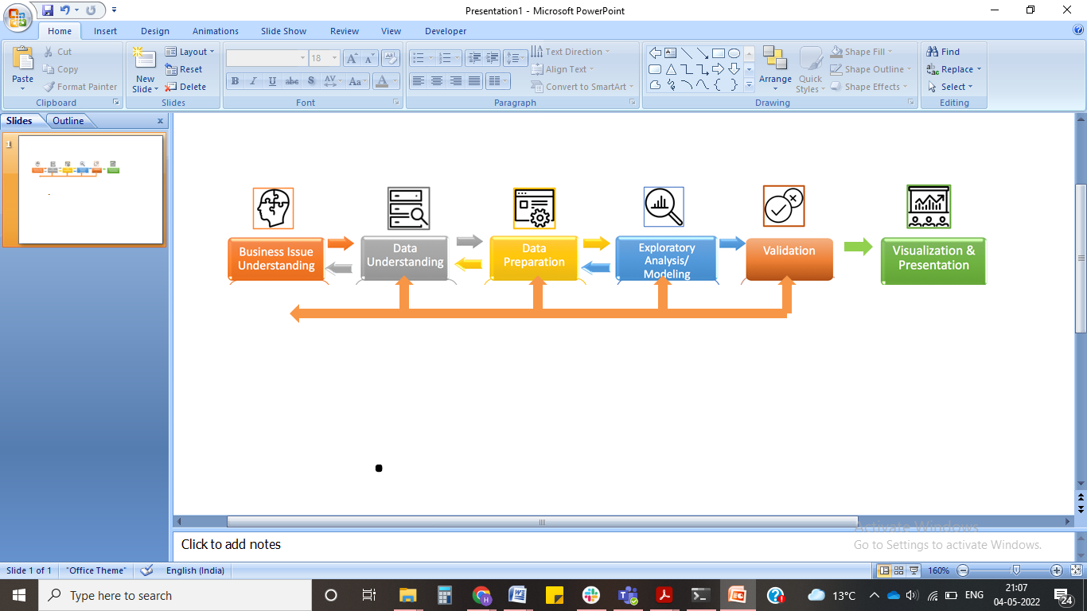

**Timeline of Project**

We will start the project as soon as the first meeting kicks off. The total time taken for the final submission of the project would be in **7 weeks**, the final presentation would be delivered on **June 22, 2022**.

|  | **Phase** | | |  | | **Days** |
| --- | --- | --- | --- | --- | --- | --- |
| **Phase 0: Analysis** | | | | | | **2.00** |
|  | **Research & Planning** | | | | | 2.00 |
|  |  |  | **Kickoff** | | |  |
|  |  |  |  | | *Discussion with project partners to define scope of work, expectation settings, high level discussion on the project components.* |  |
|  |  |  |  | |  |  |
|  |  |  | **Literature Review** | | |  |
|  |  |  |  | | *Survey and discussion of literature in the given problem of study* |  |
| **Phase 1: Data Understanding** | | | | | | **8.00** |
|  | **Data Filtering** | | | | | 1.00 |
|  |  |  |  | |  |  |
|  | **Data Cleaning** | | | | | 7.00 |
|  |  |  |  | | *We will clean the dataset and extract the useful factors from the link provided.*  *The missing values would be handled using interpolation of the data.*  *Standarization and Transformation might be applied as required.*  Follow-up meeting for review. |  |
| **Phase 2: Exploratory Analysis and Modeling** | |  |  | |  | **14.00** |
|  | **Exploratory Analysis** |  |  | |  | 2.00 |
|  |  | Digging deep into the data structure  Understanding the statistics measures  Understanding the data distribution  Follow-up meeting for review | | | |  |
|  | **Modeling and Validation** | | | | | 12.00 |
|  |  | Exploring Time series with machine learning models  Fit multiple models  Testing and validating the models and selecting the best one  Follow-up meeting for review | | |  |  |
| **Phase 3: Visualization/Dashboard** | | | | | | **13.00** |
|  | **Visualization** | | |  | | **3.00** |
|  |  | Plot type selection  Follow-up meeting or chat for review | | | |  |
|  | **Dashboard** | | |  | | **10.00** |
|  |  | Layout Designing and Styling  Follow-up meeting for review  Structure the design  Follow-up meeting for review  Visualization Compliances | | | |  |
|  |  | Functional Testing  Follow-up meeting for review | | | |  |
|  |  | Visualization Deployment | | | |  |
| **Phase 4: Presentation** | | | | | | **6.00** |
|  | **Documentation and Presentation** | | | | | **6.00** |
|  |  | Written Documentation | | | |  |
|  |  | Prepare Presentation  Follow-up meeting for review  Final Changes  Final follow up and submission | | | |  |
|  |  |  |  | | ***Project Effort*** | **0.00** |

