**ECO-FRIENDLY HYBRID ELECTRIC BIKE**

**Abstract**

The progress of automobiles for transportation has been intimately associated with the progress of civilization. The automobile of today is the result of the accumulation of many years of pioneering research development. In the modern trend automobiles have certain disadvantages soon as fuel cost relative to mileage, pollution and less efficiency.

• To improve efficiency

• To decrease the fuel cost relative to mileage

• To control the pollution is to be effect

Then our “HYBRID TWO WHEELER” is an aspect. The goal of this project was to implement the most efficient and less polluting vehicle. In our project the hybrid electric vehicle model combines the internal combustion engine of a conventional vehicle with the battery and electric motor of an electric vehicle, resulting in twice the fuel economy of conventional vehicle. We implement this hybrid electric vehicle concept for two wheelers.

**INTRODUCTION**

Today, usage of vehicle has increased erratically so that usage of fuel also increases that leads to increased emission of vehicle, which causes the ozone layer depletion, dwindle in source of fuel. In order to overcome all these troubles, we have designed a vehicle which is able to work in both gasoline and electrical supply. Initially the vehicle is run by using gasoline supply, which drives the internal combustion engine and the dynamo is connected to the vehicle chain drive which is used to convert mechanical energy into electrical energy and the energy is being stored in the battery. After the battery is fully charged, the energy stored in the battery drives the electric motor connected to the back wheel and fuel supply is stopped.

**WORKING PRINCIPLE**

The working principle of HYBRID BIKE basically involves three processes, the first process involves when the vehicle is running by means of electric motor, second process involves when the vehicle is running by means of an internal combustion engine and the third process involves when the vehicle is running in both the modes according to the requirements. When the vehicle is driven at the outside of the city and need more power to drive, the vehicle is powered by means of internal combustion engine. The power from the engine is taken from pulley and then it rotates the wheel.

**Battery Mode**

battery is used as source of fuel & electric motor drives the vehicle and it is used in city driving. In electric mode, the fuel supply stopped.

**Fuel Mode**

It should work initially at least until the battery is being fully charged & it is used in highway driving & also initially engine is working during this process.

**Dual Or Hybrid Mode**

In this mode both the engine & motor work simultaneously but the battery should be charged before this mode & it is used in climbing & also in heavy load carrying.

**Purpose Model**

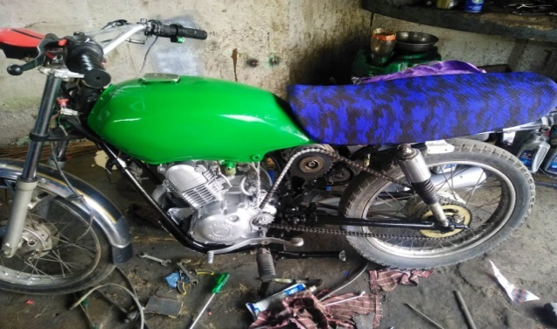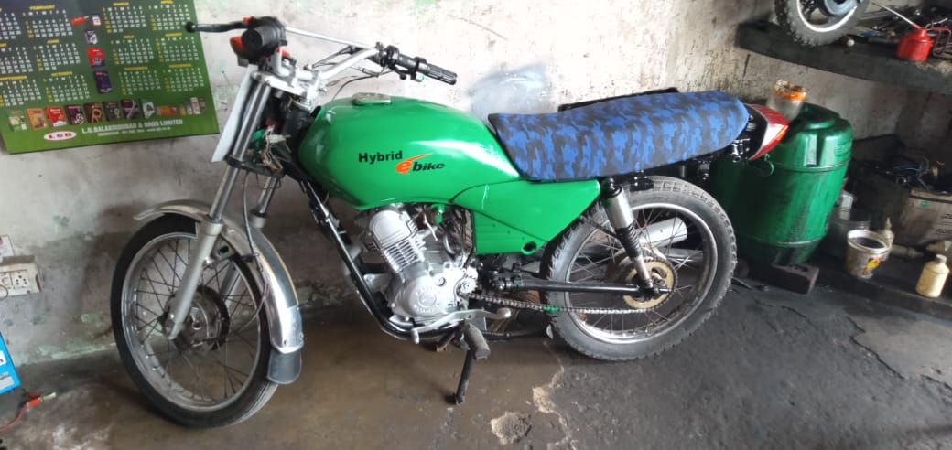

**Special feature:**

**In this project we used single chain system for motor and engine operation. When engine is working motor wheel run freely with the help of anti lock bearing system. When motor is working engine run freely in neutral conditions.**

**Merit**

* Lower emission & battery mileage
* Reduction of dependency of fossil fuel
* Cheaper routine maintenance
* Combining the best point of electrical energy & IC engine for vehicle propulsion

**Demerits**

* This system involves an additional battery which may be cumbersome to equip in the vehicle
* Though this system offers alternating to petrol vehicle it cannot offer the equivalent torque as that to a fuel engine.

**Conclusion**

Our present generation meets many problems related to global warming as there is a wide increase in the usage of private transport in comparison with the public transport system. Hence by implementing these kinds of systems, the fuel is saved and also there is reduction in usage of fuel from previous amount to lowest amount and the emission is being reduced from 71% of nitrogen to lowest percentage and 14% of carbon dioxide to some lowest percentage and 12% of water vapour to some lowest amount so that there is reduced emission of global warming gas. It strikes a right balance between fuel consumption and pollution control and can be optimized effectively in future generation vehicle. A hybrid motorcycle is capable of mounting a hybrid type drive unit, which does not project in the vehicle in sidewise direction and can be mounted even under the seat near the mudguard.

**Future scope**

hybrid vehicle are future vehicle industry before going total electric due to emission problems as well as increasing pollution there is need to go foe higher emission standard. So there is a wide scope for hybrid vehice.