FinIntel - Current Project Input / Output Screens and Database Design
This document is generated from the current FinIntel Streamlit modules, prediction forms, SQLAlchemy database models, and schema.sql.

1. Input Screens

1.1 Login Input Screen
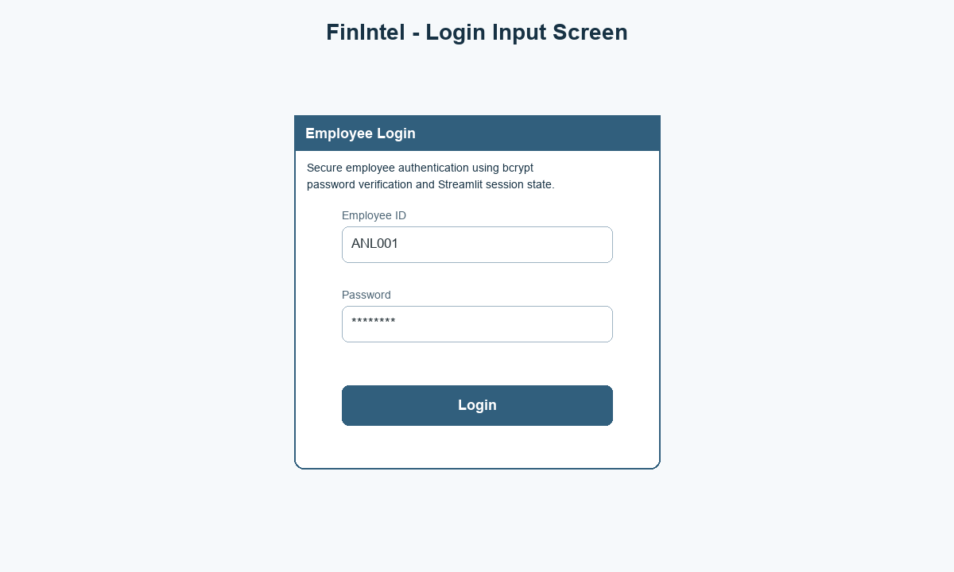
The employee enters Employee ID and Password. The authentication module validates the active employee record and bcrypt password hash.

1.2 Credit Risk Prediction Input Screen
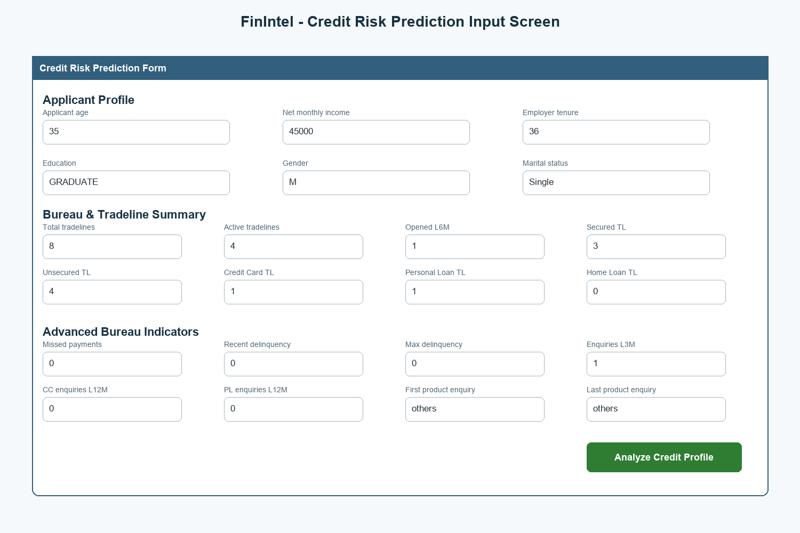
This screen represents the current credit_risk.py form: applicant profile, bureau/tradeline summary, advanced bureau indicators, product enquiries, and loan flags.

1.3 Fraud Detection Prediction Input Screen
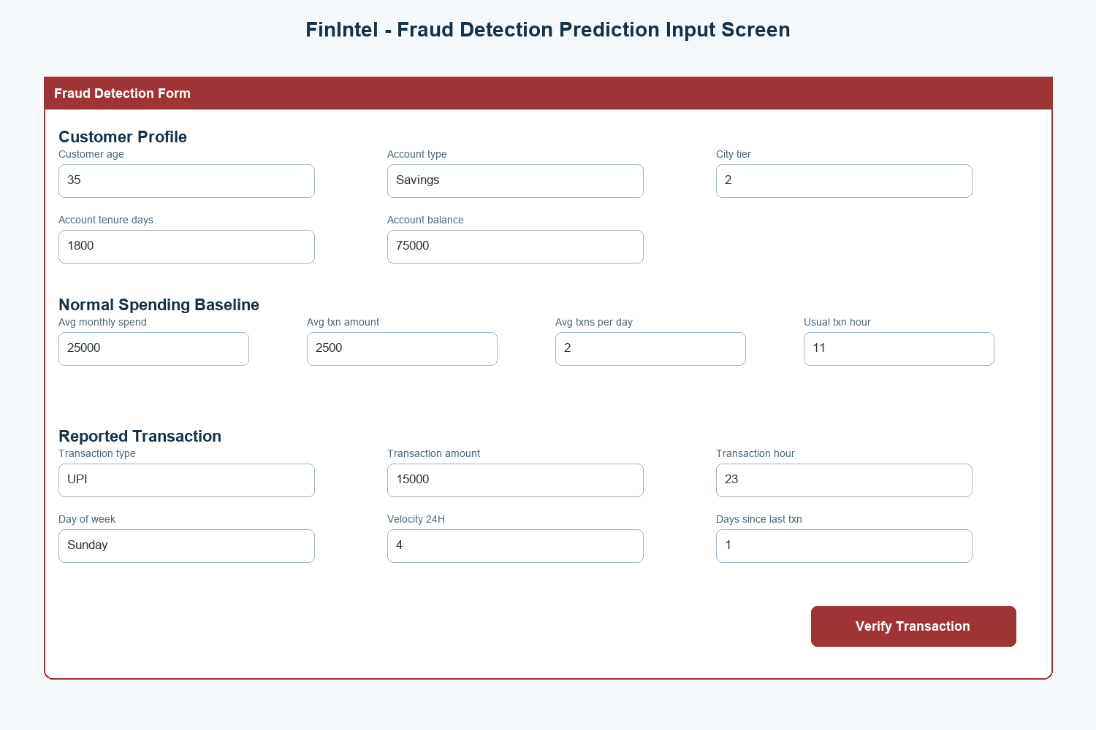
This screen represents the current fraud_detection.py form: customer profile, baseline spending, reported transaction, velocity, anomaly flags, and verification submission.
Input Area | Current Project Inputs
Login | Employee ID, password
Credit Applicant Profile | Applicant age, net monthly income, current employer tenure, education, gender, marital status
Credit Bureau & Tradeline | Total tradelines, active tradelines, opened L6M, secured/unsecured TL, CC/PL/Home TL
Advanced Credit Indicators | Missed payments, delinquency levels, enquiries, open/closed tradeline percentages, product enquiry values, loan flags
Fraud Customer Profile | Customer age, account type, city tier, tenure days, account balance
Fraud Transaction Profile | Transaction type, amount, hour, day of week, velocity 24H, days since last transaction, anomaly flags

2. Output Screens

2.1 Management Insights Output Screen
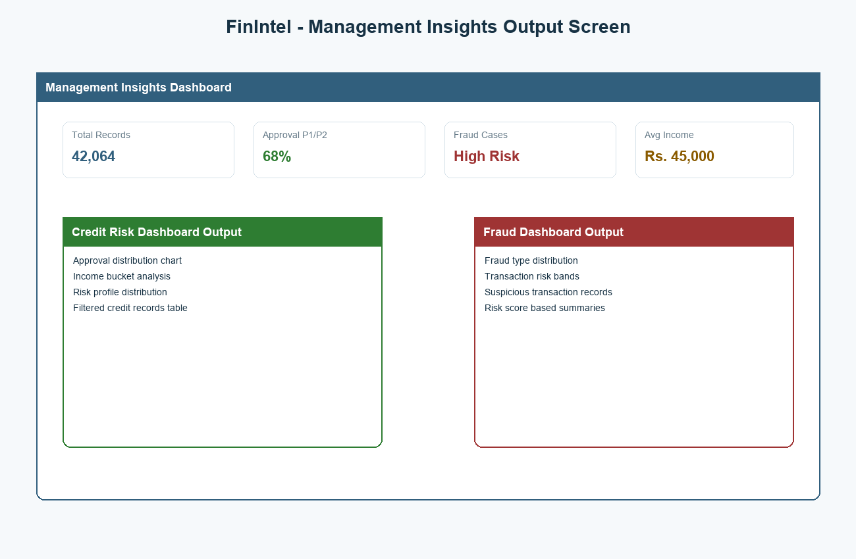
This screen represents the current management_insights.py module with Credit Risk Dashboard and Fraud Dashboard tabs.

2.2 Credit Risk Prediction Output Screen
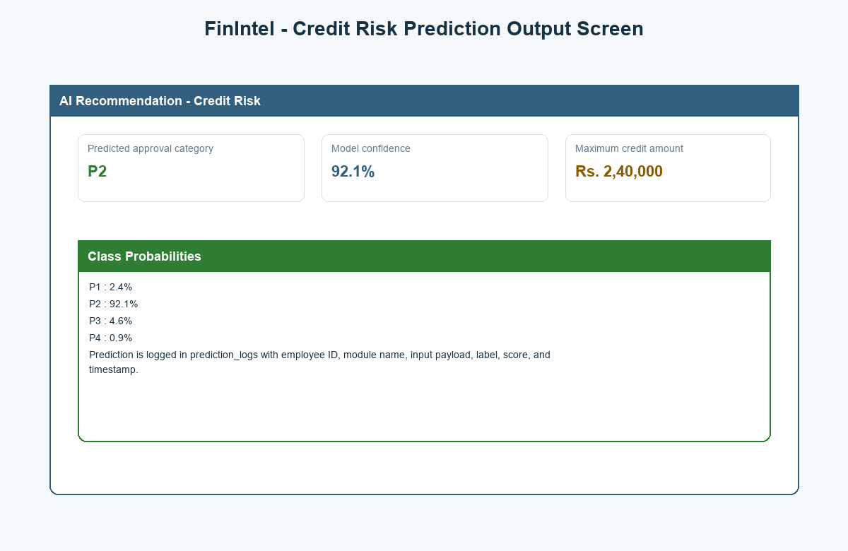
The current credit module displays predicted approval category, model confidence, maximum credit amount, and class probabilities.

2.3 Fraud Detection Prediction Output Screen
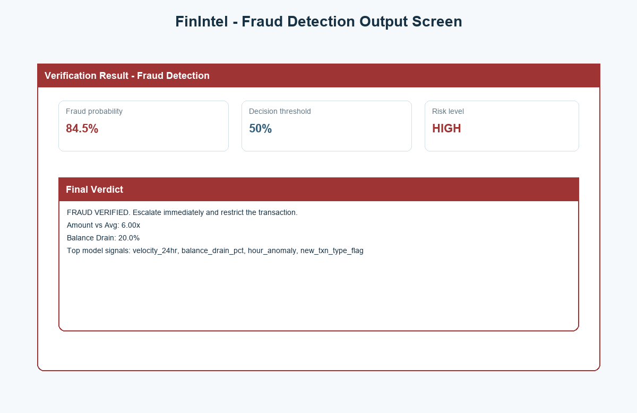
The current fraud module displays fraud probability, decision threshold, risk level, final verdict, derived signals, and top model signals.
Output Area | Current Project Outputs
Management Insights | Credit KPIs, fraud KPIs, charts, risk summaries, filtered records
Credit Risk Prediction | Approval category, confidence percentage, maximum credit amount, class probabilities
Fraud Detection Prediction | Fraud probability, threshold, risk level, final verdict, amount-to-average ratio, balance drain, top model signals
Prediction Logging | Employee ID, module name, serialized payload, predicted label, score, timestamp

3. Database Design - Current ER Diagram
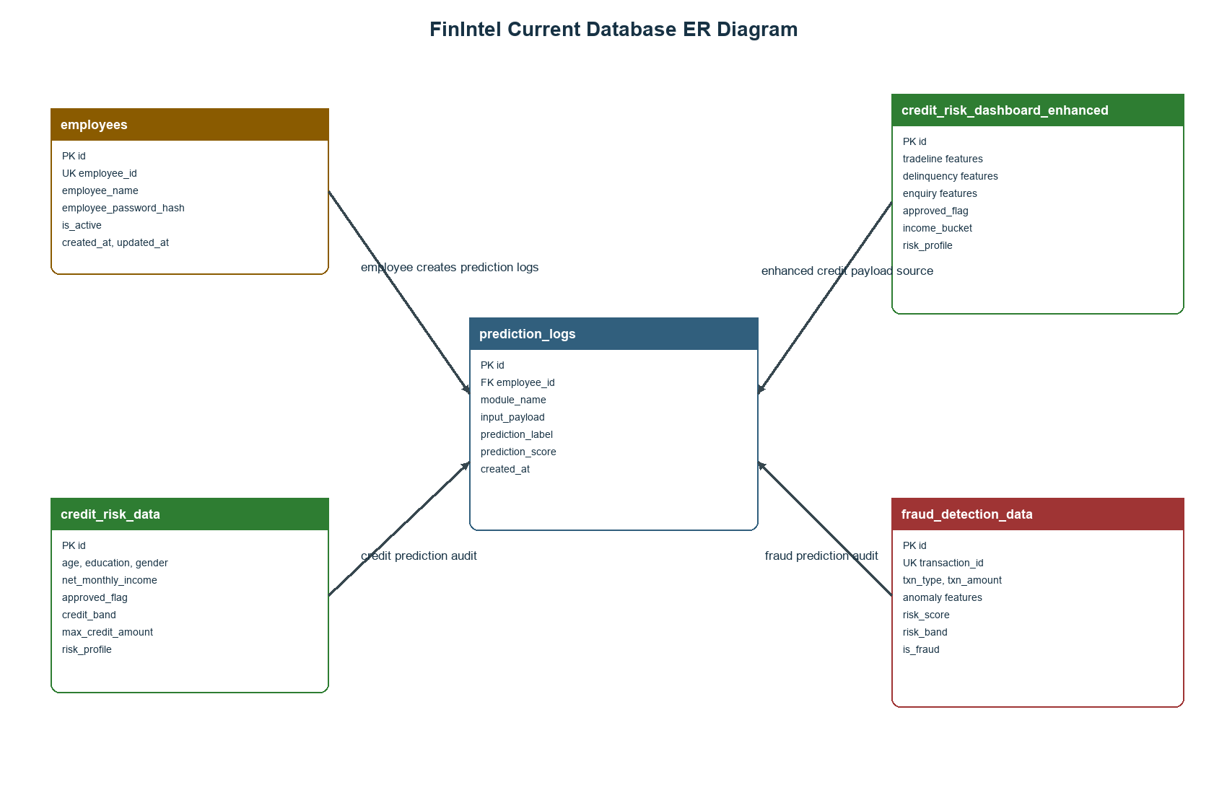
The diagram shows the current database design used by FinIntel. The employees table creates prediction_logs. Credit and fraud modules save prediction audit records after model execution.

4. Database Tables
Table Name | Primary Key | Important Columns | Purpose
employees | id | employee_id, employee_name, employee_password_hash, is_active, created_at, updated_at | Stores employee login and account status.
credit_risk_data | id | age, education, gender, marital_status, net_monthly_income, approved_flag, credit_band, max_credit_amount | Stores summarized credit risk records and outcomes.
credit_risk_dashboard_enhanced | id | tradeline features, delinquency features, enquiry features, approved_flag, income_bucket, risk_profile | Stores enhanced credit dashboard and model feature records.
fraud_detection_data | id | transaction_id, txn_type, txn_amount, anomaly fields, risk_score, risk_band, is_fraud | Stores transaction records and fraud risk output.
prediction_logs | id | employee_id, module_name, input_payload, prediction_label, prediction_score, created_at | Stores prediction audit history for credit and fraud modules.

5. Current Database Schema
CREATE TABLE IF NOT EXISTS employees (
id INTEGER PRIMARY KEY AUTOINCREMENT,
employee_id VARCHAR(30) NOT NULL UNIQUE,
employee_name VARCHAR(120) NOT NULL,
employee_password_hash VARCHAR(255) NOT NULL,
is_active BOOLEAN NOT NULL DEFAULT 1,
created_at DATETIME NOT NULL,
updated_at DATETIME NOT NULL
);

CREATE TABLE IF NOT EXISTS credit_risk_data (
id INTEGER PRIMARY KEY AUTOINCREMENT,
age FLOAT,
education VARCHAR(80),
gender VARCHAR(20),
marital_status VARCHAR(40),
net_monthly_income FLOAT,
time_with_current_employer FLOAT,
total_tradelines FLOAT,
active_tradelines FLOAT,
tradelines_opened_last_6m FLOAT,
time_since_recent_enquiry FLOAT,
approved_flag VARCHAR(20),
credit_band VARCHAR(40),
max_credit_amount FLOAT,
income_bucket VARCHAR(40),
risk_profile VARCHAR(40),
source_file VARCHAR(255),
created_at DATETIME NOT NULL
);

CREATE TABLE IF NOT EXISTS credit_risk_dashboard_enhanced (
id INTEGER PRIMARY KEY AUTOINCREMENT,
pct_tl_open_l6m FLOAT,
pct_tl_closed_l6m FLOAT,
total_tl_closed_l12m FLOAT,
pct_tl_closed_l12m FLOAT,
total_missed_payments FLOAT,
cc_tradelines FLOAT,
home_tradelines FLOAT,
personal_loan_tradelines FLOAT,
secured_tradelines FLOAT,
unsecured_tradelines FLOAT,
other_tradelines FLOAT,
age_oldest_tradeline FLOAT,
age_newest_tradeline FLOAT,
time_since_recent_payment FLOAT,
max_recent_delinquency_level FLOAT,
delinquencies_6_12m FLOAT,
times_60p_dpd FLOAT,
standard_accounts_12m FLOAT,
substandard_accounts FLOAT,
substandard_accounts_6m FLOAT,
substandard_accounts_12m FLOAT,
doubtful_accounts FLOAT,
doubtful_accounts_12m FLOAT,
loss_accounts FLOAT,
recent_delinquency_level FLOAT,
cc_enquiries_12m FLOAT,
pl_enquiries_12m FLOAT,
time_since_recent_enquiry FLOAT,
enquiries_l3m FLOAT,
net_monthly_income FLOAT,
time_with_current_employer FLOAT,
has_credit_card BOOLEAN,
has_personal_loan BOOLEAN,
has_home_loan BOOLEAN,
has_gold_loan BOOLEAN,
education_code VARCHAR(40),
approved_flag VARCHAR(20),
marital_status VARCHAR(40),
gender VARCHAR(20),
last_product_enquiry VARCHAR(80),
first_product_enquiry VARCHAR(80),
income_bucket VARCHAR(40),
risk_profile VARCHAR(40),
source_file VARCHAR(255),
created_at DATETIME NOT NULL
);

CREATE TABLE IF NOT EXISTS fraud_detection_data (
id INTEGER PRIMARY KEY AUTOINCREMENT,
transaction_id VARCHAR(80) UNIQUE,
transaction_timestamp DATETIME,
transaction_type VARCHAR(80),
amount FLOAT,
age FLOAT,
account_type VARCHAR(40),
account_type_enc INTEGER,
city_tier INTEGER,
tenure_days FLOAT,
account_balance FLOAT,
avg_monthly_spend FLOAT,
avg_txn_amount FLOAT,
avg_txn_per_day FLOAT,
usual_txn_hour INTEGER,
txn_type VARCHAR(40),
txn_type_enc INTEGER,
txn_amount FLOAT,
txn_hour INTEGER,
txn_day_of_week INTEGER,
is_weekend BOOLEAN,
amount_to_avg_ratio FLOAT,
balance_drain_pct FLOAT,
hour_anomaly BOOLEAN,
velocity_24hr INTEGER,
new_txn_type_flag BOOLEAN,
large_round_amt_flag BOOLEAN,
days_since_last_txn FLOAT,
prior_fraud_complaint BOOLEAN,
fraud_type VARCHAR(80),
age_group VARCHAR(40),
origin_account VARCHAR(80),
destination_account VARCHAR(80),
old_balance_origin FLOAT,
new_balance_origin FLOAT,
old_balance_destination FLOAT,
new_balance_destination FLOAT,
location VARCHAR(120),
risk_score FLOAT,
risk_band VARCHAR(40),
is_fraud BOOLEAN,
source_file VARCHAR(255),
created_at DATETIME NOT NULL
);

CREATE TABLE IF NOT EXISTS prediction_logs (
id INTEGER PRIMARY KEY AUTOINCREMENT,
employee_id VARCHAR(30) NOT NULL,
module_name VARCHAR(50) NOT NULL,
input_payload TEXT NOT NULL,
prediction_label VARCHAR(80),
prediction_score FLOAT,
created_at DATETIME NOT NULL
);

6. Data Dictionary
Field | Type | Table | Description
employee_id | String(30) | employees, prediction_logs | Unique employee identifier and prediction owner reference.
employee_password_hash | String(255) | employees | bcrypt hashed password.
net_monthly_income | Float | credit tables | Applicant monthly income.
approved_flag | String(20) | credit tables | Credit approval class such as P1, P2, P3, P4.
credit_band | String(40) | credit_risk_data | Assigned credit band.
max_credit_amount | Float | credit_risk_data | Estimated maximum credit amount.
transaction_id | String(80) | fraud_detection_data | Unique transaction or case identifier.
txn_type | String(40) | fraud_detection_data | Transaction mode/type.
txn_amount | Float | fraud_detection_data | Transaction amount.
amount_to_avg_ratio | Float | fraud_detection_data | Transaction amount compared with normal average.
balance_drain_pct | Float | fraud_detection_data | Percentage of account balance used by transaction.
risk_score | Float | fraud_detection_data | Fraud risk score.
risk_band | String(40) | fraud_detection_data | Low, Medium, or High risk category.
is_fraud | Boolean | fraud_detection_data | Fraud classification flag.
module_name | String(50) | prediction_logs | Module that generated the prediction.
input_payload | Text | prediction_logs | Serialized model input JSON.
prediction_label | String(80) | prediction_logs | Prediction output label.
prediction_score | Float | prediction_logs | Confidence or probability score.
created_at | DateTime | All tables | Record creation timestamp.

