FinIntel - Input / Output Screens and Database Design
Focused final document containing UI input screens, output screens, ER diagram, database tables, schema, and data dictionary.

1. Input Screens

1.1 Login Input Screen
The login screen allows an authorized employee or analyst to access the FinIntel system using valid employee credentials.
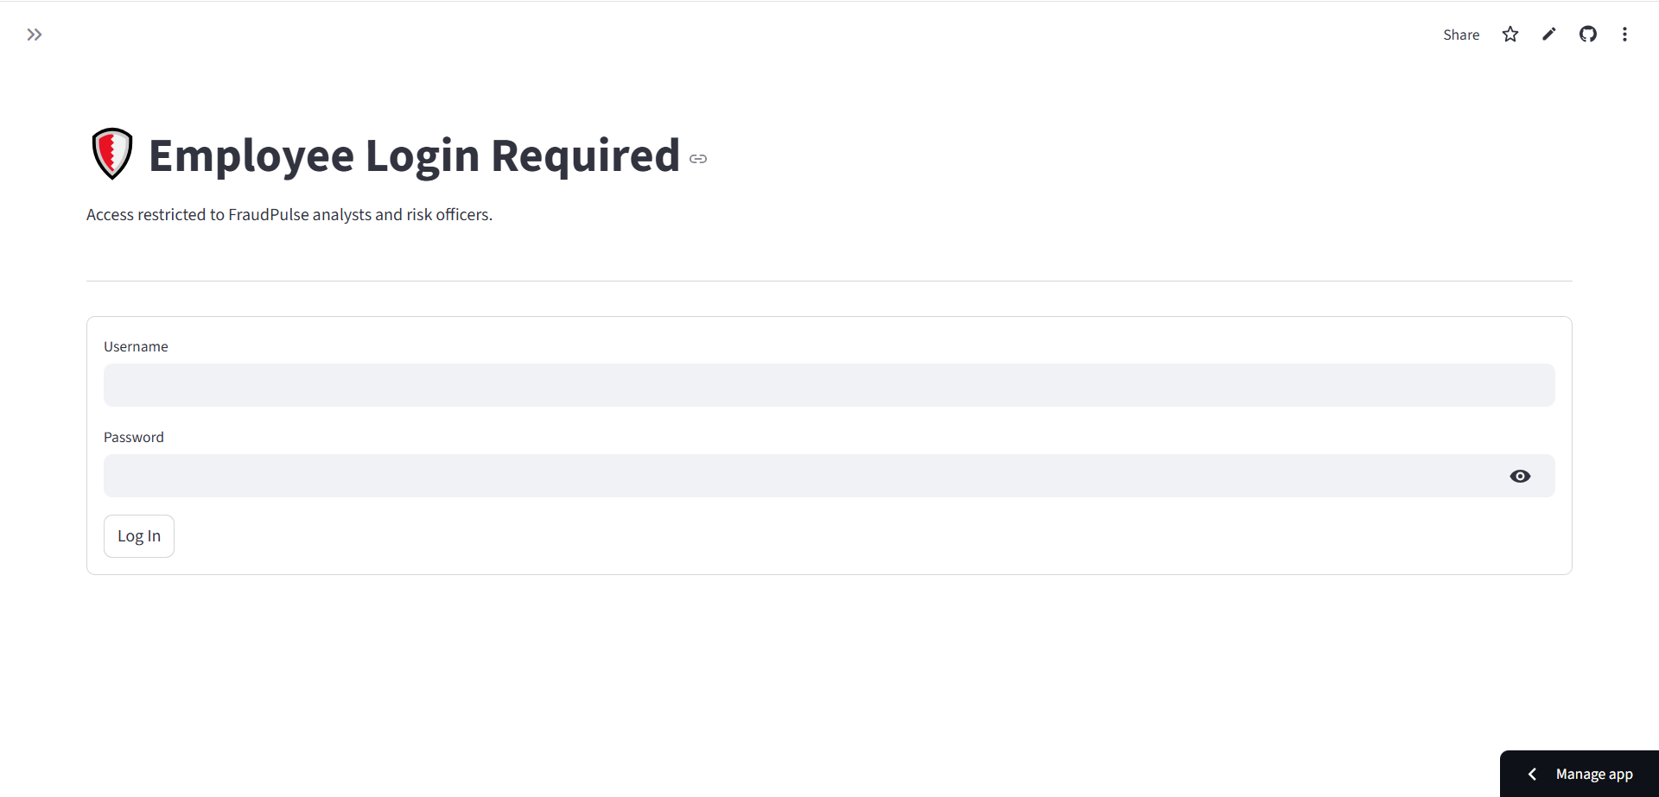
Inputs: Employee ID, Password, Login button.

1.2 Prediction Input Screen
The prediction screen allows the analyst to enter applicant, bureau, tradeline, enquiry, customer, and transaction details for credit risk and fraud prediction workflows.
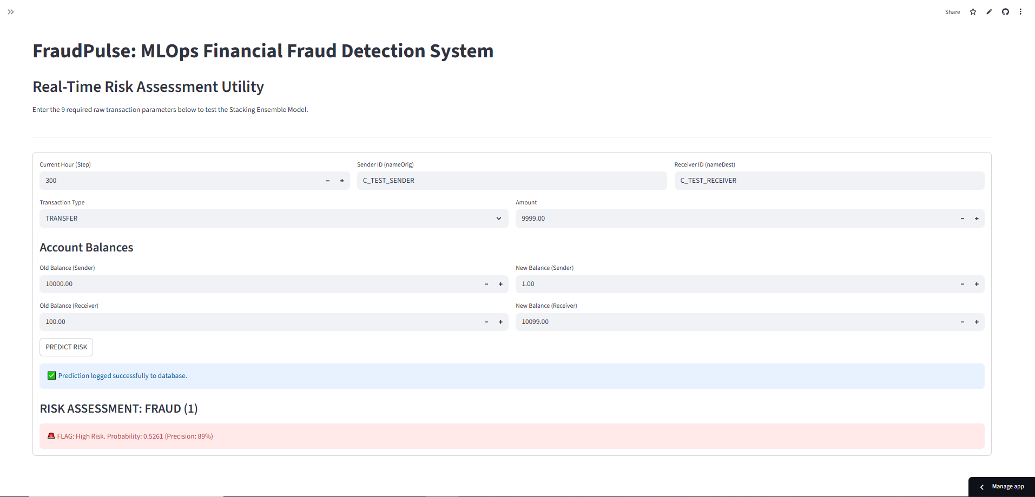
Input Screen | Main Inputs
Login Screen | Employee ID, Password, Login button
Credit Risk Prediction Screen | Applicant age, net monthly income, employer tenure, education, gender, marital status, tradelines, enquiries, delinquency values, product enquiry flags
Fraud Detection Prediction Screen | Customer age, account type, city tier, account balance, average transaction baseline, transaction amount, transaction type, hour, velocity, anomaly flags
Dashboard Filter Screen | Approval flag filters, income range, age range, transaction type, fraud type, risk flag filters

2. Output Screens

2.1 Management Dashboard Output Screen
The management dashboard shows portfolio-level KPIs, charts, filtered records, and analytical reports for credit and fraud monitoring.
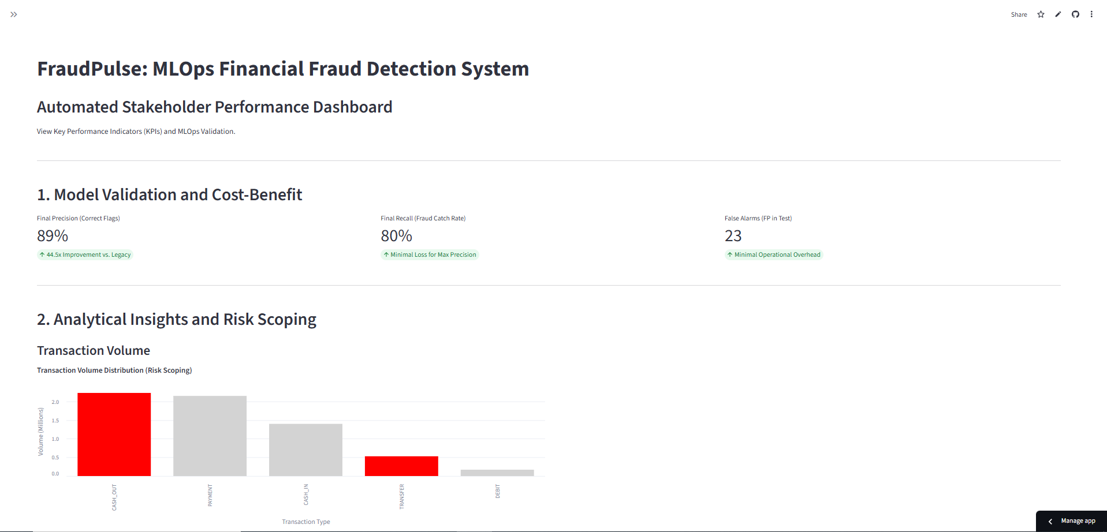

2.2 Detailed Dashboard Output Screen
The detailed dashboard output shows extended visual analysis, performance summaries, and filtered decision-support data.
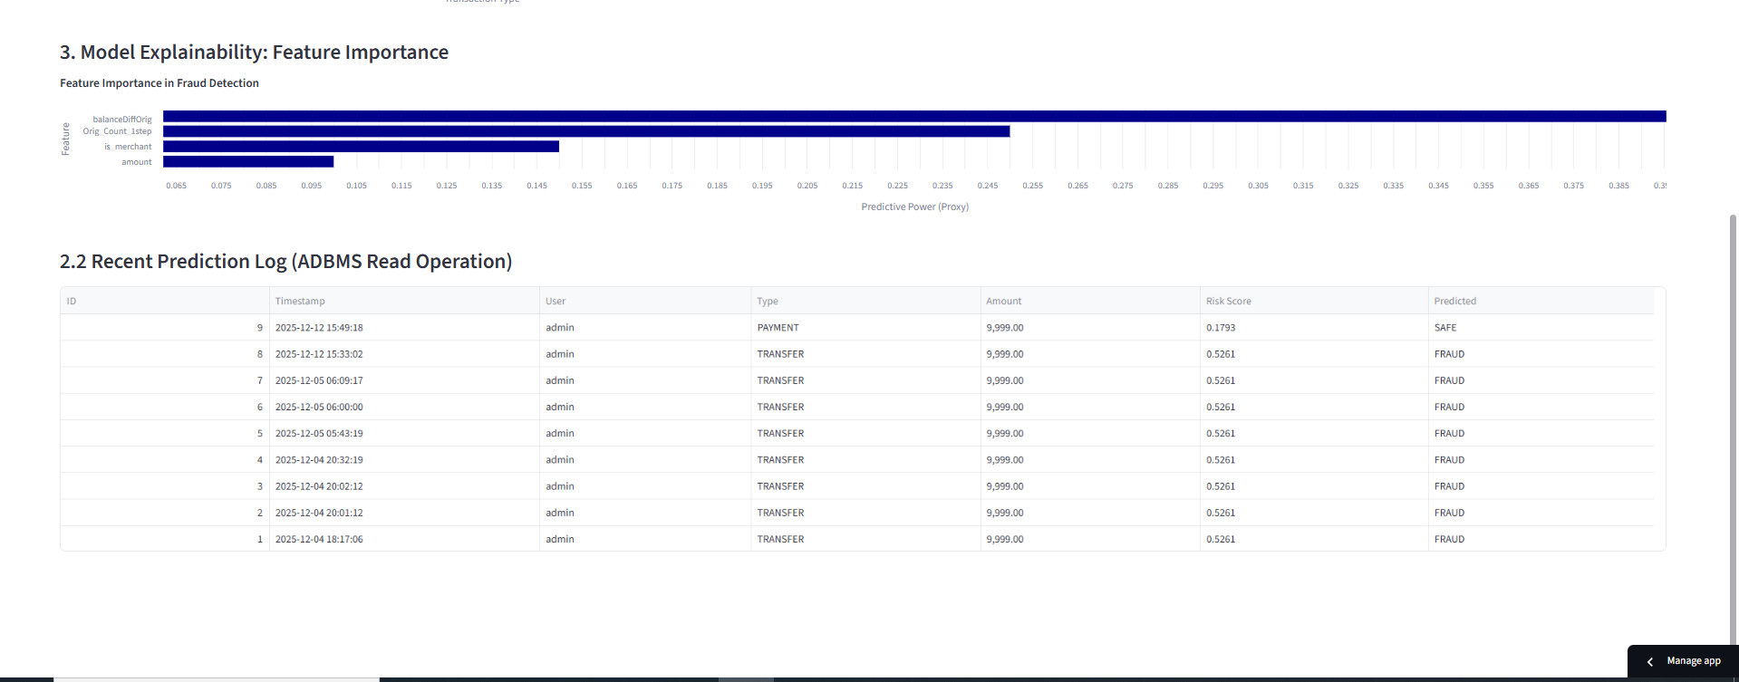

2.3 Prediction Output Screen
The prediction output screen displays model-generated result, confidence/probability, recommendation, and risk-related details.
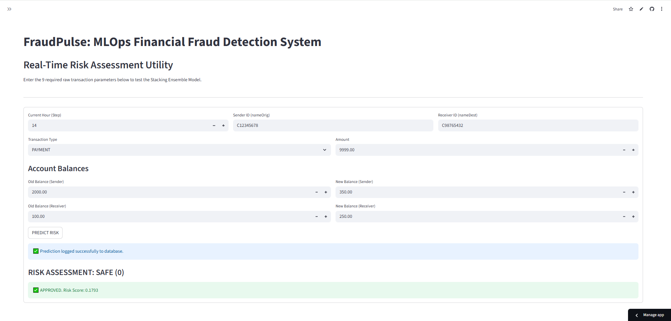
Output Screen | Displayed Output
Credit Risk Prediction Output | Predicted approval category, model confidence, class probabilities, maximum credit amount
Fraud Detection Output | Fraud probability, decision threshold, risk level, final verdict, top model signals
Credit Dashboard Output | Credit KPIs, approval distribution, income analysis, credit band analysis, filtered records
Fraud Dashboard Output | Fraud count, fraud type distribution, transaction summaries, risk breakdown, filtered records

3. Database Design - ER Diagram
The ER diagram represents the main FinIntel database entities and the way employee activity and model predictions are logged.
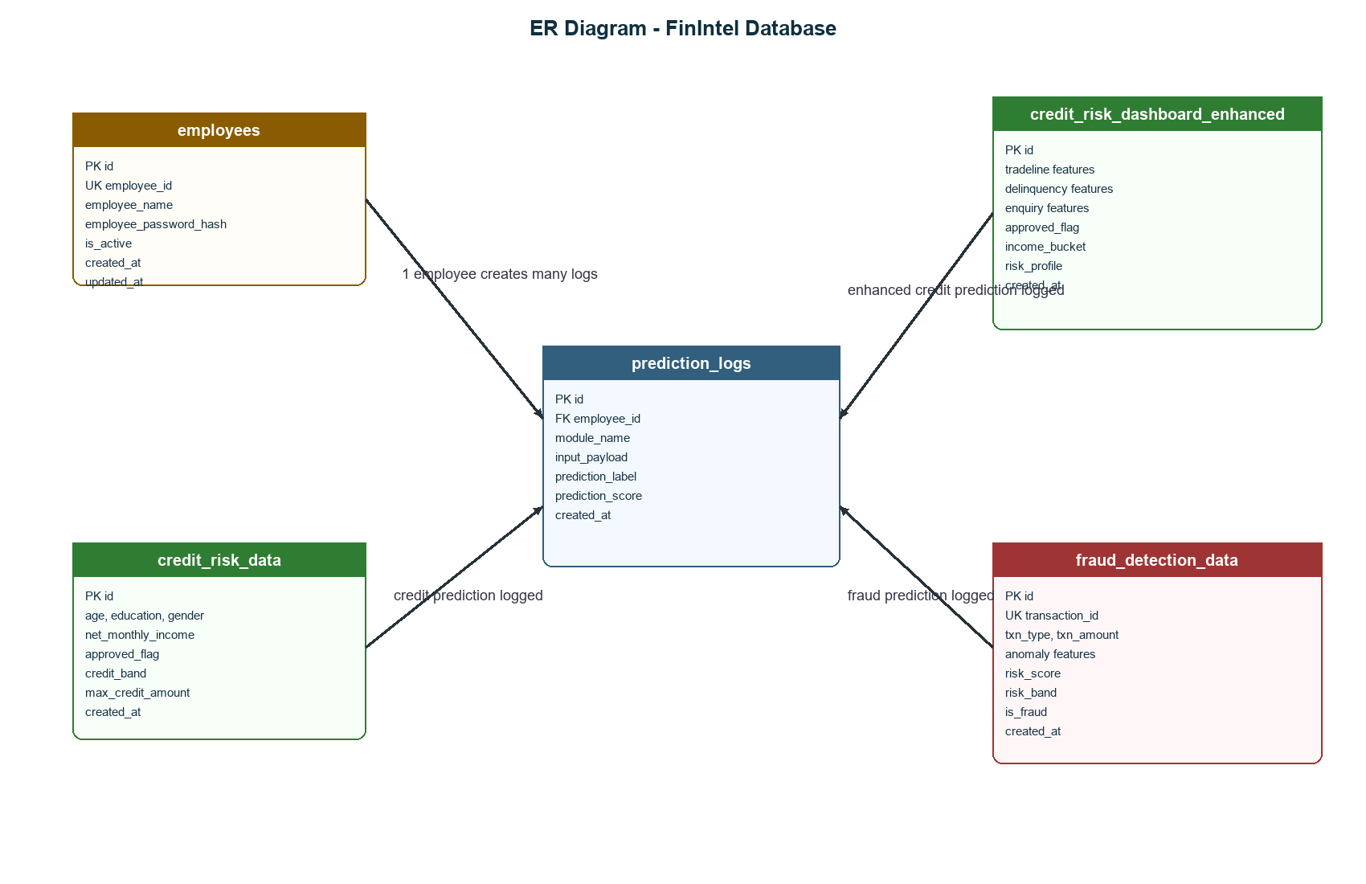

4. Database Tables
Table Name | Primary Key | Important Columns | Purpose
employees | id | employee_id, employee_name, employee_password_hash, is_active, created_at, updated_at | Stores employee login and account status.
credit_risk_data | id | age, education, gender, marital_status, net_monthly_income, approved_flag, credit_band, max_credit_amount | Stores summarized credit risk records and outcomes.
credit_risk_dashboard_enhanced | id | tradeline features, delinquency features, enquiry features, approved_flag, income_bucket, risk_profile | Stores enhanced credit dashboard and model feature records.
fraud_detection_data | id | transaction_id, txn_type, txn_amount, anomaly fields, risk_score, risk_band, is_fraud | Stores transaction records and fraud risk output.
prediction_logs | id | employee_id, module_name, input_payload, prediction_label, prediction_score, created_at | Stores prediction audit history for credit and fraud modules.

5. Database Schema
Actual schema used by the FinIntel project:
CREATE TABLE IF NOT EXISTS employees (
id INTEGER PRIMARY KEY AUTOINCREMENT,
employee_id VARCHAR(30) NOT NULL UNIQUE,
employee_name VARCHAR(120) NOT NULL,
employee_password_hash VARCHAR(255) NOT NULL,
is_active BOOLEAN NOT NULL DEFAULT 1,
created_at DATETIME NOT NULL,
updated_at DATETIME NOT NULL
);

CREATE TABLE IF NOT EXISTS credit_risk_data (
id INTEGER PRIMARY KEY AUTOINCREMENT,
age FLOAT,
education VARCHAR(80),
gender VARCHAR(20),
marital_status VARCHAR(40),
net_monthly_income FLOAT,
time_with_current_employer FLOAT,
total_tradelines FLOAT,
active_tradelines FLOAT,
tradelines_opened_last_6m FLOAT,
time_since_recent_enquiry FLOAT,
approved_flag VARCHAR(20),
credit_band VARCHAR(40),
max_credit_amount FLOAT,
income_bucket VARCHAR(40),
risk_profile VARCHAR(40),
source_file VARCHAR(255),
created_at DATETIME NOT NULL
);

CREATE TABLE IF NOT EXISTS credit_risk_dashboard_enhanced (
id INTEGER PRIMARY KEY AUTOINCREMENT,
pct_tl_open_l6m FLOAT,
pct_tl_closed_l6m FLOAT,
total_tl_closed_l12m FLOAT,
pct_tl_closed_l12m FLOAT,
total_missed_payments FLOAT,
cc_tradelines FLOAT,
home_tradelines FLOAT,
personal_loan_tradelines FLOAT,
secured_tradelines FLOAT,
unsecured_tradelines FLOAT,
other_tradelines FLOAT,
age_oldest_tradeline FLOAT,
age_newest_tradeline FLOAT,
time_since_recent_payment FLOAT,
max_recent_delinquency_level FLOAT,
delinquencies_6_12m FLOAT,
times_60p_dpd FLOAT,
standard_accounts_12m FLOAT,
substandard_accounts FLOAT,
substandard_accounts_6m FLOAT,
substandard_accounts_12m FLOAT,
doubtful_accounts FLOAT,
doubtful_accounts_12m FLOAT,
loss_accounts FLOAT,
recent_delinquency_level FLOAT,
cc_enquiries_12m FLOAT,
pl_enquiries_12m FLOAT,
time_since_recent_enquiry FLOAT,
enquiries_l3m FLOAT,
net_monthly_income FLOAT,
time_with_current_employer FLOAT,
has_credit_card BOOLEAN,
has_personal_loan BOOLEAN,
has_home_loan BOOLEAN,
has_gold_loan BOOLEAN,
education_code VARCHAR(40),
approved_flag VARCHAR(20),
marital_status VARCHAR(40),
gender VARCHAR(20),
last_product_enquiry VARCHAR(80),
first_product_enquiry VARCHAR(80),
income_bucket VARCHAR(40),
risk_profile VARCHAR(40),
source_file VARCHAR(255),
created_at DATETIME NOT NULL
);

CREATE TABLE IF NOT EXISTS fraud_detection_data (
id INTEGER PRIMARY KEY AUTOINCREMENT,
transaction_id VARCHAR(80) UNIQUE,
transaction_timestamp DATETIME,
transaction_type VARCHAR(80),
amount FLOAT,
age FLOAT,
account_type VARCHAR(40),
account_type_enc INTEGER,
city_tier INTEGER,
tenure_days FLOAT,
account_balance FLOAT,
avg_monthly_spend FLOAT,
avg_txn_amount FLOAT,
avg_txn_per_day FLOAT,
usual_txn_hour INTEGER,
txn_type VARCHAR(40),
txn_type_enc INTEGER,
txn_amount FLOAT,
txn_hour INTEGER,
txn_day_of_week INTEGER,
is_weekend BOOLEAN,
amount_to_avg_ratio FLOAT,
balance_drain_pct FLOAT,
hour_anomaly BOOLEAN,
velocity_24hr INTEGER,
new_txn_type_flag BOOLEAN,
large_round_amt_flag BOOLEAN,
days_since_last_txn FLOAT,
prior_fraud_complaint BOOLEAN,
fraud_type VARCHAR(80),
age_group VARCHAR(40),
origin_account VARCHAR(80),
destination_account VARCHAR(80),
old_balance_origin FLOAT,
new_balance_origin FLOAT,
old_balance_destination FLOAT,
new_balance_destination FLOAT,
location VARCHAR(120),
risk_score FLOAT,
risk_band VARCHAR(40),
is_fraud BOOLEAN,
source_file VARCHAR(255),
created_at DATETIME NOT NULL
);

CREATE TABLE IF NOT EXISTS prediction_logs (
id INTEGER PRIMARY KEY AUTOINCREMENT,
employee_id VARCHAR(30) NOT NULL,
module_name VARCHAR(50) NOT NULL,
input_payload TEXT NOT NULL,
prediction_label VARCHAR(80),
prediction_score FLOAT,
created_at DATETIME NOT NULL
);

6. Data Dictionary
Field | Type | Table | Description
id | Integer | All tables | Primary key with auto increment.
employee_id | String(30) | employees, prediction_logs | Unique employee identifier and prediction owner reference.
employee_name | String(120) | employees | Name of employee or analyst.
employee_password_hash | String(255) | employees | bcrypt hashed password.
is_active | Boolean | employees | Indicates whether employee can log in.
age | Float | credit_risk_data, fraud_detection_data | Applicant/customer age.
net_monthly_income | Float | credit tables | Applicant monthly income.
approved_flag | String(20) | credit tables | Credit approval class such as P1, P2, P3, P4.
credit_band | String(40) | credit_risk_data | Assigned credit band.
max_credit_amount | Float | credit_risk_data | Estimated maximum credit amount.
transaction_id | String(80) | fraud_detection_data | Unique transaction/case identifier.
txn_type | String(40) | fraud_detection_data | Transaction mode such as UPI, NEFT, IMPS, etc.
txn_amount | Float | fraud_detection_data | Transaction amount.
amount_to_avg_ratio | Float | fraud_detection_data | Transaction amount compared to normal average.
balance_drain_pct | Float | fraud_detection_data | Percentage of account balance used by transaction.
risk_score | Float | fraud_detection_data | Fraud model risk score.
risk_band | String(40) | fraud_detection_data | Low, Medium, or High risk category.
is_fraud | Boolean | fraud_detection_data | Fraud classification flag.
module_name | String(50) | prediction_logs | Module that generated the prediction.
input_payload | Text | prediction_logs | Serialized model input JSON.
prediction_label | String(80) | prediction_logs | Prediction output label.
prediction_score | Float | prediction_logs | Confidence or probability score.
created_at | DateTime | All tables | Record creation timestamp.

