FraudPulse / FinIntel Project Documentation
Actual diagrams, database design, UI/output documentation, limitations, test cases, and sample code.

1.3 Operating Environment Hardware and Software
Category | Specification
Client | Modern browser on Windows/Linux/macOS, 4 GB RAM minimum.
Server | Streamlit Cloud or equivalent Linux runtime, 2 GB+ RAM recommended for model loading.
Runtime | Python 3.10 environment.
Database | SQLite for local/demo; PostgreSQL or compatible SQL database through DATABASE_URL for production.
Network | Internet required for cloud deployment and remote access.

1.4 Brief Description about Technology Used
Technology | Purpose
Python | Application, ML, data processing, and backend logic.
Streamlit | Interactive web UI, forms, dashboards, tabs, sidebar navigation.
pandas / NumPy | Dataframe processing and feature preparation.
scikit-learn / XGBoost | Model pipelines, classifiers, regressors, and predictions.
SQLAlchemy | Database ORM, models, sessions, and queries.
bcrypt | Secure password hashing.
Plotly / Altair / Matplotlib / Seaborn | Charts and analytical reports.
joblib | Loading trained ML model artifacts.

2.1 Proposed System
FraudPulse, branded as FinIntel in the application, is a banking risk intelligence system for analyst-assisted decision support. It combines employee login, management dashboards, credit risk prediction, maximum credit amount estimation, fraud prediction, and prediction audit logging.

2.2 Module Specifications / Scope
Module | Scope
Authentication | Employee login, active employee validation, bcrypt password verification, session handling, logout.
Management Insights | Credit risk and fraud dashboards with filters, KPIs, charts, and data tables.
Credit Risk Prediction | Applicant/bureau inputs, approval category prediction, maximum credit amount estimation, probability output, log storage.
Fraud Detection Prediction | Transaction inputs, anomaly feature calculation, fraud probability, risk level, verdict, log storage.
Database Layer | SQLAlchemy models for employees, credit datasets, fraud datasets, and prediction logs.
ML Layer | joblib model loading, payload preparation, predictions, metrics, and trained artifacts.

2.3 Objectives of System
Objective No. | Objective
1 | Provide secure access for banking analysts.
2 | Display credit and fraud insights through dashboards.
3 | Predict applicant approval category and credit amount.
4 | Detect suspicious transactions using ML-based probability.
5 | Maintain prediction history for audit and review.
6 | Support local and Streamlit Cloud deployment.

3.1 ER Diagram
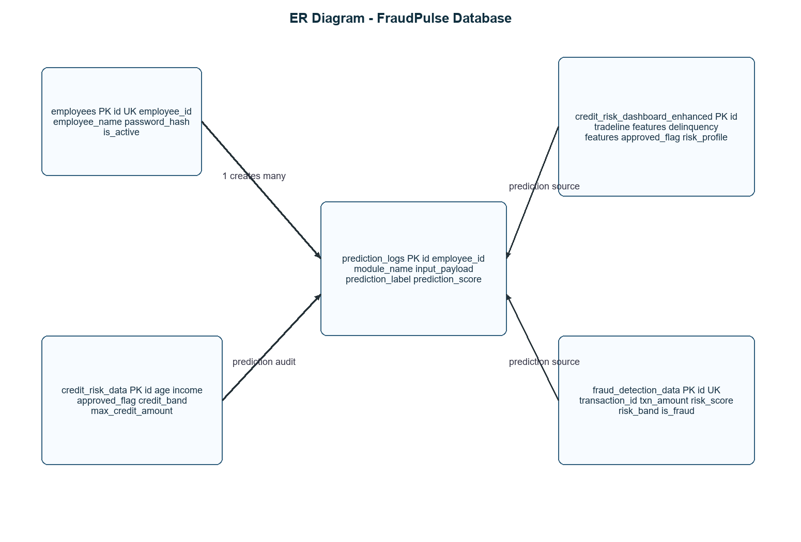

3.2 Use Case Diagram - System Use Case Diagram
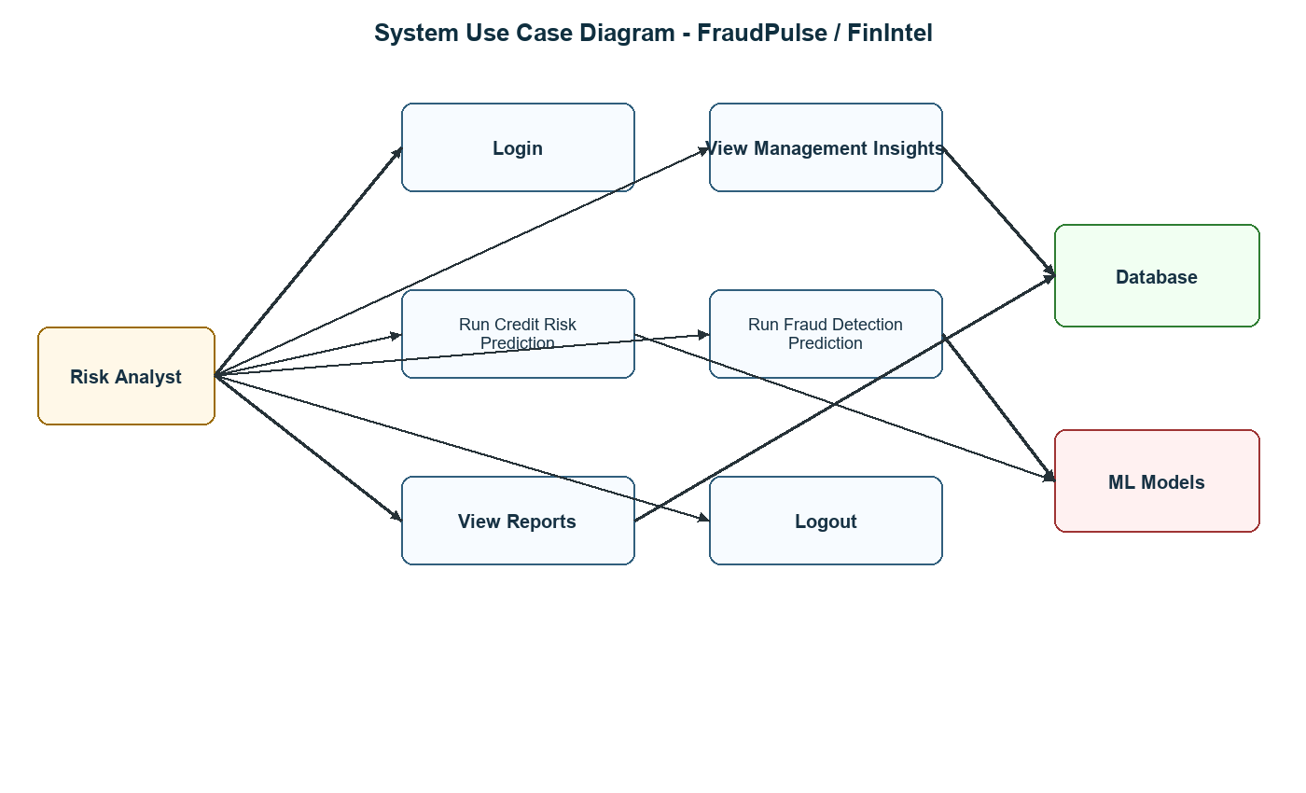

3.2.1 Use Case Diagram - Module-wise Use Case
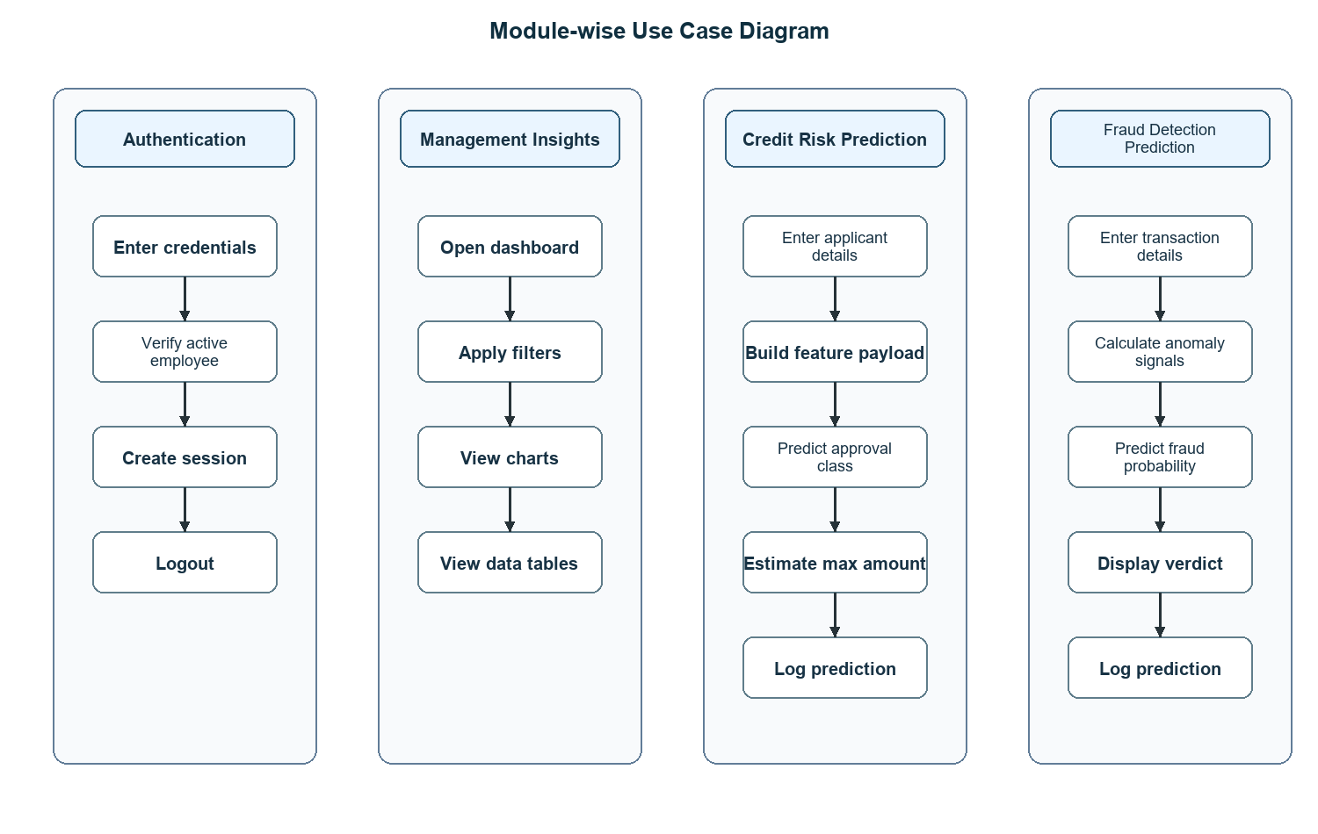

3.3 Activity Diagram
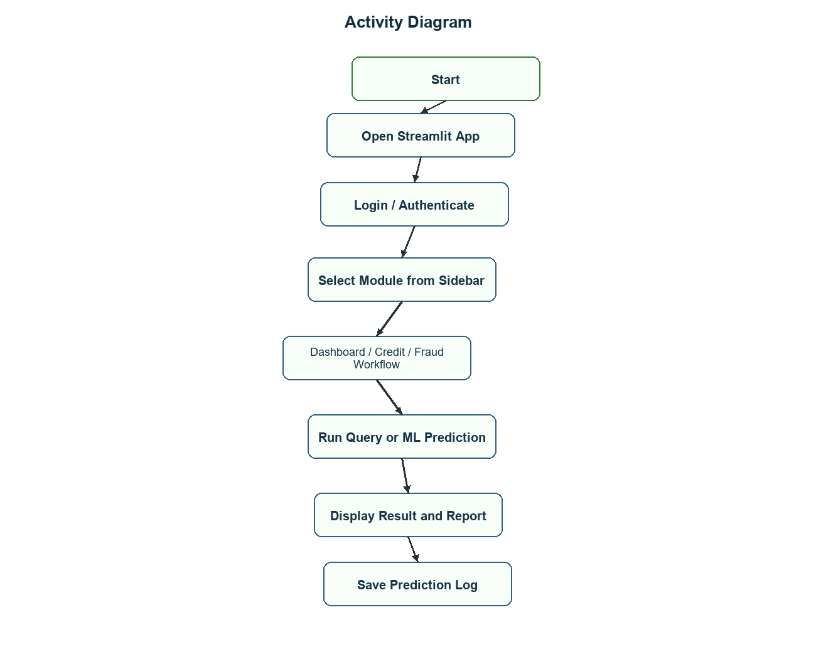

3.4 Sequence Diagram
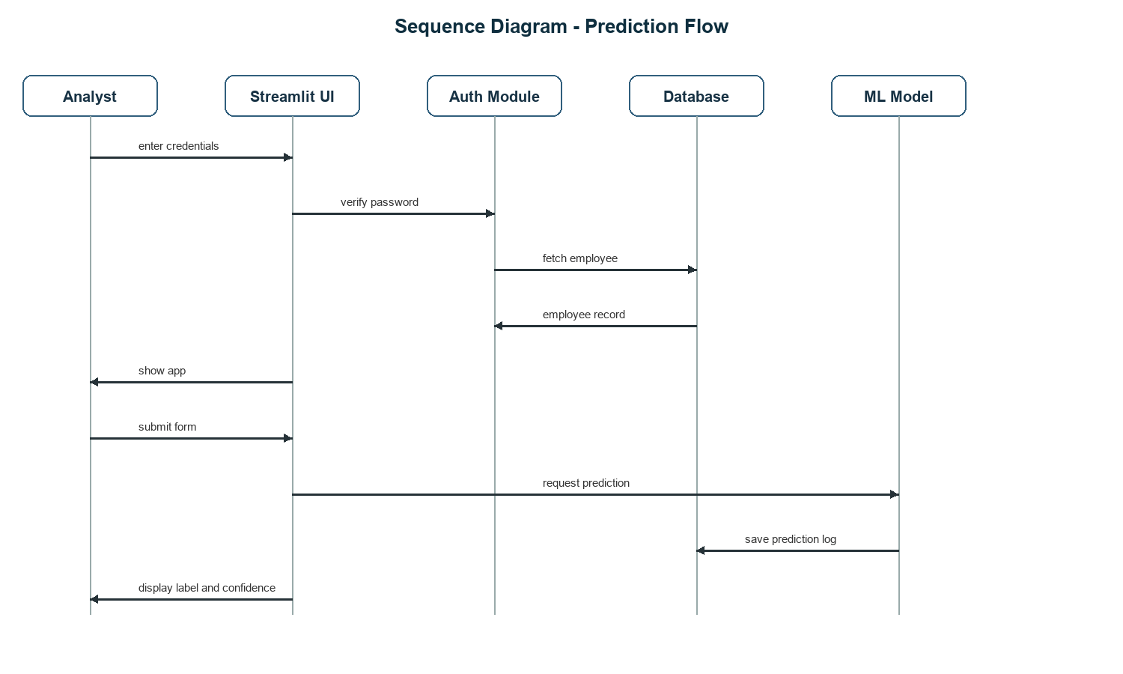

3.5 Class Diagram
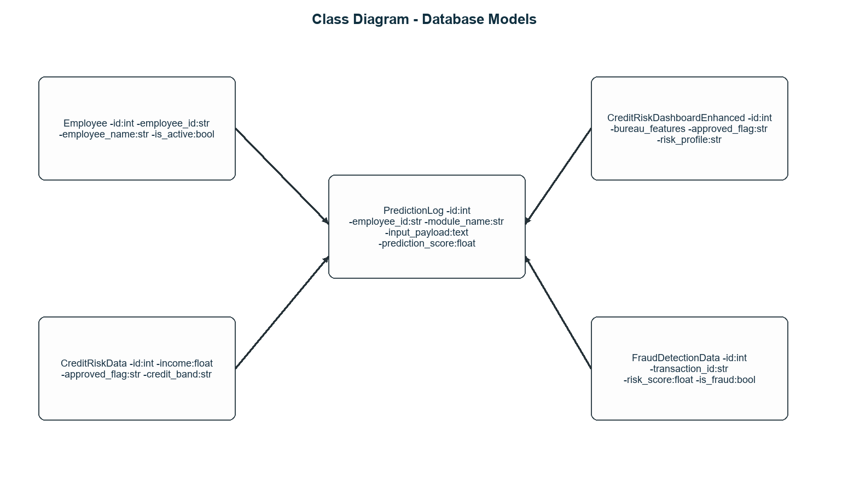

3.6 Module Hierarchy Diagram
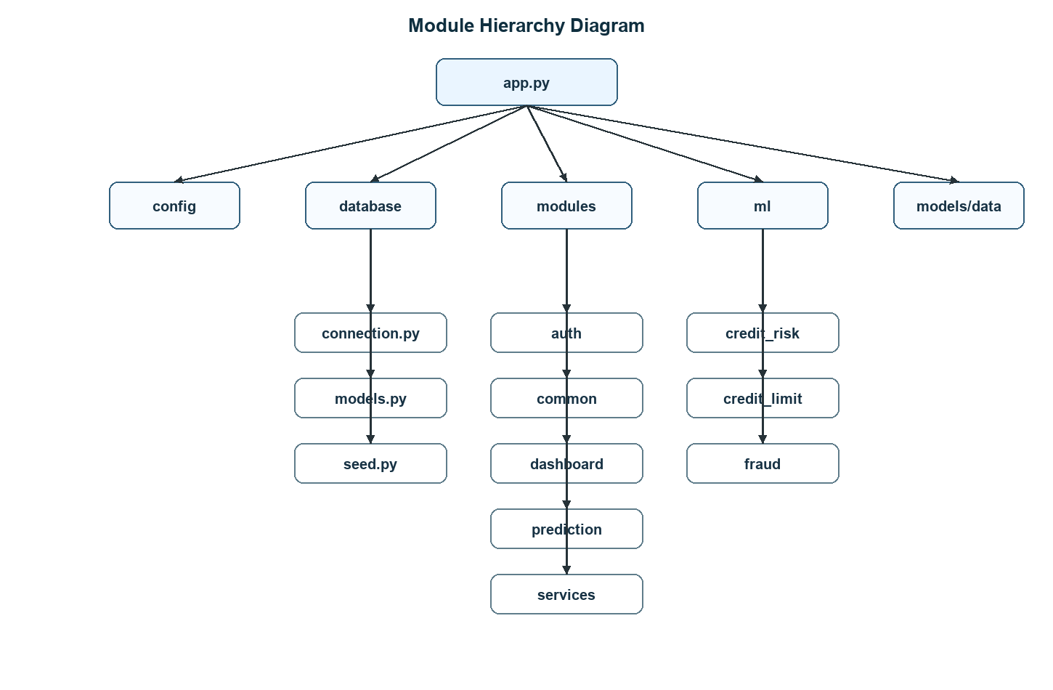

3.7 Table Specifications - Database Design
Table | Primary Key | Important Fields | Purpose
employees | id | employee_id, employee_name, employee_password_hash, is_active, created_at, updated_at | Stores employee login and status details.
credit_risk_data | id | age, education, gender, net_monthly_income, approved_flag, credit_band, max_credit_amount | Stores credit risk records and credit outcomes.
credit_risk_dashboard_enhanced | id | tradeline metrics, delinquency metrics, enquiries, approved_flag, income_bucket, risk_profile | Stores enhanced dashboard and credit model feature data.
fraud_detection_data | id | transaction_id, txn_type, txn_amount, risk_score, risk_band, is_fraud | Stores transaction and fraud analysis data.
prediction_logs | id | employee_id, module_name, input_payload, prediction_label, prediction_score, created_at | Stores audit trail for prediction submissions.

3.8 Data Dictionary
Field | Data Type | Description
employee_id | String(30) | Unique employee login ID.
employee_password_hash | String(255) | bcrypt password hash.
net_monthly_income | Float | Applicant monthly income.
approved_flag | String(20) | Approval class such as P1, P2, P3, P4.
credit_band | String(40) | Credit band assigned to applicant.
max_credit_amount | Float | Estimated maximum credit amount.
transaction_id | String(80) | Unique transaction case ID.
txn_amount | Float | Transaction amount.
amount_to_avg_ratio | Float | Transaction amount compared with normal average.
balance_drain_pct | Float | Percentage of account balance used by transaction.
risk_score | Float | Fraud model risk score.
risk_band | String(40) | Low, Medium, or High risk classification.
is_fraud | Boolean | Fraud flag result.
input_payload | Text | JSON input submitted to prediction model.
prediction_score | Float | Confidence or probability score.

4.1 User Interface Screens - Input
Screen | Actual Inputs
Login | Employee ID, password, login button.
Credit Risk Prediction | Applicant age, net monthly income, employer tenure, education, gender, marital status, tradelines, enquiries, delinquency fields, product enquiry fields, loan flags.
Fraud Detection Prediction | Customer age, account type, city tier, account tenure, balance, average spend, transaction type, transaction amount, hour, day, velocity, anomaly flags.
Management Insights | Credit dashboard tab, fraud dashboard tab, approval filters, income range, age range, transaction type filters, fraud type filters.

4.2 Output Screens with Data
Screen | Actual Output
Credit Risk Prediction | Predicted approval category, model confidence percentage, maximum credit amount, class probability table.
Fraud Detection Prediction | Fraud probability, decision threshold, risk level badge, final verdict, amount-to-average ratio, balance drain percentage, top model signals.
Credit Dashboard | KPI cards, filtered credit records, approval distribution, income and risk analysis.
Fraud Dashboard | Fraud transaction summaries, fraud type distribution, risk breakdown, filtered transaction records.

4.3 Data Reports
Report | Data Included
Credit Approval Report | Approval categories, income bands, risk profiles, applicant attributes.
Credit Amount Report | Maximum credit amount and credit band related output.
Fraud Detection Report | Transaction details, anomaly features, risk score, fraud verdict.
Prediction Log Report | Employee ID, module name, input payload, prediction label, score, timestamp.
Model Evaluation Reports | Classification report, confusion matrix, metrics JSON, feature columns.

4.4 Sample Program Code
def predict_enhanced_approved_flag(input_payload: dict) -> dict:
artifact = load_artifact(ENHANCED_MODEL_PATH)
model = artifact["model"]
label_encoder = artifact["label_encoder"]
feature_columns = artifact["feature_columns"]

frame = pd.DataFrame([input_payload])
frame = frame.reindex(columns=feature_columns)

probabilities = model.predict_proba(frame)[0]
probabilities = probabilities / probabilities.sum()
predicted_index = int(probabilities.argmax())
predicted_label = label_encoder.inverse_transform([predicted_index])[0]

return {
"predicted_approved_flag": predicted_label,
"confidence": float(probabilities[predicted_index]),
}

4.5 Limitations
No. | Limitation
1 | Model quality depends on training data quality, freshness, and representativeness.
2 | Streamlit Community Cloud does not provide durable local database persistence after restarts; external DATABASE_URL is recommended.
3 | Large joblib artifacts can increase startup time and deployment size.
4 | ML predictions support decision-making but should not replace final human or policy review.
5 | Dependency versions must remain compatible with saved model artifacts.
6 | Current employee management is limited to seeded/demo employee unless an admin module is expanded.

4.6 Test Cases
Test Case ID | Scenario | Input | Expected Result
TC-01 | Valid login | ANL001 with correct password | Dashboard is shown.
TC-02 | Invalid login | Wrong password | Login error is displayed.
TC-03 | Credit prediction | Valid applicant and bureau values | Approval category, confidence, amount, and probabilities are shown.
TC-04 | Fraud prediction | Valid transaction values | Fraud probability, risk badge, verdict, and signals are shown.
TC-05 | Prediction log | Authenticated user submits prediction | Row is inserted into prediction_logs.
TC-06 | Dashboard filter | Select approval/fraud filters | Charts and tables update according to filters.
TC-07 | Missing model file | Model artifact unavailable | Informative message is shown instead of app crash.
TC-08 | Logout | Click Logout | Session clears and login page appears.

