Contents
1. What are ACID properties? 2
Resources: https://www.geeksforgeeks.org/acid-properties-in-dbms/ 2
2. What is normalization and denormalization in dbms? 2
Resources: https://www.designgurus.io/answers/detail/what-is-sql-normalization-and-denormalization 3
3. What is mean isolation and its level in SQL? 3
4. What is CAP theorem? 4
5. What all different types of SQL commands? 5
Resources: https://www.javatpoint.com/dbms-sql-command 6
6. How to enhance the speed of the query in sql? 6
Resources: https://medium.com/womenintechnology/optimizing-sql-query-performance-a-comprehensive-guide-6cb72b9f52ef 7
7. What is mean by index in DBMS and why it required? 7
8. Diff between primary and composite key 7

What are ACID properties?
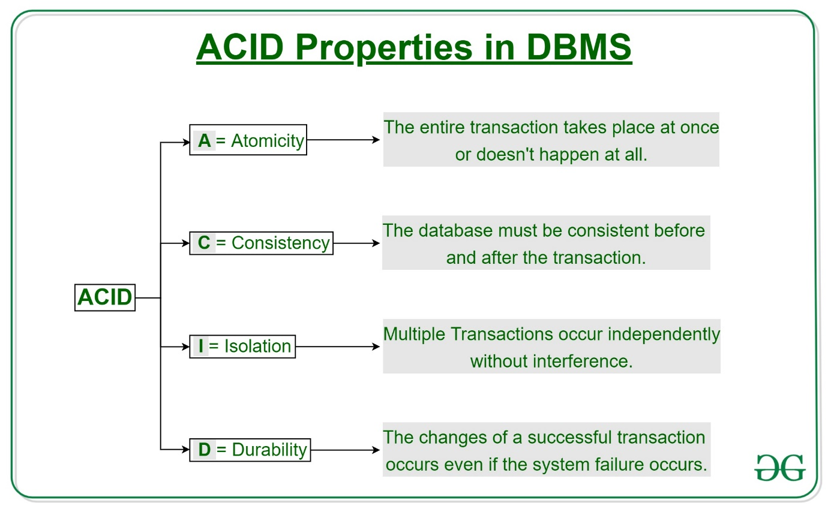

Resources: https://www.geeksforgeeks.org/acid-properties-in-dbms/

What is normalization and denormalization in dbms?

Normalization
Normalization in SQL is a database design technique that organizes tables in a manner that reduces redundancy and dependency. It involves dividing a database into two or more tables and defining relationships between them to achieve a more efficient database structure.
- Reduces Data Redundancy: Normalization eliminates duplicate data by dividing it into related tables, reducing unnecessary repetition and saving storage space.
- Improves Data Integrity and Consistency: By organizing data into smaller tables and establishing relationships, normalization ensures that updates to data are consistently reflected throughout the database, reducing the risk of inconsistencies.
- Simplifies Data Maintenance: With reduced redundancy, updates, deletions, and insertions can be handled more efficiently, making data maintenance easier and reducing anomalies such as update, insert, and delete anomalies.
- Enhances Query Performance: Although this can depend on the specific database structure and queries, normalized databases often enable more efficient indexing and retrieval, making complex queries more manageable.
- Provides Data Flexibility: Normalized databases are more adaptable to changes, as new data fields can be added with minimal adjustments to existing data, allowing for easier scalability.
- Ensures Data Accuracy: By following normalization rules, data dependencies are maintained, making it less likely for errors to propagate through the system, which leads to higher accuracy in the stored information.

Denormalization
Denormalization, on the other hand, is the process of combining tables to reduce the complexity of database queries. This can introduce redundancy but may lead to improved performance by reducing the number of joins required.

- Improves Query Performance: By reducing the need for complex joins across multiple tables, denormalization speeds up read operations, as data can often be retrieved from a single table, making it ideal for systems that require quick data retrieval.
- Reduces Join Complexity: Denormalized databases decrease the number of joins required in queries, making query logic simpler and reducing processing time, which is particularly beneficial in complex reporting or analytics queries.
- Enhances Read Efficiency in Read-Heavy Systems: In applications where reads significantly outweigh writes (e.g., data warehousing and reporting systems), denormalization allows faster read access, benefiting end-user response times.
- Facilitates Data Aggregation: Denormalized tables can store pre-calculated data or aggregates, such as totals and averages, which reduces the need for recalculating data on the fly, further speeding up reporting processes.
- Reduces the Need for Real-Time Computation: By storing derived or computed values, denormalization reduces the need for on-the-fly calculations, which can save processing resources and reduce query execution time.
- Enables Simpler Database Schema for Specific Applications: For certain applications, denormalized schemas may align more closely with the structure needed for business processes, reducing the complexity of data handling and manipulation.
- Optimizes for High-Volume, Real-Time Applications: For applications with high transactional volumes or those requiring near-instantaneous access to data (like e-commerce or social media), denormalization helps meet performance demands effectively.

Resources: https://www.designgurus.io/answers/detail/what-is-sql-normalization-and-denormalization

What is mean isolation and its level in SQL?
In SQL, isolation levels control how transactions are executed, the degree to which data is locked, and how long locks are held. The isolation level determines how much data is isolated from other processes that are running concurrently. The goal of isolation levels is to prevent incorrect data from being read or written by concurrent transactions.
The four isolation levels in the SQL standard are:
- READ COMMITTED
The default level for SQL Server, which prevents dirty reads.
- READ UNCOMMITTED
The least restrictive level, which allows transactions to read data that other transactions have modified but not yet committed. This is known as a "dirty read".
- REPEATABLE READ
A more restrictive level than READ COMMITTED, which prevents other transactions from modifying or deleting data that has been read by the current transaction until the current transaction commits.
- SERIALIZABLE
The most restrictive level, which locks entire ranges of keys until the transaction is complete.
The rule of thumb is to use the lowest isolation level that provides the consistency needed for an application.

What is CAP theorem?
The ‘C’ in CAP theorem stands for Consistency, ‘A’ stands for Availability and ‘P’ stands for Partition Tolerance and this theorem states that for a distributed system, it is possible to attain only two properties and the third would be always compromised.

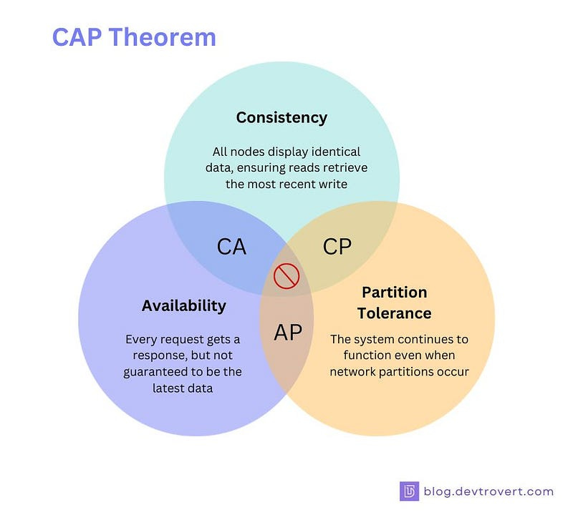

Consistency
Consistency means that all clients see the same data at the same time, no matter which node they connect to. For this to happen, whenever data is written to one node, it must be instantly forwarded or replicated to all the other nodes in the system before the write is deemed ‘successful.’
Availability
Availability means that any client making a request for data gets a response, even if one or more nodes are down. Another way to state this—all working nodes in the distributed system return a valid response for any request, without exception.
Partition tolerance
A partition is a communications break within a distributed system—a lost or temporarily delayed connection between two nodes. Partition tolerance means that the cluster must continue to work despite any number of communication breakdowns between nodes in the system.

Example
- Banking system: It must be followed CP properties they can ignore the availability, so that data should remain consistent for them
- Social media: It must be followed AP properties they can ignore the consistency, otherwise it will create the bad experience for end users if any social media won’t up and running.
- AC Properties: This practically possible but then system will act like as monolithic application because we are maintaining the only the single node of database which can be risky if server goes down. So generally, this property doesn’t consider for system design.

What all different types of SQL commands?
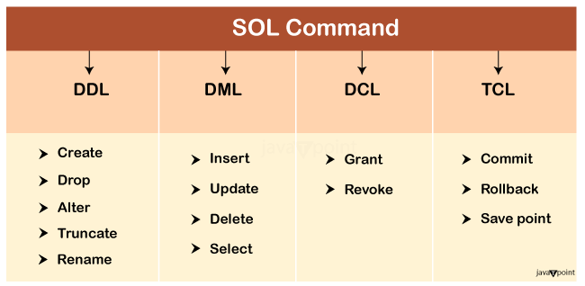
Data Definition Language (DDL)
- DDL changes the structure of the table like creating a table, deleting a table, altering a table, etc.
- All the command of DDL are auto-committed that means it permanently save all the changes in the database.
Data Manipulation Language (DML)
- DML commands are used to modify the database. It is responsible for all form of changes in the database.
- The command of DML is not auto-committed that means it can't permanently save all the changes in the database. They can be rollback.
Data Control Language (DCL)
- DCL commands are used to grant and take back authority from any database user.
Transaction Control Language (TCL)
- Transactions are atomic i.e. either every statement succeeds or none of statement succeeds. There are number of Transaction Control statements available that allow us to control this behavior. These statements ensure data consistency. TCL commands can only use with DML commands like INSERT, DELETE and UPDATE only.

Resources: https://www.javatpoint.com/dbms-sql-command

How to enhance the speed of the query in sql?
- Analyze Execution Plans
- Use Indexes Effectively
- Optimize Data Retrieval
- Refine JOIN Operations
- Use LIMIT and OFFSET
- Avoid SELECT DISTINCT
- Limit Use of Subqueries
- Choose EXISTS Over IN
- Implement Efficient Pagination
- Minimize OR Conditions
- Avoid Unnecessary Calculations
- Regular Review and Refinement
- Understand Data and Requirements
- Optimize Use of Temporary Tables

Resources: https://medium.com/womenintechnology/optimizing-sql-query-performance-a-comprehensive-guide-6cb72b9f52ef

What is mean by index in DBMS and why it required?
Indexes are a powerful tool used in the background of a database to speed up querying. Indexes contain all the necessary information needed to access items quickly and efficiently. Indexes serve as lookup tables to efficiently store data for quicker retrieval. Table keys are stored in indexes.

Diff between primary and Foreign key
