Contents
1. What is Git? 1
2. What is the difference between Git and GitHub? 1
3. What is origin git? 1
4. What is difference between git fetch and git pull? 2
5. What is difference between git rebase and git merge? 2
6. What is a ‘conflict’ in git? 4
7. What does the function of the git cherry-pick command? 4
8. How to create the branch, view all branches and checkout at same point? 4
9. What is git stash? 4
10. Explain the difference between reverting and resetting? 5
11. What is the HEAD in Git? 5
12. What is the difference between `HEAD`, `working tree` and `index` in Git? 5

What is Git?
Git is a distributed version control system that is used to track changes in source code during software development. It permits multiple developers to work on a project together without interrupting each other’s changes. Git is especially popular for its speed, and ability to manage both small and large projects capably.

What is the difference between Git and GitHub?
Git | GitHub
Git is a version control system used to track changes in files over time | GitHub is a platform where Git repositories can be stored and shared
It runs locally on your computer | It is a cloud-based service
Git can be used offline, as it operates locally on your machine. | GitHub requires an internet connection because it is hosted on the web

What is origin in git?
Origin is the default short name that git uses for a remote repository when you clone that repository so it’s just the default

Resources: https://youtu.be/LIHIRBz5ZXk?si=Iu4efqPHhx_oPMVE

What is difference between git fetch and git pull?
What is Git Fetch?
The Git Fetch command is used to fetch all changes from the remote repository to the local repository. It doesn’t make any changes to the current working directory. It stores all the changes in a separate branch called the remote-tracking branch. git merge or git rebase command is used to merge these changes into our current working directory.

What is Git Pull?
Git Pull command is used to fetch all changes from the remote repository to the current working directory. It automatically try to merge or rebase them into our current working directory. It is the combination of git fetch and git merge or git rebase. It can generate merge conflicts if there are conflict changes between our local and remote branches.
git pull = git fetch + git merge

Resources: https://www.geeksforgeeks.org/git-difference-between-git-fetch-and-git-pull/

What is difference between git rebase and git merge?
Git merge
Merging is a way to combine the changes from one branch into another. When you merge a branch, Git creates a new commit called a merge commit that has two parent commits: one from the current branch and one from the branch being merged.
git checkout feature
git merge main
Or, you can write
git merge feature main

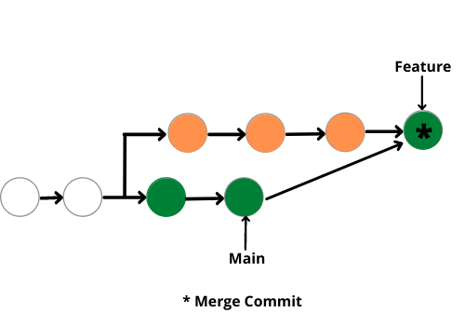

Git Rebase
Rebasing is a process of moving or combining a sequence of commits to a new base commit. It allows you to take the changes from one branch and reapply them on top of another branch.
git rebase main
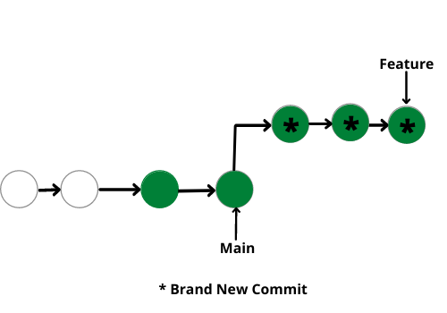

Git Merge | Git Rebase
Git Merge merges two branches to create a “feature” branch. | Git Rebase rebases the feature branch to add the feature branch to the main branch.
Git Merge is comparatively easy. | Git Rebase is comparatively harder.
Git Merge safeguards history. | Git Rabse doesn’t safeguard history.
Git Merge is more suitable for projects with the less active main branch. | Git Rebase is suitable for projects with frequently active main branches.
Git Merge forms a chain-like structure. | Git Rebase forms a linear structure.
Git Merge is preferable for large no. of people working on a project. | Git Rebase is preferable for small groups of people.
Single line command is:  git merge feature main | Single line command is:  git rebase main

Resources: https://www.geeksforgeeks.org/git-difference-between-merging-and-rebasing/

What is a ‘conflict’ in git?
Git usually manages merges automatically, but conflicts occur when two branches edit the same line or when one branch deletes a file that another edits.

What does the function of the git cherry-pick command?
The git cherry-pick command uses exact commits from one branch to another, allowing selective merging of changes without merging entire branches.
git cherry-pick <commit-hash>

Resources: https://www.geeksforgeeks.org/how-to-use-the-cherry-pick-command-in-git/

How to create the branch, view all branches and checkout at same point?
- To create the branch
  - git branch <branch name>
- To view all branches
  - git branch
- To create the branch and checkout at same time
  - git checkout -b <branch name>

What is git stash?
Git stash is Git command used to temporarily store changes in your working directory that are not yet ready to be committed. It permits developers to conserve modifications without committing them to the repository.
git stash
git stash pop

Explain the difference between reverting and resetting?
Resetting: Resetting: This command is used to change the present state of the repository to a precise point in its history. When you refresh, Git moves the ‘HEAD’ (present branch) to the particular commit, likely changing the files in your working directory and staging area. It is like reversing to a definite point in time, and it can be used to discard changes.
Reverting: Reverting, on the other a hand, makes new commit that undoes the changes made by specific commit. In place of removing or changing history like resetting does, reverting adds new commit that effectively reverses the changes introduced by the commit you specify.

What is the HEAD in Git?
In Git, HEAD is a source to the current branch or commit you are working on. HEAD normally shows the recent commit of the current branch and moves when you switch branches or check out exact commits.

What is the difference between `HEAD`, `working tree` and `index` in Git?
HEAD: Points to the currently checked-out commit or branch.
Working Tree: Includes the actual files you are currently working on or modifying.
Index (Staging Area): Acts as a middle ground where changes are prepared before committing. It keeps snapshots of change to be included in the next commit.

