Contents
1. Diff between the fail fast and fail safe iterator? 1
2. Different types of cursors in collection framework? 2
Resources: https://dotnettutorials.net/lesson/cursors-collection-framework-in-java/ 3
3. Explain the collection hierarchy 3
4. Internal working of hashmap and concurrent hashmap 3
Resources: https://youtu.be/1CJbB6SzjVw?si=ZdZGGC1TriC2VM8H, 3
https://dip-mazumder.medium.com/how-hashmap-internally-works-in-java-8-e72bb8697e06 3
5. Internal working of set? 4
Resources: https://www.geeksforgeeks.org/internal-working-of-sethashset-in-java/ 4
6. Why the treeset and treemap doesn’t allow the null keys? 4
7. Diff between the comparable and comparator interface in java 4
8. How to achieve immutability for all collection framework classes? 4

Collection Framework

Diff between the fail fast and fail safe iterator?
Key | Fail-Fast | Fail-Safe
Exception | Any changes in the collection, such as adding, removing and updating collection during a thread are iterating collection then Fail fast throw concurrent modification exception. | The fail-safe collection doesn't throw exception.
Type of collection | ArrayList and hashmap collection are the examples of fail-fast iterator | CopyOnWriteArrayList and ConcurrentHashMap are the examples of a fail-safe iterator
Performance and Memory | It's work on actual collection instead. So, this iterator doesn't require extra memory and time | It's working on a clone of the collection instead of actual collection. It is overhead in terms of time and memory
Modifications | Iterators don't allow modifications of a collection while iterating over it. | Fail-Safe iterators allow modifications of a collection while iterating over it.

Different types of cursors in collection framework?
Cursor in java something which is used to traverse the collection elements. Java supports three types of cursor.
- Iterator
This cursor is used to access the elements in the forward direction only. This cursor can be applied to any Collection Interfaces. While accessing the methods we can also delete the elements. An iterator is an interface, and we cannot create an object directly. If we want to create an object for Iterator we have to use the iterator() method.

Creation of Iterator
Syntax : Iterator it = c.iterator();
Here, the iterator() method internally creates and returns an object of a class that implements the Iterator Interface.
Methods of Iterator:
- boolean hasNext(): returns true if there is a next element in the array list.
- Object next(): returns the next element in the array list.
- void remove(): removes an element from an array list.

- List Iterator
This cursor is used to access the elements of Collection in both forward and backward directions. This cursor can be applied only for List category Collections. While accessing the methods we can also add, set, delete elements. ListIterator is an interface and we cannot create Object directly. If we want to create an object for ListIterator we have to use ListIterator() method.
Creation of ListIterator
Syntax :
ListIterator it = l.listIterator();
Here, listIterator() method internally creates and returns an object of a class that implements the ListIterator Interface.

- Enumeration(Legacy Classes)
This cursor is used to access the elements of Collection only in a forward direction. This is a legacy cursor and can be applied only for legacy classes like Vector, Stack, Hashtable. Enumeration is also an interface and we cannot create the object directly. If we want to create an object for Enumeration we have to use a legacy method called the elements() method. The Enumeration interface defines the methods by which you can enumerate (obtain one at a time) the elements in a collection of objects.

Creation of Enumeration
Syntax: Enumeration e = v.elements();
Here, the elements() method internally creates and returns an object of a class that implements the Enumeration Interface.
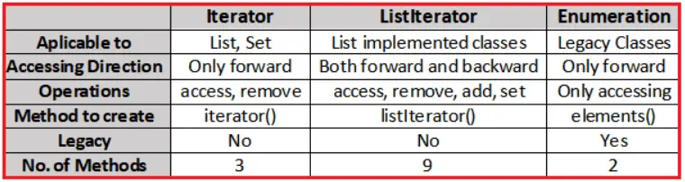

Resources: https://dotnettutorials.net/lesson/cursors-collection-framework-in-java/

Explain the collection hierarchy
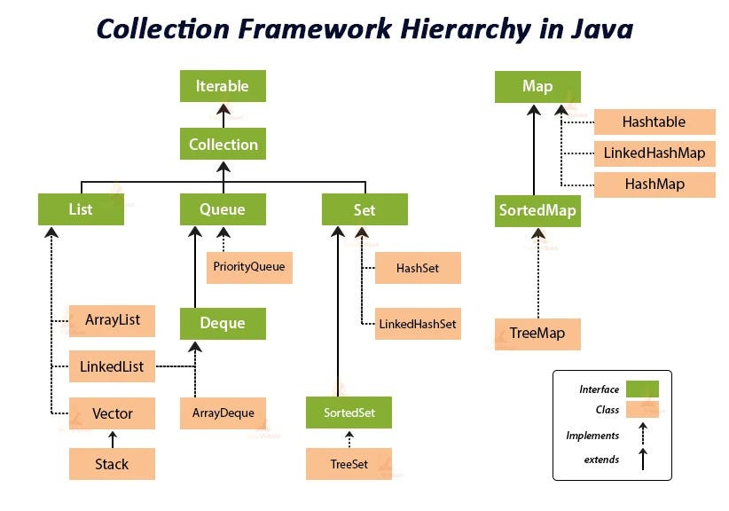

Internal working of hashmap and concurrent hashmap

Resources: https://youtu.be/1CJbB6SzjVw?si=ZdZGGC1TriC2VM8H,

https://dip-mazumder.medium.com/how-hashmap-internally-works-in-java-8-e72bb8697e06

Internal working of set?
Internally hashset also uses the hashmap to store the value

Resources: https://www.geeksforgeeks.org/internal-working-of-sethashset-in-java/

Why the treeset and treemap doesn’t allow the null keys?
Both data structures are made to put the data in sorting order. By default, the Comparable interface is used internally by TreeSet to sort the elements. Now in the Comparable Interface, the compareTo() method is used to compare one value with another to sort the elements.
So because of this purpose, null has no value, that’s why the compareTo() method cannot compare null with another value, giving a NullPointerException.

Diff between the comparable and comparator interface in java
Comparable | Comparator
Comparable provides a single sorting sequence. In other words, we can sort the collection on the basis of a single element such as id, name, and price. | The Comparator provides multiple sorting sequences. In other words, we can sort the collection on the basis of multiple elements such as id, name, and price etc.
Comparable affects the original class, i.e., the actual class is modified. | Comparator doesn't affect the original class, i.e., the actual class is not modified.
Comparable provides compareTo() method to sort elements. | Comparator provides compare() method to sort elements.
Comparable is present in java.lang package. | A Comparator is present in the java.util package.
We can sort the list elements of Comparable type by Collections.sort(List) method. | We can sort the list elements of Comparator type by Collections.sort(List, Comparator) method.
If we want to sort data in custom order using comparable, we have to implements this interface in same class | While the comparable interface we have to implement in other class in order to sort the data in custom order

How to achieve immutability for all collection framework classes?

- Using Collections.unmodifiableXXX() Methods:
unmodifiableList()
unmodifiableSet()
unmodifiableMap()
- Using Java 9+ Factory Methods:
Java 9 introduced factory methods for creating immutable collections through List, Set, and Map interfaces.
List<String> immutableList = List.of("A", "B", "C");
// Immutable Set
Set<String> immutableSet = Set.of("X", "Y", "Z");
// Immutable Map
Map<Integer, String> immutableMap = Map.of(1, "One", 2, "Two");
These collections are immutable by nature. Attempting to modify them will throw an UnsupportedOperationException.

- Use the custom logic to immutable the class

Explain Enum internally?
In Java, an enum (short for enumeration) is a special data type that enables a variable to be a set of predefined constants. Here's how Enums work internally:
1. Class Representation
Enums in Java are actually a special kind of class. When you define an enum, Java creates a class that extends java.lang.Enum. Each enum constant is an instance of this enum class.
2. Constant Instances
For each enum constant you define, Java automatically creates a static final instance of the enum class.
3. Constructor
The constructor of an enum is private. You cannot create instances of an enum outside its declaration. Each constant is initialized through this private constructor.
4. Methods
Enums can have fields, methods, and constructors. You can add additional behavior to enums. For example:
5. Built-in Methods
Enums inherit several methods from the Enum class:
values(): Returns an array of the enum constants in the order they are declared.
valueOf(String name): Returns the enum constant with the specified name.
ordinal(): Returns the ordinal (position) of the enum constant.
6. Switch Statement
Enums can be used in switch statements, which improves code readability and maintainability.

Diff between hashtable and concurrent hashmap and synchronize map?
ConcurrentHashMap | SynchronizedMap | HashTable
We will get thread safety without locking the total map object just with a bucket level lock. | We will get thread safety by locking the whole map object. | We will get thread safety by locking the whole map object
At a time multiple threads are allowed to operate on map objects safely. | At a time only one thread is allowed to perform any operation on a map object. | At a time one thread is allowed to operate on a map object.
Read operation can be performed without lock but write operation can be performed with bucket level lock. | Every read and write operations required total map object | Every read and write operations required total map object
While one thread iterating map objects the other thread is allowed to modify the map and won’t get ConcurrentModificationException. | While one thread iterating map object the other threads are not allowed to modify the map otherwise, we will get ConcurrentModificationException | While one thread iterating map object the other threads are not allowed to modify the map otherwise, we will get ConcurrentModificationException
Iterator of ConcurrentHashMap is fail-safe and won’t raise ConcurrentModificationException | Iterator of SynchronizedMap is fail-fast and it will raise ConcurrentModificationException | Iterator of HashTable is fail-fast and it will raise ConcurrentModificationException
Null is not allowed for both keys and values. | Null is allowed for both keys and values | Null is not allowed for both keys and values.
Introduce in java 1.5version | Introduce in java 1.2 version | Introduce in java 1.0version

Resources: https://www.geeksforgeeks.org/difference-between-concurrenthashmap-hashtable-and-synchronized-map-in-java/?ref=ml_lbp, https://www.baeldung.com/java-hashtable-vs-concurrenthashmap

Diff between hashset, linkedhashset and treeset in java?

HashSet | LinkedHashSet | TreeSet
HashSet uses HashMap internally to store it’s elements. | LinkedHashSet uses LinkedHashMap internally to store it’s elements. | TreeSet uses TreeMap internally to store it’s elements.
HashSet doesn’t maintain any order of elements. | LinkedHashSet maintains insertion order of elements. i.e elements are placed as they are inserted. | TreeSet orders the elements according to supplied Comparator. If no comparator is supplied, elements will be placed in their natural ascending order.
HashSet gives better performance than the LinkedHashSet and TreeSet. | The performance of LinkedHashSet is between HashSet and TreeSet. It’s performance is almost similar to HashSet. But slightly in the slower side as it also maintains LinkedList internally to maintain the insertion order of elements. | TreeSet gives less performance than the HashSet and LinkedHashSet as it has to sort the elements after each insertion and removal operations.
HashSet gives performance of order O(1) for insertion, removal and retrieval operations. | LinkedHashSet also gives performance of order O(1) for insertion, removal and retrieval operations. | TreeSet gives performance of order O(log(n)) for insertion, removal and retrieval operations.
HashSet uses equals() and hashCode() methods to compare the elements and thus removing the possible duplicate elements. | LinkedHashSet also uses equals() and hashCode() methods to compare the elements. | TreeSet uses compare() or compareTo() methods to compare the elements and thus removing the possible duplicate elements. It doesn’t use equals() and hashCode() methods for comparision of elements.
HashSet allows maximum one null element. | LinkedHashSet also allows maximum one null element. | TreeSet doesn’t allow even a single null element. If you try to insert null element into TreeSet, it throws NullPointerException.
HashSet requires less memory than LinkedHashSet and TreeSet as it uses only HashMap internally to store its elements. | LinkedHashSet requires more memory than HashSet as it also maintains LinkedList along with HashMap to store its elements. | TreeSet also requires more memory than HashSet as it also maintains Comparator to sort the elements along with the TreeMap.
Use HashSet if you don’t want to maintain any order of elements. | Use LinkedHashSet if you want to maintain insertion order of elements. | Use TreeSet if you want to sort the elements according to some Comparator.

Stream API

What is stream and its type?
Introduced in Java 8, Stream API is used to process collections of objects. A stream in Java is a sequence of objects that supports various methods that can be pipelined to produce the desired result.
There are two types of Operations in Streams:
- Intermediate Operations (lazily invoked)
Operation like filter, map, flatMap, peek, distinct
- Terminate Operations (Eagerly invoked)
Operation includes reduce, collect, sum, forEach
It also includes some short circuit operation like findFirst, findAny, allMatch, anyMatch, noneMatch

